GRAFANA SCREENSHOTS(ASSIGNMENT)

Panel: Data Bar

“Bar Chart” Type Data

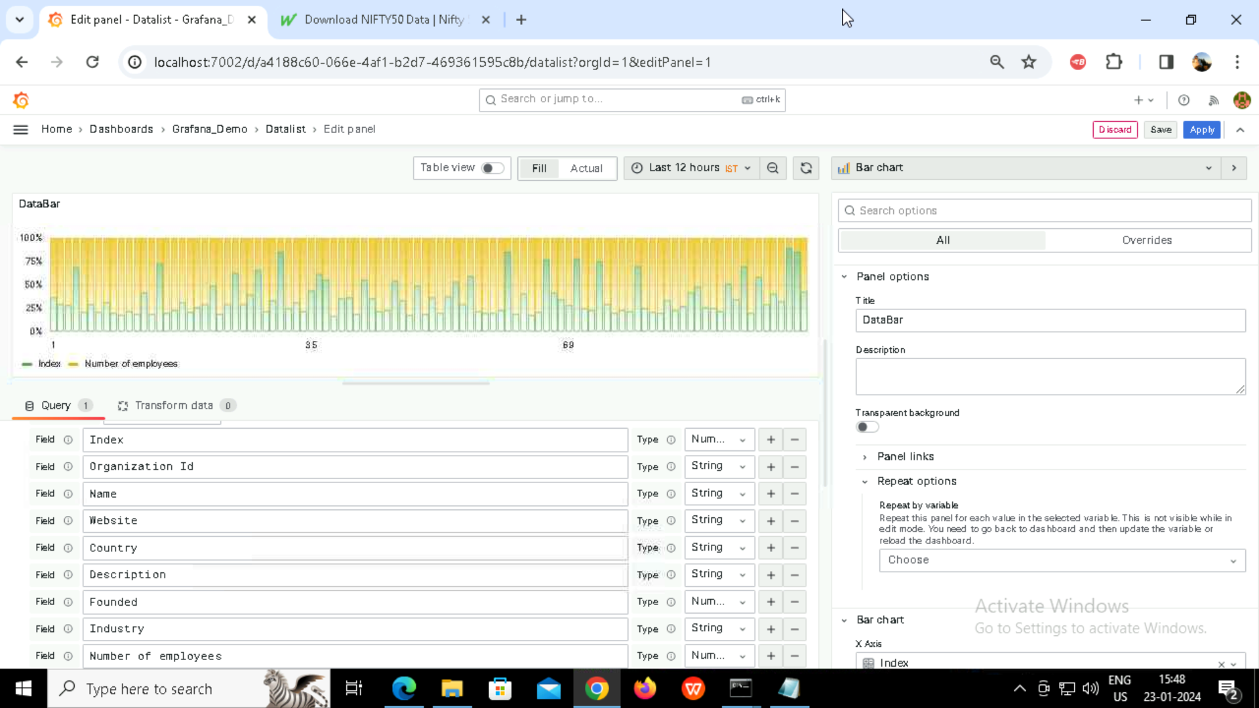

Panel: DataLol

“Datalol” Type Data

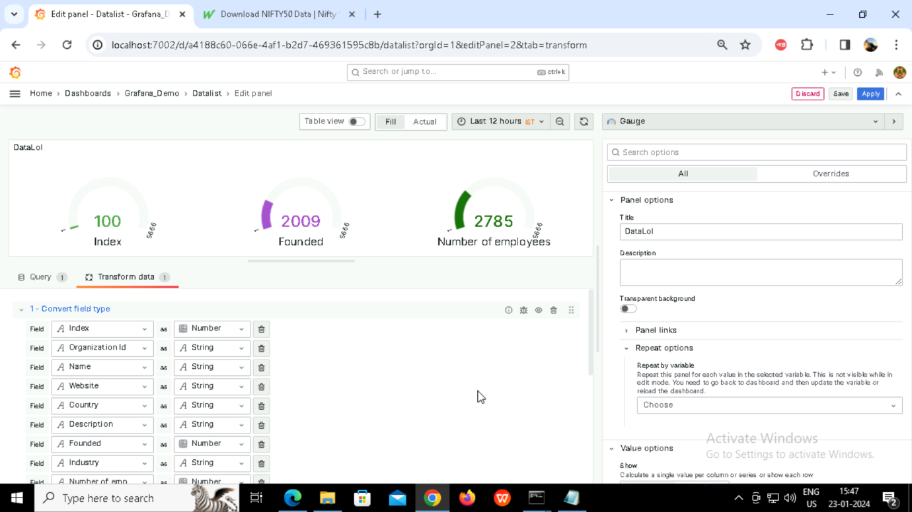

Panel: DataLol

“Datalol” Type Data

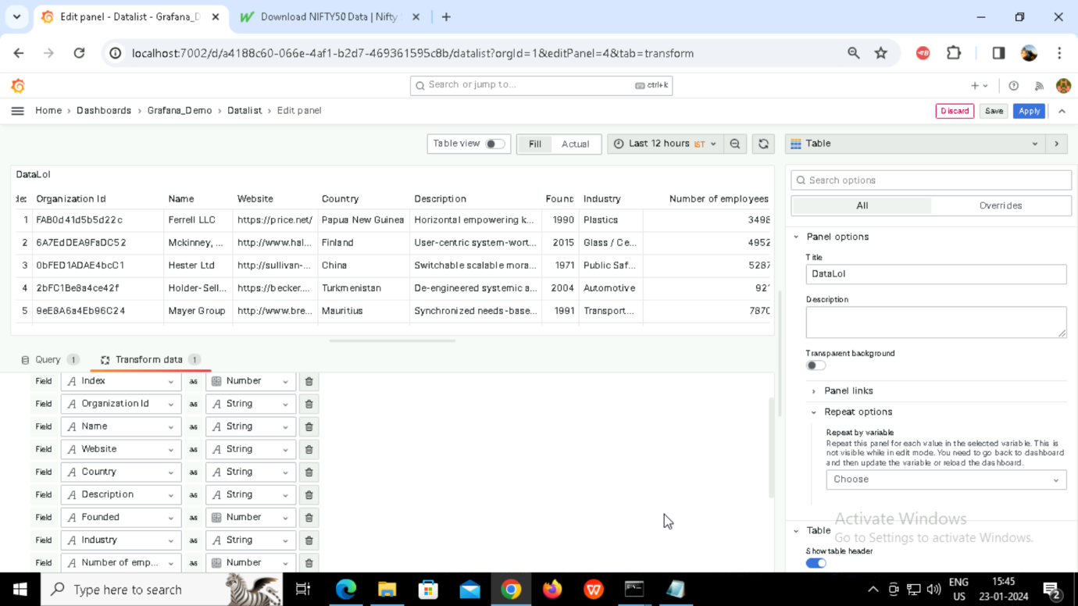

Panel: DataPie

“DataPie” Type Data

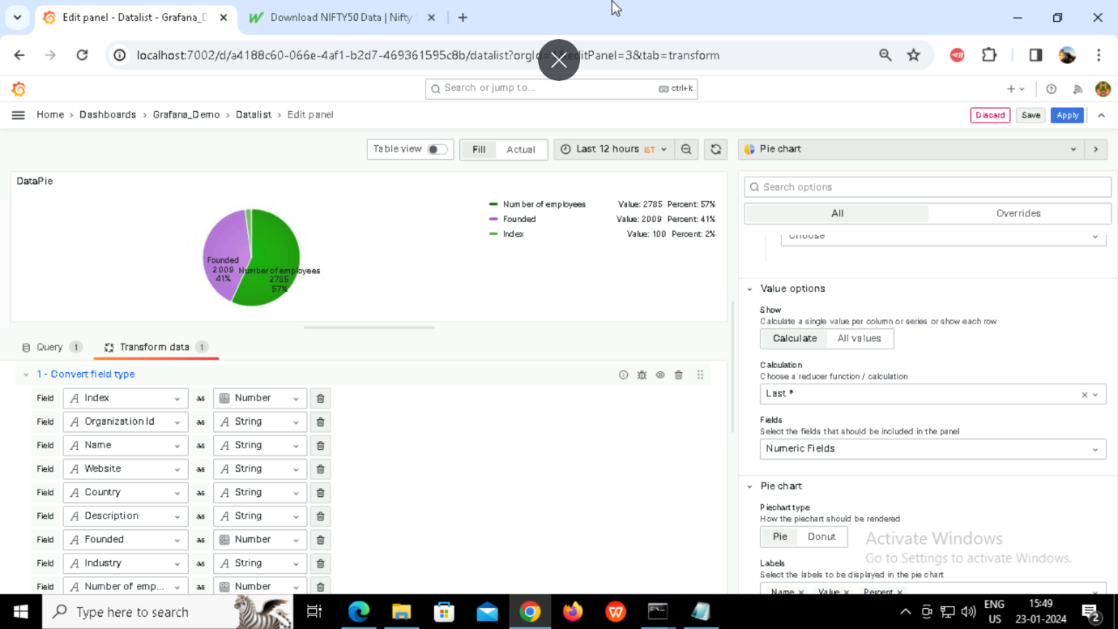

Finally all the screenshots in one shot:

