Conditionals

Sambriddhi Kunwar
Westcliff University
PRG200: Programming in the Cloud
Professor Prakash Pandey
23 May,2026

Conditionals

This all code is done in google colab.
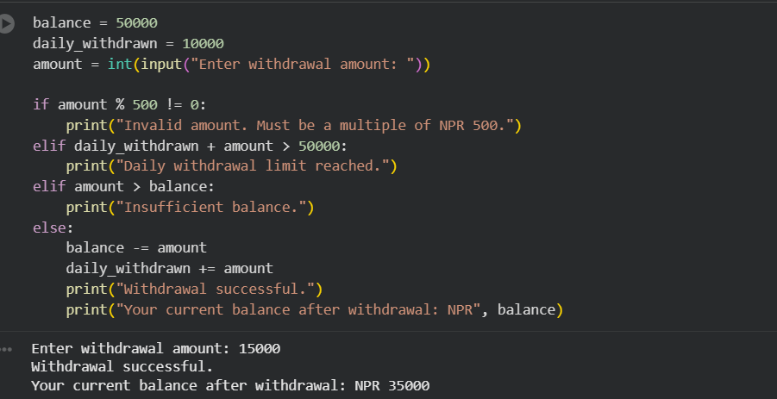

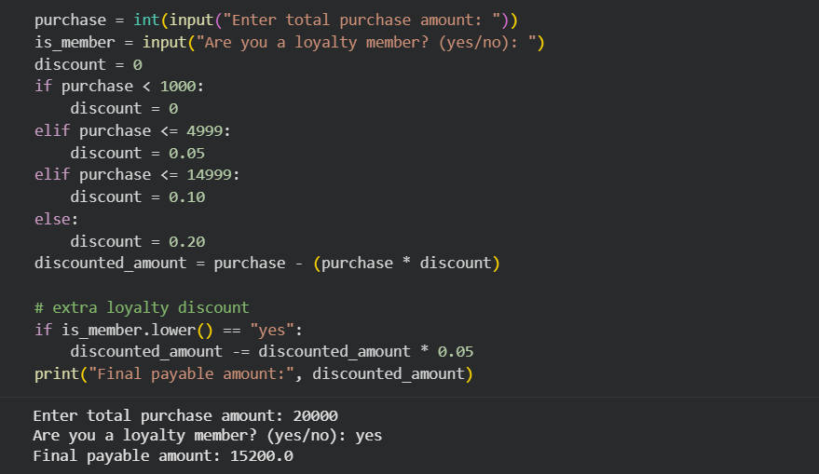

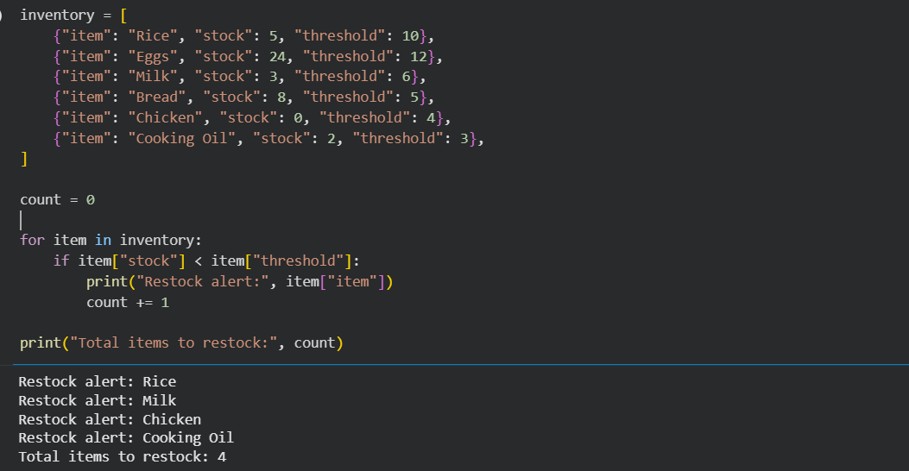

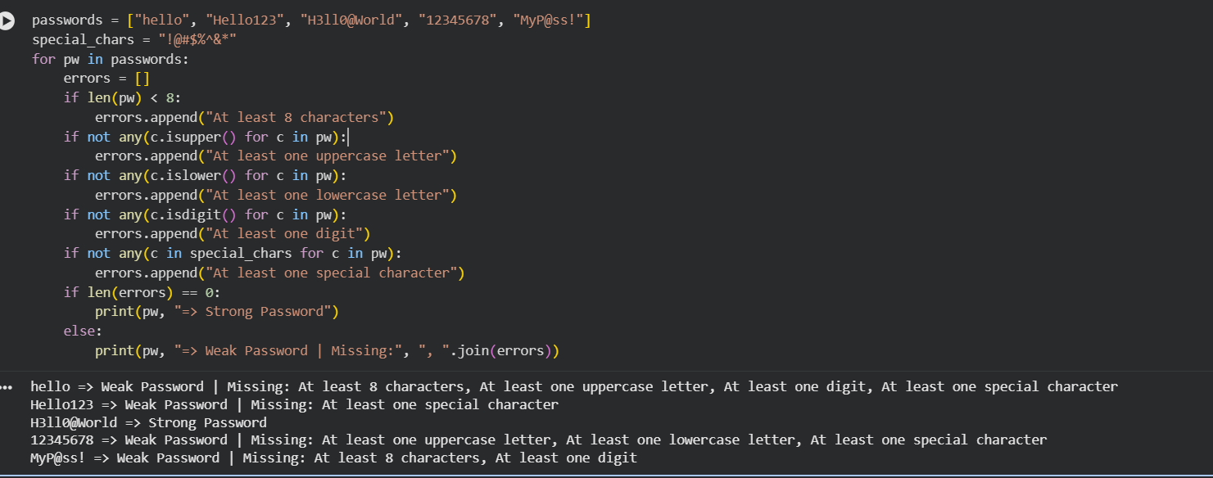

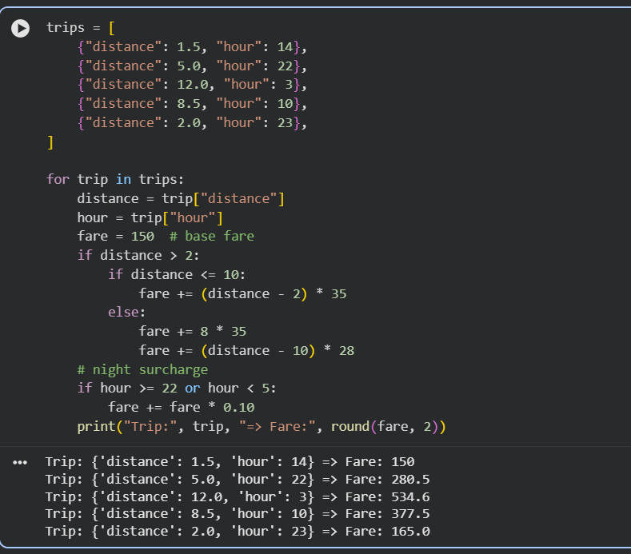

Link of Github: Upload files · Sambriddhikunwar/python

