AI-Powered Handwritten Text Recognition System Using Convolutional Neural Networks

R. Sai Charan
Dept. of CSE
K L Deemed to be University
India
University ID: 2420030140
S. Sai Rishik
Dept. of CSE
K L Deemed to be University
India
University ID: 2420030121
M. Satya Charan Reddy
Dept. of CSE
K L Deemed to be University
India
University ID: 2420030166

Project Guide: Dr. N. Sunandha
Dept. of Computer Science and Engineering, K L Deemed to be University

Abstract—Handwritten text recognition is increasingly important for digitizing handwritten documents, notes, forms, and educational content, yet variations in character shape, size, spacing, writing style, and orientation make accurate automatic recognition difficult. This paper presents an AI-powered handwritten character recognition system that converts handwritten images into editable and searchable digital text. The proposed pipeline accepts an uploaded image and applies grayscale conversion, noise removal, resizing, normalization, and segmentation. A convolutional neural network then extracts discriminative features and classifies letters and digits, and every prediction is accompanied by a confidence score. When the confidence is low, the system offers correction suggestions. The network is trained on the EMNIST dataset together with a custom handwriting dataset to improve generalization across writing styles, and results are presented through an interactive interface that shows the uploaded image, the predicted characters, and their confidence levels. Performance is assessed using recognition accuracy, character error rate, and word error rate. The system is implemented in Python using TensorFlow, Keras, OpenCV, NumPy, Pandas, Scikit-learn, Matplotlib, and Streamlit. By combining image preprocessing, deep-learning-based classification, confidence analysis, and interactive visualization, the system reduces manual transcription effort and offers a faster and more reliable route from handwriting to digital text.
Keywords—handwritten text recognition, character recognition, convolutional neural network, image preprocessing, EMNIST, deep learning, confidence score

Introduction
Handwriting remains a common medium for notes, forms, examination scripts, records, and educational material. Information written on paper, however, cannot easily be edited, searched, stored, or processed by software. Manual transcription is time-consuming, repetitive, and prone to errors, which makes the automatic conversion of handwriting into digital text a valuable capability [1].
Handwritten text recognition (HTR) is harder than printed-text recognition because handwriting varies in character shape, size, spacing, slant, and alignment, both between writers and within the work of a single writer. Existing optical character recognition (OCR) systems are generally stronger for printed text and may struggle with cursive, irregular, or low-quality handwriting [1], [2]. Deep learning has changed this picture. Convolutional neural networks (CNNs) learn visual features directly from pixels and have been successful in digit recognition since the early LeNet models [3], while public datasets such as EMNIST extend the classic digit benchmark to handwritten letters [4].
This paper presents an AI-powered handwritten character recognition system that takes an uploaded image, prepares it through an automated preprocessing pipeline, recognizes the characters with a CNN, and returns editable and searchable digital text together with a confidence score for every prediction. The main contributions are as follows.
- An end-to-end pipeline that connects image upload, preprocessing, CNN-based recognition, and digital text output.
- A confidence-scoring mechanism that flags uncertain predictions and offers correction suggestions.
- A training plan that combines EMNIST with a custom handwriting dataset to cover more writing styles.
- An evaluation framework based on recognition accuracy, character error rate (CER), and word error rate (WER).
- An interactive interface, built with Streamlit, that displays the input image, the predicted characters, and their confidence levels.
The rest of the paper is organized as follows. Section II states the problem and objectives, Section III reviews existing approaches and identifies the research gap, Section IV describes the proposed system, Section V covers implementation, Section VI defines the evaluation methodology, Section VII discusses the expected outcomes, and Section VIII concludes the paper.

Problem Statement and Objectives

Problem Statement
Handwriting remains difficult to digitize, and the central challenge is reliable recognition across varied handwriting styles and image quality. Character shape, size, spacing, writing style, and alignment differ significantly from one writer to another, and poor image quality adds further noise. Manual transcription of such material is slow and error-prone, while OCR engines designed for printed text lose accuracy on cursive, irregular, or degraded handwriting. A recognition system is therefore needed that is robust to writing variation, evaluated with measurable metrics, and simple enough to be used without expert knowledge.
The motivation is to make handwritten information easier to digitize, edit, store, search, and process. Digitization converts paper records into editable notes, reduces retyping, makes content searchable, and lowers the manual effort of data entry.

Objectives
Four measurable objectives guide the project.
- Image processing: prepare handwritten images using resizing, normalization, and noise reduction.
- Text recognition: develop or integrate an AI model for handwritten character, word, or line recognition.
- Performance evaluation: evaluate CER, WER, and recognition accuracy on a representative test set.
- Digital text generation: generate clear, editable, and searchable digital text.
Meeting these objectives is expected to yield a functional prototype that converts handwriting to text automatically, reports measurable accuracy, reduces transcription effort, and presents user-friendly output.

Literature Survey
HTR has been surveyed extensively. AlKendi et al. classify offline HTR systems by technique, dataset, publication year, and recognition level [1], and Garrido-Muñoz et al. organize methods by recognition granularity and highlight the gains of Transformer models pre-trained on synthetic data [2]. A systematic review by de Sousa Neto et al. examines data augmentation, a key strategy for offline HTR when training data are limited [5]. Table I summarizes four families of approaches whose trade-offs motivate the design of the proposed system.
- Comparison of Handwriting Recognition Approaches
Approach and technique | Advantages | Limitations
Traditional OCR: image processing with handcrafted features | Simple and lightweight | Mainly suited to printed text; weak under handwriting variation
CNN-based recognition: visual feature extraction | Effective for character and image recognition | Limited for long sequences; needs prepared input
CNN + LSTM + CTC: CNN extraction, LSTM sequence model, CTC alignment | Handles variable-length sequences; suited to words and lines | Higher computation; complex training
Transformer-based HTR: vision and text Transformer architecture | Captures contextual dependencies | Often needs substantial data and computation

Traditional Optical Character Recognition
Traditional OCR relies on image processing and handcrafted features. It is simple and lightweight, but it is designed mainly for printed text and is sensitive to handwriting variation.

Convolutional Neural Network Recognition
CNN-based recognition extracts visual features automatically from the image [3]. It is effective for character and image recognition, but it is limited for long sequences and needs input that has already been segmented and prepared.

Recurrent Sequence Models
Combining a CNN feature extractor with a long short-term memory (LSTM) sequence model and connectionist temporal classification (CTC) alignment [6], [7] allows variable-length sequences to be recognized, which suits words and lines. The cost is higher computation and more complex training.

Transformer-Based Recognition
Transformer-based recognizers such as TrOCR pair an image Transformer encoder with a text Transformer decoder and rely on large-scale pre-training [8]. They capture contextual dependencies well but often require substantial data and computational resources.

Research Gap
Comparing these approaches reveals a practical gap in robustness, cost, and usability.
- High variation in handwriting styles.
- Cursive and irregular text is difficult to recognize.
- Noisy or low-quality images reduce reliability.
- Advanced models can be computationally heavy.
- Practical deployment needs user-friendly workflows.
A practical HTR system should therefore balance accuracy, robustness, and efficiency, which is the target of the proposed design.

Proposed System
The proposed system is an end-to-end HTR pipeline that combines preprocessing, AI-based recognition, and evaluation to produce editable digital text. As shown in Fig. 1, a handwritten image passes through preprocessing, feature extraction and CNN classification, and confidence analysis before the result is presented to the user. Each stage answers a limitation identified in Section III. AI-based recognition addresses limited robustness to handwriting variation, an automated preprocessing pipeline replaces manual or inconsistent image preparation, evaluation with CER, WER, and accuracy makes performance measurable, and an editable digital output supports practical use.
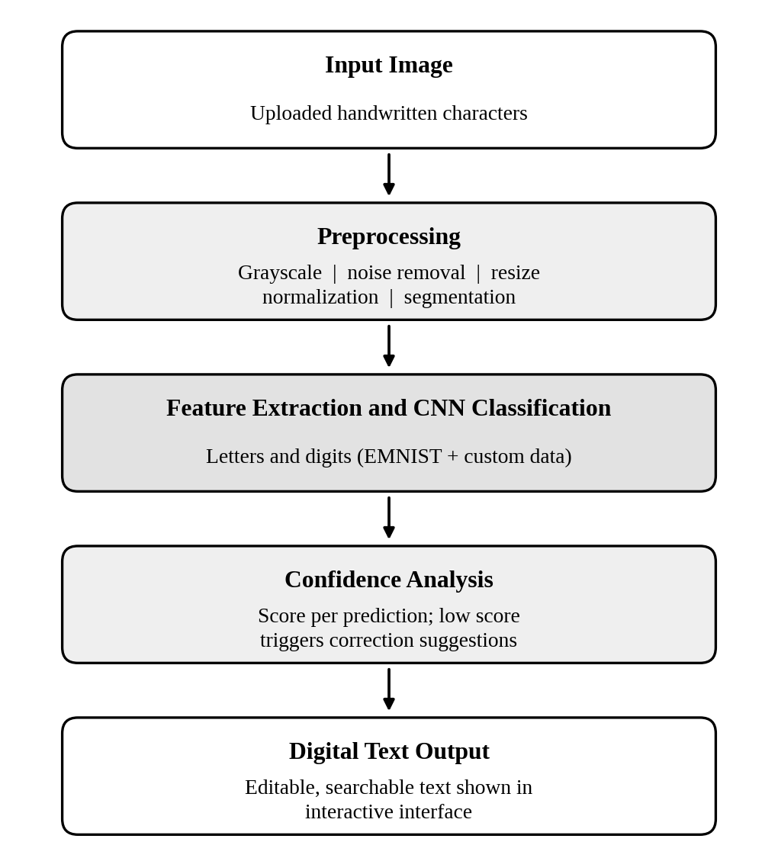
- Architecture of the proposed handwritten text recognition pipeline.

Image Acquisition and Preprocessing
The user uploads an image of handwritten characters. The image is converted to grayscale to discard color information and reduce the amount of data to process. Noise is removed with smoothing filters from the OpenCV library [9]. The image is then resized to the fixed input dimensions expected by the network, and pixel intensities are normalized to a common range. When an image contains more than one character, segmentation separates it into individual character regions that are passed to the classifier one at a time.

Feature Extraction and Convolutional Neural Network Classification
The classifier is a CNN. Stacked convolutional layers with nonlinear activation and pooling learn stroke-level and shape-level patterns such as edges, curves, loops, and junctions, and fully connected layers combine these features into a decision. The output layer applies the softmax function, which converts the class scores into probabilities:
p_{i} = exp(z_{i}) / ∑_{j} exp(z_{j}) (1)
where z_{i} is the score of class i and the sum runs over all classes, which cover the digits and the letters. The class with the highest probability is taken as the recognized character.

Confidence Scoring and Correction Suggestions
The highest softmax probability is reported as the confidence score of the prediction. If the score falls below a threshold tuned on validation data, the prediction is marked as uncertain and the interface displays correction suggestions: the next most probable classes and, for word-level output, dictionary-based candidate corrections. This lets the user verify doubtful characters quickly instead of proofreading the entire output.

Datasets and Augmentation
The network is trained on EMNIST [4], which provides handwritten digits and letters in a standardized image format, together with a custom handwriting dataset that captures additional writing styles. The data are divided into training, validation, and test subsets. Augmentation such as small rotations, shifts, and scaling simulates natural writing variation and is widely used to improve generalization when handwriting data are limited [5].

Extension to Word-Level and Line-Level Recognition
Because the objectives include word and line recognition, the character classifier is designed as the base of a larger system. Segmenting a line into characters and concatenating the predictions yields word-level and sentence-level text. For cursive or touching characters, where segmentation is unreliable, the recognizer can be extended with LSTM and CTC layers [6], [7], which do not require explicit character segmentation.

Interactive Interface
Results are presented through an interactive web interface. The user can view the uploaded image, the predicted characters, the confidence level of each prediction, and the correction suggestions, and can then edit the recognized text.

Implementation
The system is developed in Python. Table II lists the libraries used and their roles in the pipeline.
- Technology Stack
Tool | Role in the system
Python | Core programming language
TensorFlow and Keras | Building, training, and running the CNN
OpenCV | Grayscale conversion, noise removal, resizing, and segmentation
NumPy and Pandas | Array handling, normalization, and dataset management
Scikit-learn | Data splitting and evaluation metrics
Matplotlib | Training curves and confusion-matrix plots
Streamlit | Interactive web interface

The CNN is built and trained with TensorFlow and Keras. Training minimizes the categorical cross-entropy loss with the Adam optimizer [10]. The design includes dropout [11] and batch normalization [12] to limit overfitting and stabilize training, and hyperparameters such as the learning rate, batch size, and number of epochs are tuned on the validation subset. Pandas and NumPy manage the dataset and its labels, while Scikit-learn provides the data splits and evaluation metrics.
The Streamlit application wraps the trained model in a simple upload-and-view workflow, so that no programming knowledge is needed to use the system.

Evaluation Methodology
Performance is measured on a representative test set that contains held-out EMNIST samples and custom handwriting samples that were not used in training. Table III lists the metrics.
- Evaluation Metrics
Metric | What it measures
Recognition accuracy | Share of characters classified correctly on the test set
Character error rate | Substitutions, deletions, and insertions per reference character
Word error rate | The same edit-based error computed at word level
Confusion matrix | Class-wise errors between visually similar characters
Precision, recall, and F1-score | Per-class reliability and coverage
Confidence score | Agreement between confidence and correctness, used to set the low-confidence threshold

Recognition accuracy is the proportion of correctly recognized characters:
Accuracy = N_{correct} / N_{total} (2)
CER measures the edit distance between the recognized text and the reference text, normalized by the reference length:
CER = (S + D + I) / N (3)
where S, D, and I are the numbers of substitutions, deletions, and insertions, and N is the number of characters in the reference. WER is computed in the same way over words. The confusion matrix highlights systematic errors between similar characters, and the confidence scores are compared with correctness to choose the threshold used for correction suggestions.

Expected Outcomes and Discussion
This report presents the problem, the survey, and the proposed design. Quantitative results are not included here and will be reported once the evaluation described in Section VI is complete. The design is expected to deliver a functional prototype, automatic conversion of handwritten images into digital text, measurable accuracy through accuracy, CER, and WER, reduced transcription effort, and user-friendly output.
Several factors are expected to influence performance. Visually similar characters, such as the letter O and the digit 0, or the letters I and l and the digit 1, are likely sources of confusion; the confidence score and the correction suggestions are intended to bring exactly these cases to the user’s attention. Noisy or low-resolution images may reduce reliability, which is why preprocessing is a distinct stage of the pipeline. Finally, character-level classification depends on correct segmentation, so cursive and heavily connected handwriting remains the hardest case and motivates the sequence-model extension described in Section IV.

Conclusion and Future Work
This paper presented an AI-powered handwritten text recognition system that converts handwritten characters into digital text. By combining automated image preprocessing, CNN-based classification, confidence analysis with correction suggestions, and an interactive interface, the system aims to reduce manual transcription and provide a fast, intelligent, and reliable route from handwriting to editable text.
Future work includes completing training and reporting accuracy, CER, and WER on the test set, enlarging the custom dataset, extending recognition to words and sentences with CNN, LSTM, and CTC models, and exploring Transformer-based recognizers when data and computing resources allow.

Acknowledgment
The authors thank Dr. N. Sunandha, Project Guide, and the Department of Computer Science and Engineering, K L Deemed to be University, for their guidance and support during the Data Science (24AD3107) project.

References
- W. AlKendi, F. Gechter, L. Heyberger, and C. Guyeux, “Advancements and challenges in handwritten text recognition: A comprehensive survey,” J. Imaging, vol. 10, no. 1, Art. no. 18, Jan. 2024, doi: 10.3390/jimaging10010018.
- C. Garrido-Muñoz, A. Rios-Vila, and J. Calvo-Zaragoza, “Handwritten text recognition: A survey,” 2025, arXiv:2502.08417.
- Y. LeCun, L. Bottou, Y. Bengio, and P. Haffner, “Gradient-based learning applied to document recognition,” Proc. IEEE, vol. 86, no. 11, pp. 2278–2324, Nov. 1998.
- G. Cohen, S. Afshar, J. Tapson, and A. van Schaik, “EMNIST: Extending MNIST to handwritten letters,” in Proc. Int. Joint Conf. Neural Netw. (IJCNN), 2017, pp. 2921–2926.
- A. F. de Sousa Neto, B. L. D. Bezerra, G. C. D. de Moura, and A. H. Toselli, “Data augmentation for offline handwritten text recognition: A systematic literature review,” SN Comput. Sci., vol. 5, no. 2, Art. no. 258, 2024, doi: 10.1007/s42979-023-02583-6.
- B. Shi, X. Bai, and C. Yao, “An end-to-end trainable neural network for image-based sequence recognition and its application to scene text recognition,” IEEE Trans. Pattern Anal. Mach. Intell., vol. 39, no. 11, pp. 2298–2304, Nov. 2017.
- A. Graves, S. Fernández, F. Gomez, and J. Schmidhuber, “Connectionist temporal classification: Labelling unsegmented sequence data with recurrent neural networks,” in Proc. 23rd Int. Conf. Mach. Learn. (ICML), 2006, pp. 369–376.
- M. Li et al., “TrOCR: Transformer-based optical character recognition with pre-trained models,” in Proc. AAAI Conf. Artif. Intell., vol. 37, no. 11, 2023, pp. 13094–13102.
- G. Bradski, “The OpenCV library,” Dr. Dobb’s J. Softw. Tools, 2000.
- D. P. Kingma and J. Ba, “Adam: A method for stochastic optimization,” 2014, arXiv:1412.6980.
- N. Srivastava, G. Hinton, A. Krizhevsky, I. Sutskever, and R. Salakhutdinov, “Dropout: A simple way to prevent neural networks from overfitting,” J. Mach. Learn. Res., vol. 15, no. 56, pp. 1929–1958, 2014.
- S. Ioffe and C. Szegedy, “Batch normalization: Accelerating deep network training by reducing internal covariate shift,” in Proc. 32nd Int. Conf. Mach. Learn. (ICML), 2015, pp. 448–456.

