Recruitment and HR Resume Management System for Efficient Hiring
A Mini Project Report Submitted in the partial fulfillment of the requirements
for the award of the degree of

BACHELOR OF TECHNOLOGY

In
DEPARTMENT OF COMPUTER SCIENCE ENGINEERING

By
Sai Rishik – 2420030121
Chaitanya – 2420030721
Vaman – 2420030736

Under the Esteemed Guidance of

Dr. Venkateswari





K L (Deemed to be) University
DEPARTMENT OF COMPUTER SCIENCE ENGINEERING

DECLARATION

The Mini Project Report entitled “Recruitment and HR Resume Management System for Efficient Hiring” is a record of bonafide work carried out by Sai Rishik (2420030121), Chaitanya (2420030721), and Vaman (2420030736), submitted in partial fulfillment of the requirements for the award of B.Tech in Computer Science and Engineering at K L (Deemed to be) University. The work presented in this report is our project work and has not been copied from any other department, university, or institute.

Sai Rishik – 2420030121
Chaitanya – 2420030721
Vaman – 2420030736

K L (Deemed to be) University
DEPARTMENT OF COMPUTER SCIENCE ENGINEERING

CERTIFICATE

This is to certify that the mini project report entitled “Recruitment and HR Resume Management System for Efficient Hiring” is a bonafide work done and submitted by Sai Rishik (2420030121), Chaitanya (2420030721), and Vaman (2420030736), in partial fulfillment of the requirements for the award of the degree of BACHELOR OF TECHNOLOGY in Computer Science and Engineering, K L (Deemed to be) University, during the academic year 2026–2027.

Signature of the Course Co-ordinator Signature of HOD

ACKNOWLEDGEMENT

The success in this project would not have been possible but for the timely help and guidance rendered by many people. Our wish to express my sincere thanks to all those who has assisted us in one way or the other for the completion of my project.

We express our sincere gratitude to our SOA faculty guide, Dr. Venkateswari, for her valuable guidance, encouragement, and support throughout the development of this project. Her suggestions helped us refine the project design, implementation, and documentation.

We also thank the Head of the Department of Computer Science Engineering, K L (Deemed to be) University, for providing the facilities and academic environment required to complete this mini project.

We thank all teaching and non-teaching staff members, our classmates, friends, and families for their assistance and encouragement during the successful completion of this project.

Sai Rishik – 2420030121
Chaitanya – 2420030721
Vaman – 2420030736

TABLE OF CONTENTS

S.No. | Contents | Page no.
1. | Abstract | 6
 |  | 7
2. | Introduction | 8
3. | Literature survey | 9
4. | Problem Statement and Objectives | 10
5. | Hardware and Software requirements | 11
6. | Implementation | 12
7. | Results & Discussion | 13
8. | Conclusion & Future Scope | 14
9. | References

- ABSTRACT

This project presents a centralized Recruitment and HR Resume Management System designed to simplify and organize the hiring process. The platform brings together resume management, job posting, candidate management, application tracking, and notifications in one web-based application. The frontend is developed using HTML, CSS, and JavaScript, while the backend uses Java with Spring Boot microservices that communicate through REST APIs. Resume files in PDF, DOCX, and TXT formats can be uploaded and their text extracted for candidate records. The system also includes an AI Resume–Job Match and Explainable Skill Gap Analysis feature. It extracts skills from resume and job-description text, normalizes common skill aliases, calculates a match percentage based on required skills, identifies matched and missing skills, and provides understandable explanations and recommendations. Match results can be saved for review and used to support candidate ranking and shortlisting. The services use relational data models and H2 databases for local development and testing. The project aims to reduce repetitive manual work, improve information organization, and help HR users make more informed screening decisions while keeping the final hiring decision with the recruiter.
Team Name: Batch 9
Team Logo: Not applicable

Team Members:
- Sai Rishik – 2420030121 (Project development and integration)
- Chaitanya – 2420030721 (Project development and testing)
- Vaman – 2420030736 (Project development and documentation)

- INTRODUCTION

Recruitment involves several connected activities, including collecting resumes, publishing job openings, reviewing candidate profiles, tracking applications, and communicating status updates. When these activities are handled manually or across separate files, recruiters may spend significant time searching for information and maintaining records. This can lead to delays, duplicated data, and difficulty monitoring candidates through the hiring process. The Recruitment and HR Resume Management System for Efficient Hiring addresses these challenges through a centralized web application built with a service-oriented, microservice-based backend.
The system provides separate modules for resume management, job posting, candidate management, application tracking, and notifications. Its additional AI Resume–Job Match and Explainable Skill Gap Analysis module compares resume skills with job requirements and explains the match score by showing matched and missing skills. The report describes related systems, the problem and objectives, hardware and software requirements, implementation details, results, and possible future enhancements.

- LITERATURE SURVEY
The following existing recruitment and applicant-tracking platforms were reviewed to understand common features and identify opportunities for an integrated academic prototype:
1. Greenhouse
Greenhouse is an applicant tracking and hiring platform that supports job requisitions, candidate pipelines, interview coordination, and structured hiring workflows. It demonstrates how recruitment activities can be organized in a single system. Our project adopts the centralized workflow idea while implementing a lightweight microservice-based academic solution.
2. Lever
Lever combines applicant tracking with candidate relationship management. It helps recruiters maintain candidate profiles, manage job opportunities, and follow candidates through recruitment stages. This informed our candidate and application management modules; our implementation additionally provides explainable skill matching.
3. Zoho Recruit
Zoho Recruit provides recruitment automation, resume handling, candidate search, job opening management, and applicant tracking. It illustrates the value of reducing repetitive HR tasks. Our project implements comparable core workflow functions using Java Spring Boot services and a simple web frontend.
4. Workday Recruiting
Workday Recruiting is part of an enterprise human-capital-management platform and supports recruiting workflows from job requisition to candidate selection. It demonstrates the importance of connected HR information. Our project focuses on the recruitment subset and separates functions into independently managed services.
5. SmartRecruiters
SmartRecruiters provides talent acquisition tools for job publishing, candidate management, collaboration, and hiring pipeline visibility. Its workflow-oriented approach influenced our application tracking and notification modules. Our project is a smaller prototype intended to demonstrate these concepts with REST-based service communication.
6. iCIMS
iCIMS offers talent acquisition software for managing candidates, job applications, and recruitment processes. It highlights the need for searchable candidate information and consistent process tracking. Our project addresses these needs and adds a skill-gap explanation to support recruiter review.

- Problem Statement and Objectives

Problem Statement: A clear and specific articulation of the problem, outlining its importance.
Manual recruitment processes make resume screening, candidate organization, and application tracking time-consuming and difficult to manage.

Problem Description: A concise explanation of the issue or challenge that needs to be solved.
Candidate and job information may be scattered across files or tools, making it harder to identify suitable applicants and monitor each hiring stage.
Objectives:
Identify the Project's Purpose:
The project aims to provide HR users with one integrated platform for managing recruitment data and supporting faster, more transparent resume screening.
To provide a centralized facility to upload, store, retrieve, and manage candidate resumes.
To allow HR users to create, update, view, and manage job postings with required skills and experience.
To maintain candidate profiles and support filtering by relevant information such as skills and experience.
To track applications through stages such as Applied, Under Review, Shortlisted, Selected, and Rejected.
To generate notifications for important recruitment events and status changes.
To compare resume skills with job requirements and display a match percentage, matched skills, missing skills, explanations, and improvement recommendations.
To use a modular SOA/microservice architecture with REST APIs so that services can be developed and maintained independently.

- HARDWARE AND SOFTWARE REQUIREMENTS
Hardware Requirements:
• Laptop or desktop computer with a dual-core processor or better.
• Minimum 4 GB RAM (8 GB recommended) and at least 2 GB free disk space for source code and dependencies.
• Internet connection for downloading Maven dependencies and accessing development documentation.

Software Requirements:
• Operating System: Windows 10/11, Linux, or macOS.
• Java Development Kit (JDK) 17 or compatible version.
• Apache Maven for building and running Spring Boot services.
• Spring Boot, Spring Web, Spring Data JPA, and Hibernate.
• H2 relational database for local development and testing; schema is designed to be adaptable to MySQL or PostgreSQL.
• Frontend: HTML5, CSS3, and JavaScript (ES6+).
• IDE/editor: IntelliJ IDEA, Eclipse, or Visual Studio Code; browser: Chrome, Edge, or Firefox.
• Libraries: Apache PDFBox for PDF text extraction and Apache POI for DOCX processing.

- IMPLEMENTATION
- Frontend: HTML5, CSS3, and vanilla JavaScript provide a responsive single-page HR portal with dashboard navigation, forms, tables, upload controls, and match-result visualization.
- Backend: Java and Spring Boot are used to implement six independent services: Resume, Job, Candidate, Application, Notification, and Matching services. Each service exposes REST endpoints and uses Spring Data JPA for persistence.
- API Integration: The frontend communicates with the backend services through HTTP REST APIs. The services are configured on ports 8081–8086 for local development, with CORS enabled for frontend access.

1. Frontend (HTML, CSS, JavaScript):
- index.html: Defines the HR portal layout, navigation, dashboard, forms, upload area, and result sections.
- style.css: Contains page layout, responsive styling, cards, tables, modals, status tags, and match-score presentation.
- app.js: Implements frontend navigation, API calls, resume upload, candidate/job/application operations, notifications, AI match analysis, and ranking display.
- The frontend includes views for Dashboard, AI Match, Ranking, Resumes, Candidates, Jobs, Applications, and Notifications.
2. Backend (JAVA):
- Spring Boot Java source files are organized by service under backend/.
Resume service: ResumeServiceApplication.java, ResumeController.java, ResumeParserService.java, Resume.java, ResumeRepository.java, and ResumeDataLoader.java. Job service: JobServiceApplication.java, JobController.java, Job.java, JobRepository.java, and JobDataLoader.java. Candidate service: CandidateServiceApplication.java, CandidateController.java, Candidate.java, CandidateRepository.java, and CandidateDataLoader.java. Application service: ApplicationRecordServiceApplication.java, ApplicationRecordController.java, ApplicationRecord.java, ApplicationRecordRepository.java, and ApplicationDataLoader.java. Notification service: NotificationServiceApplication.java, NotificationController.java, Notification.java, NotificationRepository.java, and NotificationDataLoader.java.
- AI matching service: MatchingServiceApplication.java, MatchingController.java, MatchingService.java, SkillExtractor.java, SkillDictionary.java, MatchRequest.java, MatchResponse.java, MatchResult.java, MatchResultRepository.java, and MatchingDataLoader.java.
REST controllers expose endpoints for uploading and retrieving resumes, managing jobs and candidates, updating application stages, reading notifications, and performing match analysis. The matching endpoint /api/matching/analyze accepts candidate/resume and job information and returns the match score, matched skills, missing skills, explanation, and recommendations. Match history and candidate ranking endpoints support review of previous analyses.

- RESULTS & DISCUSSION
The implemented web portal provides a unified dashboard for HR activities. The following outputs should be captured from the running application and inserted below:
Figure 1 – HR Dashboard
Displays the main navigation and summary view for accessing recruitment modules from one place.
Figure 2 – Resume Management
Allows HR users to upload supported resume files and view extracted resume information for candidate records.
Figure 3 – AI Match Input
Allows the user to select a candidate and a job or provide resume and job-description text for analysis.
Figure 4 – Match Results and Skill Gap Analysis
Shows the match percentage, matched skills, missing required skills, explanation, and recommendations to help HR understand the result.
The backend test suite was reported to complete successfully using Maven, including unit tests for resume parsing, skill extraction, and matching scenarios. The matching tests cover different match percentages and skill-alias/boundary cases. The services use H2 in-memory databases for local execution; therefore, sample records are recreated when services restart.
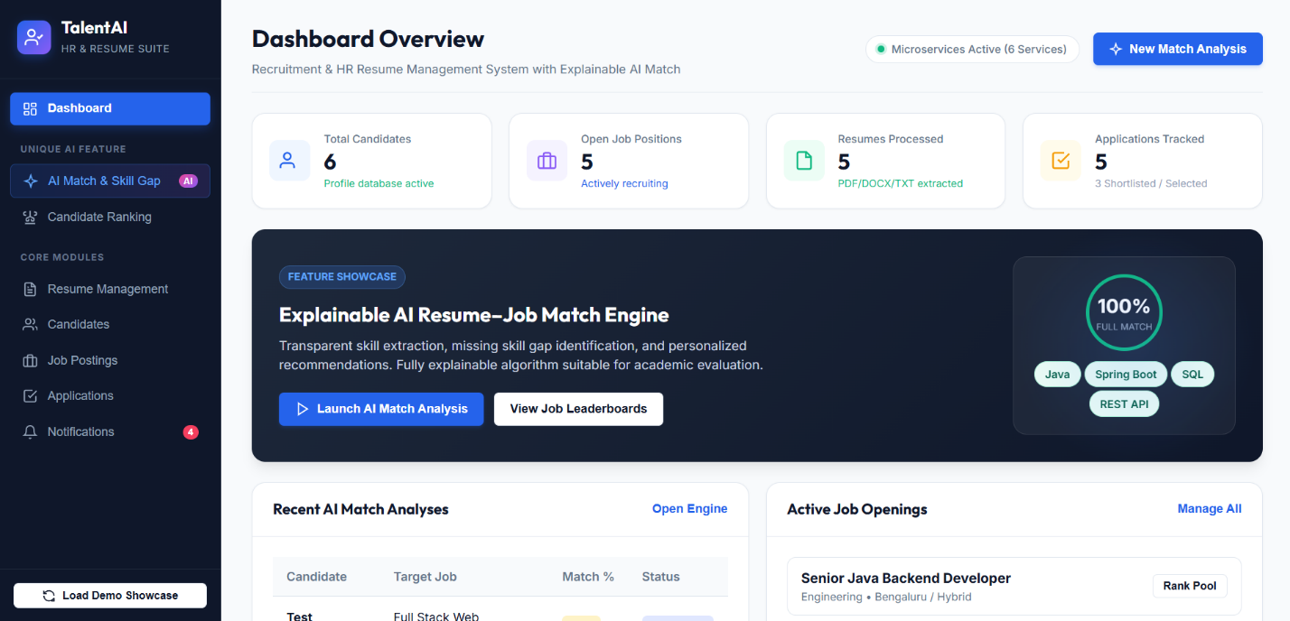

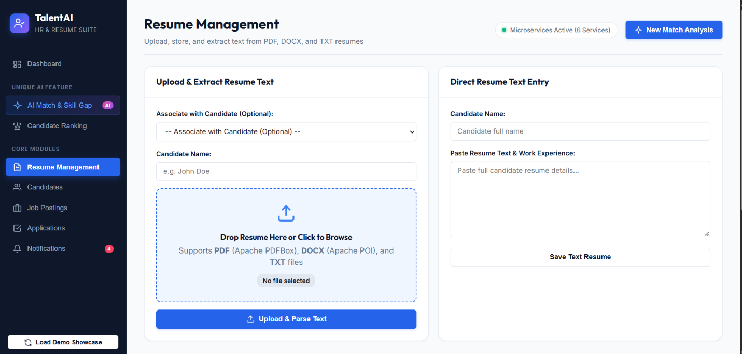

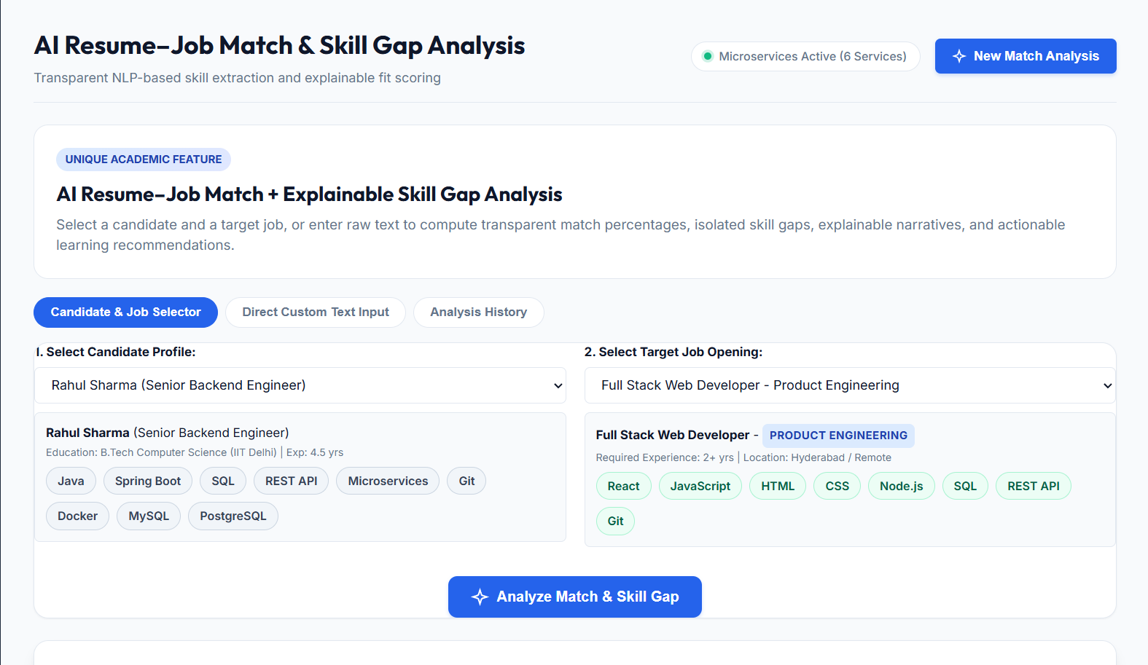
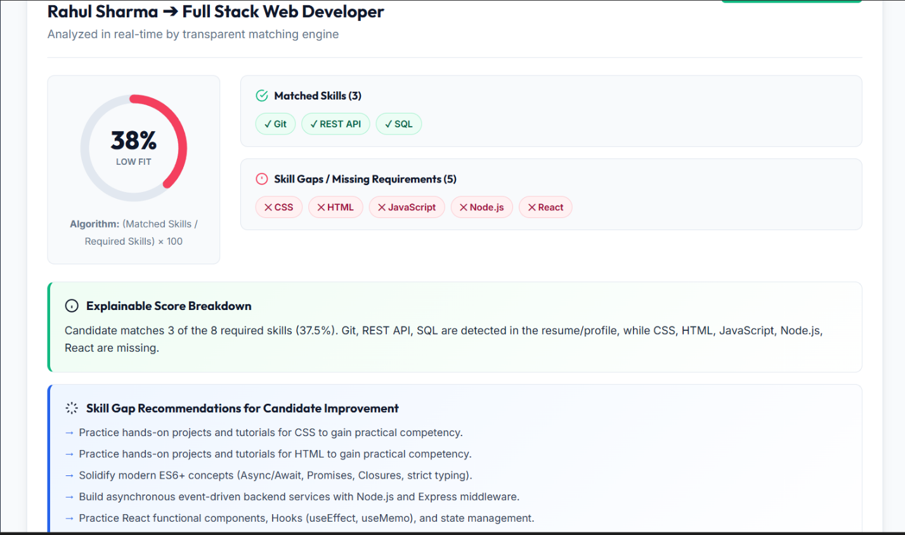

- CONCLUSION & FUTURE SCOPE
The Recruitment and HR Resume Management System integrates the main activities of a recruitment workflow into one web-based platform. The project implements resume upload and text extraction, job posting, candidate management, application-stage tracking, notifications, and AI-assisted resume–job matching. The microservice architecture separates these responsibilities into independent Spring Boot services connected through REST APIs. The explainable skill-gap feature adds transparency by showing which required skills are present or missing instead of presenting only a score. The project meets its core objective of demonstrating a centralized and modular recruitment management solution. The system is intended as decision support; recruiters remain responsible for evaluating candidates and making hiring decisions.

Future enhancements may include: (1) secure login, role-based access control, and audit logging; (2) persistent production database configuration and automated backups; (3) integration with email/SMS gateways for real notifications; (4) advanced semantic matching using NLP or machine-learning models beyond keyword/skill-dictionary matching; (5) fairness checks and bias monitoring with human review; (6) interview scheduling, calendar integration, and candidate self-service portals; (7) deployment using Docker and cloud infrastructure with API gateway, centralized logging, and monitoring; and (8) expanded automated integration and performance testing.

- REFERENCES

1. https://www.greenhouse.com/
2. https://www.lever.co/
3. https://www.zoho.com/recruit/
4. https://www.workday.com/en-us/products/talent-management/recruiting.html
5. https://www.smartrecruiters.com/
6. https://www.icims.com/
7. https://spring.io/projects/spring-boot
8. https://spring.io/guides/gs/accessing-data-jpa/
9. https://pdfbox.apache.org/ and https://poi.apache.org/
10. https://developer.mozilla.org/en-US/docs/Web/JavaScript

