Streaming Analysis Study Using the Mechanical Turk Service
Recruitment Materials

Participants will be recruited through the Amazon Mechanical Turk interface, an example of which is shown below:

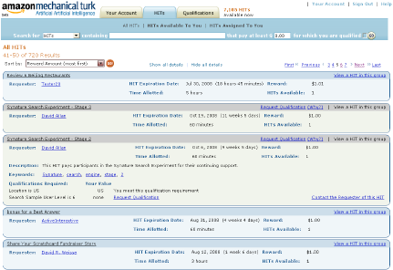

Our specific HITs will contain the following information:

Title: Streaming Analysis Experiment
Requester: Smith College
HIT Expiration Date: TBD, will depend on the start date of the study
Reward: $1.00
Time Allotted: 30 minutes
HITs Available: 1
Description: Participants will answer questions about artificial streaming data presented using data visualization techniques. A bonus of $0.10 will be awarded for each correct response, and $0.25 for correctly identifying all patterns.

