**PROJECT SUBMISSION PHASE 1**

**Project Title :** Chatbot Deployment with IBM Cloud Watson Assistant

**Project Code :** 1662

**Domain :** Cloud Application Development

**Assignment :** Problem Definition & Design Thinking

**SUBMITTED BY**

**Name :** F.Sam Charles

**Mail id :** [sc240843@gmail.com](mailto:sc240843@gmail.com)

**College Name :** Parisutham Institute of Technology & Science

**College code :** 8213

**Group 4** **:** Zone (13-16)

**Problem Statement :**

This project involves the development of a chatbot using IBM Cloud Watson Assistant. The primary goal is to create a virtual guide capable of assisting users on messaging platforms like Facebook Messenger and Slack. The chatbot should offer valuable information, answer frequently asked questions (FAQs), and provide a friendly conversational experience. The project encompasses designing the chatbot's persona, configuring responses, integrating it with messaging platforms, and ensuring a seamless user experience.

**Design Thinking:**

1. **Persona Design:**

**Objective:** Define the chatbot's persona, including its name, tone, and style of communication.

**Steps:**

* Choose a name for the chatbot that aligns with its purpose and target audience.
* Determine the appropriate tone of communication (e.g., formal, friendly, informative).
* Define the chatbot's style, which could be casual, professional, or specific to the domain it serves.

**Deliverable:** A well-defined chatbot persona with a name, tone, and communication style.

**2. User Scenarios:**

**Objective:** Identify common user scenarios and FAQs that the chatbot should be able to address.

**Steps:**

* Conduct research or consult with stakeholders to understand the typical user interactions.
* Compile a list of frequently asked questions and scenarios that users are likely to encounter.
* Prioritize these scenarios based on their importance and frequency.

**Deliverable:** A documented list of user scenarios and FAQs.

**3. Conversation Flow:**

**Objective:** Design the conversation flow, outlining how the chatbot responds to user queries and prompts.

**Steps:**

* Create a flowchart or diagram that illustrates the chatbot's decision tree for various user inputs.
* Define branching logic to handle different scenarios and questions.
* Ensure that the conversation flow is intuitive and user-friendly.

**Deliverable:** A visual representation of the chatbot's conversation flow.

**4. Response Configuration:**

**Objective:** Configure the chatbot's responses using Watson Assistant's intents, entities, and dialog nodes.

**Steps:**

* Define intents to capture user intentions or queries (e.g., "get weather information").
* Identify entities to extract specific information from user inputs (e.g., location, date).
* Create dialog nodes to craft responses and guide the conversation based on detected intents and entities.

**Deliverable:** A configured chatbot with defined intents, entities, and dialog nodes.

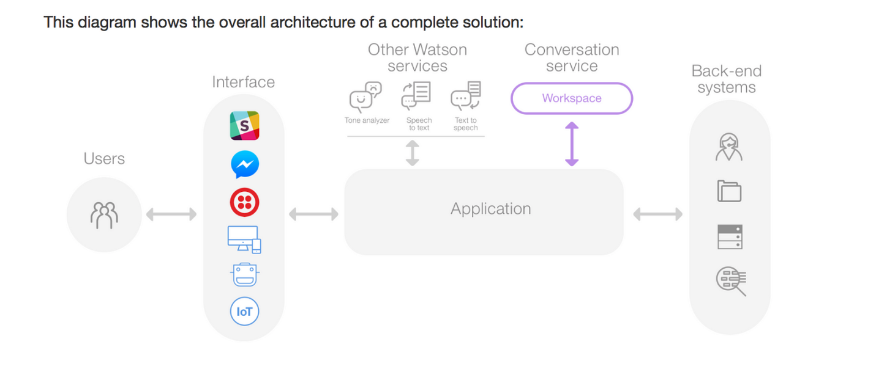

**5. Platform Integration:**

**Objective:**Integrate the chatbot with popular messaging platforms like Facebook Messenger and Slack.

**Steps:**

* Set up developer accounts on the target platforms (e.g., Facebook for Messenger, Slack).
* Configure the chatbot to work within the platform's ecosystem.
* Test the integration to ensure messages are delivered and received correctly.

**Deliverable:** A chatbot integrated with messaging platforms and ready for user interactions.

**6. User Experience:**

**Objective:** Ensure a seamless and user-friendly experience, with clear prompts and informative responses.

**Steps:**

* Conduct user testing to gather feedback on the chatbot's usability.
* Iterate on the chatbot's design and responses based on user feedback.
* Focus on providing clear and concise information to users.

**Deliverable:** A user-friendly chatbot that offers an engaging and informative experience.

**Conclusion:**

This project aims to create an intelligent chatbot using IBM Cloud Watson Assistant, capable of providing valuable assistance to users on messaging platforms. The design thinking process includes defining the chatbot's persona, identifying user scenarios, designing the conversation flow, configuring responses, integrating with messaging platforms, and optimizing the user experience. By following this structured approach, we will develop a highly effective and user-friendly virtual guide that meets the project's objectives.

Thank you