# PROJECT SUBMISSION PHASE-2

**Project Title :** Chatbot Deployment with IBM Cloud Watson Assistant

**Project Code :** 1662

**Team name :** Proj_211252_Team_1

**Domain :** Cloud Application Development

**Assignment :** Design innovation

# SUBMITTED BY

**Name :** Sam Charles F

**Mail id :** [sc240843@gmail.com](mailto:sc240843@gmail.com)

**College Name :** Parisutham Institute of Technology &Science

**College code :** 8213

**Group-4 :** Zone (13-16)

## Innovation:

Implement advanced features such as natural language understanding (NLU) for more accurate user intent recognition.

To create a helpful virtual guide using IBM Cloud Watson Assistant with advanced features such as natural language understanding (NLU) for more accurate user intent recognition, we can follow these steps:

### Define the chatbot's purpose and target audience:

What do you want the chatbot to be able to do? Who is the chatbot for? Once you have a good understanding of the chatbot's purpose and target audience, you can start to design its persona and responses.

### Design the chatbot's persona:

What is the chatbot's personality? What kind of tone should it use? The chatbot's persona should be consistent with the chatbot's purpose and target audience.

### Write the chatbot's responses.

The chatbot's responses should be informative, helpful, and friendly. They should also be tailored to the chatbot's persona and target audience.

### Implement NLU:

NLU can help the chatbot to better understand user intent and provide more relevant and accurate responses. To implement NLU, you can use IBM Cloud Watson Natural Language Understanding.

### Integrate the chatbot with messaging platforms:

This will make it easy for users to access and interact with the chatbot on their favorite platforms.

## Work flow of Natural Language Understanding:

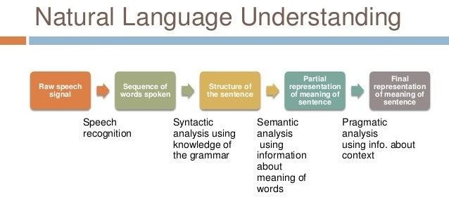

**Fig.(1)**

## To implement advanced features such as NLU in chatbot’s:

* Use NLU to identify and respond to common user requests. For example, if your chatbot is for a customer support website, you could use NLU to identify common customer support requests, such as "How do I change my password?" or "What is your return policy?" The chatbot could then be programmed to provide the appropriate response to each request.
* Use NLU to understand the sentiment of user messages. This can help the chatbot to provide more personalized and engaging responses. For example, if a user messages the chatbot saying "I'm having a bad day," the chatbot could respond with a message of support, such as "I'm sorry to hear that you're having a bad day. Is there anything I can do to help?"
* Use NLU to extract entities from user messages. This can be useful for tasks such as booking appointments or making reservations. For example, if a user messages the chatbot saying "I'd like to book an appointment for tomorrow at 10am," the chatbot could use NLU to extract the date and time of the appointment request. The chatbot could then book the appointment for the user.

## Example source code:

import numpy as np import pandas as pd

from rasa_nlu.model import Interpreter

# Load the NLU model

interpreter = Interpreter.load("./models/current/nlu")

# Receive the user message

user_message = "What is the weather like in India today?"

# Perform intent classification and entity extraction parsed_message = interpreter.parse(user_message)

# Get the user's intent

intent = parsed_message["intent"]["name"]

# Get the entities extracted from the message entities = parsed_message["entities"]

if intent == "inform_weather":

# Get the weather forecast for India weather_forecast = get_weather_forecast("India")

# Generate a response

response = "The weather in India today is {}.".format(weather_forecast) else:

# Generate a default response

response = "I'm sorry, I don't understand your request."

By implementing advanced features such as NLU, you can create a chatbot that is more helpful, informative, and engaging than traditional chatbots. This will lead to a better user experience and more positive outcomes for businesses and organizations.

Once you have implemented your chatbot, you can start to promote it to your target audience. You can do this by adding links to your chatbot on your website and social media pages. You can also send out email campaigns to your customers and subscribers.

By following these steps, you can create a helpful virtual guide using IBM Cloud Watson Assistant with advanced features such as natural language understanding (NLU) for more accurate user intent recognition.