TalentSync AI
Secure AI-Assisted Recruitment Management Platform
Capstone I Project Documentation
Florida International University
Department of Knight Foundation School of Computing and Information Sciences
Course: CIS 3950 – IT Capstone I
Instructor: Dr. Seyedmasoud Sadjadi
Team Members
- Samuel Chonay
- Neilia Dillon
- Junnorry Fil
- Josue Guerra
- Devin Blake
Semester
Summer 2026
1. Executive Summary
TalentSync AI is a secure recruitment management platform designed to assist recruiters and hiring managers throughout the hiring process. The system centralizes job postings, candidate information, and interview feedback while providing AI-assisted resume analysis and candidate summaries. Rather than replacing human decision-making, the platform uses artificial intelligence to reduce administrative effort by highlighting relevant skills, summarizing resumes, and organizing applicant information.
The project was developed following Agile and Scrum methodologies throughout Capstone I. Sprint planning, backlog refinement, daily standups, sprint reviews, and retrospectives were used to manage project progress and coordinate responsibilities among team members. The project emphasizes planning, documentation, architecture, and system design while establishing a foundation for future development in Capstone II.
2. Project Overview
Recruitment is often a time-consuming process that involves reviewing resumes, tracking applicants across multiple stages, coordinating interviews, and maintaining organized hiring records. Many organizations rely on manual processes or disconnected software solutions that make collaboration difficult and reduce efficiency.
TalentSync AI addresses these challenges by providing a centralized web application where recruiters can manage job openings, review candidate information, upload resumes, and leverage AI-generated summaries to quickly identify qualified applicants. The platform also supports interview tracking, hiring workflows, and secure administration through role-based access control.
The system is intended to improve recruiter productivity while maintaining transparency, security, and human oversight throughout the hiring process.
3. Problem Statement
Recruiters and hiring managers often spend significant time manually reviewing resumes, tracking applicants, and organizing interview feedback across multiple systems. These manual processes increase administrative workload, make collaboration more difficult, and can delay hiring decisions.
Organizations need a centralized platform that streamlines recruitment activities while maintaining secure access controls and preserving human decision-making. Existing tools may not provide sufficient flexibility for smaller organizations or educational demonstration projects.
TalentSync AI aims to improve recruitment efficiency by organizing hiring data in one system and providing AI-assisted insights that help recruiters evaluate candidates more quickly.
4. Proposed Solution
TalentSync AI is a web-based recruitment management platform that combines applicant tracking with artificial intelligence assistance.
The system allows authorized users to:
- Create job postings
- Upload candidate resumes
- Manage applicants
- Record interview feedback
- Generate AI-assisted resume summaries
- Compare candidate qualifications to job requirements
- Track application status
- Maintain secure user management through role-based access control
The platform is designed using a modular architecture that separates the user interface, backend services, database, and AI integration.
5. Project Goals
The primary objectives of TalentSync AI include:
- Streamline recruitment workflows.
- Reduce manual resume screening.
- Improve organization of hiring data.
- Provide AI-assisted resume summaries.
- Maintain secure access using role-based authentication.
- Create a scalable architecture suitable for future development.
- Demonstrate Agile and Scrum practices throughout project development.
6. Project Scope
Included
- Recruiter account management
- Job posting management
- Candidate management
- Resume upload
- AI-assisted resume summaries
- Interview tracking
- User authentication
- Role-based permissions
- Database documentation
- API planning
- Deployment planning
- System architecture
- UI mockups
- Prototype implementation
Excluded
- Automated hiring decisions
- Payroll integration
- Background check services
- Video interviewing
- Third-party HR software integration
- Production cloud deployment
7. Stakeholders
Primary stakeholders include:
- Recruiters- Responsible for creating job postings, reviewing candidates, and managing hiring activities.
- Hiring Managers- Review applicants, conduct interviews, and make final hiring decisions.
- System Administrators- Manage user accounts, permissions, and system maintenance.
- Applicants- Submit resumes and apply for available job openings.
8. User Roles
Administrator
Responsibilities:
- Manage users
- Assign roles
- Reset passwords
- View audit logs
- Configure system settings
Recruiter
Responsibilities:
- Create job postings
- Upload resumes
- Review AI summaries
- Schedule interviews
- Update candidate status
Hiring Manager
Responsibilities:
- Review candidates
- Record interview evaluations
- Recommend hiring decisions
9. Functional Requirements
Examples:
FR-001 User authentication
FR-002 User registration by administrator
FR-003 Role-based authorization
FR-004 Create job postings
FR-005 Edit job postings
FR-006 Upload resumes
FR-007 Store candidate information
FR-008 Generate AI-assisted resume summaries
FR-009 Track application status
FR-010 Schedule interviews
FR-011 Record interview feedback
FR-012 View recruiter dashboard
FR-013 Audit user activity
FR-014 Search applicants
FR-015 Export hiring reports
10. Nonfunctional Requirements
The system shall:
- Use secure password hashing.
- Support role-based access control.
- Validate uploaded files.
- Store sensitive configuration in environment variables.
- Be deployable using Docker.
- Support PostgreSQL.
- Maintain consistent response times under normal usage.
- Provide maintainable and documented source code.
11. User Stories
- As a recruiter, I want to create a job posting so that applicants can apply for open positions.
- As a recruiter, I want to upload resumes so that candidate information is stored in one location.
- As a recruiter, I want AI-generated resume summaries so that I can quickly evaluate applicants.
- As a hiring manager, I want to review interview notes so that I can make informed hiring decisions.
- As an administrator, I want to manage user roles so that only authorized personnel can access sensitive data.
12. Product Backlog
ID | User Story | Priority
PB-01 | User Authentication | High
PB-02 | Recruiter Dashboard | High
PB-03 | Job Posting Management | High
PB-04 | Candidate Management | High
PB-05 | Resume Upload | High
PB-06 | AI Resume Summary | Medium
PB-07 | Interview Tracking | Medium
PB-08 | Reporting Dashboard | Low

13. System Architecture Diagram
Figure 13. TalentSync AI System Architecture
The System Architecture Diagram shows the major components of TalentSync AI and how they communicate. The platform follows a layered architecture consisting of a user layer, frontend layer, backend layer, database layer, and external AI service.
Users interact with the system through the React frontend. The supported users include recruiters, hiring managers, administrators, and applicants. The frontend contains the application pages, reusable user-interface components, state management, and API calls. It sends requests to the Flask backend and displays the information returned by the system.
The Flask backend contains the REST API, business logic, authentication, authorization, and AI integration functions. It processes requests from the frontend, verifies whether users have permission to perform requested actions, and communicates with the PostgreSQL database.
PostgreSQL stores system information, including users, jobs, candidates, applications, interviews, and audit logs. The backend also connects to the OpenAI API to generate resume summaries, extract skills, and assist with candidate-to-job comparisons.
This architecture was selected because it separates the major responsibilities of the system. Changes to the user interface, backend logic, database, or AI service can be managed independently, making the application easier to maintain and expand. 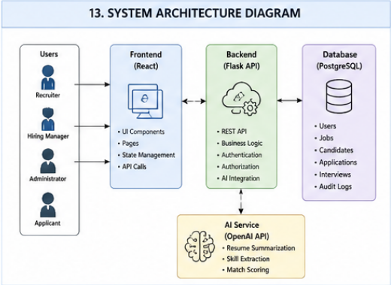
14. Deployment Architecture Diagram
Figure 14. Proposed AWS Deployment Architecture
The Deployment Architecture Diagram illustrates how TalentSync AI could be hosted using Amazon Web Services. This represents a proposed production deployment and may be implemented during a future phase of the project.
Users connect to the system through the internet. Amazon Route 53 provides domain name resolution and directs incoming traffic to an Application Load Balancer. The load balancer distributes requests between backend application servers running on Amazon EC2.
The EC2 instances are placed inside an AWS Virtual Private Cloud. Multiple availability zones can be used to improve reliability and reduce the effect of an individual server or availability-zone failure. The application servers communicate with an Amazon RDS PostgreSQL database that stores the platform’s structured data.
Amazon S3 stores uploaded resume files and other project documents. AWS CloudWatch collects application logs, performance information, and infrastructure monitoring data. Security groups and AWS Identity and Access Management policies control which services and users can access each resource.
This design supports scalability, centralized monitoring, data protection, and future system growth. For Capstone I, the diagram represents the team’s planned deployment rather than a claim that the entire AWS environment has already been implemented.
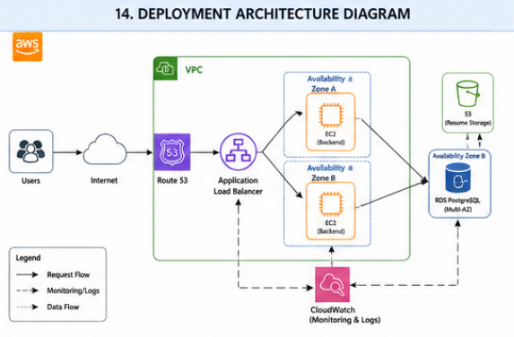
15. Use Case Diagram
Figure 15. TalentSync AI Use Case Diagram
The Use Case Diagram identifies the major users of TalentSync AI and the functions available to each role. The main actors are the recruiter, hiring manager, administrator, and applicant.
Recruiters perform most of the daily recruitment activities. They can manage job postings, upload resumes, manage candidates, view AI-generated resume summaries, track applications, and schedule interviews.
Hiring managers review candidate information and participate in the evaluation process. They can review applicants, examine AI-assisted summaries, track the progress of applications, and record interview feedback.
Administrators manage the operation and security of the platform. Their responsibilities include managing user accounts, assigning roles, reviewing system activity, and generating administrative reports.
Applicants interact with the system by applying for available jobs and submitting their information. The applicant role has more limited access than internal users because applicants should not be able to view confidential recruiting records or information belonging to other candidates.
The use cases demonstrate the role-based structure of TalentSync AI. Each user is given access only to the functions required for that role.
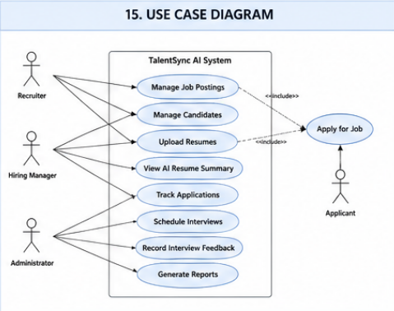
16. Entity-Relationship Diagram
Figure 16. TalentSync AI Entity-Relationship Diagram
The Entity-Relationship Diagram describes the planned PostgreSQL database structure. The primary entities are Users, Jobs, Candidates, Applications, Interviews, and Audit Logs.
The Users table stores information about administrators, recruiters, and hiring managers. Each user has identifying information, login credentials, a system role, an account status, and account creation information.
The Jobs table stores each job posting. It includes the job title, description, department, required skills, current status, and the user who created the posting. One user can create multiple job postings.
The Candidates table stores candidate contact information, resume location, extracted skills, and the AI-generated resume summary. Candidate data is separated from application data so that one candidate may apply for multiple positions.
The Applications table connects candidates to jobs. Each application belongs to one candidate and one job. It stores the application status, AI-assisted match score, application date, and last update date. This resolves the many-to-many relationship between candidates and job postings.
The Interviews table stores interview details for an application, including the interviewer, interview date, notes, and recommendation. One application may have one or more interviews during the hiring process.
The Audit Logs table records important system actions performed by users. These records may include the action performed, affected resource, timestamp, and user responsible for the activity.
This database design reduces unnecessary duplication while maintaining clear relationships between recruitment records.
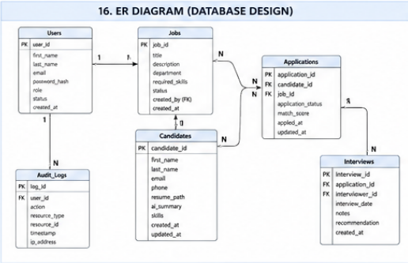
17. Activity Diagram – Recruitment Workflow
Figure 17. TalentSync AI Recruitment Activity Diagram
The Activity Diagram shows the main recruitment workflow from job creation through interview feedback. It also identifies which system participant is responsible for each activity.
The process begins when a recruiter creates a job posting. The system validates and stores the job information in the database. The recruiter then uploads a candidate resume or receives a resume associated with an application.
The system extracts the resume text and stores the candidate record. The extracted text is sent to the AI service, which produces an assisted summary and identifies relevant skills. The returned information is stored with the candidate record for recruiter review.
The recruiter reviews the candidate’s information, resume, and AI-assisted results. The recruiter may then update the application status to indicate whether the candidate should move forward, remain under review, or no longer be considered.
If the candidate advances, the hiring manager reviews the candidate and participates in the interview process. After the interview, feedback and a recommendation are recorded in the system.
This workflow preserves human oversight. The AI service provides supporting information, but recruiters and hiring managers remain responsible for candidate evaluation and final hiring decisions.
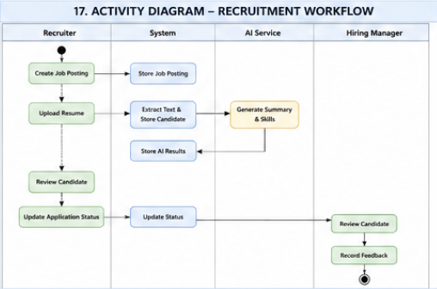
18. Sequence Diagram – Resume Upload and AI Summary
Figure 18. Resume Upload and AI Summary Sequence Diagram
The Sequence Diagram shows the order of communication between the recruiter, React frontend, Flask backend, OpenAI service, and PostgreSQL database during resume processing.
First, the recruiter selects and uploads a resume through the frontend. The frontend sends the file to the Flask backend through a resume-upload API endpoint.
The backend validates the file before accepting it. Validation may include checking the file type, size, and required candidate information. After validation, the backend stores the file or its storage reference and creates or updates the candidate record in the database.
The backend extracts text from the resume and sends the relevant content to the OpenAI service. The AI service analyzes the resume and returns an assisted summary and a list of identified skills.
The backend stores the returned AI results in PostgreSQL. After the information is successfully saved, the backend returns the candidate information and summary to the frontend. The frontend then displays the result to the recruiter.
This sequence keeps the OpenAI API separated from the frontend. API credentials remain on the server, and the backend controls what information is sent to and returned from the external service.
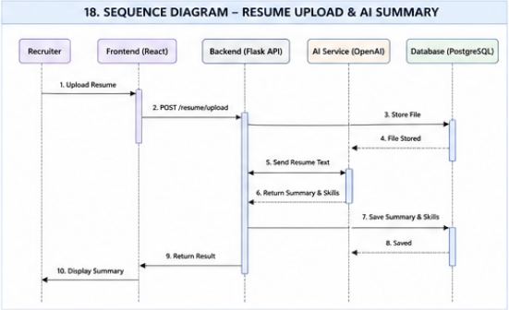
19. Class Diagram
Figure 19. TalentSync AI Key Class Diagram
The Class Diagram represents the planned software objects and services used in TalentSync AI. It connects the application’s object-oriented design to the entities shown in the database model.
The User class represents authorized internal users. It contains information such as the user ID, name, email address, password hash, role, and account status. User-related methods may support login, profile updates, and account management.
The Job class represents an available position. It contains the job title, description, department, required skills, status, and creator. Its methods may support creating, updating, and closing job postings.
The Candidate class stores candidate information, including contact information, resume location, identified skills, and AI summary. Its methods may support uploading a resume and retrieving candidate information.
The Application class connects a candidate to a job. It maintains the application status, match score, and relevant dates. Methods may allow authorized users to update an application or retrieve an AI-assisted comparison score.
The Interview class represents an interview associated with an application. It stores the interviewer, date, notes, and recommendation. Its methods support recording and updating interview feedback.
The AIService class isolates communication with the external AI provider. It may include methods for summarizing resumes, extracting skills, and calculating or describing candidate-to-job alignment.
The AuthService class is responsible for authentication and authorization. It verifies credentials, protects restricted functions, and determines whether a user has permission to perform an action.
Separating these responsibilities improves maintainability and allows individual components to be tested independently.
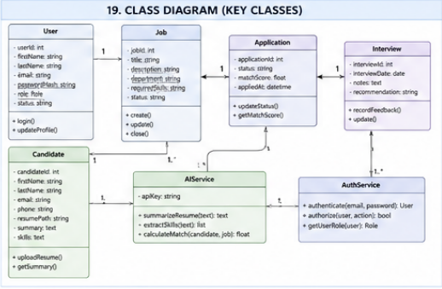
20. Data Flow Diagram
Figure 20. TalentSync AI Level 1 Data Flow Diagram
The Data Flow Diagram illustrates how information moves between users, system processes, the database, and the AI service.
Recruiters provide job information, candidate data, resumes, and application updates. The system processes this information through job-management and candidate-management functions before saving it to the database.
Hiring managers receive candidate and interview information from the system. They provide interview feedback and recommendations, which are stored as interview and application records.
Administrators provide account and role-management instructions. The system updates user records and returns system activity or audit information for administrative review.
Applicants provide application information and resume data. The system associates this information with the appropriate candidate and job records.
The AI service receives extracted resume text or relevant candidate and job information. It returns resume summaries and identified skills to the main system. These results are stored in the database and later displayed to authorized recruiters and hiring managers.
The database functions as the central data store for users, jobs, candidates, applications, interviews, and logs. Data is not passed directly between users and the database. It is processed by the backend to support validation, authorization, and consistency.
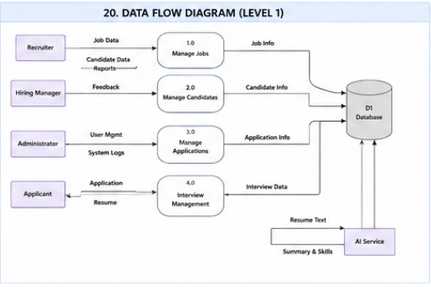
21: Network Diagram
Figure 21. Proposed TalentSync AI Network Architecture
The Network Diagram presents the planned network organization for a cloud-hosted TalentSync AI environment. The design places internet-facing resources separately from protected database resources.
Incoming traffic is routed through Route 53 and an Application Load Balancer. Application servers are hosted on EC2 instances inside public application subnets. The load balancer can distribute traffic across multiple instances to improve availability.
The PostgreSQL database is hosted using Amazon RDS in a private subnet. It is not directly accessible from the public internet. Only approved application servers should be permitted to connect to the database on the required PostgreSQL port.
Amazon S3 stores candidate resumes and other uploaded files. Access to the storage bucket is controlled through IAM policies and application permissions. AWS CloudWatch collects logs and monitoring information from the application and supporting services.
Security groups act as virtual firewalls. The load balancer accepts approved web traffic, application servers accept traffic from the load balancer, and the database accepts traffic only from the application layer. This layered network design reduces unnecessary exposure of sensitive recruitment information.

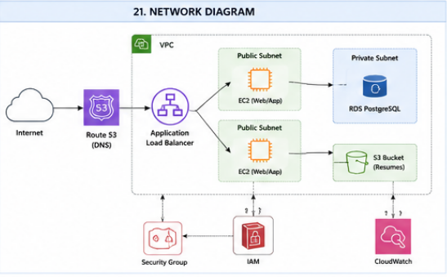
22. Conclusion
TalentSync AI was designed as a realistic solution for improving the organization and efficiency of recruitment activities. The proposed platform centralizes job postings, candidate records, applications, interview feedback, and AI-assisted resume analysis within a secure web-based system. By combining recruitment management features with artificial intelligence support, the project demonstrates how technology can reduce administrative work while preserving human involvement in hiring decisions.
During Capstone I, the team focused primarily on Agile and Scrum practices, including sprint planning, daily standups, backlog refinement, sprint reviews, retrospectives, task coordination, and project documentation. These activities helped the team define the project vision, assign responsibilities, track progress, respond to challenges, and maintain accountability throughout the semester. Although a fully production-ready application was not required, the team developed a realistic foundation that includes requirements, user stories, architecture, database design, API planning, security controls, deployment planning, testing procedures, and interface concepts.
The proposed architecture separates the React frontend, Flask backend, PostgreSQL database, and OpenAI integration into distinct components. This modular design supports maintainability, security, scalability, and future development. The database model provides a structured way to manage users, job postings, candidates, applications, interviews, and audit logs. The planned security controls, including authentication, role-based access control, input validation, protected file storage, and audit logging, are intended to protect sensitive recruitment information.
TalentSync AI is not intended to replace recruiters or automatically make employment decisions. Instead, the AI features are designed to assist authorized users by summarizing resumes, identifying skills, and organizing candidate information. Recruiters and hiring managers remain responsible for reviewing the information, conducting interviews, and making final decisions.
The work completed during Capstone I provides a strong starting point for Capstone II. Future development may include implementing the complete frontend and backend, connecting the PostgreSQL database, integrating the OpenAI API, deploying the system through AWS and Docker, conducting usability and security testing, and expanding reporting and administrative features.
Overall, the project allowed the team to practice managing a realistic information technology project in an Agile/Scrum environment. The resulting documentation and design artifacts show the evolution of TalentSync AI from an initial idea into a structured and technically feasible project plan.

