Installation Guide-MongoDB



In order to execute the baseball.ai file, we first need MongoDB. Many exe file don’t need any language program or other platforms because they all aimed to just ‘execute’. However, this baseball.ai file has to be installed to get to the database created by file. MongoDB is a free and open-source cross-platform document-oriented database. It’s classified as a NoSQL database, and it avoids the traditional table-based relational database structure in favor of JSON-like documents with dynamic schemas. With the use of MongoDB, much of the functionality can be accessed through JAVA and python.

Installation MongoDB on windows.

Step 1.

Visit downloads page and find your version of Windows. We are going to place all these files directly inside a directory C:\mongodo\. So once the download finishes, extract the zip and open the folders until you find /bin/ with a few other files. Select all these and cut/paste into our new C:\mongodb\directory.

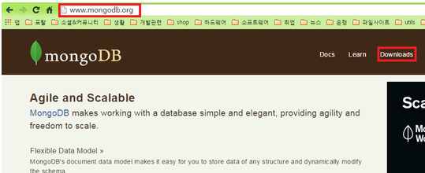

<http://www.mongodb.org/>

<http://www.mongodb.org/downloads>

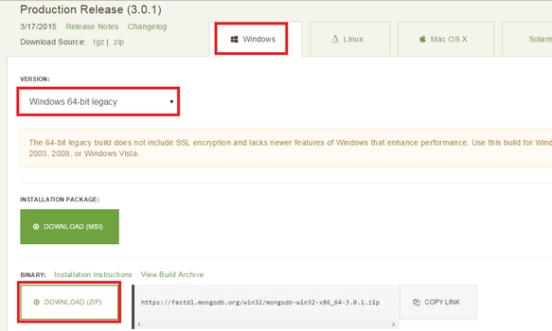

Check your version and OS then downloads.

Step 2.

Add route. Add new route named MONGODB_HOME and put the address on which you uncompressed.

Revise Path as showed below.

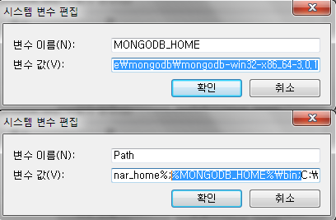

Step 3.

Now, inside this folder alongside \bin\ create a new folder named “log” which will store all the MongoDB system logs. We also need to create two external directories for data storage, C:\data\ and C:\data\db.

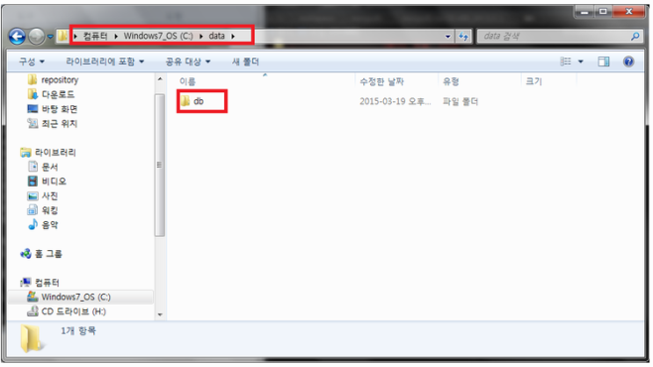

Step 4.

After creating new directory, and put ‘mongod’ on the DOS command. Then we can see the server is on like below.

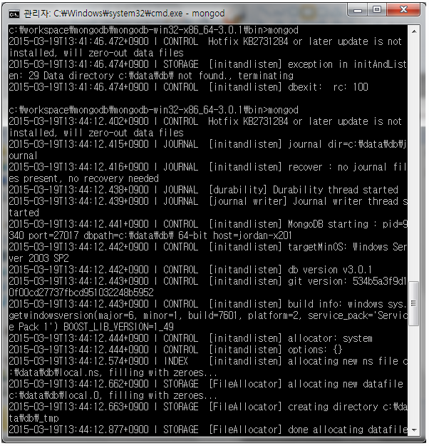

Then, let’s put new command and put word ‘mongo’’. If you are succeed to follow up to here, you can see the databased to ‘test’ , which means that it’s successfully installed.

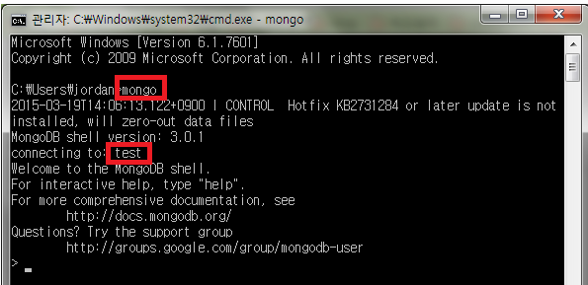

Step 5.

If we open up the command prompt and run cd C:\mongodb\bin, we are looking to start the mongod.exe in shell, but after running this you’ll notice the operation will freeze when listening for connections. Well it’s not actually frozen, we are running Mongo directly through the terminal.

So, to start comman Mongo automatically as a Windows Service, first create a log file and configuration for the service. The code below executes creating the log file.



Now run the next two lines in terminal to create the service and get it started.



Following line shows all current databases on the server:

