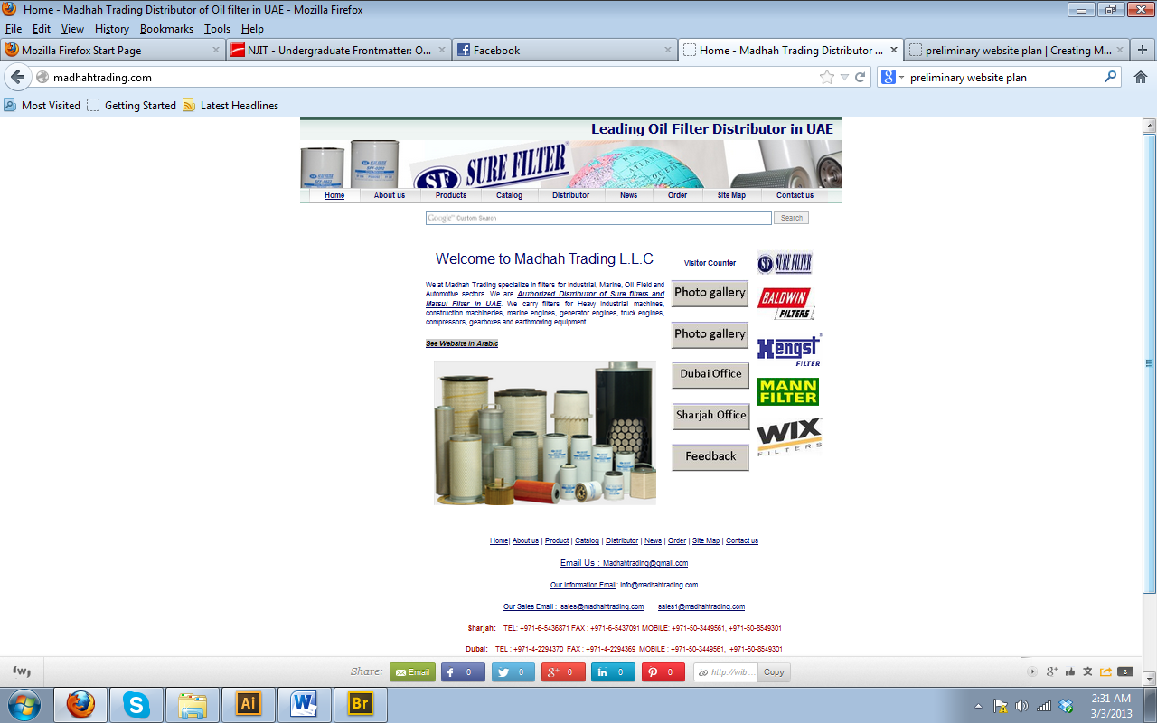

**SWOT Matrix**

|  |  |
| --- | --- |
| **Strengths**:  They have the direct links to their distributors which help the customers see more variety | **Weakness**:  Not a professional design  Content remains static  Too much white space |
| **Opportunities**:  Can be better off by having a customized page for their customers where they can chose their products, study details etc.  Can have a page showing all their products containing detailed information about each | **Threats**:  Photo gallery might  Visitor rate is low  Poor online presence |

**Client brief that explains the project**

After the first brief interview with the client, I understood the following requirements. I’ll have a better vision of the design and display in the upcoming meetings:

* The homepage of Lipsum should be simple and elegant. I want to display as many pictures of my products as possible. There should be a small introduction followed by our top product stories. Stories can be displayed by texts, pictures or texts + pictures.
* Recent updates about our new product launch etc. should be displayed on the home page.
* Our distributors’ link is one of the most important feature and should be made available on each page. Clicking on that link directs them to the product home page of that particular company
* The main categories/menu will be on left followed by sign up link for receiving our updates via email.
* The users are from various countries, so there should be an option on the TOP to change the language.
* Search bar is another important feature.
* The secondary page, for example, Ipsum should be neat and crisp.
* There should also be a block for facts about the feature/product etc(depending on the page).
* Distributors link

**Preliminary plan that addresses the issues raised in the SWOT**

**Site Purpose:** To attract dealers and buyers in their products. Also show their authorized dealership with the market dominations such as Sure Filters and Matsui Filter

**Site Audience:** Auto dealers and buyers interested in buying Auto Filters near Middle East, Africa and India.

**Website Marketing:** Explain how you intend to attract your niche audience; through advertising, word of mouth, special promotions, and so on.

**Web Copy:** Photo gallery of the company warehouse, products available in company’s packaging to give the customers a clear vision of their products.

Maps showing their warehouses and offices

Customized page for customers where they can compare different products from various brands.

**Look and Feel:** Blue and white colors. More pictures and details about each product.