**FileUpload Control:**

A FileUpLoad control allows developers to drop the control on a page and let it browse a file and upload it on the server.

To create a control, simply drop the FileUpload control from Toolbox to a Web page. The following code adds the FileUpLoad control:

<asp:FileUpLoad id="FileUpLoad1" runat="server" />

To support file upload, we need to add a Button control:

<asp:Button id="UploadBtn" Text="Upload File" OnClick="UploadBtn_Click

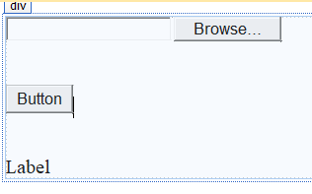

**CodeFile:**

using System;

public partial class FileUploadControl : System.Web.UI.Page

{

protected void Page_Load(object sender, EventArgs e)

{

}

protected void Button1_Click(object sender, EventArgs e)

{

if (FileUpload1.HasFile)

{

string FileExtension = System.IO.Path.GetExtension(FileUpload1.FileName);

if (FileExtension.ToLower() != ".doc" && FileExtension.ToLower() != ".docx")

{

lblmessage.Text = " Please select doc file";

lblmessage.ForeColor = System.Drawing.Color.Red;

}

else

{

FileUpload1.SaveAs(Server.MapPath("~/Uploads/" + FileUpload1.FileName));

lblmessage.Text = "File Uploaded Successfully";

lblmessage.ForeColor = System.Drawing.Color.Green;

}

}

else

{

lblmessage.Text = "Please select a file to upload";

}

}

}

In example, We have file upload control which will search the file. When we click on button, then present file will save to the given path and same time it displays a message in label that “File Uploaded Successfully”. It will check whether file is .doc file or not? If it is not .doc file then it displays message “Please Select doc file”. And if file is not selected then it will display message in label that “Please select a file to upload”.

**Calendar Control:**

User can select date from calendar control.

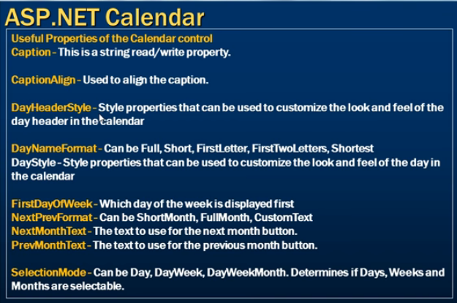

In example, we have three controls Textbox, ImageButton and Calendar control.

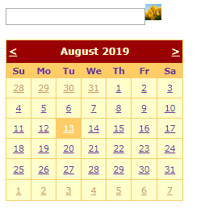

When our page will load at that time calendar control should not display on page.

At the same time when we click on image button then calendar control have to display and it will again disable when we select date from calendar control.

Date should be display in Textbox.

**Code:**

protected void Page_Load(object sender, EventArgs e)

{

if (!IsPostBack)

{

Calendar1.Visible = false;

}

}

protected void ImageButton1_Click(object sender, ImageClickEventArgs e)

{

if (Calendar1.Visible)

{

Calendar1.Visible = false;

}

else

{

Calendar1.Visible = true;

}

}

protected void Calendar1_SelectionChanged(object sender, EventArgs e)

{

TextBox1.Text = Calendar1.SelectedDate.ToString("d");

Calendar1.Visible = false;

}

protected void Calendar1_DayRender(object sender, DayRenderEventArgs e)

{

if (e.Day.IsOtherMonth || e.Day.IsWeekend)

{

e.Day.IsSelectable = false;

e.Cell.BackColor = System.Drawing.Color.Red;

e.Cell.Font.Bold = true;

e.Cell.Text = "X";

e.Cell.ToolTip = "Booked";

}

}

protected void Calendar2_VisibleMonthChanged(object sender, MonthChangedEventArgs e)

{

Response.Write("Month Changed");

}

In example, At the time of page load calendar control is not visible and when we click on image button then calendar can visible. From this calendar we can select date and that date is display in TextBox. After that calendar is again visible false.

Another thing is We can not select date from weekend and other month.

It has different formats which are shown in below:

