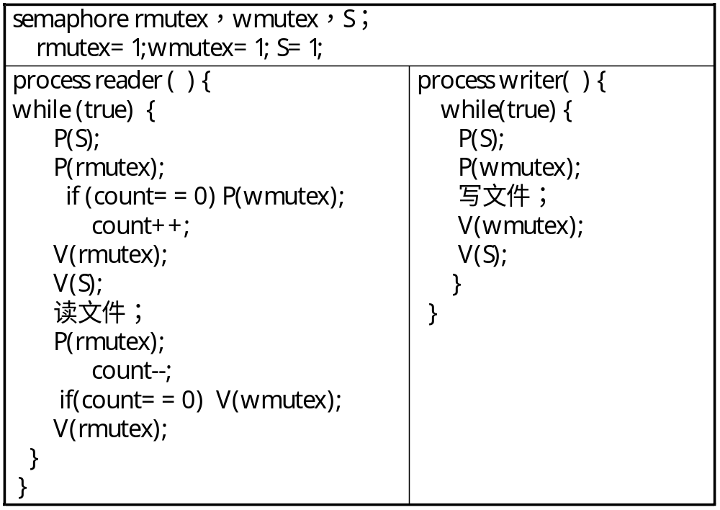
初值 rmutex=1, wmutex=1, S=1, count=0;
假设，执行P(S)操作的各进程的次序为R3, R1, W2, R2, R0, 那么
 | 调用进程 | 被调用的操作 | 信号量状态
 | R3 | P(S) | S=0, rmutex=1, wmutex=1, count=0  //R3先抢到S信号量，读进程先占据主动
 | R1 | P(S) | S=-1 (R1), rmutex=1, wmutex=1, count=0
 | W2 | P(S) | S=-2 (R1, W2), rmutex=1, wmutex=1, count=0  //W2写进程插入S信号量的等待队列，将使得后续执行P(S)操作的读进程暂时不能顺畅的涌进来，因为排队在W2之后，只有等到，W2进入临界区，退出之后才能然W2之后的读进程进入。
 | R2 | P(S) | S=-3 (R1, W2, R2), rmutex=1, wmutex=1, count=0
 | R0 | P(S) | S=-4 (R1, W2, R2, R0), rmutex=1, wmutex=1, count=0
 | R3 | P(rmutex) | S=-4 (R1, W2, R2, R0), rmutex=0, wmutex=1, count=0
 | R3 | P(wmutex) | S=-4 (R1, W2, R2, R0), rmutex=0, wmutex=0 , count=0  //此时wmutex在读者进程手中  //R3作为第一批读进程代表进入临界区
 | R3 | Count++ | S=-4 (R1, W2, R2, R0), rmutex=0, wmutex=0, count=1  //此时wmutex在读者进程手中
 | R3 | V(rmutex) | S=-4 (R1, W2, R2, R0), rmutex=1, wmutex=0, count=1
 | R3 | V(S) | S=-3 R1(W2, R2, R0), rmutex=1, wmutex=0, count=1  //R3唤醒R1
 | R1 | P(rmutex) | S=-3 (W2, R2, R0), rmutex=0, wmutex=0, count=1
 | R1 | Count++ | S=-3 (W2, R2, R0), rmutex=0, wmutex=0, count=2  //此时wmutex在读者进程手中
 | R1 | V(rmutex) | S=-3(W2, R2, R0), rmutex=1, wmutex=0, count=2
 | R1 | V(S) | S=-2 W2 (R2, R0), rmutex=1, wmutex=0, count=2  //R1唤醒W2
 | W2 | P(wmutex) | S=-2 (R2, R0), rmutex=1, wmutex=-1 (W2), count=2  //W2阻塞
 | R3 | P(rmutex) | S=-2 (R2, R0), rmutex=0, wmutex=-1 (W2),count=2
 | R3 | Count-- | S=-2 (R2, R0), rmutex=0, wmutex=-1 (W2), count=1
 | R3 | V(rmutex) | S=-2 (R2, R0), rmutex=1, wmutex=-1 (W2), count=1
 | R1 | P(rmutex) | S=-2 (R2, R0), rmutex=0, wmutex=-1 (W2),count=1
 | R1 | Count-- | S=-2 (R2, R0), rmutex=0, wmutex=-1 (W2), count=0
 | R1 | V(wmutex) | S=-2 (R2, R0), rmutex=0, wmutex=0 W2( ), count=0  //R1唤醒W2，接下来W2进入临界区
 | R1 | V(rmutex) | S=-2 (R2, R0), rmutex=1, wmutex=0, count=0
 | W2 | V(wmutex) | S=-2 (R2, R0), rmutex=1, wmutex=1, count=0
 | W2 | V(S) | S=-1 R2 (R0), rmutex=1, wmutex=1, count=0  //接下来R2作为第二批读进程的代表进入临界区，后续不再赘述

