Capabilities Covered:
1.Use C# Programming to implement business layer of your application

Objective

Assignment 1: Constructor
Estimated time: 1 hour

- Write a class User having the following data members
  - userId : int
  - dateOfBirth : string
  - userName : string
  - gender : char
  - guardianName : string

Write a parameterized constructor which takes the above parameters
Create a class UserManager which has the following methods
- createUser(User user) to accepts User details
- showUserDetails(User user) to display User details

- Write a class Transaction having the following data members
  - transactionId : int
  - amount: double
  - transDate: Date

Write a parameterized constructor which takes the above parameters
Create a class Transaction Manager which has the following methods
- create Transaction (Transaction trans) to accepts Transaction details
- showTransactionDetails(Transaction trans) to display Transaction details

Assignment 2: Constructor Parameterized
Estimated time: 30 minutes
- Write a class ContactInfo having the following data members
  - address : string
  - city : string
  - state : string
  - country : string
  - phoneNo : string
  - mobileNo : string
  - emailId : string

Write a parameterized constructor which takes the above values.

Create a class ContactInfoManager which has following methods
- createContact(ContactInfo contactInfo)
- displayContactDetails(ContactInfo contactInfo)

Assignment 3: Abstract Class
Estimated time: 1 hour

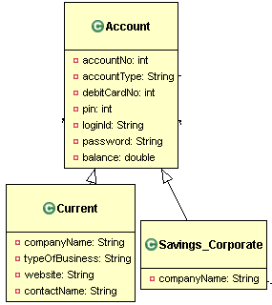
Create Current and Savings_Corporate classes extending Account
Design Classes for the Class Diagram shown.
Create a class AccountManager which has following methods
- CreateAccount(Account acc)
- DisplayAccount(Account acc)

