**Logistic Regression in R**

**About the Dataset:**

The dataset chosen is quite simple. It has the following features:

* 400 instances
* 4 variables:
  + Admit: This is the class to be determined. 0 shows the failure to get admission whereas, 1 denotes successful admission.
  + GRE: This variable contains the GRE score of a particular candidate
  + GPA: This denotes the graduation GPA of a student
  + Rank: This is the position of a student in a class

**Steps:**

* We will read the dataset and print its values:

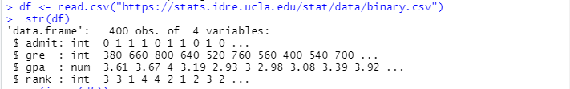

* The dataset will be checked for Null Values. For the proper application of Algorithm, it is mandatory that the dataset should not contain NULL values.



* Then we will for our own understanding of the dataset, print the description of the Dataset.

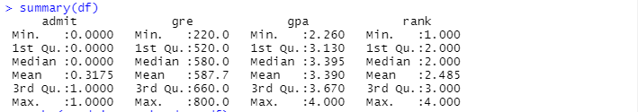

* Now we will set the Features and the Labels respectively and call the Logistic Regression function. Since, there are only two outcomes (Admitted, Not Admitted) denoted by 0 and 1 the family will be binary.

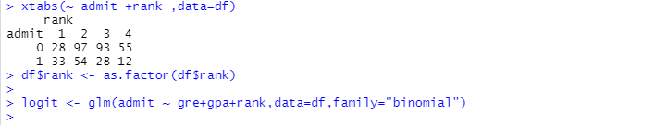

* Let us check the summary of the model.

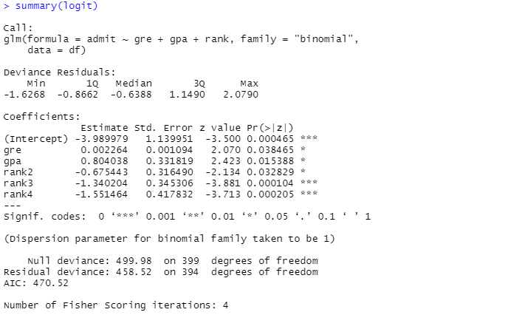

* Once, the model has been trained we will run and classify some values set by ourselves.

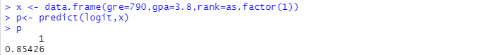

* Here we can observe that there is 85.4% probability that the student will be admitted.