body {

        display: flex;

        align-content: center;

        gap: 30px;

        flex-direction: row;

        flex-wrap: wrap;

    }

background-image: linear-gradient(to right,#d16ba5,#c777b9,#ba83ca,#aa8fd8,#9a9ae1,#8aa7ec,#79b3f4,#69bff8,#52cffe,#41dfff,#46eefa,#5ffbf1);

userenvelop

- usercontainer

-userpic

-username

- container

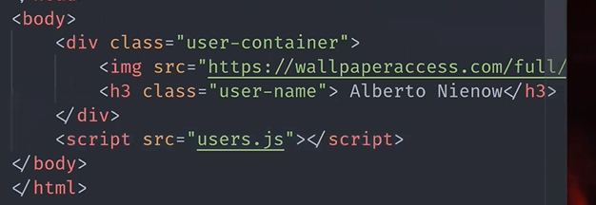

body{

Font-family:roboto

}

Replace background colour with background-image:linear on usercontainer

Here the + in innerHtml is basically appending to the same userlist rather than overwriting it.

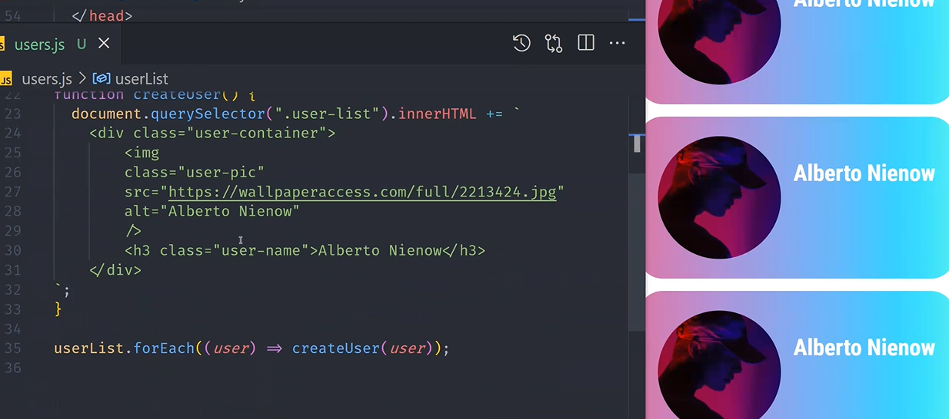

.outer {

    height:250px;

    max-width: 500px;

    display:flex;

    flex-direction: row;

    align-items: center;

    background-color: rgb(255, 246, 127);

    gap:20px;

    border: 2px solid black;

    box-shadow: -12px 10px 5px 0px rgba(0,0,0,0.75);

-webkit-box-shadow: -12px 10px 5px 0px rgba(0,0,0,0.75);

-moz-box-shadow: -12px 10px 5px 0px rgba(0,0,0,0.75);

}

.userpic {

   height:200px;

   width:200px;

   border-radius: 50%;

   background-position: contain;

   background-repeat:no-repeat;

   padding: 10px

}

.userdata {

    margin-bottom: 4px;

    padding-bottom: 2px;

    font-family: sans-serif;

}

span{

    font-weight: bolder;

}

body {

        display: flex;

        align-content: center;

        gap: 30px;

        flex-direction: row;

        flex-wrap: wrap;

    }

