<https://github.com/ragavkumarv/space-invaders>

<https://codesandbox.io/s/laughing-mountain-h5s71h?file=/index.html>

var enemies = [{ left: 200, top: 100 },{ left: 300, top: 100 },{ left: 400, top: 100 },{ left: 500, top: 100 },{ left: 600, top: 100 },{ left: 700, top: 100 },{ left: 800, top: 100 },{ left: 900, top: 100 },{ left: 200, top: 175 },{ left: 300, top: 175 },{ left: 400, top: 175 },{ left: 500, top: 175 },{ left: 600, top: 175 },{ left: 700, top: 175 },{ left: 800, top: 175 },{ left: 900, top: 175 }];

document.addEventListener(“click”) == document.onkeydown

document.body.setAttribute(“style”, “background:red”) == document.body.style.backgrond=red

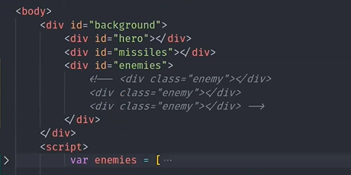

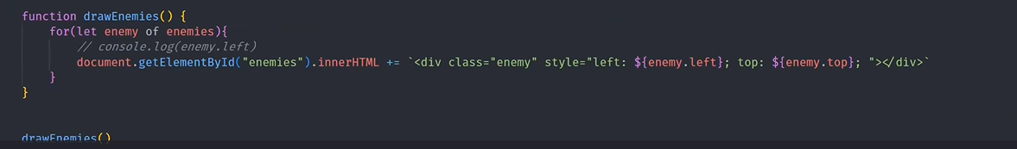

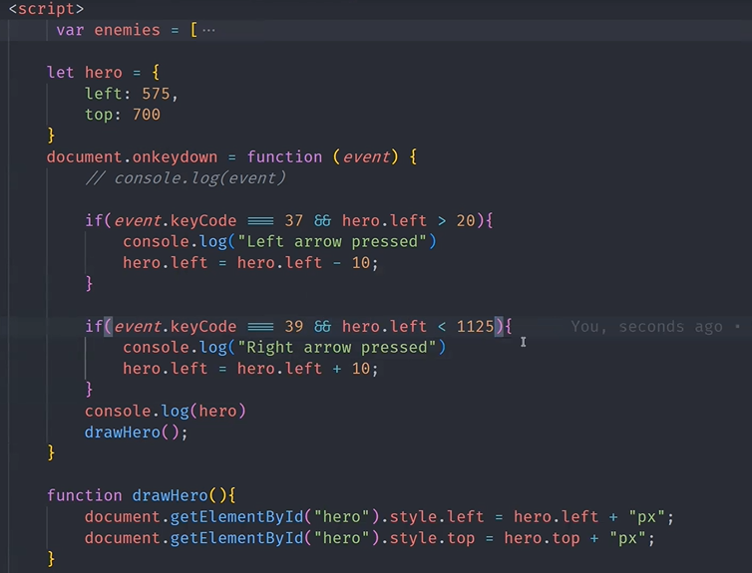

Later add missiles logic as below

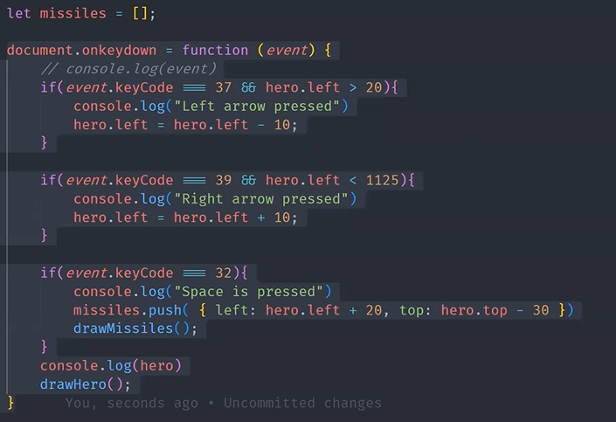

Until now

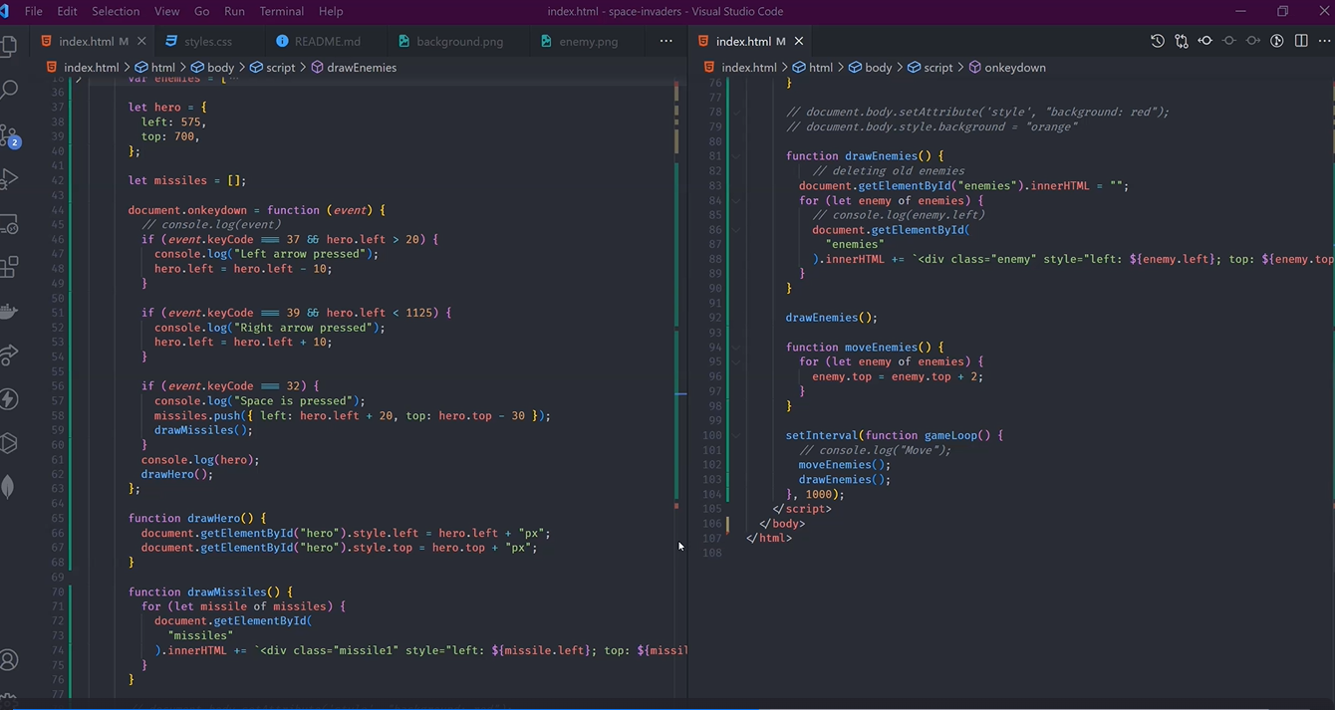

Here missiles is empty list, when space is clicked the missile needs to be made exactly as per the current hero.left and hero.right values so it needs to be along with the event and it gets added into the missile empty list so that the draw missile can be made.

The enemies need to move and not add to the existing list of top values so it has to be made zero every time the drawenemis function is called.

So when the enemy.top changes it changes the position of the enemy and looks like moving. Its been kept in the set interval to move every second. O every second the move happens followed by drawenemies.

Next make missiles move

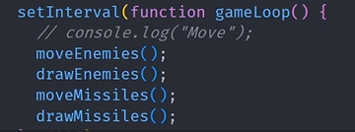

And remember to make the innerhtml empty within drawmissles so that it gets replaced based on new top value.

Shooting logic

Based on enemy location and missile location considered within a range considered based on enemy.left and top value as a square, there is a splice added to the enemy to remove it.

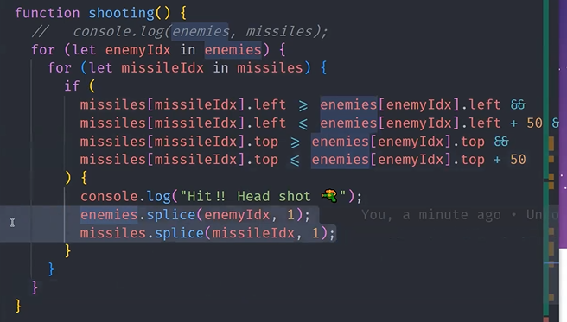

Next, logic of gameend and result,

