Meta Menu – A Dynamic Restaurant Menu System

Course- Database Management Systems (DBMS) Project

Submitted by:
Batch : C2
Members:

Sr. No. | UEC No. | Name
1 | UEC2023348 | Sameeksha Rawat
2 | UEC2023350 | Devina Shetty
3 | UEC2023351 | Shreya Shinde

Guided by: Prof. Ravikant Suryawanshi
E&TC Department, Cummins College of Engineering for Women
Date: 27 October 2025

Abstract
Meta Menu is a dynamic Database Management System designed to digitize and automate restaurant menu management. The system enables real-time menu updates, automated pricing and billing triggers, and seamless integration between the frontend interface and MySQL database.
Built with Node.js, Express, MySQL, HTML, CSS, and JavaScript, Meta Menu allows restaurants to manage food items, prices, and billing efficiently. Automated triggers in the database update prices based on popularity or demand, ensuring dynamic and adaptive pricing strategies.
The project demonstrates key DBMS concepts such as entity-relationship modeling, normalization, and real-time data handling, while showcasing how technology can improve operational efficiency and enhance customer experience in the hospitality industry.

Table of Contents

1. Introduction
2. System Analysis
3. System Design
4. Implementation
5. Testing
6. Results
7. Conclusion
8. Future Enhancements
9. References
10. Appendix

Introduction

Background and Motivation
Traditional restaurant menus are static, making updates time-consuming and prone to errors. As restaurants expand and digitize, there is a growing need for a centralized, database-driven system that allows dynamic updates and automated billing.

Problem Statement
Existing systems often lack flexibility in menu updates and require manual intervention for billing and pricing adjustments. Restaurants need a real-time, automated, and efficient solution for managing menu data.

Objectives
- To create a centralized database for restaurant items, categories, and orders
- To automate menu price updates using triggers.
- To integrate the billing process with database operations.
- To design a responsive frontend interface connected to a Node.js backend.

Scope and Limitations
The project currently works as a web-based restaurant management system supporting dynamic menus and automated billing. Future versions can include online ordering, payment gateway integration, and mobile apps for customers.

System Analysis

Existing System
Menu management in many restaurants still relies on manual updates or static pages, which are inefficient and prone to inconsistencies in pricing or availability.

Proposed System
Meta Menu automates the menu management process by connecting a MySQL database with a Node.js server. It enables real-time menu updates and uses triggers to maintain billing consistency and pricing automation.

Feasibility
- Technical: Uses open-source technologies (Node.js, MySQL, HTML, CSS, JS).
- Economic: Low-cost implementation; no proprietary software.
- Operational: Easy for restaurant staff to manage menus and billing.

System Design

Data Flow (Level 0)
User → Node.js Server → MySQL Database → Response → User

ER Diagram

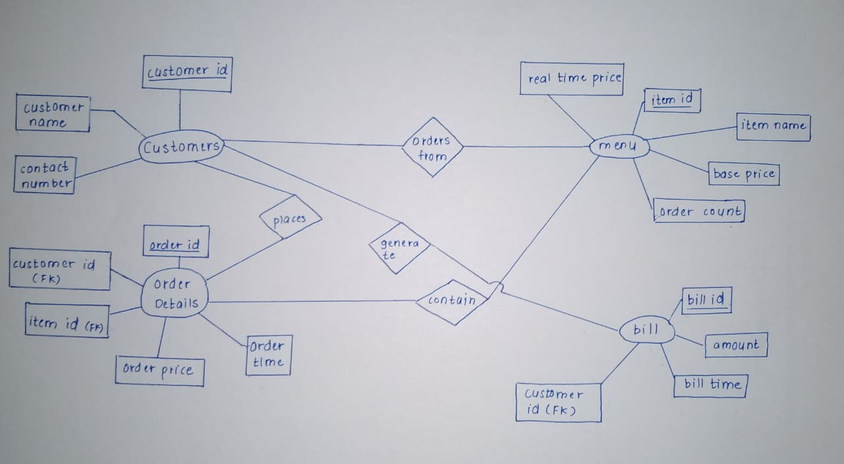

Table | Fields | Description
Menu_Item | item_id (PK), name, category, price, popularity, availability | Stores menu items
Order | order_id (PK), order_date, total_amount, status | Records each customer order
Order_Item | order_item_id (PK), order_id (FK), item_id (FK), quantity, item_total | Junction table for order and menu
Bill | bill_id (PK), order_id (FK), total_amount, payment_method, payment_status | Maintains billing details

Normalization Steps
1NF: All attributes contain atomic values (no repeating groups).
2NF: All non-key attributes depend entirely on the primary key in each table.
3NF:No transitive dependencies (non-key attributes don’t depend on other non-key attributes).
All tables in MetaMenu are normalized up to 3NF.

Implementation

Technologies Used
Frontend: HTML, CSS, JavaScript
Backend: Node.js with Express
Database: MySQL
Tools: VS Code, MySQL Workbench

Key Functionalities
- Add/Edit/Delete menu items
- Real-time updates reflected on the frontend
- Automatic trigger-based price and billing calculations
- Secure and structured data storage

Sample SQL Table Creation
CREATE TABLE menu_items (
item_id INT PRIMARY KEY AUTO_INCREMENT,
name VARCHAR(100),
category VARCHAR(50),
price DECIMAL(10,2),
popularity INT DEFAULT 0
);

Example Trigger
CREATE TRIGGER update_price_on_popularity
AFTER UPDATE ON menu_items
FOR EACH ROW
BEGIN
IF NEW.popularity > 100 THEN
UPDATE menu_items SET price = price * 1.1 WHERE item_id = NEW.item_id;
END IF;
END;

Sample Node.js Route
app.post('/add-item', (req, res) => {
const { name, category, price } = req.body;
db.query('INSERT INTO menu_items (name, category, price) VALUES (?, ?, ?)',
[name, category, price], (err) => {
if (err) throw err;
res.redirect('/menu');
});
});

Testing

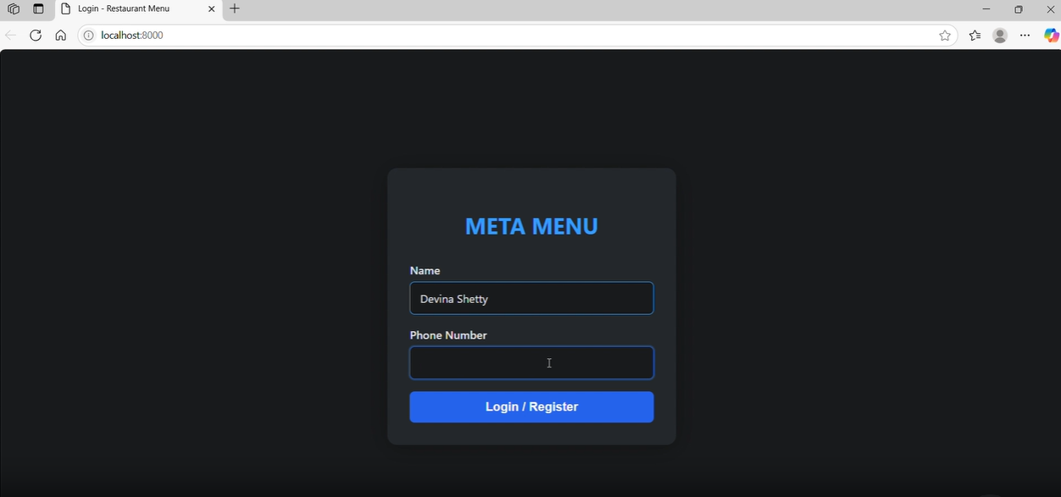

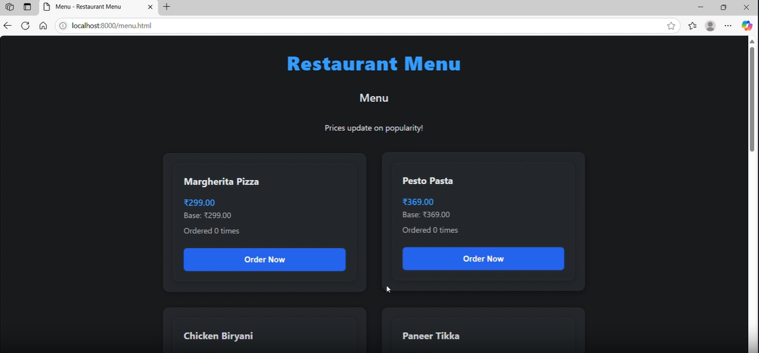

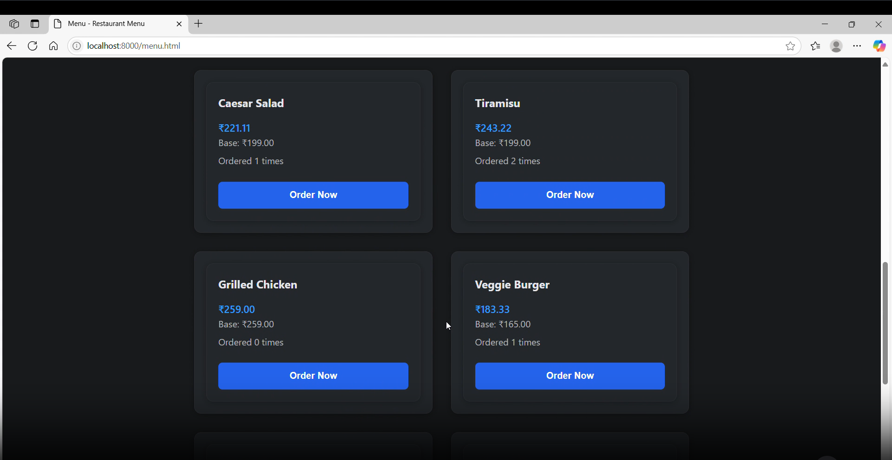
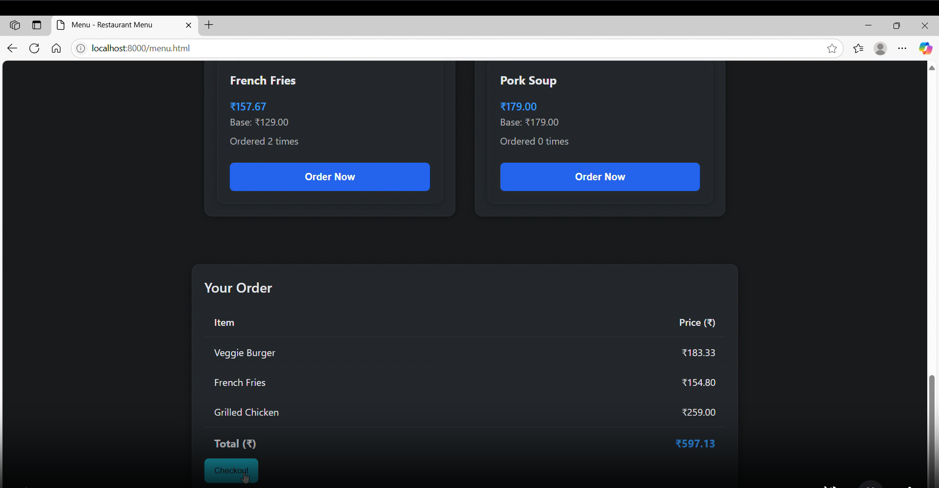

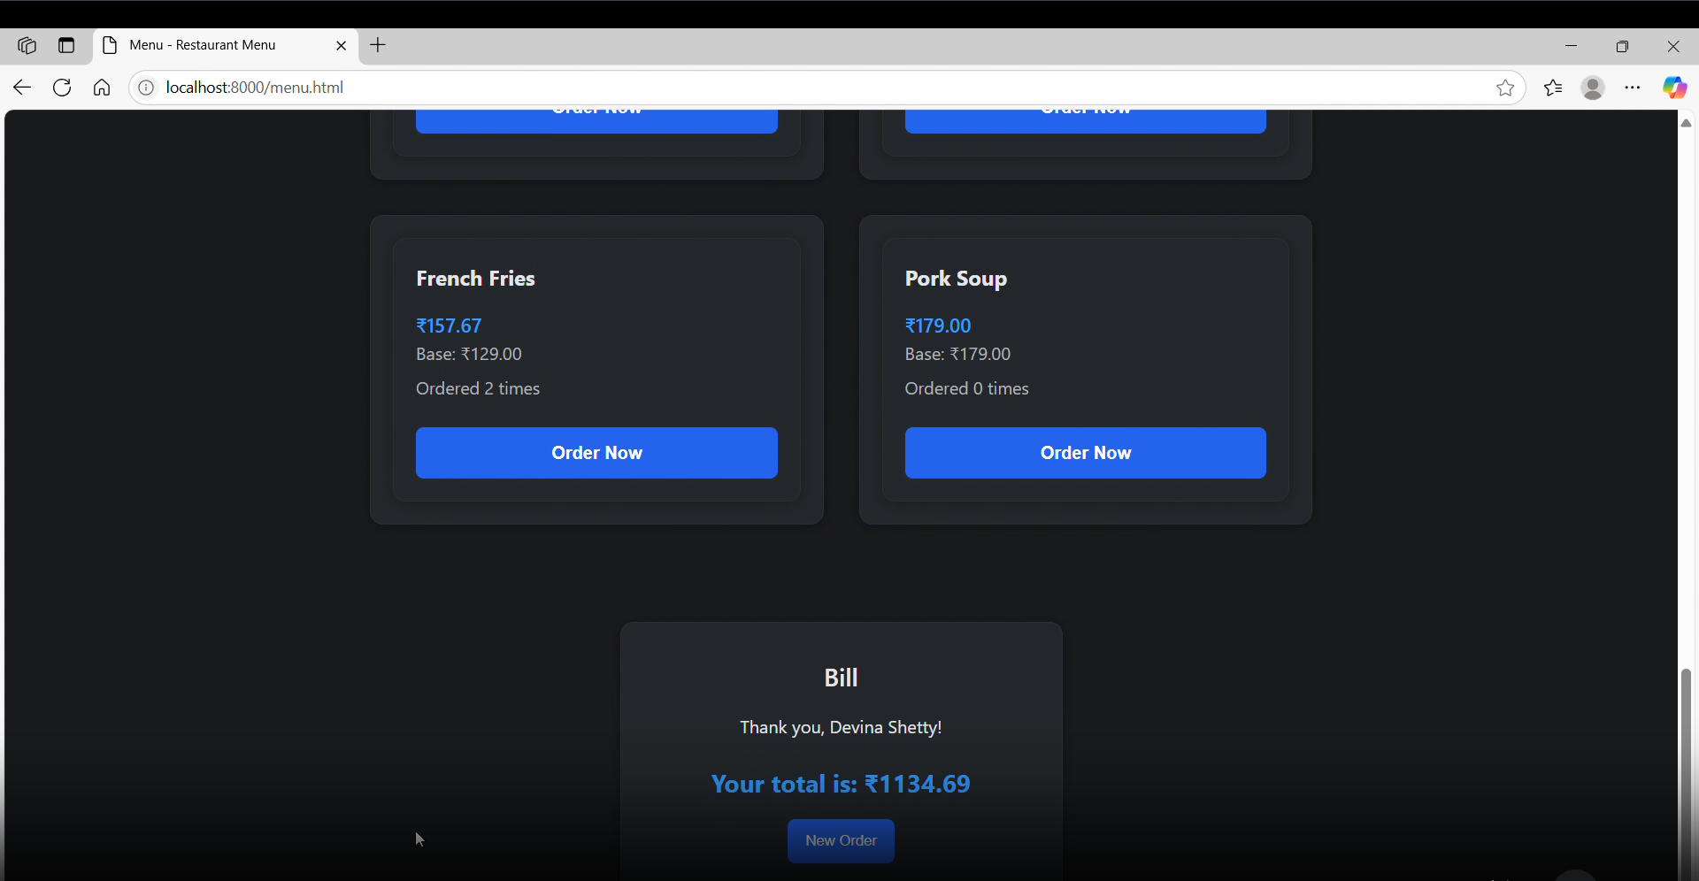

Results
- Successfully developed a dynamic menu system.
- Real-time updates reflected immediately on the frontend.
- Automated billing and price management through triggers.
- Improved efficiency and reduced manual menu maintenance.

Conclusion
Meta Menu successfully demonstrates the integration of web development and DBMS concepts. It provides an automated, user-friendly solution for menu and billing management. The project showcases how Node.js and MySQL can be used together to build scalable, data-driven applications.

Future Enhancements
- Admin dashboard for analytics and staff management.
- Online ordering and payment integration.
- Mobile app for customers and restaurant staff.

