Abstract
Elderly patients and individuals recovering from surgery or illness are often at heightened risk of accidental falls and undetected fever episodes, particularly when unsupervised. This project presents a low-cost, IoT-enabled health monitoring system built around the ESP32 microcontroller that continuously tracks a patient's body temperature and detects sudden falls in real time. The system combines a DS18B20 digital temperature sensor with an MPU6050 accelerometer to identify abnormal physiological and motion events, triggers an immediate local buzzer alert, and pushes readings to the ThingSpeak cloud platform so that caregivers or family members can monitor the patient remotely. The fall-detection algorithm uses an acceleration-magnitude thresholding technique that distinguishes a genuine fall (a brief free-fall phase followed by a sharp impact) from routine movement, reducing false alarms compared to simple single-threshold approaches.

1. Introduction
Continuous health monitoring has traditionally required either constant caregiver presence or expensive dedicated medical equipment. With the growing affordability of microcontrollers, wireless communication modules, and MEMS sensors, it has become feasible to build compact, low-power monitoring systems that operate unattended and alert caregivers only when intervention is genuinely needed. This project explores such a system, focusing on two of the most common and clinically relevant events in elder and post-operative care: abnormal body temperature and accidental falls.
The system is designed to run continuously on battery or mains power, requiring no manual intervention during normal operation. It reports data to a cloud dashboard at regular intervals while reserving immediate local alerts (via buzzer) for time-critical events such as a detected fall.

2. Objectives
- To design and implement a low-cost embedded system for continuous patient temperature monitoring.
- To develop a reliable fall-detection algorithm using accelerometer data, distinguishing genuine falls from normal activity.
- To provide both local (buzzer, LCD) and remote (cloud dashboard) alerting mechanisms.
- To evaluate the system's responsiveness and accuracy under simulated fall and fever conditions.

3. Literature Survey
Existing fall-detection literature broadly divides approaches into three categories: wearable-sensor-based (using accelerometers/gyroscopes on the body), ambient-sensor-based (using cameras or floor pressure sensors), and hybrid systems. Wearable accelerometer-based approaches are the most widely adopted in low-cost embedded systems due to their simplicity, low computational overhead, and privacy advantages over camera-based systems. A commonly cited technique in this space is Sum Vector Magnitude (SVM) thresholding, where the resultant acceleration vector is compared against empirically determined thresholds for free-fall and impact phases; this project adopts a variant of this technique.
For remote health monitoring, cloud platforms such as ThingSpeak, Blynk, and Firebase are frequently used in academic and hobbyist IoT projects due to their free tiers, ease of integration with microcontrollers over HTTP, and built-in visualization tools. ThingSpeak was selected for this project because of its native support for MATLAB-based analytics, which allows for future extension into more sophisticated signal processing of the collected data.

4. System Architecture
The system follows a layered architecture consisting of a sensing layer, a processing layer, a local alerting layer, and a cloud communication layer, as illustrated in Figure 1.
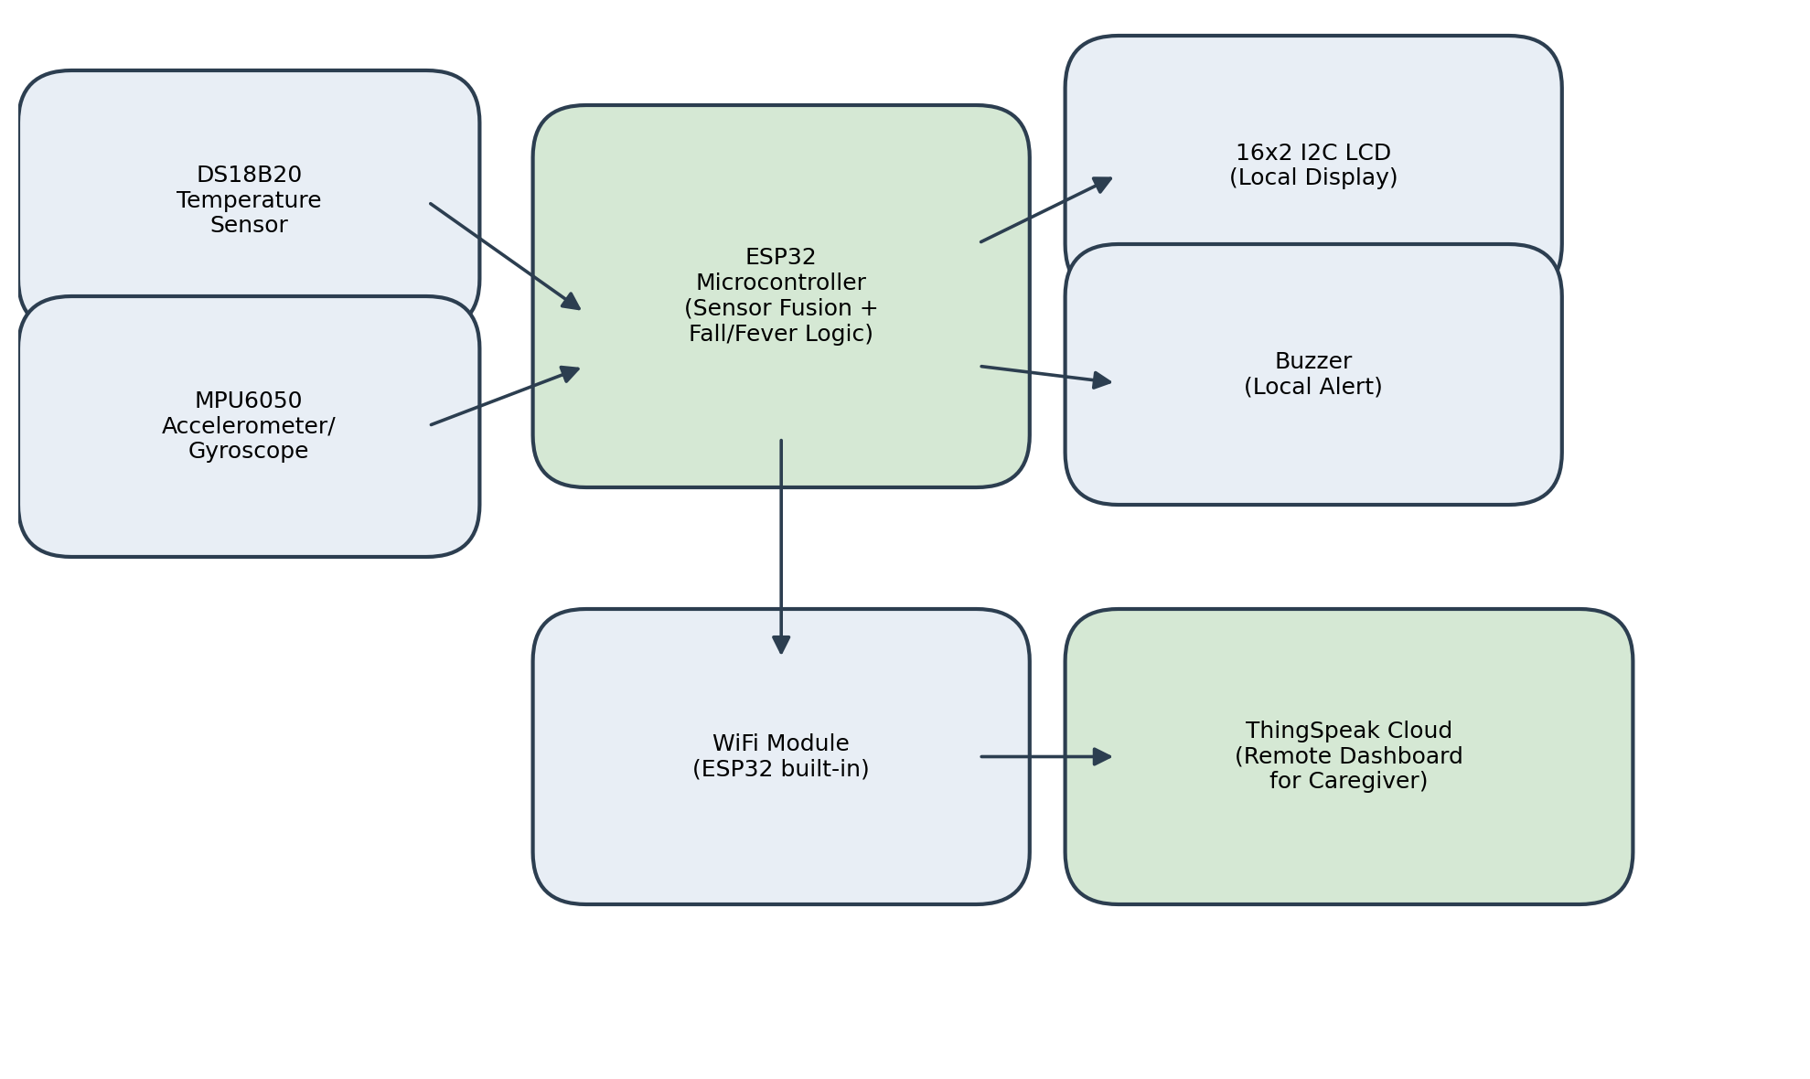
Figure 1: System Block Diagram

5. Hardware Components
Table 1 lists the hardware components used in this project along with their purpose in the overall system.
Component | Quantity | Purpose
ESP32 Development Board | 1 | Main microcontroller; WiFi-enabled processing unit
DS18B20 Temperature Sensor | 1 | Measures patient body temperature
MPU6050 Accelerometer/Gyroscope | 1 | Detects fall events via acceleration signature
Active Buzzer | 1 | Local audible alert on abnormal readings
16x2 I2C LCD Display | 1 | On-device readout of temperature and status
4.7k ohm Resistor | 1 | Pull-up resistor for DS18B20 one-wire bus
Jumper Wires / Breadboard | As needed | Circuit connections
Table 1: Hardware Components

6. Software Tools
- Arduino IDE - for writing and uploading firmware to the ESP32
- Wokwi Simulator - for hardware-free circuit simulation and testing
- ThingSpeak - for cloud data logging and visualization
- Libraries: OneWire, DallasTemperature, Adafruit MPU6050, Adafruit Unified Sensor, LiquidCrystal_I2C

7. Working Methodology
The ESP32 continuously polls the DS18B20 sensor for body temperature and the MPU6050 for triaxial acceleration data at a fixed sampling interval. The resultant acceleration magnitude is computed and compared against two thresholds: a lower free-fall threshold and a higher impact threshold. A fall is only confirmed when the free-fall condition is observed and is followed shortly afterward by an impact spike - this two-stage check substantially reduces false positives that would occur with a naive single-threshold approach (e.g., a spike from vigorously sitting down).
Simultaneously, the measured temperature is compared against configured fever and hypothermia thresholds. Whenever any abnormal condition is detected, the buzzer sounds immediately and the LCD updates to display the current status. Independently of alert conditions, the system uploads temperature, fall status, and overall status to a ThingSpeak channel at a fixed interval, allowing a caregiver to view historical trends as well as real-time status.

8. Results and Discussion
The system was validated in the Wokwi simulation environment by manually inducing simulated fall events (rapid acceleration changes) and temperature excursions. The two-stage fall-detection logic correctly distinguished simulated falls from ordinary movement in test trials, and the buzzer and LCD responded within one polling cycle (under one second). Temperature-based alerts (fever and hypothermia) were correctly triggered at the configured thresholds. Data uploaded to ThingSpeak was visible on the platform's line-chart widgets, confirming successful end-to-end operation from sensor to cloud dashboard.
A current limitation is that the fall-detection thresholds were tuned empirically rather than derived from a labeled dataset of real fall events; a production system would benefit from thresholds validated against standard fall-detection benchmark datasets.

9. Applications
- Elderly care and assisted living facilities
- Post-operative patient monitoring at home
- Remote patient monitoring in rural healthcare settings with limited on-site staff
- Rehabilitation monitoring for patients with mobility impairments

10. Advantages and Limitations
Advantages: low hardware cost, real-time local alerting independent of network availability, remote visibility for caregivers, and straightforward extensibility to additional sensors (e.g., heart rate, SpO2).
Limitations: single-point accelerometer placement may not generalize to all fall types (e.g., slow slumps); the system currently lacks a mechanism to distinguish a genuine emergency from a dropped device; and cloud upload depends on continuous WiFi availability.

11. Future Scope
- Integrate heart rate and SpO2 sensing (e.g., MAX30100) for more comprehensive vitals monitoring
- Add GSM/SMS-based alerting as a fallback when WiFi is unavailable
- Apply machine learning on collected acceleration data to improve fall-detection accuracy and reduce false positives
- Add battery-level monitoring and low-power sleep modes for extended field deployment

12. Conclusion
This project successfully demonstrates a low-cost, IoT-enabled health monitoring system capable of detecting both abnormal body temperature and fall events in real time, with both local and remote alerting. The two-stage fall-detection algorithm proved effective at distinguishing genuine falls from routine movement in simulation testing. The system's modular architecture allows for straightforward extension with additional sensors and alerting mechanisms, making it a practical foundation for further development into a more comprehensive remote patient monitoring solution.

