STATEFUL and STATELESS widgets in Flutter

Stateless Widgets
Stateless widgets are immutable, meaning their properties can't change once they're built. They are typically used for widgets that don't require any mutable state (i.e., they don't change over time or in response to user interactions). Examples of stateless widgets include Text, Icon, and Container.

Key Points:
- Immutable
- Used for static content
- Lightweight and simple to use

Structure:
- Stateless widget class that extends StatelessWidget.
- build() method that returns the widget's UI based on the input properties.
class MyWidget extends StatelessWidget {
const MyWidget({super.key});

@override
Widget build(BuildContext context) {
return /* ... Widget tree */;
}
}

Example:
import 'package:flutter/material.dart';

void main() => runApp(const MaterialApp(home: MyStatelessWidget()));

class MyStatelessWidget extends StatelessWidget {
const MyStatelessWidget({super.key});

@override
Widget build(BuildContext context) {
return Scaffold(
appBar: AppBar(title: const Text('Stateless Widget')),
body: const Center(
child: Text('Hello, I am a stateless widget!'),
),
);
}
}

Output:
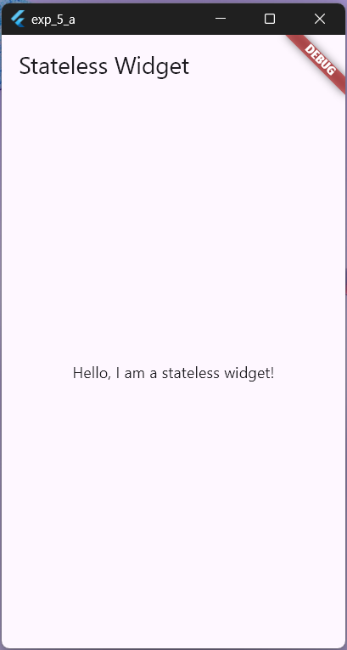

Stateful Widgets
Stateful widgets are dynamic and can change their state during their lifetime. They are used when the widget needs to update based on user interactions or other factors. Examples of stateful widgets include Checkbox, Radio, Slider, and TextField.
Stateful widgets consist of two classes:
- A StatefulWidget class that is immutable and can be used to create an instance of the widget.
- A State class that contains the mutable state for that widget.

Key Points:
- Mutable state
- Used for dynamic content
- More complex than stateless widgets

Structure:
- StatefulWidget class that extends StatefulWidget.
- State class that extends State and manages the widget's mutable state.
- createState() method that creates an instance of the State class.
- build() method in the State class that returns the widget's UI based on the current state.
class MyWidget extends StatefulWidget {
const MyWidget({super.key});

@override
State<MyWidget> createState() => _MyWidgetState();
}

class _MyWidgetState extends State<MyWidget> {
@override
Widget build(BuildContext context) {
return /* ... Widget tree and stateManagament if needed */;
}
}

Stateful vs Stateless Widgets:
Feature | Stateful Widget | Stateless Widget
Mutability | Mutable | Immutable
State Management | Manages its own state | Does not manage any state
Lifecycle Methods | Complex lifecycle methods (initState(), dispose(), setState()) | Simple lifecycle (build())
Reactivity | Can react to changes and update UI dynamically | Cannot react to changes, static UI
Performance | Slightly heavier due to state management | Lighter, more efficient
Use Cases | Dynamic content that changes over time | Static content that does not change
Examples | Forms, animations, interactive elements | Text, icons, containers
Rebuild Frequency | Rebuilt when setState() is called | Rebuilt only when parameters or parent changes
Initialization | Uses createState() to create state object | Directly creates widget through build() method
Complexity | More complex due to state handling | Simpler and easier to use

