4(a) Set up navigation between different screens using Navigator
"In Flutter, moving from one screen to another is called Navigation. Flutter uses a class called Navigator to manage screens."
Navigator is responsible for:
- Opening a new screen
- Going back to the previous screen
- Managing multiple screens like a stack of books.
Top of Stack

---------------
| Screen 3 |
---------------

---------------
| Screen 2 |
---------------

---------------
| Home Screen |
---------------

Bottom

- Every new screen is pushed onto the stack.
- When we press Back, the current screen is popped from the stack.

Navigation Methods

Push
Moves to another screen.
Navigator.push(
context,
MaterialPageRoute(
builder: (context) => SecondScreen(),
),
);
- Navigator.push → Open another screen.
- context → Current application context.
- MaterialPageRoute → Creates the page transition.
- builder → Builds the next screen.
- SecondScreen() → Destination screen.

Pop
Returns to previous screen.
Navigator.pop(context);
When user presses Back,
Second Screen
↓
Home Screen

4(b)Implement navigation with named routes
"Suppose your college has many classrooms."
Instead of saying
"Go to the room beside the library"
it's easier to say
"Go to Room C307."
Similarly,
instead of writing the complete path every time,
Flutter allows us to give every screen a name.
This is called Named Routes.

Without Named Routes
Navigator.push(
context,
MaterialPageRoute(
builder: (context)=>SecondScreen(),
),
);
Flutter creates the page manually.

With Named Routes
First register routes.
MaterialApp(

routes: {

'/': (context) => HomeScreen(),

'/second': (context) => SecondScreen(),

},

);
Explain:
'/' → Home Screen

'/second' → Second Screen
Flutter remembers these names.

Navigate
Navigator.pushNamed(context, '/second');
Instead of creating the page,
Flutter simply looks for
'/second'
and opens it.

Return
Navigator.pop(context);

Difference Between Navigator.push() and Navigator.pushNamed()
Navigator.push() | Navigator.pushNamed()
Opens screen directly | Opens screen using its route name
Suitable for small apps | Suitable for medium and large apps
Creates MaterialPageRoute every time | Route is defined only once
More code | Less code
Harder to manage many screens | Easier to maintain many screens

Flutter Program: Screen Navigation Without & With Named Routes
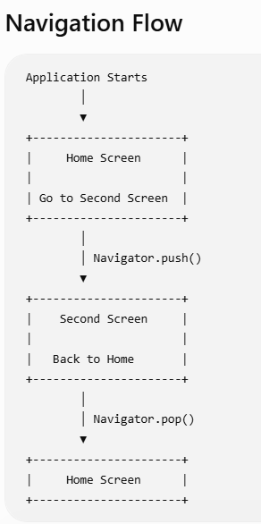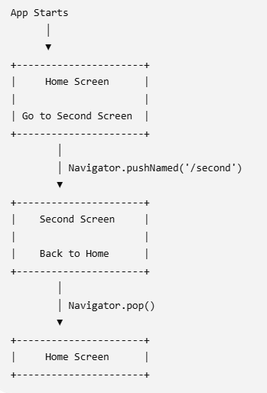
WITHOUT NAMED ROUTES WITH NAMED ROUTES

Program to develop a Flutter application that meets the following requirements:
- Create two screens: HomeScreen and SecondScreen.
- Place a button on the Home Screen labeled "Go to Second Screen".
- Use Navigator.push() to open the Second Screen.
- On the Second Screen, place a button labeled "Back".
- Use Navigator.pop() to return to the Home Screen.
- Register named routes ('/' and '/second') in MaterialApp.
- Replace Navigator.push() with Navigator.pushNamed() and verify that navigation still works.

