AIM:5B- Implement state management using set State and Provider.
Think of Provider as a delivery system for your data. It helps you share data/state across your app without passing it manually through every widget.
State Management
Without Provider:
Parent Widget → passes data → Child → passes data → Grandchild... gets messy = "prop drilling"
With Provider:
Provider holds the data at the top → any widget below can access it directly
Classes Used in provider
ChangeNotifierProvider : Creates your CounterModel and puts it "above" the app. Now the whole app can see it.
ChangeNotifier in counter_model.dartThis is your data class. When you call notifyListeners(), it shouts "Hey I changed!"
Consumer<CounterModel>"I'm listening". Rebuilds only this part when CounterModel changes. More efficient than rebuilding whole page.
Provider.of<CounterModel>(context, listen: false)"Just give me the model, I don't need to rebuild". Used in buttons to call increment().
import 'package:flutter/foundation.dart';
foundation.dart :gives you access to ChangeNotifier and Listenable classes.
These are the core classes that provider package uses to manage state.Without this import, extends ChangeNotifier won't work.
SYNTAX:
import 'package:flutter/foundation.dart';
class CounterModel extends ChangeNotifier {
int _counter = 0;
// Getter to access the counter value
int get counter => _counter;
// Method to increment counter
void increment() {
_counter++;
notifyListeners(); // Tells all Consumer widgets to rebuild
}
// Method to decrement counter
void decrement() {
if (_counter > 0) {
_counter--;
notifyListeners();
}
}
// Method to reset counter
void reset() {
_counter = 0;
notifyListeners();
}
}
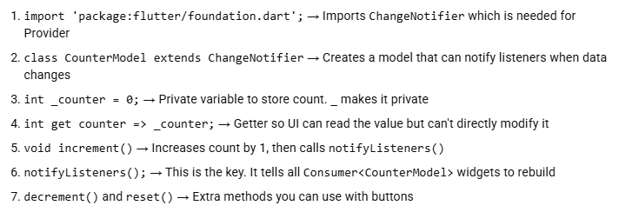
How it connects to main dart:
Your ChangeNotifierProvider(create: (context) => CounterModel()) creates this class once.
Then Consumer<CounterModel> listens to it, and Provider.of<CounterModel>(context, listen: false).increment() calls these methods.

AIM:5B- Implement state management using set State and Provider.
// Import necessary packages
import 'package:flutter/material.dart';
import 'package:provider/provider.dart';
import 'counter_model.dart';
// Main function
void main() {
runApp(
// Wrap the app with ChangeNotifierProvider to provide the CounterModel
ChangeNotifierProvider(
create: (context) => CounterModel(),
child: const MyApp(),
),
);
}
// MyApp widget
class MyApp extends StatelessWidget {
const MyApp({super.key});
@override
Widget build(BuildContext context) {
return const MaterialApp(
home: CounterPage(),
);
}
}
// CounterPage widget
class CounterPage extends StatelessWidget {
const CounterPage({super.key});
@override
Widget build(BuildContext context) {
return Scaffold(
appBar: AppBar(
title: const Text('Counter App'),
),
body: Center(
child: Consumer<CounterModel>(
builder: (context, counterModel, child) {
return Column(
mainAxisAlignment: MainAxisAlignment.center,
children: [
const Text('You have pushed the button this many times:'),
Text(
'${counterModel.counter}',
style: Theme.of(context).textTheme.displayLarge,
),
],
);
},
),
),
floatingActionButton: FloatingActionButton(
onPressed: () {
// Call the increment method of CounterModel using Provider
Provider.of<CounterModel>(context, listen: false).increment();
},
tooltip: 'Increment',
child: const Icon(Icons.add),
),
);
}
}
