1.HALF ADDER simulation:
module half_adder(a,b,sum,carry);
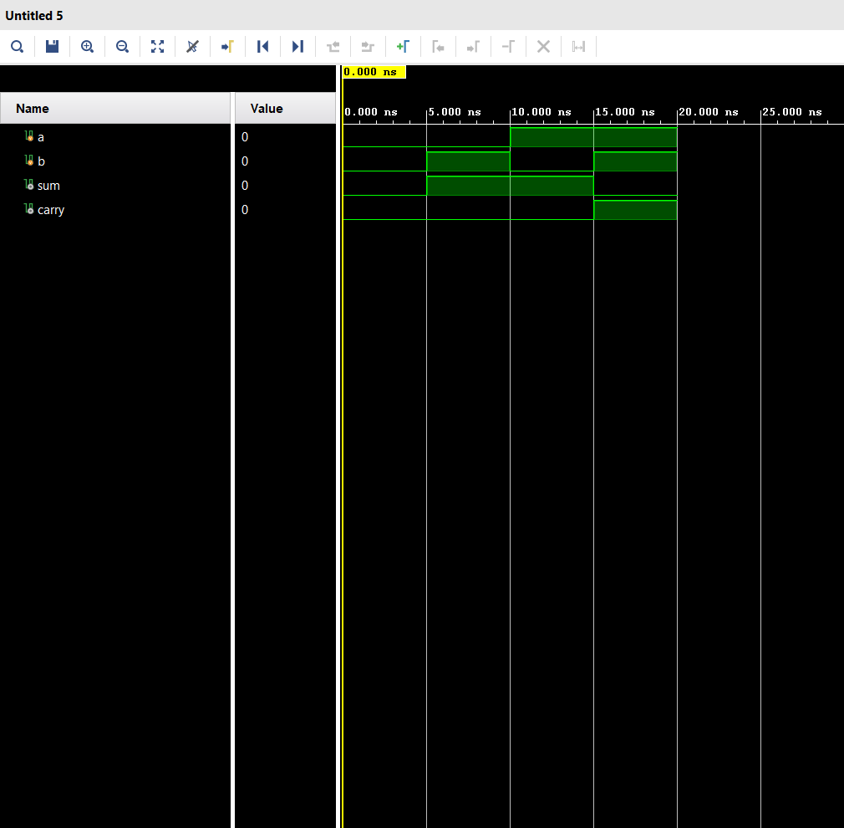
input a,b;
output sum,carry;
xor(sum,a,b);
and(carry,a,b);
endmodule
TESTBENCH:
module half_adder_tb();
reg a,b;
wire sum,carry;
half_adder dut(a,b,sum,carry);
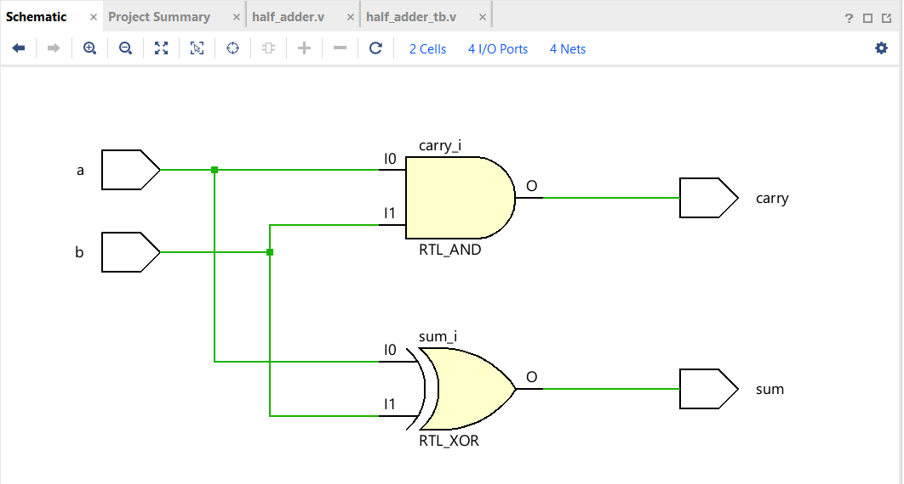
initial begin
a=1'b0;b=1'b0;
#5 a=1'b0;b=1'b1;
#5 a=1'b1;b=1'b0;
#5 a=1'b1;b=1'b1;
#5 $finish;
end
endmodule

DATE: 25-06-2026
2.FULL ADDER using HALF ADDER simulation:
module full_adder(a,b,cin,sum,carry);
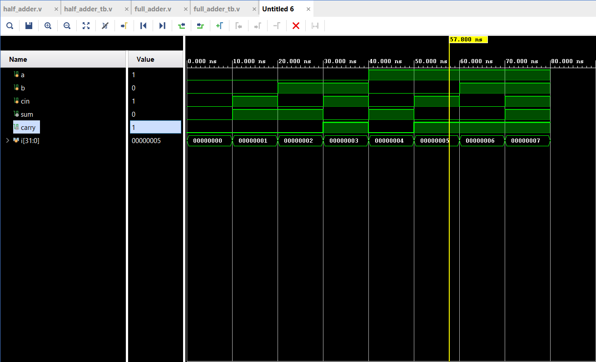
input a,b,cin;
output sum,carry;
wire sum1,carry1,carry2;
half_adder ha1(a,b,sum1,carry1);
half_adder ha2(sum1,cin,sum,carry2);
or(carry,carry1,carry2);
endmodule
TESTBENCH:
module full_adder_tb();
reg a,b,cin;
wire sum,carry;
full_adder dut(a,b,cin,sum,carry);
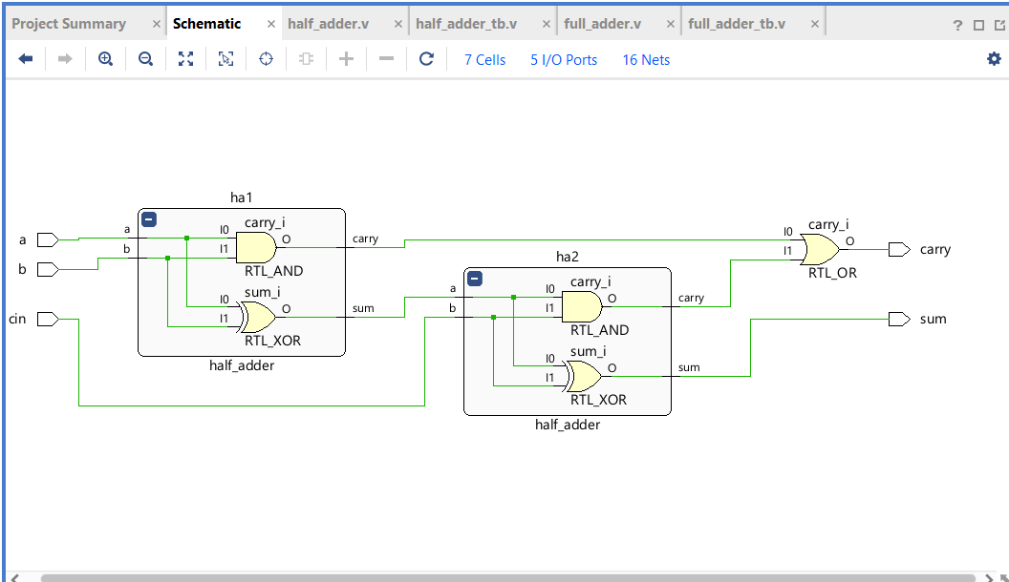
integer i;
initial begin
for(i=0;i<8;i=i+1)begin
{a,b,cin}=i;
#10;
end
$finish;
end
endmodule

DATE: 25-06-2026
3. 4 Bit Adder using 4 full adders simulation
module adder_4bit(a,b,sum,carry);
input [3:0]a,b;
output [3:0]sum;
output carry;
wire c1,c2,c3;
full_adder fa1(a[0],b[0],1'b0,sum[0],c1);
full_adder fa2(a[1],b[1],c1,sum[1],c2);
full_adder fa3(a[2],b[2],c2,sum[2],c3);
full_adder fa4(a[3],b[3],c3,sum[3],carry);
endmodule
TESTBENCH:
module adder_4bit_tb();
reg [3:0]a,b;
wire [3:0]sum;
wire carry;
adder_4bit dut(a,b,sum,carry);
initial begin
a=4'd1;b=4'd2;
#10 a=4'd5;b=4'd5;
#10 a=4'd10;b=4'd5;
#10 a=4'd0;b=4'd15;
#10 a=4'd15;b=4'd15;
#10 a=4'd5;b=4'd9;
#10 a=4'd6;b=4'd9;
#10 a=4'd1;b=4'd2;
#10 a=4'd3;b=4'd7;
#10 $finish;
end
initial begin
$monitor("Sum of a=%d & b=%d is %d & the carry = %d",a,b,sum,carry);
end
endmodule
