
DATAMITES — in association with Rubiex Internship Program
ARTIFICIAL INTELLIGENCE CAPSTONE PROJECT
PRAICP-1002 : TrafSignDetc — Traffic Sign Recognition (Short Report)
Team Code | Project Code | Submitted By | Dataset | Report Date
PTID-AIE-JUL-26-11142 | PRAICP-1002 | Sameeksha | DataMites TrafSignDetc | October 2026
1. Problem Statement & Objective
Missing or misreading a traffic sign (stop, speed limit, warning) is a common cause of road accidents, and driver-assistance and self-driving systems must recognise signs automatically from camera images. This project builds a Convolutional Neural Network (CNN) that looks at a photo of a traffic sign and predicts which of 43 sign classes it is. It covers the two goals of the DataMites brief: (1) image preprocessing and (2) an ML model to predict the sign, built as: explore data → preprocess and split → augment → baseline CNN → tune with Keras Tuner → evaluate → predict on a new image → save the model.
2. Dataset & Exploratory Analysis
The ZIP holds one folder per sign (folder name = label). It is too large to load fully, so it was indexed without extracting, and at most 400 random images per class were used (seed 42).
Property | Full dataset | Working subset used
Images | 39,209 | 15,460
Classes | 43 (folders 0–42) | 43
Smallest / largest class | 0 (210) / 2 (2,250) | 0 (210) / 400 (cap)
Imbalance ratio | 10.71 : 1 | 1.90 : 1
Corrupt images / colour mode | — | 0 / RGB (.png)
Original sizes | 2,066 different sizes, 25×25 to 224×219 px (median ≈ 44×43)
Table 1: Dataset summary.
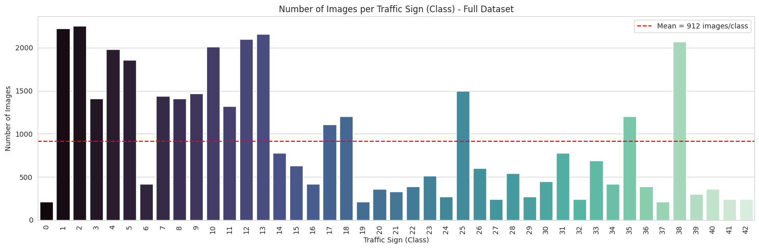
Figure 1: Images per class in the full dataset (strongly imbalanced).
Key findings: classes are unequal; images are small and vary in brightness, blur, angle and size; and some signs look alike (for example speed limits differ only by the number). These findings justify resizing, class weights and augmentation.
3. Preprocessing, Split & Augmentation
1. Resize every image to RGB 64×64; store as compact uint8 (190 MB instead of 760 MB).
2. Normalise by 1/255 using a Rescaling layer inside the model, so training and new images are treated identically (one shared preprocess_image function).
3. Stratified split 70 / 15 / 15: 10,822 train, 2,319 validation, 2,319 test. The test set is used only once, at the end.
4. Class weights (balanced, from training labels): 1.71 for the smallest classes (0, 19, 37) down to 0.90 for classes at the 400-image cap.
5. Augmentation (training only, built into the model): rotation ±11°, shift 10%, zoom 10%, contrast 20%. No horizontal flip, because mirror-image signs (turn left / turn right, keep left / keep right) would change class.
4. Models & Hyperparameter Tuning
A baseline CNN was built first: Rescaling → three Conv2D layers (32, 64, 128 filters, 3×3, each followed by 2×2 max-pooling) → Flatten → Dense(128) → Dropout(0.5) → Dense(43, softmax). It has 688,747 parameters and uses the Adam optimiser, sparse categorical cross-entropy, batch size 32, up to 30 epochs, EarlyStopping and ReduceLROnPlateau.
Keras Tuner RandomSearch tried 8 of the 96 possible combinations (filters in layers 1 and 2, dense units, dropout, learning rate, batch size), ranked by validation accuracy only, taking about 2 h 26 min on CPU. A learning rate of 0.001 clearly beat 0.0001.
Rank | Batch | Filters 1 | Filters 2 | Dense | Dropout | LR | Val. Acc.
1 (best) | 16 | 32 | 128 | 128 | 0.4 | 0.001 | 0.9918
2 | 32 | 32 | 64 | 256 | 0.3 | 0.001 | 0.9897
3 | 16 | 32 | 128 | 256 | 0.5 | 0.001 | 0.9871
8 (worst) | 32 | 32 | 64 | 128 | 0.5 | 0.0001 | 0.9064
Table 2: Selected tuning trials (top 3 and worst of 8).
The final CNN was rebuilt with the best settings (conv filters 32/128/128, dense 128, dropout 0.4, learning rate 0.001, batch 16) and trained up to 40 epochs. It has 780,971 parameters. Its validation accuracy rose from 49% (epoch 1) to above 99% with no sign of overfitting.
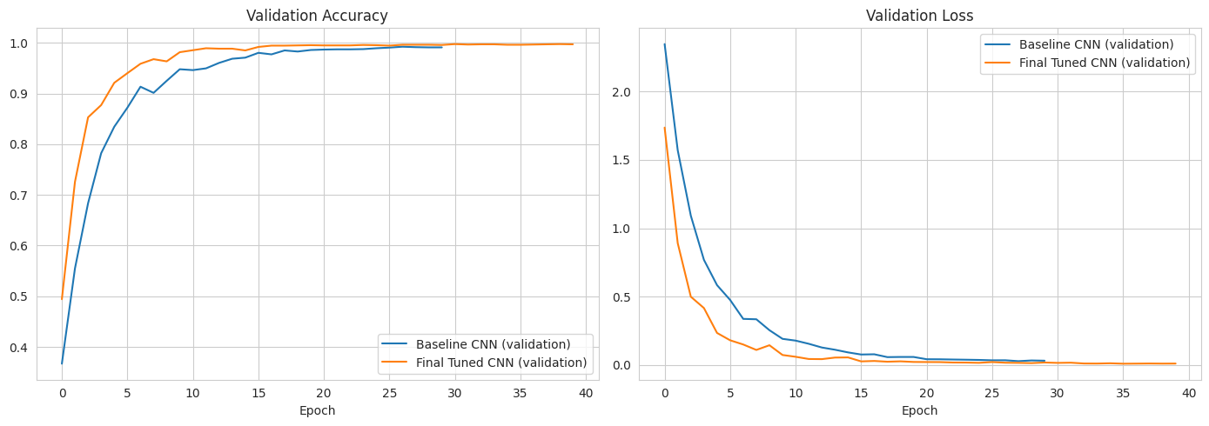
Figure 2: Validation accuracy and loss of the baseline and final models.
5. Results
Model / Split | Accuracy | Precision (macro) | Recall (macro) | F1 (macro)
Baseline CNN — Validation | 0.9914 | 0.9920 | 0.9918 | 0.9918
Baseline CNN — Test | 0.9935 | 0.9941 | 0.9939 | 0.9940
Final Tuned CNN — Validation | 0.9961 | 0.9964 | 0.9960 | 0.9961
Final Tuned CNN — Test | 0.9953 | 0.9957 | 0.9957 | 0.9957
Table 3: Baseline vs final tuned CNN (best model chosen on validation accuracy).
1. Final model: 99.53% test accuracy; 2,308 of 2,319 test images correct; only 11 errors. Tuning gave a small but consistent gain over the baseline (test 99.35% → 99.53%, about four more images).
2. Weakest signs (F1 0.97–0.98): Speed limit 80 and 100 km/h, Dangerous curve right, Children crossing, Right-of-way. Errors are mostly speed-limit mix-ups (for example 50→60, 80→100) and look-alike red warning triangles, as predicted in the domain analysis.
3. New-image prediction: the predict_sign() function returns the sign, confidence and top-3 probabilities. Four random test images were all correct (99.9–100% confidence).
4. Saved model: TrafficSign_CNN_Model.keras (9.4 MB) plus a class-names JSON; the reloaded model gave identical predictions.
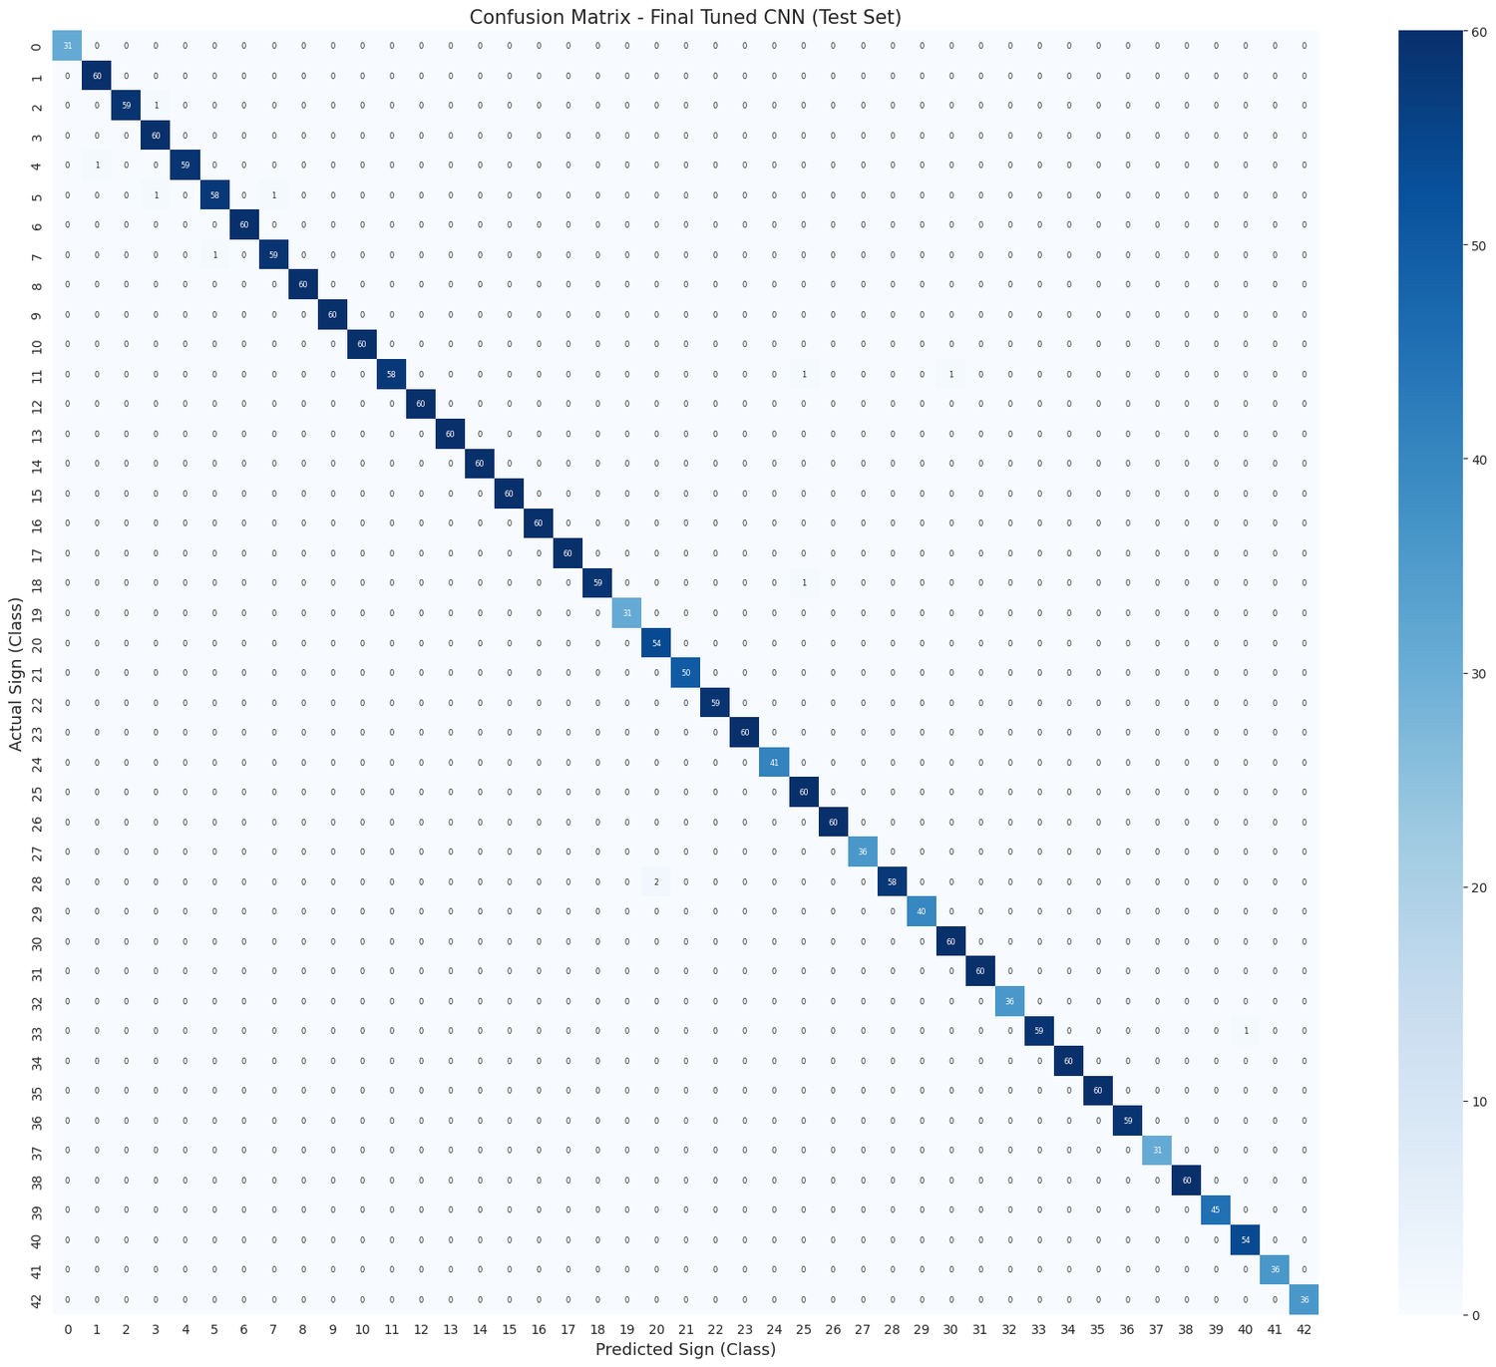
Figure 3: Confusion matrix on the test set (almost perfectly diagonal).
6. Insights, Limitations & Future Scope
Business value: a sign classifier is a building block for driver-assistance alerts and autonomous vehicles; shared preprocessing lets one model handle photos from different cameras; and the confusion analysis shows where to collect more data (speed limits).
Limitations: (a) the random image-level split may put near-identical frames of the same physical sign in train and test, so 99.53% is probably optimistic; (b) only 15,460 of 39,209 images and 64×64 resolution were used; (c) it classifies cropped signs, not signs inside full road scenes; (d) classes follow the German (GTSRB) numbering, so it should not be assumed to work on Indian signs; (e) it is not field-tested and not safety-validated.
Future scope: group-aware split and external validation; use the full dataset on a GPU; higher resolution; transfer learning (MobileNetV2/EfficientNet); a detection stage (YOLO/SSD); real-time camera deployment (TensorFlow Lite); robustness tests for night, rain and glare.
Conclusion: a baseline CNN and a Keras-Tuner-tuned CNN were compared fairly on identical splits; the tuned model reached 99.53% test accuracy (macro F1 0.9957) and is saved for reuse.
Links: GitHub: https://github.com/Sameekshagithub/PRAICP-1002-Traffic-Sign-Detection-Using-Deep-Learning.git | Drive: https://drive.google.com/drive/folders/1pcADNaZ2l3gGNx7uDhTEBlcqMi5VIEOh?usp=drive_link

