
DataMites | Rubixe Internship Project
PRAICP-1004: Rainfall Time Series Forecasting
Project Explanation Summary | Prepared by: Sameeksha
Project Snapshot
Project Code | PRAICP-1004
Dataset | Rainfall Time Series – Changi Climate Station
Period Covered | 462 months (Jan 1982 – Jun 2020)
Models Compared | SARIMA, Linear Regression, Random Forest, Gradient Boosting, XGBoost
Forecast Horizon | 12 months ahead
Best Test-Set Model | Linear Regression (RMSE 82.84)

1. What This Project Is About
PRAICP-1004 is an Artificial Intelligence Capstone Project undertaken during the DataMites / Rubixe Internship Program. It uses 38+ years of historical monthly rainfall data (January 1982 to June 2020) recorded at the Changi Climate Station to build machine learning and time-series forecasting models. The dataset tracks three linked signals each month: the total rainfall, the highest rainfall recorded on any single day that month, and the number of rainy days.
The project has two business goals: (1) forecast the total monthly rainfall for the next 12 months, and (2) forecast the highest single-day rainfall expected within each of those months, since that number matters for flash-flood risk even when the monthly total looks normal.

2. Why It Matters
Rainfall forecasting supports real decisions — reservoir management, flood preparedness, drainage planning, and agricultural scheduling. Because rainfall is strongly seasonal (driven by the monsoon) but also noisy and unpredictable at a fine-grained level, this project deliberately compares a model built specifically for seasonal data against several general-purpose machine-learning models, to see which approach actually forecasts rainfall best.

3. Tools & Techniques Used
- Python, Pandas & NumPy — data merging, cleaning and manipulation.
- Matplotlib & Seaborn — trend, seasonality, distribution and correlation visualizations.
- Statsmodels — SARIMA modelling, seasonal decomposition, and the ADF stationarity test.
- Scikit-learn & XGBoost — Linear Regression, Random Forest, Gradient Boosting, XGBoost, GridSearchCV, TimeSeriesSplit.

4. How the Project Was Carried Out

4.1 Data Understanding & Cleaning
The three rainfall files were merged into a single monthly table of 462 records. Basic checks confirmed there were no missing values, no duplicate rows, and no gaps in the monthly calendar, so the data was clean and ready for analysis without needing any imputation.

4.2 Exploratory Data Analysis (EDA)
The historical trend, seasonal pattern, year-to-year variation, and correlations between the three variables were all visualized and studied. This revealed a clear monsoon pattern — November, December and January are consistently the wettest months, while February is consistently the driest — plus a strong positive relationship between total rainfall, rainy days, and the daily maximum. An Augmented Dickey-Fuller test confirmed the series is statistically stationary, supporting the use of a seasonal statistical model.

4.3 Feature Engineering
For the machine-learning models, each month was turned into a row of features: the calendar month and year, rainfall from 1, 2, 3, 6 and 12 months earlier (lag features), and 3-month and 12-month rolling averages. The most recent 15% of the timeline (68 months) was reserved purely for testing, and the data was always split in chronological order — never shuffled — to avoid letting the model “see the future.”

4.4 Model Building
Five different forecasting approaches were trained and compared on identical test data: a classical seasonal statistical model (SARIMA), and four machine-learning regressors — Linear Regression, Random Forest, Gradient Boosting, and XGBoost. Each was scored using three standard error metrics: MAE, RMSE, and R².

4.5 Tuning & Model Selection
The most promising tree-based model (Random Forest) was further improved using GridSearchCV combined with TimeSeriesSplit cross-validation — a tuning method that respects chronological order. This reduced its error but still did not beat the simpler Linear Regression and SARIMA models, which is a useful and realistic finding: more complex models are not automatically better on noisy climate data.

5. Key Results
Model | MAE | RMSE | R²
Linear Regression (best) | 68.857 | 82.842 | 0.095
SARIMA | 69.557 | 84.519 | 0.058
Gradient Boosting | 69.118 | 85.416 | 0.038
Random Forest (Tuned) | 76.245 | 95.204 | −0.195
XGBoost | 77.162 | 100.440 | −0.330
Random Forest (default) | 82.671 | 103.404 | −0.410

Linear Regression produced the lowest error on unseen test data, with SARIMA a close second. Because SARIMA models seasonality directly and produces principled confidence intervals, it was chosen to generate the final 12-month production forecast, with the tuned Random Forest used as a cross-check.
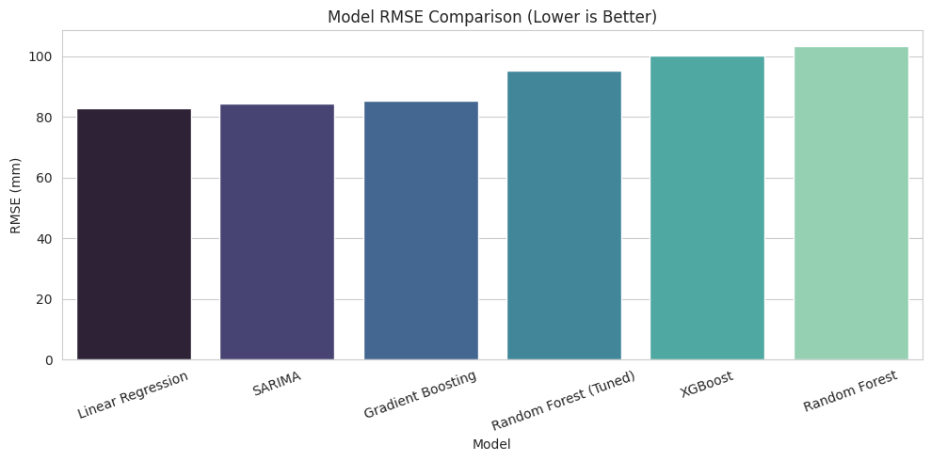
Model RMSE Comparison — Lower is Better

5.1 The Forecast Itself
- The SARIMA model forecasts total rainfall rising toward a peak in December (about 324 mm) and falling to a low around February (about 107 mm) — matching the historical monsoon pattern.
- A second Random Forest model forecasts the highest single-day rainfall for each of the next 12 months, giving planners an early warning signal for extreme rain events independent of the monthly total.
- Both the total-rainfall model and the highest-daily-rainfall model agree on the broad seasonal shape of the year ahead, which adds confidence to the forecast direction even though exact monthly figures vary slightly between the two approaches.

6. What Was Learned
1. Seasonality matters most. Models that explicitly capture the 12-month monsoon cycle (SARIMA) or stay simple enough to avoid overfitting noise (Linear Regression) outperformed the more complex, flexible ensemble models on this dataset.
2. Rainfall is inherently hard to predict precisely. Even the best model's R² was under 0.10, reflecting how noisy monthly rainfall is — the value of these models lies in capturing the seasonal pattern and giving a realistic range (via confidence intervals), not in predicting an exact number.
3. Time-series discipline is essential. Every split, cross-validation fold, and forecast had to respect chronological order; ordinary random splitting or standard k-fold CV would have leaked future information into training and produced misleadingly good results.

7. Business Insights
- Seasonal planning: agencies can anticipate the wettest months (Nov–Jan) and plan drainage, agriculture, and water storage accordingly.
- The 1-year SARIMA outlook supports reservoir management and flood-preparedness budgeting.
- The highest-daily-rainfall forecast flags months with a higher chance of a single intense storm, useful for flash-flood risk assessment.
- Models can be periodically retrained as new monthly readings arrive, keeping the forecast current.
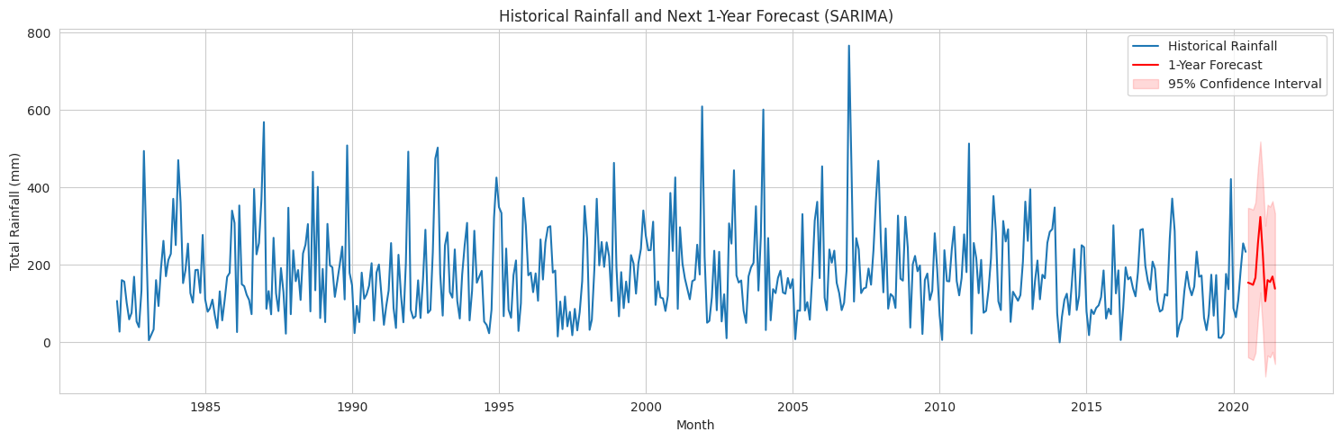
Historical Rainfall and the Next 1-Year SARIMA Forecast

8. Key Challenges
- Monthly-only data meant the “highest daily rainfall” had to be forecast as a monthly summary statistic, not a true daily series.
- Chronological splitting and TimeSeriesSplit cross-validation were required throughout to avoid leaking future information into training.
- Machine-learning regressors predict one step at a time, so a recursive loop was built to generate the full 12-month forecast.
- Rainfall's high natural variability keeps error metrics relatively high compared to a typical regression problem, regardless of model choice.

9. Conclusion
This project successfully delivered both required forecasts — a 12-month total-rainfall outlook and a 12-month highest-daily-rainfall outlook — for the Changi Climate Station, built on a rigorous, leakage-free time-series workflow and benchmarked across five different modelling approaches. The results support practical use cases such as reservoir planning, flood-risk preparedness, and agricultural scheduling, and the same pipeline can be refit as new monthly data becomes available to keep the forecast current.

