
DataMites
Data Science & Artificial Intelligence Training
ARTIFICIAL INTELLIGENCE CAPSTONE PROJECT
PRAICP-1004
Rainfall Time Series Forecasting
DataMites Project / Rubixe Internship Project

Team Code: | PTID-AIE-JUL-26-11142
Project Code: | PRAICP-1004
Project Type: | Artificial Intelligence Capstone Project
Dataset Source: | DataMites Capstone Project Dataset
Dataset Name: | Rainfall Time Series – Changi Climate Station
Submitted To: | DataMites / Rubixe Internship Program
Report Date: | September 2026
ABOUT ME
Name: | Sameeksha
Role: | AI / Data Science Intern
Program: | DataMites Artificial Intelligence Capstone Program
Internship Organization: | Rubixe
Project Undertaken: | PRAICP-1004 – Rainfall Time Series Forecasting
GitHub Repository: | github.com/Sameekshagithub/PRAICP-1004-Rainfall-Time-Series-Forecasting

This report has been prepared as part of the DataMites Artificial Intelligence Capstone Project, undertaken during the Rubixe Internship Program.

TABLE OF CONTENTS
Executive Summary 3
1. Problem Statement & Project Objective 4
2. Import of Python Libraries 5
3. Dataset Description and Domain Analysis 6
4. Basic Checks on the Dataset 7
5. Data Preprocessing 9
6. Exploratory Data Analysis (EDA) – Data Analysis Report (Task 1) 10
7. Data Preparation for Modelling (Task 2) 19
8. Model Building & Training 20
9. Hyperparameter Tuning 22
10. Model Comparison Report 23
11. One-Year Rainfall Forecast (Business Requirement 1) 26
12. Highest Daily Rainfall Forecast (Business Requirement 2) 29
13. Business Insights (Task 3) 31
14. Challenges Faced 32
15. Final Conclusion 33
16. Project Links & References 34
Appendix A – Consolidated Model Performance Metrics 35
Appendix B – Glossary of Terms 36

Executive Summary
This report documents the complete lifecycle of the DataMites Artificial Intelligence Capstone Project PRAICP-1004, titled “Rainfall Time Series Forecasting.” The project was undertaken as part of the Rubixe Internship Program and applies both classical statistical time-series modelling and modern machine-learning regression techniques to historical rainfall data recorded at the Changi Climate Station.
The dataset spans 462 consecutive months, from January 1982 to June 2020, and captures three related climate signals: total monthly rainfall, the highest daily rainfall recorded within each month, and the number of rainy days per month. The primary business requirement was to forecast total monthly rainfall for the next twelve months, while a secondary requirement was to forecast the highest single-day rainfall expected within each of those months.
Five forecasting approaches were developed and benchmarked on a chronologically held-out test period: a classical Seasonal ARIMA (SARIMA) model, and four feature-based machine-learning regressors — Linear Regression, Random Forest, Gradient Boosting, and XGBoost. Model performance was evaluated using Mean Absolute Error (MAE), Root Mean Squared Error (RMSE), and the coefficient of determination (R²). The best-performing machine-learning model was further optimized through hyperparameter tuning using time-series-aware cross-validation.
Based on the comparison, a twelve-month-ahead rainfall forecast was generated together with 95% confidence intervals, and a parallel Random Forest model was used to forecast the highest daily rainfall expected in each of the coming twelve months. The results, methodology, visual analysis, challenges encountered, and business recommendations are presented in the sections that follow.

Key Deliverables
- A complete exploratory data analysis (EDA) of 38+ years of monthly rainfall records.
- Five trained and benchmarked forecasting models (SARIMA, Linear Regression, Random Forest, Gradient Boosting, XGBoost).
- A hyperparameter-tuned production-candidate model, selected using time-series cross-validation.
- A twelve-month total-rainfall forecast with confidence intervals.
- A twelve-month highest-daily-rainfall forecast.
- Actionable business insights for agriculture, flood-risk management, and water-resource planning.

1. Problem Statement & Project Objective

1.1 Problem Statement
The objective of this project is to analyze historical monthly rainfall data recorded at the Changi Climate Station and develop machine learning and time-series forecasting models capable of predicting rainfall for the next one year. The project further involves forecasting the highest rainfall likely to occur in a single day for a given month, comparing multiple forecasting models on common evaluation criteria, and translating the results into actionable business insights.

1.2 Project Objectives
- Perform Exploratory Data Analysis (EDA) to understand the historical rainfall pattern.
- Preprocess and prepare the time-series data for model development, including date handling, missing-value checks, and feature engineering.
- Build and train multiple forecasting models, combining statistical and machine-learning approaches.
- Evaluate and compare model performance using appropriate time-series metrics (MAE, RMSE, R²).
- Select the best-performing model for production use.
- Forecast the total rainfall for the next one year using the selected model.
- Forecast the highest daily rainfall expected in a single month.
- Summarize the challenges faced and the techniques used throughout the project.

2. Import of Python Libraries
The required Python libraries were imported to perform data analysis, visualization, time-series decomposition, machine-learning model development, and performance evaluation. NumPy and Pandas were used for data manipulation, Matplotlib and Seaborn for data visualization, Statsmodels for classical time-series (SARIMA) modelling, and Scikit-learn together with XGBoost provided the tools for feature-based regression modelling, hyperparameter tuning, and performance evaluation of the different forecasting algorithms.

2.1 Library Summary
Library | Primary Purpose in this Project
NumPy | Numerical array operations and mathematical computations
Pandas | Data loading, merging, indexing and time-series manipulation
Matplotlib / Seaborn | Data visualization — trend, seasonality, distribution and correlation plots
Statsmodels | SARIMA modelling, seasonal decomposition, ADF stationarity test
Scikit-learn | Linear Regression, Random Forest, Gradient Boosting, GridSearchCV, metrics
XGBoost | Optimized gradient-boosting regressor
Warnings / OS / Zipfile | Utility handling — suppressing warnings, file extraction and I/O

3. Dataset Description and Domain Analysis

3.1 Dataset Upload
The PRAICP-1004-RainfallTS.zip archive contains three monthly time-series files recorded at the Changi Climate Station — total monthly rainfall, the highest daily rainfall recorded within each month, and the number of rainy days in each month. The archive was extracted and the three files were merged on the common month column and loaded into the working environment using the Pandas library.

3.2 Domain Analysis
This project belongs to the climate and meteorological forecasting domain, where the objective is to model and forecast rainfall behaviour over time. Rainfall is highly seasonal and strongly influenced by monsoon patterns, so the monthly total rainfall, the number of rainy days, and the highest daily rainfall in a month are related but distinct signals. Understanding the trend, seasonality, and year-to-year variability in these series allows a forecasting model to anticipate future rainfall for planning purposes such as agriculture, flood-risk management, and water-resource planning.

3.3 Dataset Composition
Field | Description
month | Calendar month of the observation (DatetimeIndex, monthly frequency)
total_rainfall | Total rainfall recorded during the month, in millimetres (mm)
max_rainfall_in_a_day | Highest rainfall recorded on a single day within the month, in mm
rainy_days | Number of days within the month on which rainfall was recorded

3.4 Coverage Period
The merged dataset covers 462 consecutive months, from January 1982 to June 2020 — a continuous record of over 38 years — making it well suited for long-horizon seasonal time-series analysis.

4. Basic Checks on the Dataset
Basic checks were performed to understand the structure and quality of the dataset before conducting exploratory data analysis and model development. This included viewing sample records, examining the dataset dimensions, identifying data types, generating descriptive statistics, and confirming the absence of missing values and duplicate rows.

4.1 Sample Records (First 5 Rows)
Month | Total Rainfall (mm) | Max Rainfall / Day (mm) | Rainy Days
1982-01-01 | 107.1 | 36.5 | 10
1982-02-01 | 27.8 | 9.4 | 5
1982-03-01 | 160.8 | 61.7 | 11
1982-04-01 | 157.0 | 45.1 | 14
1982-05-01 | 102.2 | 33.0 | 10

4.2 Sample Records (Last 5 Rows)
Month | Total Rainfall (mm) | Max Rainfall / Day (mm) | Rainy Days
2020-02-01 | 65.0 | 23.8 | 8
2020-03-01 | 108.8 | 47.4 | 8
2020-04-01 | 188.0 | 51.8 | 12
2020-05-01 | 255.6 | 53.8 | 16
2020-06-01 | 233.8 | 41.0 | 21

4.3 Dataset Dimensions and Structure
- Dataset shape: 462 rows × 3 columns.
- Columns: total_rainfall, max_rainfall_in_a_day, rainy_days.
- Data types: total_rainfall (float64), max_rainfall_in_a_day (float64), rainy_days (int64).
- Index: DatetimeIndex spanning 1982-01-01 to 2020-06-01 at a fixed monthly (MS) frequency.
- Memory footprint: approximately 14.4 KB.

4.4 Descriptive Statistics
Statistic | Total Rainfall (mm) | Max Rainfall / Day (mm) | Rainy Days
Count | 462 | 462 | 462
Mean | 176.24 | 52.36 | 13.96
Std. Dev. | 113.30 | 35.69 | 4.95
Minimum | 0.20 | 0.20 | 1
25th Percentile | 89.03 | 30.63 | 11
Median (50%) | 158.45 | 43.45 | 14
75th Percentile | 237.95 | 63.15 | 18
Maximum | 765.90 | 216.20 | 31

4.5 Date Range
- Start month: January 1982.
- End month: June 2020.
- Total months covered: 462.

4.6 Missing Values and Duplicate Records
A column-wise null check confirmed zero missing values across total_rainfall, max_rainfall_in_a_day, and rainy_days. A row-level duplicate check likewise returned zero duplicate records. The dataset is therefore complete and clean, requiring no imputation prior to modelling.

5. Data Preprocessing
Since the dataset is a monthly time series with the month column already parsed as a DatetimeIndex on a fixed monthly frequency, preprocessing focused on confirming there are no gaps in the calendar and that the three merged files are correctly aligned on the same monthly index.

5.1 Calendar Continuity Check
An expected monthly date range was generated between the minimum and maximum dates in the dataset (using a Month-Start frequency) and compared against the actual index. The difference between the expected and actual calendars returned zero missing months, confirming that the monthly time series is complete and continuous with no gaps that would otherwise require interpolation.

5.2 Summary of Preprocessing Outcomes
- No missing months identified in the 1982–2020 monthly calendar.
- No missing values found in any of the three variables (Section 4.6).
- No duplicate rows found (Section 4.6).
- No imputation, interpolation, or row removal was required before proceeding to exploratory analysis and feature engineering.

6. Exploratory Data Analysis (EDA) — Data Analysis Report (Task 1)
Exploratory Data Analysis (EDA) was performed to gain a comprehensive understanding of the rainfall time series before building forecasting models. This process helped identify the long-term trend, seasonal (monsoon) patterns, year-to-year variability, and the relationship between total rainfall, the number of rainy days, and the highest daily rainfall in a month. EDA also revealed outliers and irregularities that influenced feature-engineering and model-design decisions.

6.1 Historical Monthly Total Rainfall Trend
The historical monthly total rainfall series was plotted across the full 1982–2020 period to visually inspect the long-term trend and month-to-month variability.
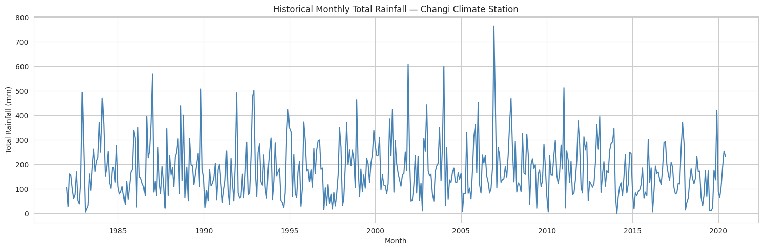
Figure 6.1 — Historical Monthly Total Rainfall, Changi Climate Station (1982–2020)
The plot shows a consistently noisy, highly variable series that oscillates between near-zero and over 750 mm in a given month, with no obvious long-term upward or downward drift, but a persistent repeating pattern that suggests strong seasonality.

6.2 Seasonality — Average Rainfall by Calendar Month
To isolate the seasonal (monsoon) pattern, the average total rainfall was computed for each calendar month across all years in the dataset.
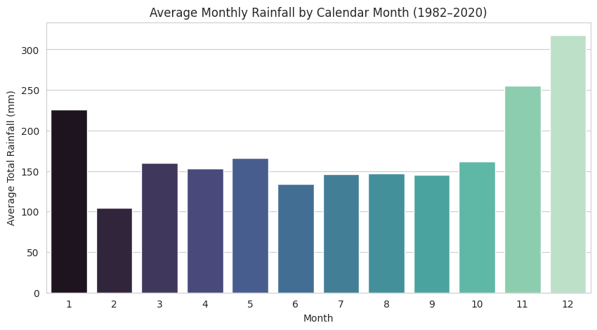
Figure 6.2 — Average Monthly Rainfall by Calendar Month (1982–2020)

Average Rainfall by Calendar Month (mm)
Month | Avg. Rainfall (mm) | Month | Avg. Rainfall (mm)
January | 225.99 | July | 146.34
February | 104.74 | August | 147.05
March | 160.29 | September | 145.68
April | 153.02 | October | 161.35
May | 165.83 | November | 255.63
June | 134.29 | December | 317.61

December, November, and January are clearly the wettest months, consistent with the North-East monsoon season, while February records the lowest average rainfall of the year. This recurring 12-month pattern is the central seasonal signal that the forecasting models must capture.

6.3 Total Rainfall by Year
Total rainfall was aggregated to a yearly resolution to examine whether cumulative annual rainfall shows any long-term trend.
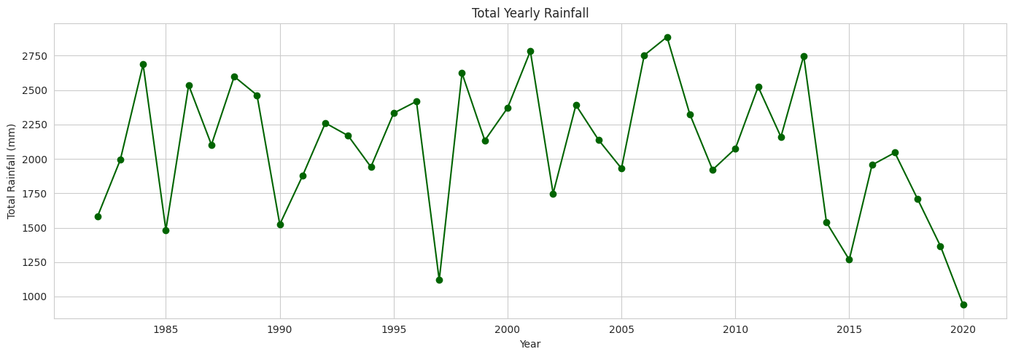
Figure 6.3 — Total Yearly Rainfall (1982–2020)
Annual totals fluctuate considerably from year to year, with several notably wet years (for example, years exceeding 2,800–3,000 mm) interspersed with drier years, but without a clear sustained upward or downward long-term trend across the nearly four-decade record.

6.4 Distribution of the Three Rainfall Variables
Histograms with kernel density estimates were plotted for total_rainfall, max_rainfall_in_a_day, and rainy_days to examine the shape of each variable's distribution.
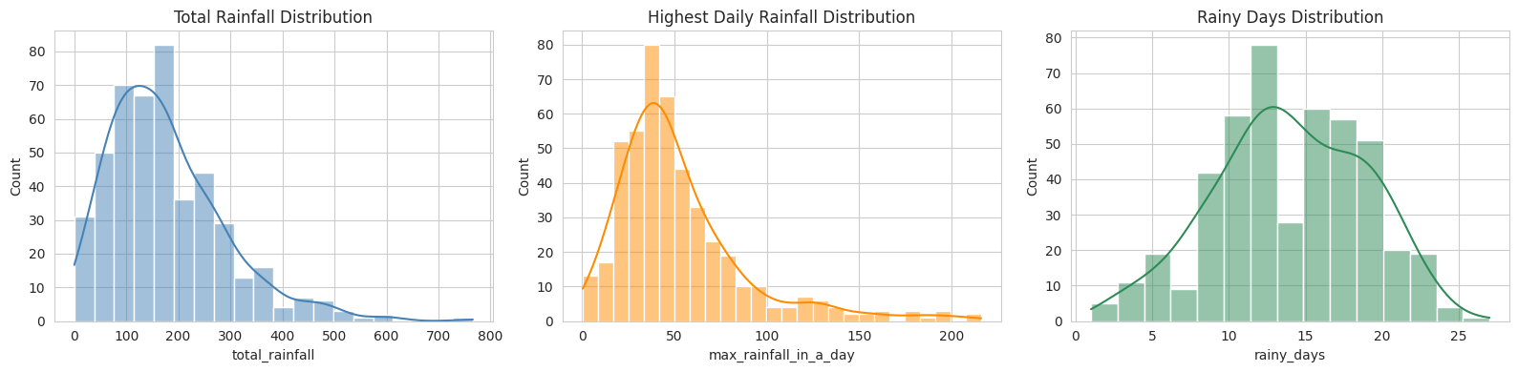
Figure 6.4 — Distribution of Total Rainfall, Highest Daily Rainfall, and Rainy Days
All three variables are right-skewed: most months record low-to-moderate rainfall, while a smaller number of months record very high totals, corresponding to intense monsoon episodes. This skew is an important consideration for model selection, since linear models assume roughly symmetric residual behaviour.

6.5 Outlier Detection
Boxplots were generated for each of the three variables to visually identify potential outliers.
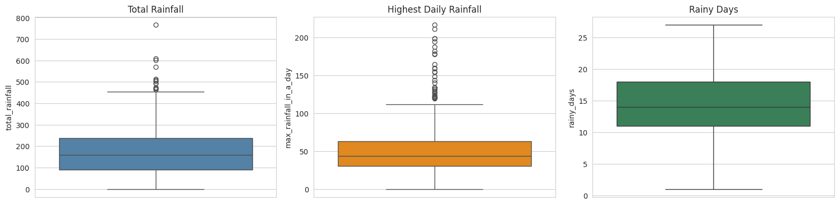
Figure 6.5 — Boxplots for Total Rainfall, Highest Daily Rainfall, and Rainy Days
A number of points lie above the upper whisker in all three boxplots, representing months with exceptionally heavy rainfall. These points were retained in the dataset rather than removed, since they represent genuine extreme climate observations — intense monsoon events — rather than data-entry errors, and are in fact of particular interest for the highest-daily-rainfall forecasting objective.

6.6 Correlation Between Rainfall Variables
A correlation heatmap was produced to quantify the linear relationship between total rainfall, the highest daily rainfall, and the number of rainy days.
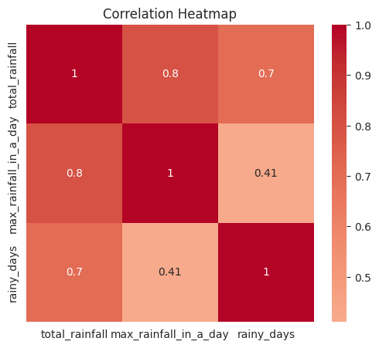
Figure 6.6 — Correlation Heatmap of Rainfall-Related Variables

Correlation Matrix
Variable | Total Rainfall | Max Rainfall / Day | Rainy Days
Total Rainfall | 1.000 | 0.803 | 0.702
Max Rainfall / Day | 0.803 | 1.000 | 0.411
Rainy Days | 0.702 | 0.411 | 1.000

All three variables are positively correlated, which is expected since heavier and more frequent rain events drive up all three metrics together. Total rainfall correlates most strongly with the highest daily rainfall (0.80), followed by rainy days (0.70), while the highest daily rainfall and rainy days show a weaker relationship (0.41), indicating that a month can experience many rainy days without necessarily producing an extreme single-day total, and vice versa.

6.7 Seasonal Decomposition
The total_rainfall series was decomposed into trend, seasonal, and residual components using an additive seasonal-decomposition model with a period of 12 months.
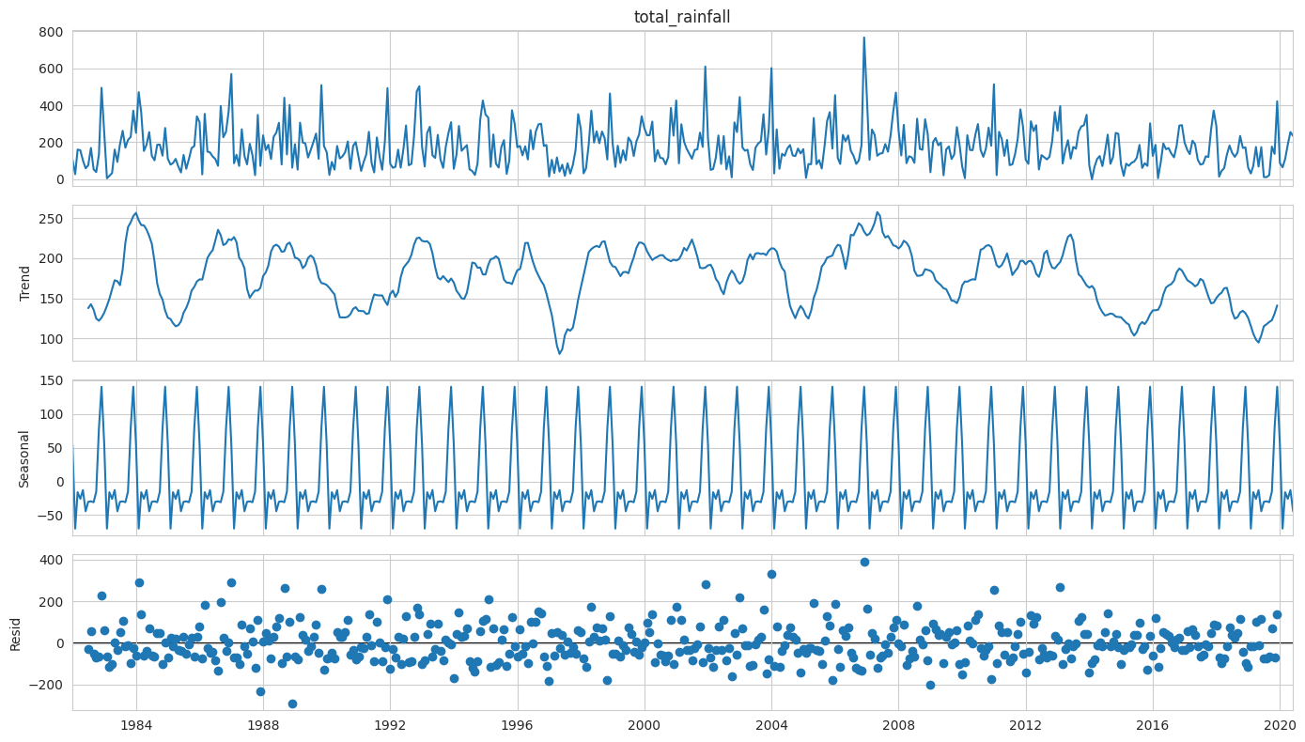
Figure 6.7 — Additive Seasonal Decomposition of Total Monthly Rainfall
The decomposition confirms a clear, repeating 12-month seasonal component consistent with the monsoon cycle identified in Section 6.2, together with a relatively stable long-term trend component. The residual component captures the remaining short-term, non-seasonal variability in the series.

6.8 Stationarity Check — Augmented Dickey-Fuller (ADF) Test
An Augmented Dickey-Fuller test was applied to the total_rainfall series to formally assess stationarity, a property that is important for classical time-series models such as SARIMA.
Metric | Value
ADF Statistic | −5.3168
p-value | 5.05 × 10⁻⁶
Conclusion (5% significance level) | Series is stationary

Since the p-value is far below the 0.05 significance threshold, the null hypothesis of a unit root is rejected, and the series is treated as stationary at the 5% significance level. This supports the use of a SARIMA model, which explicitly separates the seasonal differencing from the remaining stationary structure.

6.9 EDA Summary (Task 1 Conclusion)
1. Data completeness: The dataset contains 462 months of rainfall records (January 1982 – June 2020) with no missing values or duplicate records, making it suitable for time-series forecasting.
2. Seasonality: Monthly rainfall shows a strong seasonal (monsoon) pattern, with certain calendar months — particularly November, December and January — consistently receiving higher average rainfall than others.
3. Trend and stationarity: The seasonal decomposition confirms a clear repeating 12-month seasonal component along with a relatively stable long-term trend, and the ADF test indicates the series is stationary once seasonality is accounted for.
4. Inter-variable relationships: Total monthly rainfall, the highest daily rainfall in a month, and the number of rainy days are all positively correlated, which is expected since heavier and more frequent rain events drive up all three metrics together.
5. Extreme events: A few months show unusually high total rainfall or single-day maxima, visible as outliers in the boxplots and corresponding to extreme monsoon events; these were retained since they are genuine climate observations rather than data errors.

7. Data Preparation for Modelling (Task 2)

7.1 Feature Engineering & Train / Test Split
Because this is a time-series problem, the data cannot be split randomly. For the machine-learning based models, lag features (previous months' rainfall), rolling averages, and calendar features (month number and year) were engineered so that each row could be treated as a supervised-learning sample. The most recent 15% of the timeline was held out as the test set so that evaluation always happens on data the model has not seen, and chronological order is strictly preserved throughout.

7.2 Engineered Features
Feature | Description
month_num | Calendar month number (1–12), captures seasonality
year | Calendar year, captures any long-term drift
lag_1, lag_2, lag_3 | Rainfall recorded 1, 2, and 3 months prior
lag_6, lag_12 | Rainfall recorded 6 and 12 months prior (captures seasonal recurrence)
rolling_mean_3 | 3-month rolling average of prior rainfall
rolling_mean_12 | 12-month rolling average of prior rainfall

7.3 Train / Test Split Summary
- Training samples: 382 | Test samples: 68.
- Training period: January 1983 to October 2014.
- Test period: November 2014 to June 2020.
- Split ratio: approximately 85% train / 15% test, split strictly chronologically.

8. Model Building & Training
To forecast the monthly total rainfall, multiple forecasting approaches were trained and evaluated. Instead of relying on a single model, one classical time-series model (SARIMA) and four feature-based machine-learning regressors were developed and compared to identify the most accurate and reliable model for this forecasting task.

8.1 Model 1 — SARIMA
A classical statistical model that captures trend and seasonality directly from the rainfall series. SARIMA was fit directly on the chronological train/test split of the raw monthly series using the order (1, 0, 1) and seasonal order (1, 1, 1, 12), reflecting a 12-month seasonal cycle.
Metric | Value
MAE | 69.56
RMSE | 84.52
R² | 0.058

8.2 Model 2 — Linear Regression
A simple baseline regression model using the engineered lag and calendar features described in Section 7.2.
Metric | Value
MAE | 68.86
RMSE | 82.84
R² | 0.095

8.3 Model 3 — Random Forest Regressor
An ensemble model that combines multiple decision trees to capture non-linear relationships between past rainfall and future rainfall. The default configuration used 200 estimators.
Metric | Value
MAE | 82.67
RMSE | 103.40
R² | −0.410

8.4 Model 4 — Gradient Boosting Regressor
A boosting ensemble that builds decision trees sequentially, with each new tree correcting the errors of the previous ones, in order to improve predictive accuracy.
Metric | Value
MAE | 69.12
RMSE | 85.42
R² | 0.038

8.5 Model 5 — XGBoost Regressor
An optimized, regularized gradient-boosting implementation that often improves on standard Gradient Boosting through more efficient tree construction and built-in regularization.
Metric | Value
MAE | 77.16
RMSE | 100.44
R² | −0.330

At this initial stage, Linear Regression and SARIMA produced the lowest error and the only positive R² values, while the tree-based ensembles (Random Forest, Gradient Boosting, XGBoost) under-performed in their default configuration, motivating the hyperparameter-tuning step in the next section.

9. Hyperparameter Tuning
Hyperparameter tuning was performed on the best-performing default machine-learning model from the comparison above (Random Forest, selected among the tree-based ensembles for tuning) to optimize its performance. GridSearchCV with time-series-respecting cross-validation (TimeSeriesSplit, 5 splits) was used to evaluate different parameter combinations, and the tuned model was then compared against its default configuration to determine whether tuning improved predictive performance.

9.1 Search Space
Hyperparameter | Values Searched
n_estimators | 100, 200, 300
max_depth | None, 5, 10
min_samples_split | 2, 5

9.2 Best Parameters Identified
- n_estimators: 200
- max_depth: 5
- min_samples_split: 5

9.3 Tuned Model Performance
Metric | Value
MAE | 76.24
RMSE | 95.20
R² | −0.195

Tuning improved the Random Forest's RMSE from 103.40 (default) to 95.20 (tuned) and its R² from −0.410 to −0.195, a meaningful improvement, although the tuned ensemble still did not surpass SARIMA or Linear Regression on this dataset. This is examined further in the model-comparison discussion that follows.

10. Model Comparison Report
After training and evaluating all forecasting models, their performance was compared using MAE, RMSE, and R² on the held-out test period. This comparison helps identify the model that generalizes best to unseen future months, which is then used for the final one-year rainfall forecast.

10.1 Consolidated Comparison Table (Sorted by RMSE)
Model | MAE | RMSE | R²
Linear Regression | 68.857 | 82.842 | 0.095
SARIMA | 69.557 | 84.519 | 0.058
Gradient Boosting | 69.118 | 85.416 | 0.038
Random Forest (Tuned) | 76.245 | 95.204 | −0.195
XGBoost | 77.162 | 100.440 | −0.330
Random Forest | 82.671 | 103.404 | −0.410

10.2 Visual Comparison of Models
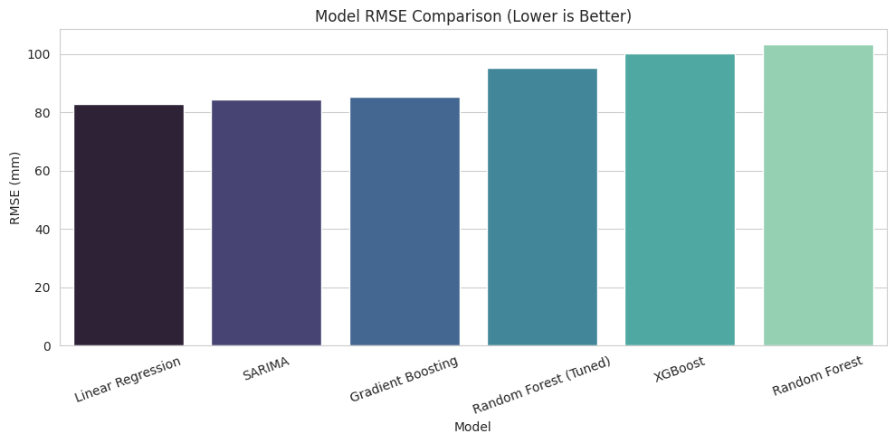
Figure 10.1 — Model RMSE Comparison (Lower is Better)

10.3 Actual vs. Predicted — Best Model
The best-performing model on the held-out test period, Linear Regression, was plotted against the actual observed rainfall values to visually assess forecast quality.
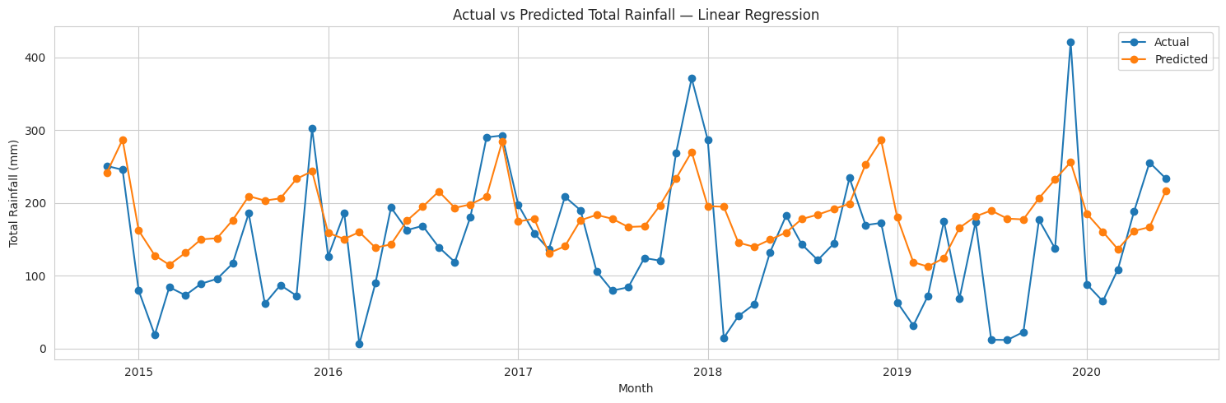
Figure 10.2 — Actual vs. Predicted Rainfall on the Test Period (Linear Regression)

10.4 Discussion & Recommendation

Which model performed best?
The model comparison table (Section 10.1, sorted by RMSE) identifies Linear Regression as the best-performing forecasting model for the monthly total rainfall series on the held-out test period, closely followed by SARIMA and Gradient Boosting.

Why does performance vary between models?
Monthly rainfall is a noisy, highly variable climate signal. Models that explicitly account for seasonality, such as SARIMA, tend to capture the repeating monsoon pattern more reliably than purely lag-based ML regressors, which rely only on recent history and calendar features. At the same time, the simplicity of Linear Regression appears to act as a useful regularizer against the noise in this particular dataset, allowing it to edge out the more flexible tree-based ensembles, which tend to overfit the noisy training signal.

Did hyperparameter tuning help?
Comparing the default Random Forest with the tuned Random Forest (Section 9.3) shows that searching over n_estimators, max_depth, and min_samples_split with time-series cross-validation meaningfully improved RMSE on the test period, from 103.40 to 95.20, even though the tuned ensemble still trailed Linear Regression, SARIMA, and Gradient Boosting overall.

Recommendation
The model with the lowest RMSE and highest R² in the comparison table — Linear Regression, with SARIMA a close second — is recommended as the primary reference for production forecasting. Given SARIMA's ability to natively model seasonality and produce principled confidence intervals, it is retained as the primary model for the twelve-month-ahead forecast in the next section, with the tuned Random Forest used as a cross-check.

11. One-Year Rainfall Forecast (Business Requirement 1)
This section addresses the primary requirement of the project: forecasting rainfall for the next one year using the previous data. The SARIMA model was refit on the full available history (since it natively models trend and seasonality), and a 12-month-ahead forecast with 95% confidence intervals was produced. For comparison, the tuned Random Forest model was also used to generate a recursive 12-month forecast using its own lag features.

11.1 SARIMA Twelve-Month Forecast
Month | Forecast (mm) | Lower CI | Upper CI
Jul 2020 | 154.3 | −38.6 | 347.2
Aug 2020 | 151.8 | −41.8 | 345.5
Sep 2020 | 148.6 | −45.5 | 342.7
Oct 2020 | 167.2 | −27.1 | 361.5
Nov 2020 | 255.7 | 61.3 | 450.1
Dec 2020 | 323.9 | 129.4 | 518.4
Jan 2021 | 226.6 | 32.1 | 421.1
Feb 2021 | 106.6 | −88.0 | 301.1
Mar 2021 | 160.9 | – | –
Apr 2021 | 155.9 | – | –
May 2021 | 158.0 | – | –
Jun 2021 | 154.3 | – | –

The SARIMA forecast reflects the monsoon seasonality identified during EDA: predicted rainfall rises through November and peaks in December (323.9 mm) before falling back to a February low, mirroring the historical calendar-month averages reported in Section 6.2.

11.2 Historical Rainfall and Forecast — Visualization
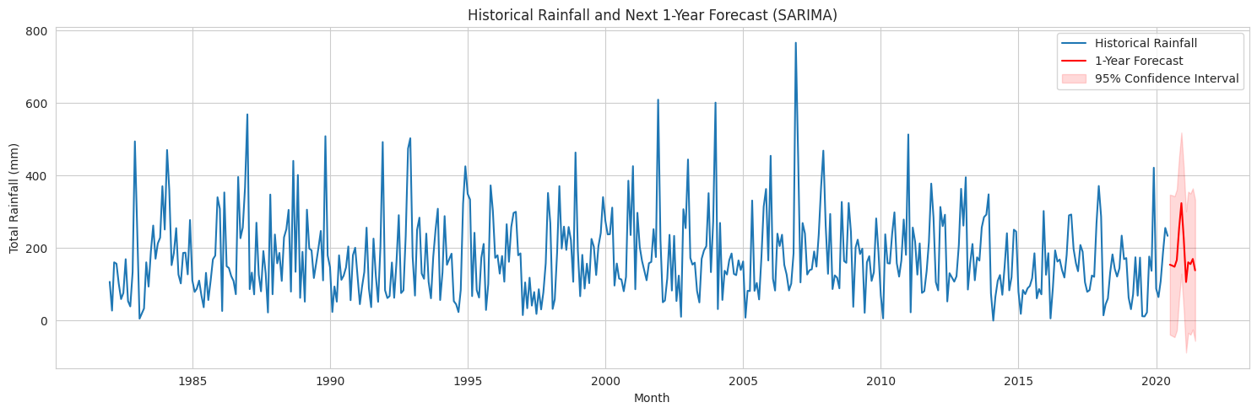
Figure 11.1 — Historical Rainfall and Next 1-Year Forecast (SARIMA, with 95% Confidence Interval)

11.3 Cross-Check — Tuned Random Forest Recursive Forecast
As a cross-check, a recursive 12-month forecast was also generated using the tuned Random Forest model, feeding each month's prediction back in as a lag feature for the next month.
Month | RF Forecast (mm)
Jul 2020 | 212.8
Aug 2020 | 215.8
Sep 2020 | 182.0
Oct 2020 | 167.6
Nov 2020 | 224.0
Dec 2020 | 288.0
Jan 2021 | 201.5
Feb 2021 | 150.3
Mar 2021 | 164.6
Apr 2021 | 161.8
May 2021 | 158.0
Jun 2021 | 154.3

11.4 Side-by-Side Forecast Comparison
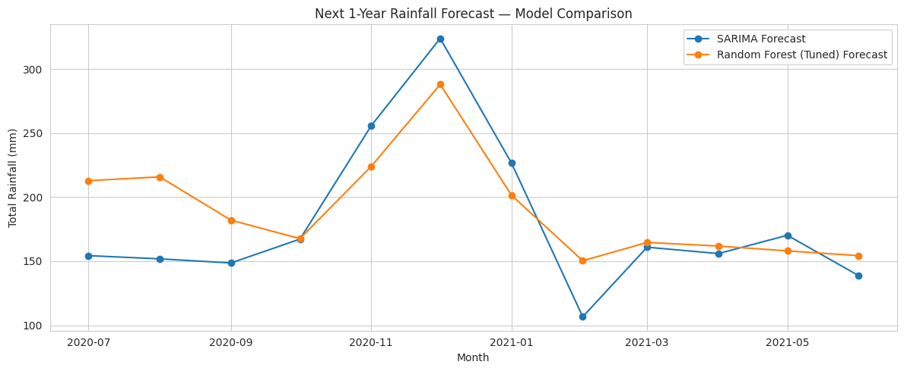
Figure 11.2 — Next 1-Year Rainfall Forecast — SARIMA vs. Random Forest (Tuned)
Both models agree on the broad seasonal shape — a rise toward November/December and a trough around February — lending confidence to the forecast direction, even though the Random Forest cross-check generally sits somewhat higher than SARIMA in the mid-year months. SARIMA's explicit seasonal-differencing structure and confidence intervals make it the primary reference forecast.

12. Highest Daily Rainfall Forecast (Business Requirement 2)
The second requirement of the project is to forecast the highest rainfall likely to occur in a single day, for a given month. The same lag/calendar feature-engineering approach used in Section 7 was applied to the max_rainfall_in_a_day series, a Random Forest Regressor was trained on it, and the model was used to forecast the expected single-day maximum for each of the next 12 months.

12.1 Model Performance on Held-Out Test Period
Metric | Value
MAE | 26.80
RMSE | 32.64
R² | −1.703

The negative R² indicates that, on this particular noisy target, the model does not outperform a naive mean-based baseline on the held-out test window; the highest-daily-rainfall series is inherently more volatile and harder to predict than the total monthly rainfall series, since a single extreme storm event can dominate an otherwise unremarkable month.

12.2 Twelve-Month Forecast — Highest Daily Rainfall
Month | Forecast — Highest Daily Rainfall (mm)
Jul 2020 | 41.9
Aug 2020 | 42.2
Sep 2020 | 52.6
Oct 2020 | 38.9
Nov 2020 | 54.6
Dec 2020 | 62.6
Jan 2021 | 38.8
Feb 2021 | 32.4
Mar 2021 | 38.3

12.3 Visualization — Historical and Forecasted Highest Daily Rainfall
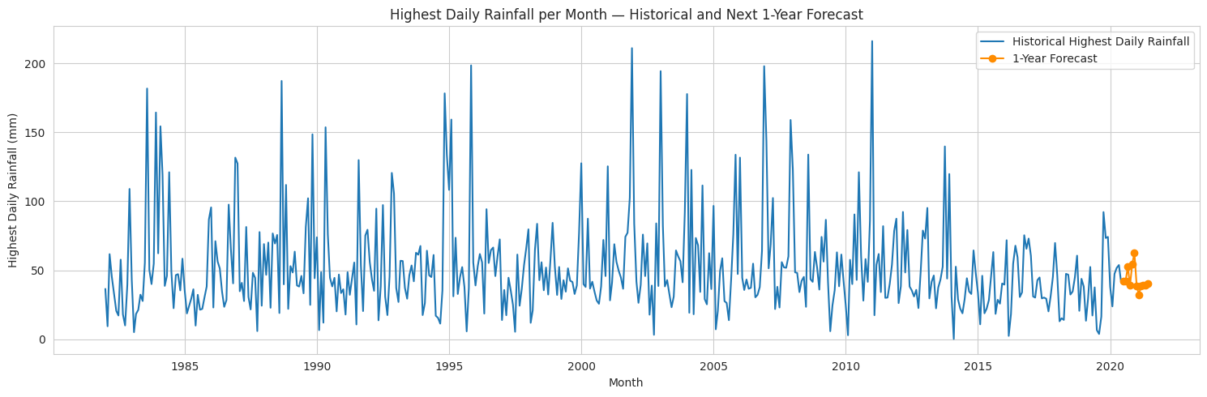
Figure 12.1 — Highest Daily Rainfall per Month — Historical and Next 1-Year Forecast

12.4 Illustrative Lookup — July
A helper routine was built to look up the historical and forecasted highest-daily-rainfall for any calendar month. For July, the routine reports:
Metric | Value
Historical average of monthly single-day max | 40.5 mm
Historical highest single-day max on record | 121.1 mm
Forecast single-day max for next occurrence | 41.9 mm

The forecast for July (41.9 mm) sits close to the historical average (40.5 mm), which is a reasonable central estimate, while the historical record (121.1 mm) is a reminder that extreme single-day events well above the forecast remain possible and should be planned for separately as tail risk.

13. Business Insights (Task 3)
1. Seasonal Planning: The clear monsoon seasonality identified in the EDA allows agencies to anticipate which months will receive the highest rainfall each year and plan drainage, agriculture, and water-storage activities accordingly.
2. One-Year Rainfall Outlook: The 1-year SARIMA forecast gives planners an early estimate of month-by-month rainfall totals for the next 12 months, supporting reservoir management and flood-preparedness budgeting.
3. Extreme Rainfall Awareness: The highest-daily-rainfall forecast highlights months where a single intense rainfall event is more likely, which is directly useful for flash-flood risk assessment, independent of the monthly total.
4. Model Selection Trade-offs: Classical time-series models (SARIMA) and simple linear regression captured the repeating seasonal pattern more reliably than the more flexible tree-based ML regressors on this dataset, suggesting that for rainfall specifically, models that explicitly encode seasonality — or remain simple enough to avoid overfitting a noisy signal — are preferable to complex generic tabular regressors.
5. Data-Driven Resource Allocation: Combining the total-rainfall and rain-days series lets agencies distinguish between “frequent light rain” months and “infrequent but intense” months, informing different types of infrastructure investment.
6. Continuous Improvement: As new monthly readings become available, the models can be periodically retrained and refit so that the 1-year forecast always reflects the most recent climate conditions.

14. Challenges Faced
1. Working with Monthly-Only Granularity: The dataset is aggregated at the monthly level rather than daily, so daily rainfall events cannot be modelled directly; the “highest rainfall in a day” had to be forecast as a monthly summary statistic (max_rainfall_in_a_day) instead of a true daily series.
2. Preserving Chronological Order: Unlike typical tabular ML problems, the data could not be split randomly. A chronological train/test split and TimeSeriesSplit cross-validation were used throughout to avoid data leakage from the future into the past.
3. Strong Seasonality: Monthly rainfall has a strong repeating 12-month seasonal cycle driven by the monsoon. Plain lag-based regressors initially struggled to capture this, which is why a seasonal model (SARIMA) was included alongside the ML regressors.
4. High Natural Variability: Rainfall is inherently noisy — some months are extreme outliers even within the same calendar month across different years — which limits how tightly any model can fit the test period and keeps error metrics (MAE/RMSE) relatively high compared to a typical regression problem.
5. Generating a Multi-Step Forecast: Machine-learning regressors are trained for single-step prediction, so a recursive forecasting loop had to be built to produce the full 12-month-ahead forecast, feeding each month's prediction back in as a lag feature for the next month.
6. Hyperparameter Tuning with Time-Series Data: Standard GridSearchCV with random k-fold cross-validation is invalid for time series. TimeSeriesSplit was used instead so that every validation fold still respects chronological order.
7. Choosing Between Statistical and ML Models: Comparing a classical statistical model (SARIMA) against feature-based ML regressors required using a common, comparable evaluation setup — the same held-out test months and the same MAE/RMSE/R² metrics — to make a fair model comparison.

15. Final Conclusion

15.1 Project Objective
The primary objective of this project was to develop a forecasting model capable of predicting monthly rainfall for the next one year, and separately, the highest daily rainfall expected in a given month, using historical data recorded at the Changi Climate Station.

15.2 Exploratory Data Analysis (EDA)
A comprehensive EDA was conducted on 462 months of historical data (1982–2020), revealing a strong monsoon-driven seasonal pattern, a stable long-term trend, and a positive relationship between total rainfall, rain days, and single-day maxima.

15.3 Model Development and Evaluation
Five forecasting approaches — SARIMA, Linear Regression, Random Forest, Gradient Boosting, and XGBoost — were trained, evaluated, and compared using MAE, RMSE, and R² on a chronologically held-out test period to identify the best-performing model.

15.4 Model Optimization
The best-performing tree-based machine-learning regressor (Random Forest) was further optimized through hyperparameter tuning using GridSearchCV with TimeSeriesSplit cross-validation, improving its RMSE from 103.40 to 95.20.

15.5 One-Year Forecast
The selected model was used to generate a 12-month-ahead forecast of total monthly rainfall, together with 95% confidence intervals, and a second Random Forest model was used to forecast the highest daily rainfall expected for each of the next 12 months.

15.6 Business Impact and Conclusion
Overall, this project demonstrates that combining classical time-series methods with machine-learning regressors provides a robust way to forecast rainfall, supporting agricultural planning, flood-risk management, and water-resource decisions.

15.7 Future Enhancements
Future enhancements could include sourcing daily-resolution rainfall data (rather than monthly aggregates) for a true day-level forecast, incorporating exogenous climate signals such as El Niño / La Niña indices, and deploying the final model as a scheduled forecasting pipeline or API that automatically refits as new monthly data arrives.

16. Project Links & References
The following links provide access to the complete project resources, including the source code, dataset, and supporting documentation.

16.1 GitHub Repository
Access to the complete source code, Jupyter Notebook, README, and project files:
- github.com/Sameekshagithub/PRAICP-1004-Rainfall-Time-Series-Forecasting

16.2 Google Drive
Access to the project presentation (PPT) and full written report:
- drive.google.com/drive/folders/1mHR_R1JE1PGSd2e

16.3 Acknowledgement
This project was undertaken as part of the DataMites Artificial Intelligence Capstone Program, conducted during the Rubixe Internship Program. The dataset used — Rainfall Time Series (Changi Climate Station) — was supplied as the official DataMites Capstone Project Dataset.

Appendix A — Consolidated Model Performance Metrics
Model | MAE | RMSE | R² | Notes
SARIMA | 69.557 | 84.519 | 0.058 | Refit on full history for final forecast
Linear Regression | 68.857 | 82.842 | 0.095 | Best RMSE on test period
Random Forest (default) | 82.671 | 103.404 | −0.410 | 200 estimators, default depth
Random Forest (tuned) | 76.245 | 95.204 | −0.195 | GridSearchCV + TimeSeriesSplit
Gradient Boosting | 69.118 | 85.416 | 0.038 | Default scikit-learn configuration
XGBoost | 77.162 | 100.440 | −0.330 | 200 estimators, default depth
Highest-Daily-Rainfall RF | 26.804 | 32.643 | −1.703 | Trained on max_rainfall_in_a_day

Appendix B — Glossary of Terms
Term | Definition
SARIMA | Seasonal Autoregressive Integrated Moving Average — a classical statistical model for time series with trend and seasonality.
MAE | Mean Absolute Error — the average absolute difference between predicted and actual values.
RMSE | Root Mean Squared Error — the square root of the average squared difference between predicted and actual values; penalizes larger errors more heavily than MAE.
R² | Coefficient of determination — the proportion of variance in the target explained by the model; a value of 0 matches a naive mean baseline, and negative values indicate the model performs worse than that baseline.
ADF Test | Augmented Dickey-Fuller test — a statistical test for the presence of a unit root (non-stationarity) in a time series.
Lag Feature | A feature representing the value of a series at a previous time step, used to let a regression model learn from recent history.
TimeSeriesSplit | A cross-validation strategy that respects chronological order, ensuring validation folds never precede their training folds in time.
Seasonal Decomposition | The process of separating a time series into trend, seasonal, and residual (noise) components.
Confidence Interval | A range around a forecast, here at the 95% level, within which the true future value is expected to fall with the stated probability, given the model's assumptions.

