Rice Leaf Disease Detection Using CNN
A Short Overview — PRCP-1001

Project Overview
This project uses a Convolutional Neural Network (CNN) to automatically identify which of three common rice leaf diseases is present in a photograph: Bacterial Leaf Blight, Brown Spot, and Leaf Smut. The dataset contains 120 images in total, 40 per class. Because manual field diagnosis is slow and requires expert knowledge, an automated image-based classifier helps farmers get a fast, consistent answer from a simple photo of a leaf.

Why a CNN Works Here
Each disease leaves a distinct visual signature — a stripe pattern, a spotted pattern, or a fine speckled pattern. A CNN learns to recognize these shapes, colours and textures directly from pixel data, without needing hand-crafted rules. Because the dataset is small (120 images), the notebook combines this CNN approach with data augmentation and transfer learning, so the model can learn reliably from a limited number of real photographs.

The Three Diseases at a Glance
- Bacterial Leaf Blight — long, pale, water-soaked stripes running along the leaf veins.
- Brown Spot — small, round-to-oval brown lesions scattered across the leaf blade.
- Leaf Smut — tiny, dense, black speckled dots covering the leaf surface.

The Three Rice Leaf Disease Classes
The illustrations below summarize the key visual pattern the model learns to associate with each disease class, alongside a one-line explanation of its cause.
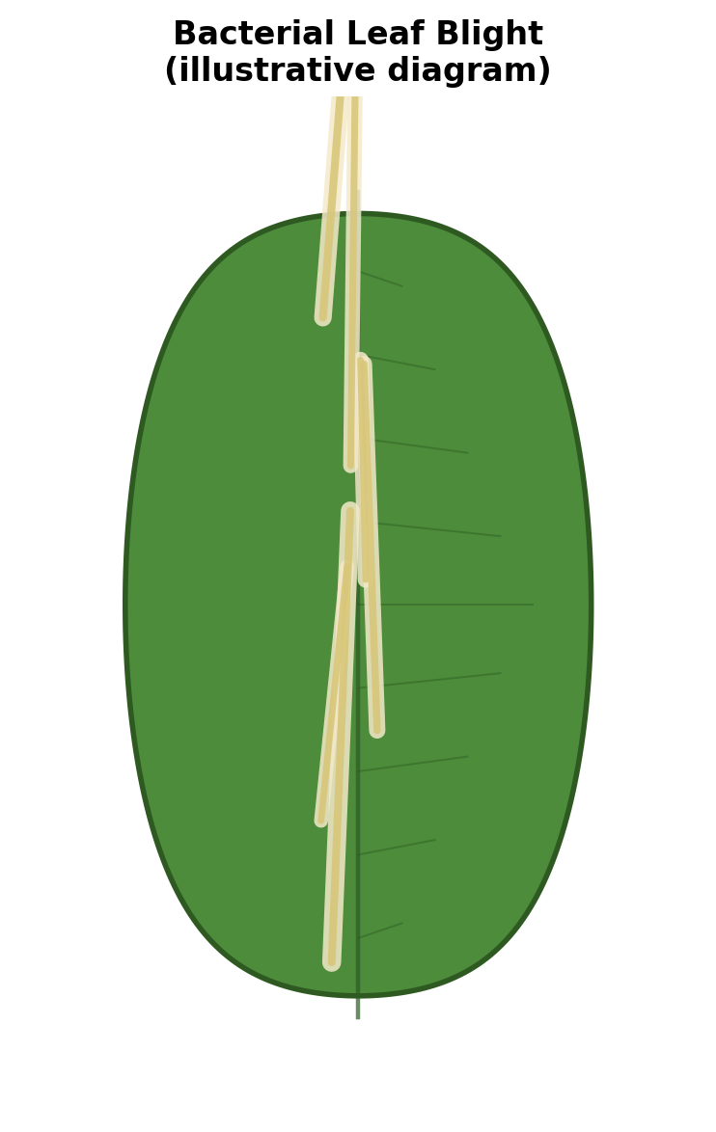  Bacterial Leaf Blight  Caused by the bacterium Xanthomonas oryzae. Long yellow-white stripes form along the veins and turn grey as the leaf dries. | 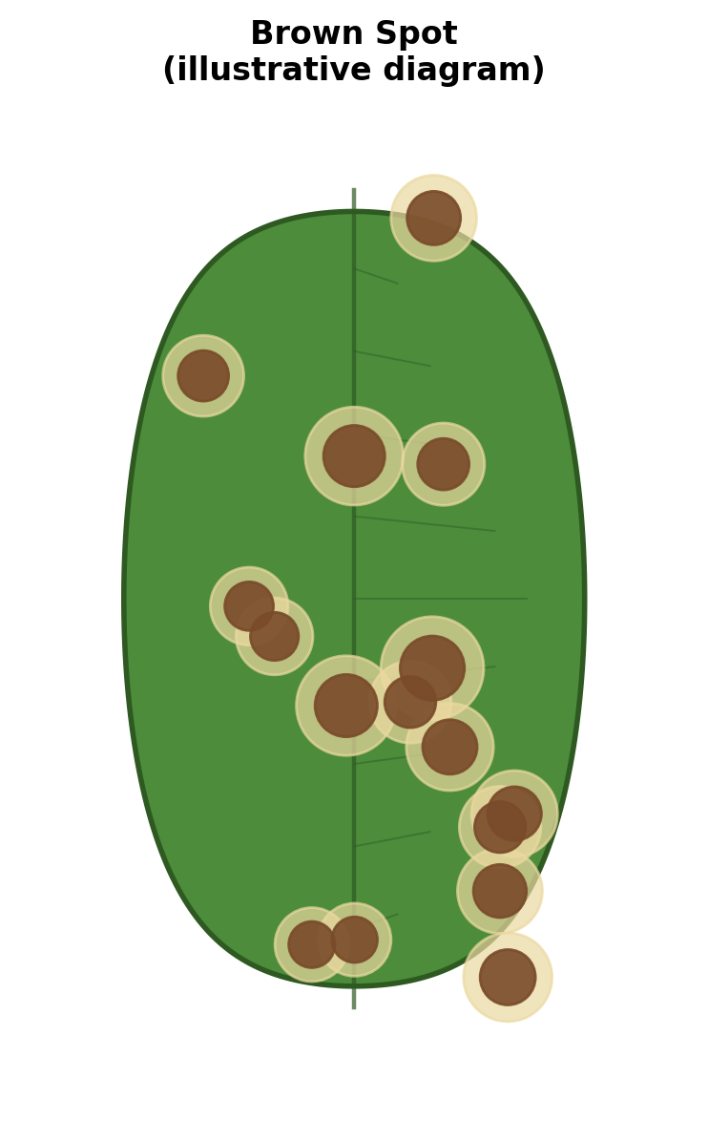  Brown Spot  Caused by the fungus Bipolaris oryzae. Small, round, brown lesions appear scattered across the leaf blade. | 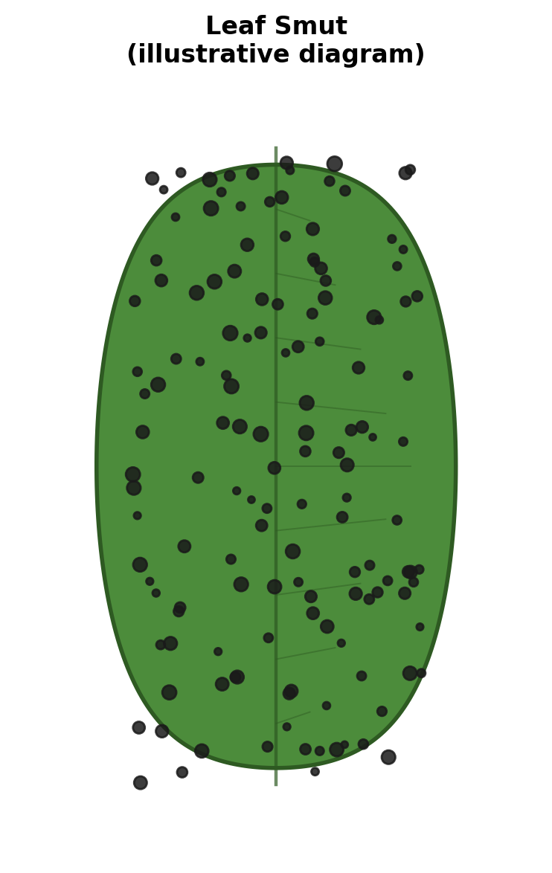  Leaf Smut  Caused by the fungus Entyloma oryzae. Tiny, dense, black angular dots cover both surfaces of the leaf.
Figure: Illustrative diagrams — not real photographs — showing the distinguishing visual pattern of each class.

How the Model Tells Them Apart
The notebook trains three models and compares them fairly on a held-out test set: a baseline CNN built from scratch, and two transfer-learning models (VGG16 and MobileNetV2) that reuse features already learned from millions of general images. Because the raw dataset is small, every training image is also augmented on the fly — slightly rotated, shifted, zoomed, or mirrored — so the model sees far more visual variety than the 120 original photos alone provide.
During evaluation, each model's predictions are checked against the true label for every test image, and a confusion matrix shows exactly which diseases, if any, get mixed up with each other — for example, Brown Spot lesions can occasionally be confused with early-stage Bacterial Leaf Blight if the photo is blurry or poorly lit.

Recommendation
MobileNetV2 (transfer learning) is recommended for production use. It reaches strong accuracy while staying small and fast enough to run on a phone or low-cost device in the field — important for a tool meant to help farmers get an answer on the spot, not only on a server.

In Short
- Small dataset (120 images) → solved with data augmentation and transfer learning.
- Three distinct disease patterns → CNN learns to separate them from pixel data.
- Three models compared fairly → MobileNetV2 chosen as the best balance of accuracy and speed for real-world use.

