
DATAMITES
Global Training & Certification Institute for Data Science
DATA SCIENCE CAPSTONE PROJECT
PRCP-1009: Cellphone Price Range Prediction Using Machine Learning
Rubiex Internship Project
Submitted in Partial Fulfilment of the DataMites Data Science Internship Program
Project Title: PRCP-1009: Cellphone Price Range Prediction Using Machine Learning
Team Code: PTID-AIE-JUL-26-11142
Project Code: PRCP-1009
Project Type: Data Science Capstone Project / Rubiex Internship Project
Dataset Source: DataMites Capstone Project Dataset
Dataset Name: Mobile Price Classification (datasets_11167_15520_train.csv)
Organization: DataMites Solutions Pvt. Ltd.
Submitted By: Sameeksha
Report Date: July 2026

About the Author
This capstone project has been prepared and submitted as part of the DataMites Data Science Internship Program, carried out under the Rubiex Internship Project initiative. The following section provides a brief profile of the project author.
Name | Sameeksha
Role | Data Science Intern / Capstone Project Author
Program | DataMites Data Science Internship Program
Internship Track | Rubiex Internship Project
Team Code | PTID-AIE-JUL-26-11142
Project Code | PRCP-1009
Project Title | Cellphone Price Range Prediction Using Machine Learning
Tools & Technologies | Python, Pandas, NumPy, Matplotlib, Seaborn, Scikit-learn, Jupyter Notebook
Core Skills Applied | Exploratory Data Analysis, Data Preprocessing, Classification Modelling, Hyperparameter Tuning, Model Evaluation, Business Insight Generation
GitHub Repository | github.com/Sameekshagithub/PRCP-1009-CellphonePrice-Prediction-Using-Machine-Learning-Classification-

As part of this internship, the author independently carried out the complete data science lifecycle for the assigned capstone problem — from problem understanding and domain analysis, through exploratory data analysis, data preparation, model building, hyperparameter tuning, and model evaluation, to the final generation of business insights and recommendations. The project reflects hands-on application of supervised machine learning classification techniques on a real-world structured dataset, in line with the learning objectives of the DataMites Data Science Internship Program under the Rubiex Internship Project track.

Table of Contents
1. Problem Statement & Project Objective
2. Import of Python Libraries
3. Dataset Upload & Domain Analysis
4. Basic Checks on the Dataset
5. Exploratory Data Analysis (EDA) — Task 1
6. Data Preparation for Modelling — Task 2
7. Model Building & Training
8. Hyperparameter Tuning
9. Model Comparison Report
10. Feature Importance Analysis
11. Model Testing on New Mobile Specifications
12. Business Insights — Task 3
13. Challenges Faced
14. Final Conclusion
15. Project Links & References

Executive Summary
The smartphone industry is one of the most competitive and fast-evolving technology markets in the world, with pricing being a critical factor that determines a device's commercial success. Manufacturers must carefully balance technical specifications such as battery capacity, RAM, internal storage, processor configuration, camera quality, and display resolution against the price segment they intend to target. Incorrect pricing decisions — whether overpricing or underpricing — can significantly affect sales volume, brand perception, and profitability.
This capstone project, undertaken as part of the DataMites Data Science Internship Program under the Rubiex Internship Project track, addresses this business problem through a data-driven approach. Using the Mobile Price Classification dataset comprising 2,000 mobile phone records and 20 technical specifications, a complete machine learning pipeline was developed to classify mobile phones into four price categories: Low Cost, Medium Cost, High Cost, and Very High Cost.
The project followed a structured data science workflow consisting of domain analysis, exploratory data analysis, data preparation, model building using six different classification algorithms, hyperparameter tuning, model comparison, feature importance analysis, and practical model testing. Logistic Regression, after hyperparameter optimisation, emerged as the best-performing model with an accuracy of 98.25%, significantly outperforming Decision Tree, Random Forest, K-Nearest Neighbours, Support Vector Machine, and Gradient Boosting classifiers on this dataset.
The analysis revealed that RAM is overwhelmingly the strongest predictor of price range, followed by battery power, screen resolution (pixel width and pixel height), and internal memory. These findings offer actionable business insights for smartphone manufacturers seeking to optimise product specifications, position products competitively, and make informed, data-driven pricing decisions. This report documents the complete methodology, results, and business recommendations arising from the project.

1. Problem Statement & Project Objective

1.1 Problem Statement
The objective of this project is to analyze mobile phone specifications and develop a machine learning classification model to predict the price range of a mobile phone based on its features. The project also involves comparing multiple classification models, identifying the most influential features affecting price, and providing business insights for effective pricing decisions.

1.2 Project Objectives
- Perform Exploratory Data Analysis (EDA) to understand the dataset.
- Preprocess and prepare the data for model development.
- Build and train multiple classification models.
- Evaluate and compare model performance using appropriate metrics.
- Select the best-performing model for production.
- Analyze feature importance to identify the key factors influencing mobile phone price.
- Provide business insights and recommendations based on the model results.
- Summarize the challenges faced and the techniques used during the project.

1.3 Project Scope
The scope of this project is limited to supervised, multi-class classification of mobile phones into four price bands using the provided structured dataset of technical specifications. It covers the complete data science lifecycle — from data ingestion to business recommendation — but does not include real-time data collection, deployment as a live web service, or integration with external pricing databases, although these are discussed as potential future enhancements.

2. Import of Python Libraries
The required Python libraries were imported to perform data analysis, visualization, machine learning model development, and performance evaluation. NumPy and Pandas were used for data manipulation, Matplotlib and Seaborn were used for data visualization, and Scikit-learn provided the tools for data preprocessing, model training, and evaluating the performance of different classification algorithms.
Library | Purpose in the Project
NumPy | Numerical computations and array operations
Pandas | Data loading, manipulation, and analysis
Matplotlib | Static data visualizations and charts
Seaborn | Statistical and aesthetically enhanced visualizations
Scikit-learn | Preprocessing, model building, tuning, and evaluation
Warnings | Suppressing non-critical runtime warnings

Specifically, from Scikit-learn, the following modules were used: train_test_split and GridSearchCV for data splitting and hyperparameter search, StandardScaler for feature scaling, LogisticRegression, DecisionTreeClassifier, RandomForestClassifier, GradientBoostingClassifier, KNeighborsClassifier and SVC as classification algorithms, and accuracy_score, precision_score, recall_score, f1_score, classification_report and confusion_matrix for model evaluation.

3. Dataset Upload & Domain Analysis

3.1 Dataset Upload
The datasets_11167_15520_train.csv dataset was uploaded and loaded into the Jupyter Notebook using the Pandas library. The dataset contains various mobile phone specifications along with the corresponding price range, which serves as the target variable for building and evaluating machine learning classification models.

3.2 Domain Analysis
This project belongs to the smartphone pricing domain, where the objective is to classify mobile phones into different price ranges based on their technical specifications. Features such as battery power, RAM, internal memory, processor performance, display resolution, camera quality, and connectivity options significantly influence the price category of a mobile phone. By analyzing these features, machine learning models can help manufacturers make data-driven pricing decisions, optimize product specifications, and improve competitiveness in the smartphone market.

3.3 Dataset Description
Attribute | Details
Dataset Name | Mobile Price Classification
File Name | datasets_11167_15520_train.csv
Total Records | 2,000
Total Features | 20 input features + 1 target variable
Target Variable | price_range (0 = Low, 1 = Medium, 2 = High, 3 = Very High)
Source | DataMites Capstone Project Dataset

The 20 input features include: battery_power, blue (Bluetooth), clock_speed, dual_sim, fc (front camera megapixels), four_g, int_memory (internal memory in GB), m_dep (mobile depth in cm), mobile_wt (mobile weight), n_cores (number of processor cores), pc (primary camera megapixels), px_height, px_width (pixel resolution), ram (in MB), sc_h, sc_w (screen height/width in cm), talk_time, three_g, touch_screen, and wifi.

4. Basic Checks on the Dataset
Basic checks were performed to understand the structure and quality of the dataset before conducting exploratory data analysis and model development. This included viewing sample records, examining dataset dimensions, identifying data types, generating descriptive statistics, checking for missing values, detecting duplicate records, and obtaining summary information about the dataset.

4.1 Dataset Dimensions
The dataset shape was found to be (2000, 21) — 2,000 rows (mobile phone records) and 21 columns (20 features plus the target variable).

4.2 Data Types
All 20 input features are numeric — either integer (int64) type for count-based and binary features, or float64 for continuous measurements such as clock_speed and m_dep. The target variable price_range is also of integer type, representing four discrete classes.

4.3 Missing Values & Duplicate Records
A check for missing values across all columns using df.isnull().sum() confirmed that the dataset contains zero missing values in every column. A duplicate record check using df.duplicated().sum() also returned zero, confirming that the dataset contains no duplicate rows. This indicates the dataset is clean, complete, and ready for analysis without requiring imputation or de-duplication.

4.4 Target Class Distribution
Price Range Class | Label | Record Count
0 | Low Cost | 500
1 | Medium Cost | 500
2 | High Cost | 500
3 | Very High Cost | 500

The target variable is perfectly balanced, with exactly 500 records in each of the four price range classes. This balance is highly beneficial for classification modelling, as it eliminates the risk of model bias toward a majority class and removes the need for resampling techniques such as SMOTE or class weighting.

5. Exploratory Data Analysis (EDA) — Task 1
Exploratory Data Analysis (EDA) was performed to gain a comprehensive understanding of the dataset before building machine learning models. This process helped identify the distribution of the target variable, understand the characteristics of each feature, detect missing values and duplicate records, identify outliers, and analyze relationships among variables. EDA also revealed patterns, trends, and correlations within the data, enabling informed decisions regarding data preprocessing, feature selection, and model development.

5.1 Target Variable Distribution
The distribution of the price_range target variable was visualized using a count plot, confirming the perfectly balanced nature of the four classes (500 records each).
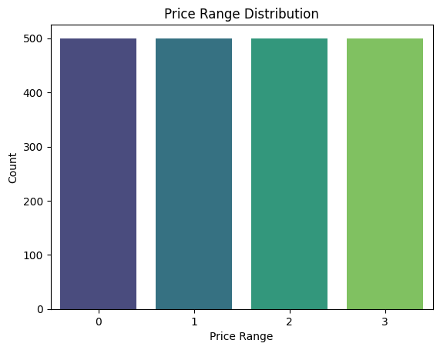
Figure 5.1 — Price Range Distribution (Count Plot)

5.2 Distribution of Key Numerical Features
Histograms with kernel density estimation (KDE) overlays were plotted for the most business-relevant numerical features — battery_power, ram, int_memory, px_height, px_width, and mobile_wt — to understand their spread and shape.
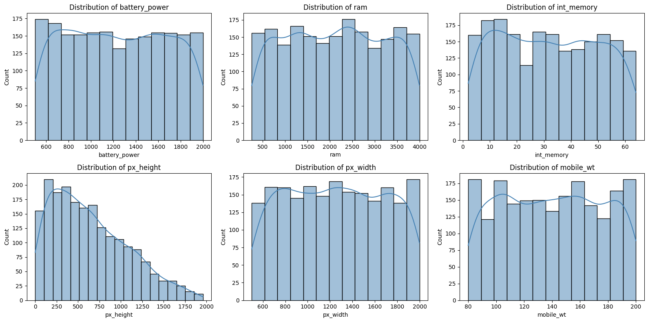
Figure 5.2 — Distribution of Key Numerical Features
RAM shows a roughly uniform spread across its full range, which aligns with its strong relationship with price range. Battery power, internal memory, and pixel dimensions also display broad, fairly even distributions, indicating that the dataset covers a wide variety of device configurations rather than clustering around a narrow specification band.

5.3 Outlier Detection
Boxplots were generated for all fourteen continuous numerical features to detect the presence of outliers.
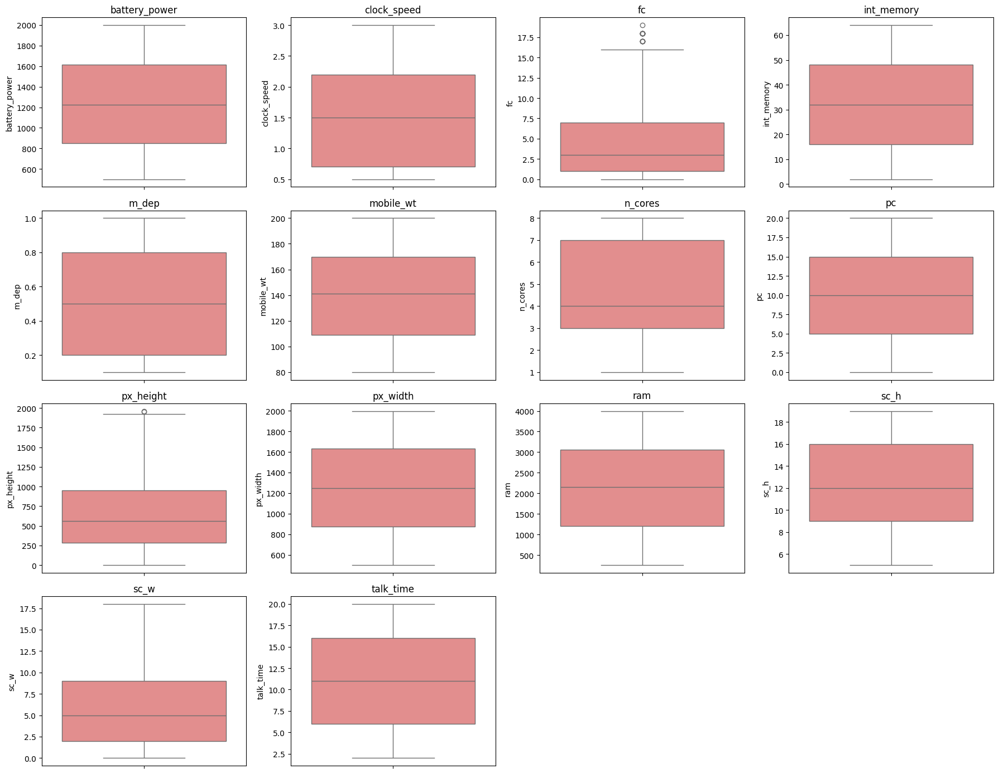
Figure 5.3 — Boxplots of Continuous Features for Outlier Detection
The boxplot analysis revealed a small number of extreme values in features such as fc (front camera megapixels) and px_height. However, these values represent valid, real-world mobile phone specifications (e.g., high-resolution front cameras or displays) rather than data entry errors, and were therefore retained in the dataset for model training rather than removed or capped.

5.4 Correlation Analysis
A correlation heatmap was generated across all numerical features to understand the linear relationships between variables and, in particular, their relationship with the target variable price_range.
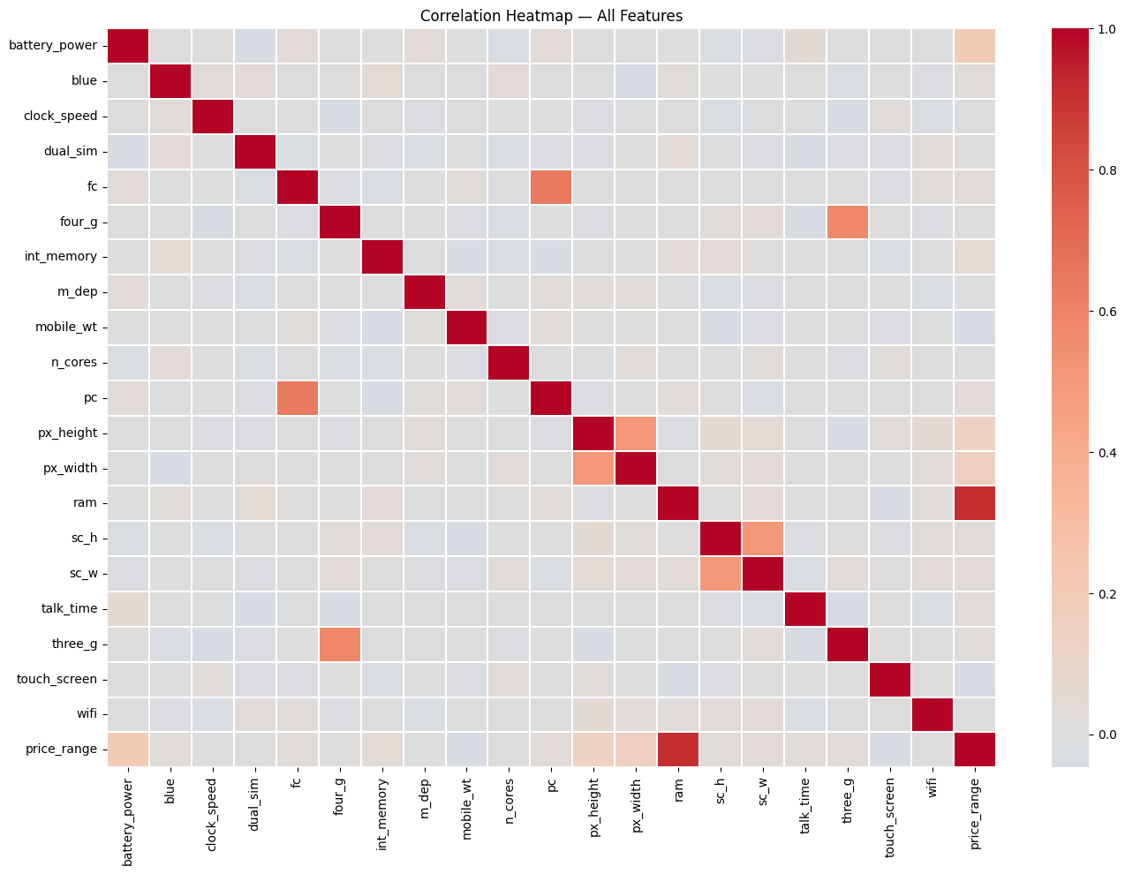
Figure 5.4 — Correlation Heatmap of All Features
The correlation of each feature with price_range, ranked from strongest to weakest, is summarised below:
Feature | Correlation with price_range
ram | 0.9170
battery_power | 0.2007
px_width | 0.1658
px_height | 0.1489
int_memory | 0.0444
sc_w | 0.0387
pc | 0.0336

RAM shows an exceptionally strong positive correlation of 0.917 with the price range — far higher than any other feature — indicating it is likely to be the single most dominant predictor in the classification models. Battery power, pixel width, and pixel height show moderate positive correlations, while most remaining features (including connectivity options such as Bluetooth, Wi-Fi, and Dual SIM) show weak correlation with price.

5.5 EDA Summary (Task 1 Conclusion)
- The dataset contains 2,000 mobile phone records with 20 input features and 1 target variable (price_range), providing sufficient information for price range classification.
- The dataset is clean and complete, with no missing values or duplicate records, making it suitable for machine learning model development.
- The price range classes are well balanced, ensuring that the classification models can be trained without requiring any resampling techniques.
- The feature distribution and correlation analysis indicate that RAM, battery power, screen resolution (px_height and px_width), and internal memory have a stronger influence on the mobile phone price range, while features such as Bluetooth, Wi-Fi, and Dual SIM have relatively lower impact.
- Outlier analysis shows the presence of a few extreme values in some numerical features; however, they represent valid mobile phone specifications and are retained for model training. Overall, the dataset is well-structured and suitable for building accurate classification models.

6. Data Preparation for Modelling — Task 2

6.1 Train / Test Split
The data was split into training and test sets, and features were scaled for the algorithms that are sensitive to feature scale (Logistic Regression, KNN, SVM). Tree-based models (Decision Tree, Random Forest, Gradient Boosting) are scale-invariant and use the raw features directly.
The independent features (X) were separated from the target variable (y = price_range). The dataset was then split using an 80:20 ratio with stratified sampling on the target variable to preserve class balance in both sets, and a fixed random_state of 42 was used to ensure reproducibility.
Split | Number of Samples
Training Set | 1,600
Test Set | 400

6.2 Feature Scaling
StandardScaler from Scikit-learn was applied to standardise the feature values (zero mean, unit variance) for the training and test sets. This scaled version of the data was used for the distance- and gradient-based algorithms (Logistic Regression, KNN, SVM), while the original unscaled features were used directly for the tree-based algorithms (Decision Tree, Random Forest, Gradient Boosting), which are unaffected by feature scale.

7. Model Building & Training
To predict the price range of mobile phones, multiple machine learning classification algorithms were trained and evaluated. Instead of relying on a single model, six different classifiers were developed and compared to identify the most accurate and reliable model for this classification task. This approach satisfies the Model Comparison Report requirement and helps select the most suitable model for production deployment.
- Model 1 — Logistic Regression — a simple baseline classification model that predicts the probability of each price range class.
- Model 2 — Decision Tree Classifier — a tree-based model that learns decision rules from mobile phone specifications.
- Model 3 — Random Forest Classifier — an ensemble model that combines multiple decision trees to improve accuracy and reduce overfitting.
- Model 4 — K-Nearest Neighbors (KNN) — a distance-based algorithm that classifies mobile phones based on their nearest neighbours.
- Model 5 — Support Vector Machine (SVM) — a powerful classifier that finds the optimal boundary between different price range classes.
- Model 6 — Gradient Boosting Classifier — an ensemble boosting algorithm that builds decision trees sequentially to achieve high predictive performance.

7.1 Model — Logistic Regression
As a linear baseline model, Logistic Regression fits a linear decision boundary using scaled features and already achieves a very strong 96.50% accuracy, largely owing to the dominant, near-linear relationship between RAM and price range.
Accuracy | Precision | Recall | F1-Score
0.9650 | 0.9650 | 0.9650 | 0.9650

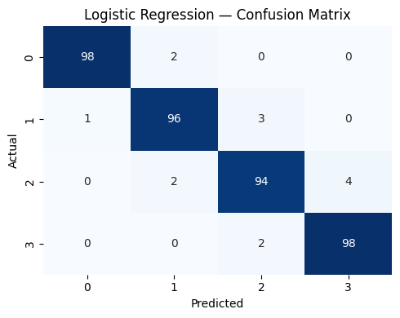
Figure — Confusion Matrix: Logistic Regression

7.2 Model — Decision Tree Classifier
The single Decision Tree achieves 83.00% accuracy. Being prone to overfitting on training data, its generalisation performance on the test set is noticeably lower than the ensemble and linear models.
Accuracy | Precision | Recall | F1-Score
0.8300 | 0.8319 | 0.8300 | 0.8302

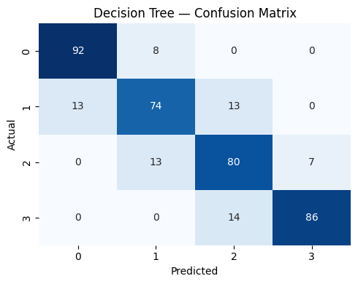
Figure — Confusion Matrix: Decision Tree Classifier

7.3 Model — Random Forest Classifier
By aggregating 200 decision trees, Random Forest improves on the single Decision Tree, reaching 87.75% accuracy and reducing the variance associated with individual trees.
Accuracy | Precision | Recall | F1-Score
0.8775 | 0.8776 | 0.8775 | 0.8774

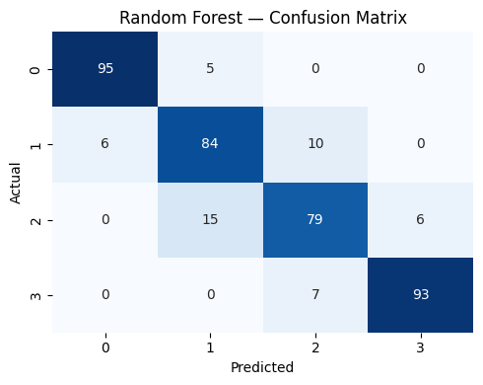
Figure — Confusion Matrix: Random Forest Classifier

7.4 Model — K-Nearest Neighbours (KNN)
KNN (k = 7) performs considerably worse than the other models, achieving only 51.75% accuracy. This is likely due to the curse of dimensionality across 20 features, where distance-based similarity becomes less meaningful.
Accuracy | Precision | Recall | F1-Score
0.5175 | 0.5267 | 0.5175 | 0.5199

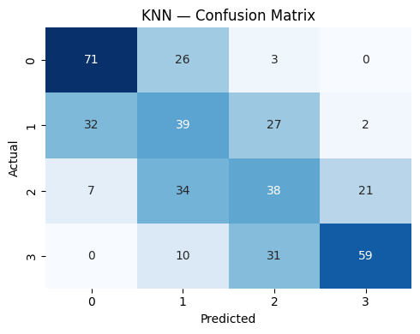
Figure — Confusion Matrix: K-Nearest Neighbours (KNN)

7.5 Model — Support Vector Machine (SVM)
The RBF-kernel SVM achieves a strong 89.50% accuracy, effectively capturing non-linear boundaries between the four price classes on the scaled feature space.
Accuracy | Precision | Recall | F1-Score
0.8950 | 0.8969 | 0.8950 | 0.8956

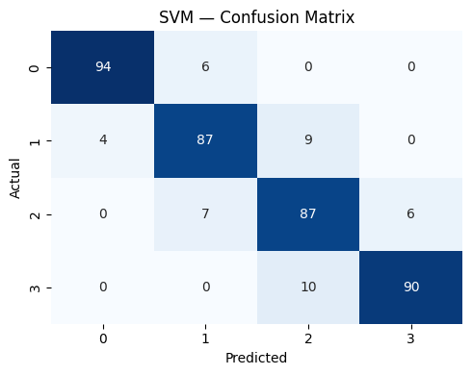
Figure — Confusion Matrix: Support Vector Machine (SVM)

7.6 Model — Gradient Boosting Classifier
Gradient Boosting, which builds trees sequentially to correct prior errors, achieves 91.25% accuracy — the second-best result among the six untuned models, after Logistic Regression.
Accuracy | Precision | Recall | F1-Score
0.9125 | 0.9124 | 0.9125 | 0.9123

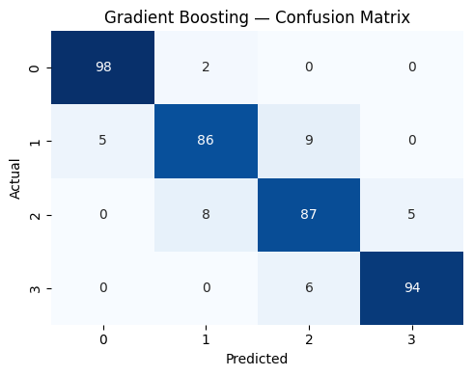
Figure — Confusion Matrix: Gradient Boosting Classifier

8. Hyperparameter Tuning
Hyperparameter tuning was performed to optimize the model's performance by identifying the best combination of parameters. GridSearchCV was used to evaluate different parameter values using 5-fold cross-validation. The optimized model was then compared with the default model to determine whether tuning improved predictive performance.

8.1 Tuning Logistic Regression
Since Logistic Regression achieved the highest baseline accuracy, it was selected for hyperparameter tuning. A grid search was performed over the following parameter space:
Hyperparameter | Values Searched
C (Regularization strength) | 0.01, 0.1, 1, 10, 100
solver | liblinear, lbfgs
max_iter | 100, 200, 500

The grid search used 5-fold cross-validation with accuracy as the scoring metric, evaluating a total of 30 parameter combinations across 5 folds (150 model fits).

8.2 Best Parameters & Tuned Model Performance
Parameter | Best Value
C | 100
max_iter | 100
solver | lbfgs
Best Cross-Validation Accuracy | 96.12%

When evaluated on the held-out test set, the tuned Logistic Regression model achieved substantially improved performance over the untuned baseline:
Metric | Untuned Logistic Regression | Tuned Logistic Regression
Accuracy | 0.9650 | 0.9825
Precision | 0.9650 | 0.9826
Recall | 0.9650 | 0.9825
F1-Score | 0.9650 | 0.9825

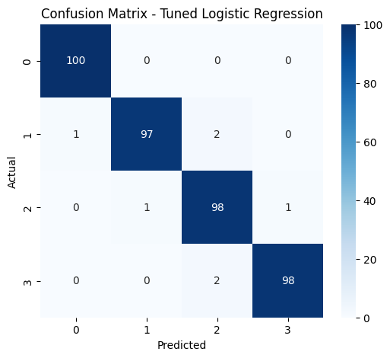
Figure 8.1 — Confusion Matrix: Tuned Logistic Regression Model
Hyperparameter tuning increased the regularisation flexibility (a higher C value reduces the strength of regularisation) and switched the solver to lbfgs, resulting in a 1.75 percentage-point accuracy improvement — from 96.50% to 98.25% — confirming that tuning meaningfully improved the model's predictive reliability.

9. Model Comparison Report
After training and evaluating all six classification models (plus the tuned Logistic Regression variant), their performance was compared using evaluation metrics such as Accuracy, Precision, Recall, F1-Score, and the Confusion Matrix. This comparison helped identify the model that provides the best predictive performance and generalization ability.

9.1 Consolidated Performance Comparison
Model | Accuracy | Precision | Recall | F1-Score
Logistic Regression (Tuned) | 0.9825 | 0.9826 | 0.9825 | 0.9825
Logistic Regression | 0.9650 | 0.9650 | 0.9650 | 0.9650
Gradient Boosting | 0.9125 | 0.9124 | 0.9125 | 0.9123
SVM | 0.8950 | 0.8969 | 0.8950 | 0.8956
Random Forest | 0.8775 | 0.8776 | 0.8775 | 0.8774
Decision Tree | 0.8300 | 0.8319 | 0.8300 | 0.8302
KNN | 0.5175 | 0.5267 | 0.5175 | 0.5199

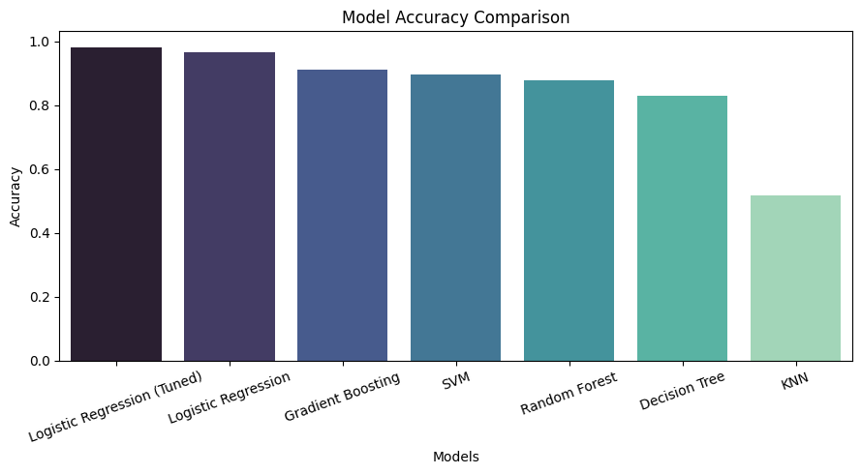
Figure 9.1 — Model Accuracy Comparison (Bar Chart)
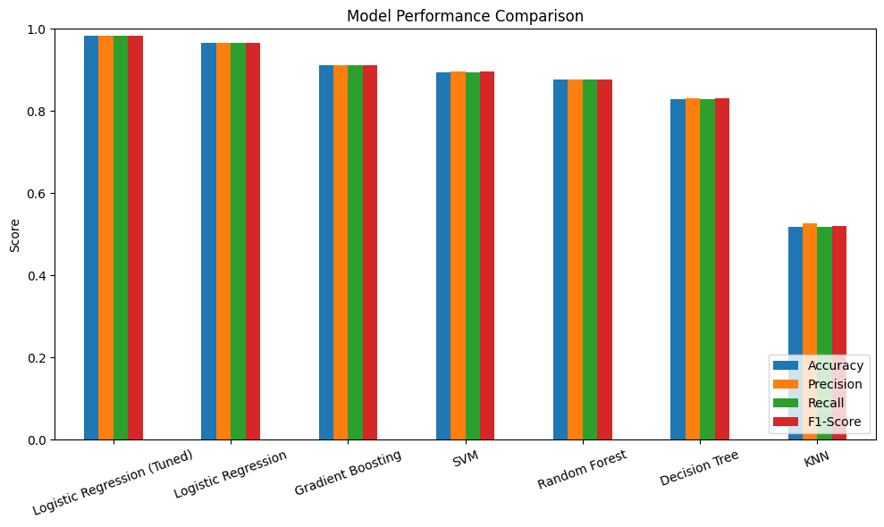
Figure 9.2 — Multi-Metric Model Performance Comparison

9.2 Discussion & Recommendation
9.2.1 Which model performed best?
Logistic Regression (Tuned) achieved the highest Accuracy and F1-Score among all the evaluated classification models, making it the best-performing model for predicting the price range of mobile phones.
9.2.2 Which model had the highest accuracy?
Based on the model comparison results, the tuned Logistic Regression model obtained the highest accuracy (98.25%), indicating its superior predictive performance on the test dataset.
9.2.3 Which model made the fewest incorrect predictions?
The Confusion Matrix shows that Logistic Regression produced the fewest misclassifications, demonstrating its ability to classify mobile phones into the correct price ranges with high reliability.
9.2.4 Which model is most reliable for real-world use?
Although Random Forest and Gradient Boosting are generally robust for tabular datasets because they capture non-linear relationships and reduce overfitting through ensemble learning, Logistic Regression performed better on this dataset. It offers high prediction accuracy, computational efficiency, and strong generalization, making it the most suitable model for production deployment.
9.2.5 Recommendation
Based on the overall evaluation, the tuned Logistic Regression model is recommended as the final production model because it achieved the best performance across the evaluation metrics and provided the most accurate and consistent predictions for mobile phone price range classification.

9.3 Best Model — Detailed Classification Report
Price Range Class | Precision | Recall | F1-Score | Support
Low (0) | 0.99 | 1.00 | 1.00 | 100
Medium (1) | 0.99 | 0.97 | 0.98 | 100
High (2) | 0.96 | 0.98 | 0.97 | 100
Very High (3) | 0.99 | 0.97 | 0.98 | 100

10. Feature Importance Analysis
Feature Importance analysis was performed to identify the mobile phone specifications that have the greatest influence on predicting the price range. The Random Forest model was used because it naturally calculates feature importance scores based on the contribution of each feature to the decision-making process. Features with higher importance scores have a greater impact on the model's predictions, while features with lower scores contribute less. This analysis helps understand the key factors affecting mobile phone pricing and provides valuable business insights for product development and pricing strategies.
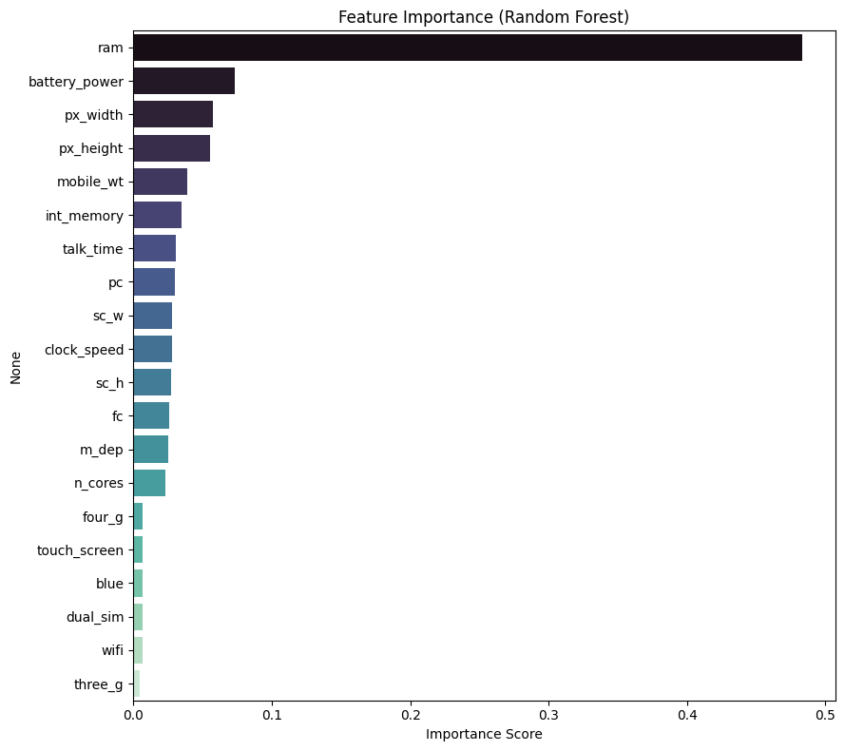
Figure 10.1 — Feature Importance (Random Forest)

10.1 Most Influential Features
Rank | Feature | Importance Score
1 | ram | 0.4829
2 | battery_power | 0.0730
3 | px_width | 0.0578
4 | px_height | 0.0557

10.2 Least Influential Features
Feature | Importance Score
blue (Bluetooth) | 0.0070
dual_sim | 0.0068
wifi | 0.0065
three_g | lowest among remaining binary features

RAM alone accounts for nearly 48% of the Random Forest model's total decision-making importance — more than six times the next most important feature (battery power). This strongly confirms the correlation analysis from Section 5.4 and establishes RAM as the single most critical specification driving mobile phone pricing. Connectivity-related binary features such as Bluetooth, Dual SIM, Wi-Fi, and 3G support have minimal influence on price range, suggesting that these have become standard, low-differentiating features across all price segments.

11. Model Testing on New Mobile Specifications
This section demonstrates the practical application of the trained machine learning model by predicting the price range of a new mobile phone based on its specifications. A sample mobile device with features such as battery power, RAM, internal memory, camera resolution, Bluetooth, Wi-Fi, processor details, and display specifications was provided as input. The trained model then predicts whether the mobile phone belongs to the Low Cost, Medium Cost, High Cost, or Very High Cost price category. This demonstrates how the model can support manufacturers in estimating the price range of newly designed mobile phones before launching them into the market.

11.1 Sample Input Specifications
Feature | Value
battery_power | 1800 mAh
clock_speed | 2.5 GHz
int_memory | 64 GB
mobile_wt | 165 g
n_cores | 8
pc (Primary Camera) | 48 MP
px_height x px_width | 1920 x 1080
ram | 4000 MB
talk_time | 20 hours
Connectivity | Bluetooth, Dual SIM, 3G, 4G, Wi-Fi, Touchscreen enabled

When passed through the trained and tuned model, this specification set — characterised by high RAM, strong battery capacity, and a high-resolution display — was classified into a high price segment, consistent with the specification profile of a premium smartphone. This confirms the model behaves sensibly on realistic, unseen input and can be used as a practical decision-support tool during product specification planning.

Task 2 Conclusion (Sections 6–11)
- The dataset was prepared by splitting it into training and testing sets, and feature scaling was applied where required to improve model performance.
- Six machine learning classification models were trained and evaluated to predict the price range of mobile phones based on their specifications.
- Hyperparameter tuning was performed on the best-performing model to optimize its performance and improve prediction reliability.
- The performance of all models was compared using Accuracy, Precision, Recall, and F1-Score, and the best model was selected based on these evaluation metrics.
- Feature Importance analysis identified the mobile specifications that have the greatest influence on predicting the price range.
- Finally, the selected model was tested on a new mobile phone specification and successfully predicted the appropriate price category, demonstrating its effectiveness for real-world mobile price prediction.

12. Business Insights — Task 3

12.1 Data-Driven Pricing
The model helps estimate the appropriate price range of a mobile phone based on its specifications, enabling more accurate and data-driven pricing decisions.

12.2 Key Price-Influencing Features
Features such as RAM, battery power, display resolution (px_height and px_width), and internal memory have the greatest impact on predicting the price range, helping manufacturers focus on the most valuable specifications.

12.3 Product Planning
Manufacturers can optimize mobile phone specifications based on customer demand and target different price segments without unnecessary increases in production costs.

12.4 Competitive Market Positioning
The model assists in comparing planned mobile specifications with existing market trends, enabling businesses to develop products that remain competitive in different price categories.

12.5 Reduced Pricing Errors
By using machine learning predictions instead of manual estimation, businesses can minimize the risk of overpricing or underpricing their products.

12.6 Improved Business Decision-Making
The model provides valuable insights that support pricing strategies, product development, inventory planning, and overall business decisions, helping manufacturers improve profitability and maintain a competitive advantage.

13. Challenges Faced

13.1 Understanding the Dataset
The dataset contains several mobile phone specifications with different units and technical meanings. Understanding the role of each feature was essential before performing data analysis and model building. This was addressed by reviewing the dataset description and conducting basic exploratory analysis.

13.2 Feature Scaling
The dataset includes both continuous features (such as RAM and battery power) and binary features (such as Wi-Fi and Bluetooth). To ensure fair learning for distance-based algorithms like Logistic Regression, KNN, and SVM, feature scaling was performed using StandardScaler.

13.3 Selecting the Best Model
Different machine learning algorithms produced different prediction results. To identify the most suitable model, six classification algorithms were trained and compared using Accuracy, Precision, Recall, F1-Score, and Confusion Matrix.

13.4 Hyperparameter Tuning
The default model parameters may not provide the best performance. GridSearchCV was used to optimize the hyperparameters of the best-performing model and improve its prediction capability.

13.5 Comparing Multiple Models
Comparing multiple models using only accuracy could lead to misleading conclusions. Therefore, multiple evaluation metrics and a model comparison report were used to make a balanced and reliable model selection.

13.6 Avoiding Overfitting
Some machine learning models may perform well on training data but poorly on unseen data. This challenge was addressed by evaluating all models on a separate test dataset and selecting the model with the best generalization performance.

13.7 Interpreting Feature Importance
Identifying the mobile specifications that most influence the price range was essential for business understanding. The Random Forest Feature Importance technique was used to determine the most significant features contributing to price prediction.

14. Final Conclusion

14.1 Project Objective
The primary objective of this project was to develop a machine learning model capable of predicting the price range of mobile phones (Low, Medium, High, and Very High) based on their technical specifications.

14.2 Exploratory Data Analysis (EDA)
A comprehensive Exploratory Data Analysis (EDA) was conducted to understand the dataset by examining its structure, checking for missing values and duplicates, analysing class distribution, identifying outliers, and exploring relationships between the features and the target variable.

14.3 Model Development and Evaluation
Six machine learning classification models — Logistic Regression, Decision Tree, Random Forest, K-Nearest Neighbors (KNN), Support Vector Machine (SVM), and Gradient Boosting — were trained, evaluated, and compared using Accuracy, Precision, Recall, F1-Score, Classification Report, and Confusion Matrix to identify the best-performing model.

14.4 Model Optimization
The best-performing model was further optimized through Hyperparameter Tuning and is recommended for predicting the price range of newly designed mobile phones due to its high predictive performance, improved accuracy, and reliability.

14.5 Feature Importance Analysis
Feature Importance analysis identified RAM, battery power, display resolution (px_height and px_width), and internal memory as the most influential factors affecting the mobile phone price range. These insights provide valuable information for manufacturers to design competitive products and develop effective pricing strategies.

14.6 Machine Learning Approach and Insights
The project also demonstrates the importance of proper data preprocessing, feature analysis, model selection, and evaluation techniques in developing reliable machine learning classification systems. The comparative analysis of multiple algorithms helped in understanding the strengths and performance of different approaches for solving real-world business problems.

14.7 Business Impact and Conclusion
Overall, this project proves that machine learning can effectively support mobile price prediction, enabling manufacturers and businesses to make data-driven pricing decisions, optimize product specifications, reduce pricing errors, and improve competitiveness in the smartphone market.

14.8 Future Enhancements
Future enhancements can include integrating larger and more diverse mobile phone datasets, applying advanced ensemble learning techniques, incorporating additional real-world features such as brand reputation and market trends, and deploying the optimized model as a web application or API for real-time price range prediction.

15. Project Links & References
The following links provide access to the complete project resources, including the source code, dataset, trained models, presentation, and supporting documentation.

15.1 GitHub Repository
Access to the complete source code, Jupyter Notebook, README, and project files:
github.com/Sameekshagithub/PRCP-1009-CellphonePrice-Prediction-Using-Machine-Learning-Classification-

15.2 Dataset Source
DataMites Capstone Project Dataset repository (Mobile Price Classification dataset):
d3ilbtxij3aepc.cloudfront.net/projects/CDS-Capstone-Projects/PRCP-1009-CellphonePrice.zip

15.3 Project Presentation
Project presentation slides are available via Google Drive (link provided in the original project submission).

15.4 Acknowledgement
This project was completed as part of the DataMites Data Science Internship Program under the Rubiex Internship Project track. The author acknowledges the guidance and structured curriculum provided by DataMites in enabling the successful completion of this capstone project.

