
DATAMITES
Rubiex Internship Project — Data Science Capstone Project
PRCP-1009: Cellphone Price Range Prediction Using Machine Learning
Executive Summary Report
Submitted By | Sameeksha
Team Code / Project Code | PTID-AIE-JUL-26-11142 / PRCP-1009
Dataset | Mobile Price Classification — 2,000 records, 20 features
Best Model | Logistic Regression (Tuned) — 98.25% Accuracy

1. Problem Statement & Objective
The objective of this project is to analyze mobile phone specifications and build a machine learning classification model to predict the price range of a mobile phone — Low, Medium, High, or Very High — based on its technical features. The project compares multiple classification algorithms, identifies the most influential price-driving features, and delivers business insights for effective pricing decisions.

2. Dataset & Methodology
The dataset (datasets_11167_15520_train.csv) contains 2,000 mobile phone records with 20 input features — including battery power, RAM, internal memory, camera resolution, processor cores, screen dimensions, and connectivity options — and a balanced target variable (price_range) with 500 records in each of the four classes. The data was found to be clean, with no missing values or duplicate records.
The dataset was split 80:20 into training and test sets with stratified sampling. Features were scaled using StandardScaler for distance-sensitive algorithms (Logistic Regression, KNN, SVM), while tree-based models used raw features. Six classification algorithms — Logistic Regression, Decision Tree, Random Forest, KNN, SVM, and Gradient Boosting — were trained and evaluated, and the best model was further optimised using GridSearchCV hyperparameter tuning.

3. Model Comparison & Results
Model | Accuracy | Precision | Recall | F1-Score
Logistic Regression (Tuned) | 0.9825 | 0.9826 | 0.9825 | 0.9825
Logistic Regression | 0.9650 | 0.9650 | 0.9650 | 0.9650
Gradient Boosting | 0.9125 | 0.9124 | 0.9125 | 0.9123
SVM | 0.8950 | 0.8969 | 0.8950 | 0.8956
Random Forest | 0.8775 | 0.8776 | 0.8775 | 0.8774
Decision Tree | 0.8300 | 0.8319 | 0.8300 | 0.8302
KNN | 0.5175 | 0.5267 | 0.5175 | 0.5199

After GridSearchCV tuning (best parameters: C=100, solver='lbfgs'), Logistic Regression improved from 96.50% to 98.25% accuracy, making it the recommended production model. It offers the highest accuracy, fewest misclassifications, and strong computational efficiency compared to the ensemble and distance-based alternatives tested.

4. Key Findings — Feature Importance
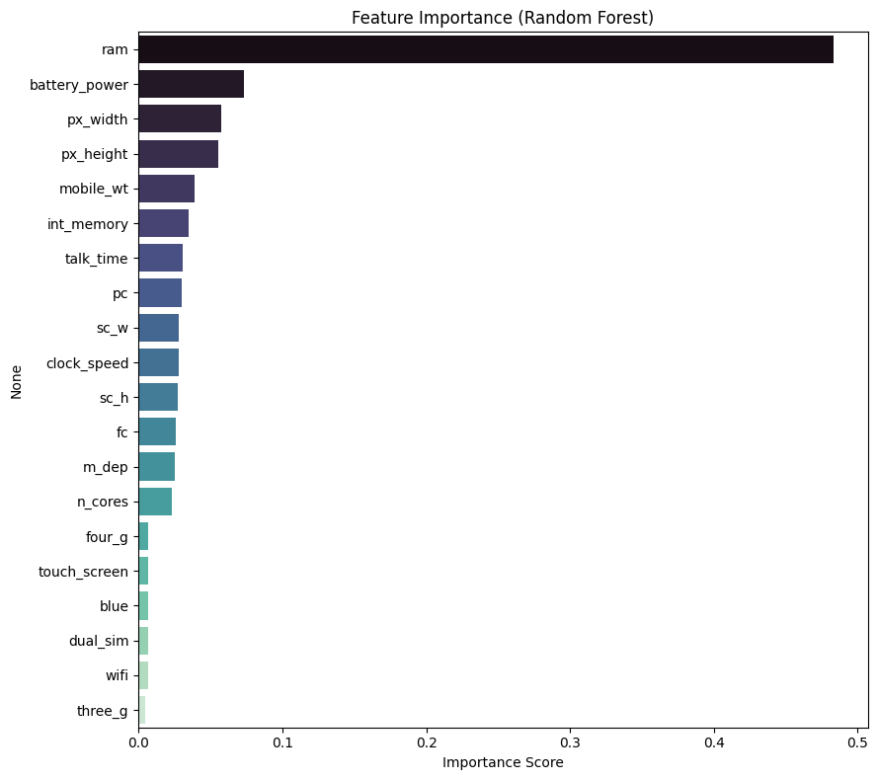
Feature Importance (Random Forest)
- RAM: By far the strongest predictor (~48% importance / 0.917 correlation with price range).
- Battery Power: Second most influential specification (~7% importance).
- Screen Resolution (px_width, px_height): Moderately influential; higher resolution associates with higher price tiers.
- Internal Memory: Meaningful but secondary influence on price range.
- Connectivity (Bluetooth, Wi-Fi, Dual SIM, 3G): Minimal influence — largely standardised across all price segments.

5. Business Insights
- Data-Driven Pricing: The model enables manufacturers to estimate the appropriate price range from a device's specifications rather than relying on manual estimation.
- Product Planning: Manufacturers can optimise specifications for target price segments without unnecessary cost increases.
- Competitive Positioning: The model supports benchmarking planned specifications against market price trends.
- Reduced Pricing Errors: Machine-learning-based estimation minimises the risk of overpricing or underpricing new devices.

6. Conclusion
This capstone project successfully developed and validated a machine learning pipeline capable of classifying mobile phones into four price categories with 98.25% accuracy using a tuned Logistic Regression model. RAM, battery power, and display resolution were identified as the primary drivers of mobile phone pricing. The findings provide manufacturers with a reliable, data-driven decision-support tool for product specification planning and competitive pricing strategy. Future enhancements could include larger and more diverse datasets, additional real-world features such as brand and market trends, and deployment of the model as a live web application or API.

7. Project Links
GitHub Repository: github.com/Sameekshagithub/PRCP-1009-CellphonePrice-Prediction-Using-Machine-Learning-Classification-

