
DATAMITES
Rubiex Internship Project — Data Science Capstone Project
PRCP-1025: Flight Fare Prediction Using Machine Learning
Executive Summary Report
Submitted By | Sameeksha
Team Code / Project Code | PTID-AIE-JUL-26-11142 / PRCP-1025
Dataset | Flight Fare Prediction — 10,462 records (after cleaning), 10 features
Best Model | Random Forest Regressor (Tuned) — R² Score 0.8298

1. Problem Statement & Objective
Flight ticket prices are highly dynamic — the same flight can cost a different amount today, tomorrow, and next week. The objective of this project is to analyze historical flight booking data and build a machine learning regression model that predicts flight fare based on features such as airline, source, destination, route, duration, number of stops, and journey date. The project compares multiple regression algorithms, identifies the most influential price-driving features, and delivers business insights for effective fare estimation.

2. Dataset & Methodology
The dataset (Flight_Fare.xlsx) originally contained 10,683 flight booking records with 10 input features. After removing 1 missing-value row and 220 duplicate rows, 10,462 clean records remained. Raw Date_of_Journey, Dep_Time, Arrival_Time, and Duration text fields were engineered into numeric features (journey day/month, departure/arrival hour and minute, duration in minutes); Total_Stops was ordinal-encoded, and Route/Additional_Info were dropped due to high cardinality and redundancy.
The dataset was split 80:20 into training (8,369) and test (2,093) sets. Features were scaled using StandardScaler for distance-sensitive algorithms (Linear Regression, KNN, SVR), while tree-based models used raw features. Six regression algorithms — Linear Regression, Decision Tree, Random Forest, KNN, SVR, and Gradient Boosting — were trained and evaluated, and the best model was further optimised using GridSearchCV hyperparameter tuning.

3. Model Comparison & Results
Model | MAE (₹) | RMSE (₹) | R² Score
Random Forest (Tuned) | 1,129.25 | 1,884.02 | 0.8298
Random Forest | 1,168.995 | 1,964.965 | 0.8148
Gradient Boosting | 1,536.82 | 2,267.96 | 0.7533
KNN | 1,393.16 | 2,276.94 | 0.7513
Decision Tree | 1,383.09 | 2,439.33 | 0.7146
Linear Regression | 1,998.64 | 2,945.80 | 0.5838
SVR | 3,364.94 | 4,408.22 | 0.0680

After GridSearchCV tuning (best parameters: max_depth=20, min_samples_split=5, n_estimators=200), Random Forest improved from an R² Score of 0.8148 to 0.8298 (RMSE ₹1,964.97 → ₹1,884.02), making it the recommended production model. It offers the lowest prediction error and best generalisation compared to the linear and distance-based alternatives tested.

4. Key Findings — Feature Importance
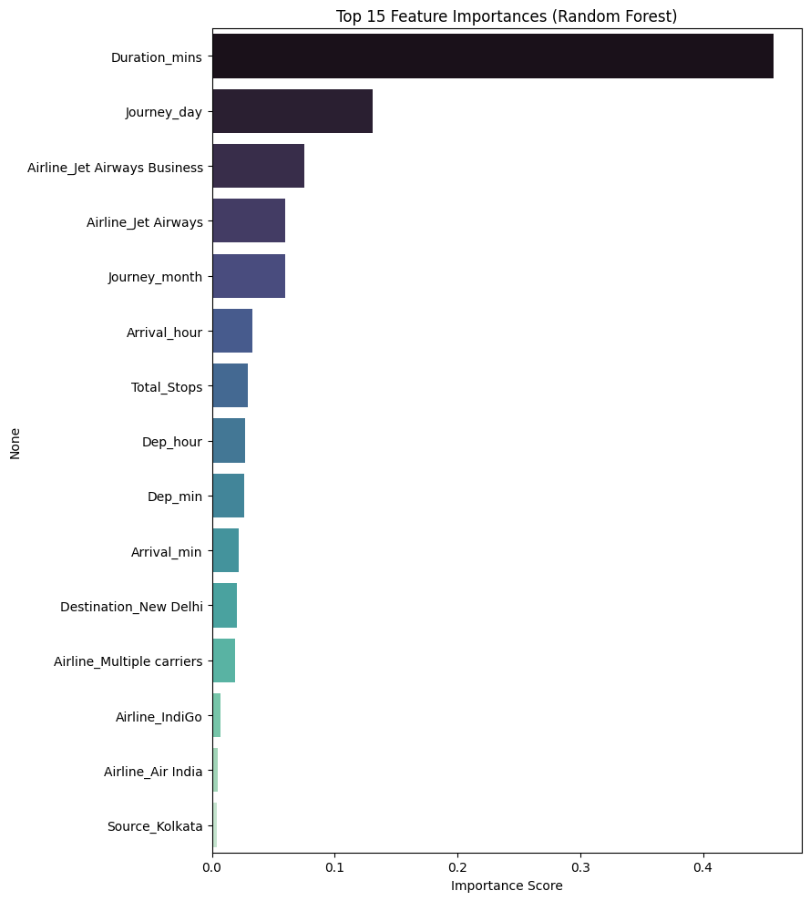
Feature Importance (Random Forest)
- Flight Duration: By far the strongest predictor (~46% importance).
- Journey Day: Second most influential factor (~13% importance).
- Airline (Jet Airways Business/Jet Airways): Premium carriers and business class command notably higher fares.
- Journey Month: Meaningful but secondary influence on fare.
- Source / Destination City: Minimal influence — most route-city categories contribute very little individually.

5. Business Insights
- Data-Driven Fare Estimation: The model enables customers and travel platforms to estimate expected fares from booking details rather than relying on manual estimation.
- Customer Booking Guidance: Customers can identify cheaper booking windows, route/stop combinations, and travel dates to plan journeys more cost-effectively.
- Route & Capacity Planning: Airlines can compare predicted fares against actual market prices on specific routes to fine-tune pricing and capacity strategies.
- Reduced Pricing Errors: Machine-learning-based estimation minimises the risk of mispricing tickets relative to the market.

6. Conclusion
This capstone project successfully developed and validated a machine learning pipeline capable of predicting flight ticket fares with an R² Score of 0.8298 using a tuned Random Forest Regressor. Flight duration, journey day, and airline/class were identified as the primary drivers of flight pricing. The findings provide travellers and travel businesses with a reliable, data-driven decision-support tool for fare estimation and pricing strategy. Future enhancements could include larger and more recent datasets, advanced boosting techniques (XGBoost, LightGBM), additional real-world features such as seasonal demand and fuel prices, and deployment as a live web application or API.

7. Project Links
GitHub Repository: github.com/Sameekshagithub/PRCP-1025-Flight-Fare-Price-Prediction-Using-Machine-Learning-Regression

