
DATAMITES
Global Training & Certification Institute for Data Science
DATA SCIENCE CAPSTONE PROJECT
PRCP-1025: Flight Fare Prediction Using Machine Learning
Rubiex Internship Project
Submitted in Partial Fulfilment of the DataMites Data Science Internship Program
Project Title: PRCP-1025: Flight Fare Prediction Using Machine Learning
Team Code: PTID-AIE-JUL-26-11142
Project Code: PRCP-1025
Project Type: Data Science Capstone Project / Rubiex Internship Project
Dataset Source: DataMites Capstone Project Dataset
Dataset Name: Flight Fare Prediction Dataset (Flight_Fare.xlsx)
Organization: DataMites Solutions Pvt. Ltd.
Submitted By: Sameeksha
Report Date: August 2026

About the Author
This capstone project has been prepared and submitted as part of the DataMites Data Science Internship Program, carried out under the Rubiex Internship Project initiative. The following section provides a brief profile of the project author.
Name | Sameeksha
Role | Data Science Intern / Capstone Project Author
Program | DataMites Data Science Internship Program
Internship Track | Rubiex Internship Project
Team Code | PTID-AIE-JUL-26-11142
Project Code | PRCP-1025
Project Title | Flight Fare Prediction Using Machine Learning
Tools & Technologies | Python, Pandas, NumPy, Matplotlib, Seaborn, Scikit-learn, Jupyter Notebook
Core Skills Applied | Exploratory Data Analysis, Feature Engineering, Regression Modelling, Hyperparameter Tuning, Model Evaluation, Business Insight Generation
GitHub Repository | github.com/Sameekshagithub/PRCP-1025-Flight-Fare-Price-Prediction-Using-Machine-Learning-Regression

As part of this internship, the author independently carried out the complete data science lifecycle for the assigned capstone problem — from problem understanding and domain analysis, through exploratory data analysis, feature engineering, model building, hyperparameter tuning, and model evaluation, to the final generation of business insights and recommendations. The project reflects hands-on application of supervised machine learning regression techniques on a real-world structured dataset, in line with the learning objectives of the DataMites Data Science Internship Program under the Rubiex Internship Project track.

Table of Contents
1. Problem Statement & Project Objective
2. Import Python Libraries
3. Upload the Dataset & Domain Analysis
4. Basic Checks
5. Exploratory Data Analysis (EDA) — Task 1
6. Data Preparation for Modelling — Task 2
7. Model Building & Training
8. Hyperparameter Tuning
9. Model Comparison Report
10. Feature Importance
11. Model Testing on New Flight Details
12. Business Insights — Task 3
13. Challenges Faced
14. Final Conclusion
15. Project Links

Executive Summary
Flight ticket prices are highly dynamic — the same flight can cost a different amount today, tomorrow, and next week, depending on airline, route, timing, number of stops, and how far in advance it is booked. This unpredictability makes it difficult for both travellers and travel businesses to plan bookings and pricing strategies effectively.
This capstone project, undertaken as part of the DataMites Data Science Internship Program under the Rubiex Internship Project track, addresses this problem through a data-driven approach. Using a historical flight booking dataset of 10,683 records, a complete machine learning regression pipeline was developed to predict flight ticket fares from booking details such as airline, source, destination, route, duration, number of stops, and journey date.
The project followed a structured data science workflow consisting of domain analysis, exploratory data analysis, feature engineering, model building using six different regression algorithms, hyperparameter tuning, model comparison, feature importance analysis, and practical model testing. A tuned Random Forest Regressor emerged as the best-performing model, achieving an R² Score of 0.8298 (an RMSE of ₹1,884), outperforming Linear Regression, Decision Tree, K-Nearest Neighbours, Support Vector Regressor, and Gradient Boosting on this dataset.
The analysis revealed that flight duration is overwhelmingly the strongest predictor of fare, followed by the day of the journey and airline (particularly Jet Airways Business class). These findings offer actionable business insights for both travellers seeking cheaper fares and airlines or travel platforms seeking to fine-tune pricing strategy. This report documents the complete methodology, results, and business recommendations arising from the project.

1. Problem Statement & Project Objective

1.1 Problem Statement
Flight ticket prices are highly dynamic — the same flight can cost a different amount today, tomorrow, and next week. The objective of this project is to analyze historical flight booking data and develop a machine learning regression model that predicts the fare of a flight based on features such as airline, source, destination, route, duration, number of stops, and journey date. The project also involves comparing multiple regression models, identifying the most influential features affecting price, and providing business insights for effective fare estimation.

1.2 Project Objectives
- Perform Exploratory Data Analysis (EDA) to understand the dataset.
- Preprocess and prepare the data for model development.
- Build and train multiple regression models.
- Evaluate and compare model performance using appropriate metrics.
- Select the best-performing model for production.
- Analyze feature importance to identify the key factors influencing flight price.
- Provide business insights and recommendations based on the model results.
- Summarize the challenges faced and the techniques used during the project.

2. Import Python Libraries
The required Python libraries were imported to perform data analysis, visualization, machine learning model development, and performance evaluation. NumPy and Pandas were used for data manipulation, Matplotlib and Seaborn were used for data visualization, and Scikit-learn provided the tools for data preprocessing, model training, and evaluating the performance of different regression algorithms.
Library | Purpose in the Project
NumPy | Numerical computations and array operations
Pandas | Data loading, manipulation, and analysis (including reading the Excel dataset)
Matplotlib | Static data visualizations and charts
Seaborn | Statistical and aesthetically enhanced visualizations
Scikit-learn | Preprocessing, model building, tuning, and evaluation
Warnings | Suppressing non-critical runtime warnings

Specifically, from Scikit-learn, the following modules were used: train_test_split and GridSearchCV for data splitting and hyperparameter search, StandardScaler for feature scaling, LinearRegression, DecisionTreeRegressor, RandomForestRegressor, GradientBoostingRegressor, KNeighborsRegressor and SVR as regression algorithms, and mean_absolute_error, mean_squared_error and r2_score for model evaluation.

3. Upload the Dataset & Domain Analysis

3.1 Upload the Dataset
The Flight_Fare.xlsx dataset was uploaded and loaded into the Jupyter Notebook using the Pandas library. The dataset contains historical flight booking records along with the corresponding ticket price, which serves as the target variable for building and evaluating machine learning regression models.

3.2 Domain Analysis
This project belongs to the airline pricing domain, where the objective is to estimate the fare of a flight based on its booking details. Features such as airline, source, destination, route, duration, number of stops, and journey date significantly influence the ticket price. By analyzing these features, machine learning models can help customers plan bookings around cheaper fares and help airlines understand which factors drive their pricing.

3.3 Dataset Description
Attribute | Details
Dataset Name | Flight Fare Prediction Dataset
File Name | Flight_Fare.xlsx
Total Records (raw) | 10,683
Total Columns | 11 (10 input features + 1 target variable)
Target Variable | Price (flight ticket fare, in ₹)
Source | DataMites Capstone Project Dataset

The 10 input features include: Airline, Date_of_Journey, Source, Destination, Route, Dep_Time, Arrival_Time, Duration, Total_Stops, and Additional_Info.

4. Basic Checks
Basic checks were performed to understand the structure and quality of the dataset before conducting exploratory data analysis and model development. This included viewing sample records, examining dataset dimensions, identifying data types, generating descriptive statistics, checking for missing values, detecting duplicate records, and obtaining summary information about the dataset.

4.1 Dataset Dimensions
The raw dataset shape was found to be (10683, 11) — 10,683 flight booking records and 11 columns (10 features plus the Price target variable).

4.2 Data Types
All 10 input feature columns are of object (text) type, since Airline, Source, Destination, Route, timing, and duration were all stored as strings in the raw file. Only the target variable, Price, is numeric (int64).

4.3 Unique Values per Column
Column | Unique Values
Airline | 12
Date_of_Journey | 44
Source | 5
Destination | 6
Route | 128
Dep_Time | 222
Arrival_Time | 1,343
Duration | 368
Total_Stops | 5
Additional_Info | 10
Price | 1,870

4.4 Missing Values & Duplicate Records
A check for missing values using df.isnull().sum() found 1 missing value in Route and 1 missing value in Total_Stops (both from the same incomplete row). A duplicate record check using df.duplicated().sum() found 220 duplicate rows. Both the missing-value row and the 220 duplicate rows were dropped, and the index was reset, leaving a clean dataset of 10,462 records for further analysis and modelling.

4.5 Target Variable Summary (After Cleaning)
Statistic | Price (₹)
Count | 10,462
Mean | 9,026.79
Std. Dev. | 4,624.85
Minimum | 1,759
25th Percentile | 5,224
Median (50%) | 8,266
75th Percentile | 12,344.75
Maximum | 79,512

5. Exploratory Data Analysis (EDA) — Task 1
Exploratory Data Analysis (EDA) was performed to gain a comprehensive understanding of the dataset before building machine learning models. This process helped identify the distribution of the target variable, understand the characteristics of each feature, detect missing values and duplicate records, identify outliers, and analyze relationships among variables. EDA also revealed patterns, trends, and correlations within the data, enabling informed decisions regarding data preprocessing, feature selection, and model development.

5.1 Target Variable Distribution
The distribution of the Price target variable was visualized using a histogram with a kernel density estimate (KDE) overlay.
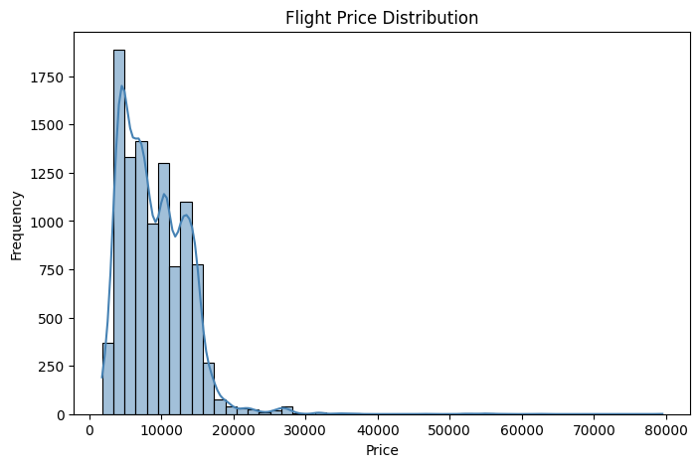
Figure 5.1 — Flight Price Distribution
The Price distribution is right-skewed, with most fares concentrated in the lower-to-mid range (broadly ₹5,000–₹12,000) and a smaller number of high-fare bookings extending up to ₹79,512.

5.2 Distribution of Key Categorical Features
Count plots were generated for the most business-relevant categorical features — Airline, Source, Destination, and Total_Stops — to understand the composition of the dataset.
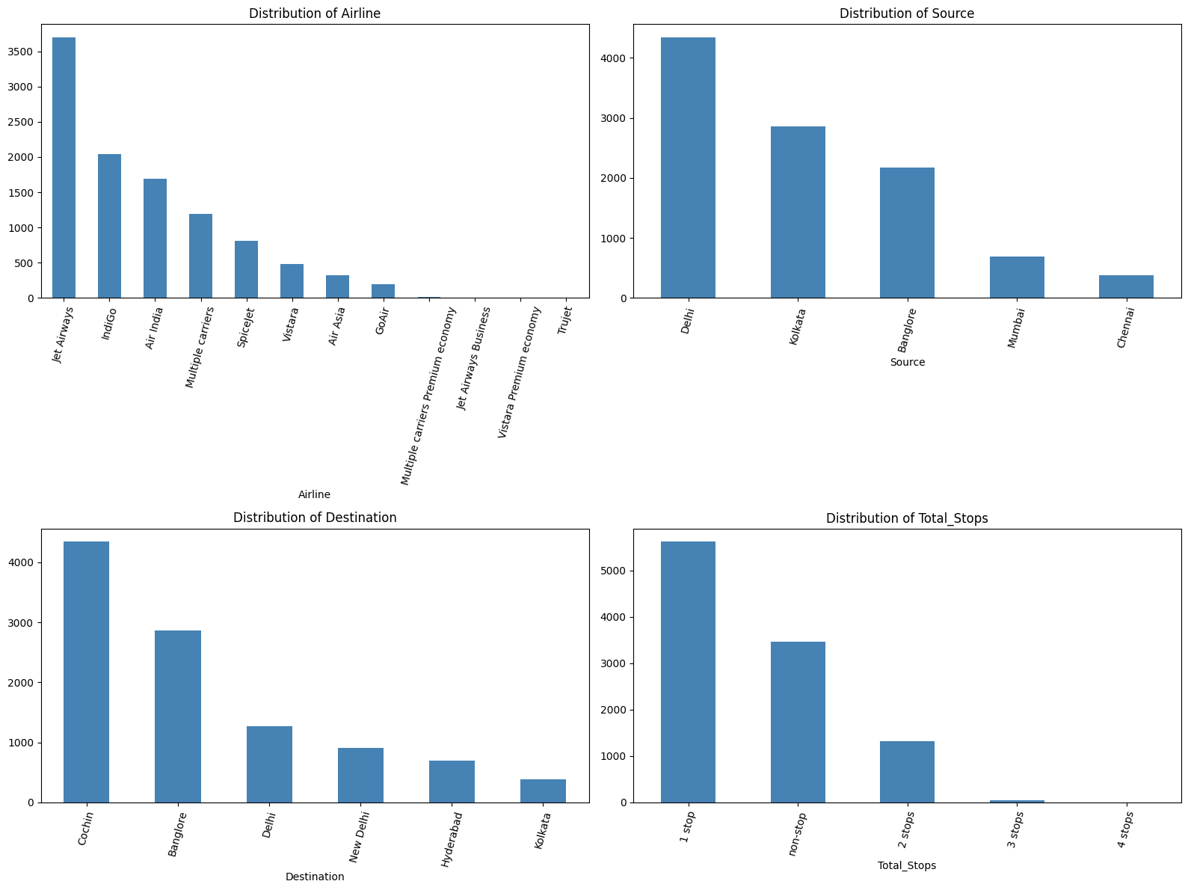
Figure 5.2 — Distribution of Key Categorical Features
Jet Airways and IndiGo dominate the Airline column, Delhi and Kolkata are the most frequent Source cities, Cochin is the most frequent Destination, and flights with 1 stop are the most common Total_Stops category in the dataset.

5.3 Bivariate Analysis — Feature Relationships with Price
Boxplots were used to examine how each key categorical feature relates to the Price target variable.
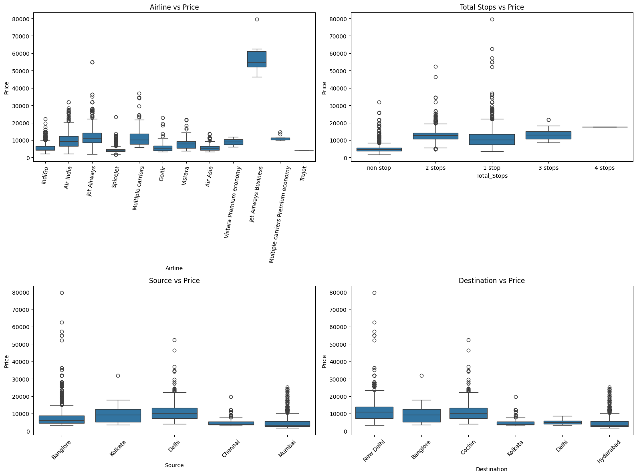
Figure 5.3 — Bivariate Analysis: Airline, Source, Destination and Total_Stops vs. Price
Bivariate analysis shows that Airline, Total_Stops, Source, and Destination all visibly shift the price distribution — for example, Jet Airways Business class commands substantially higher fares than economy carriers, and fares generally increase with the number of stops — confirming they are informative features for the regression model.

5.4 Outlier Detection
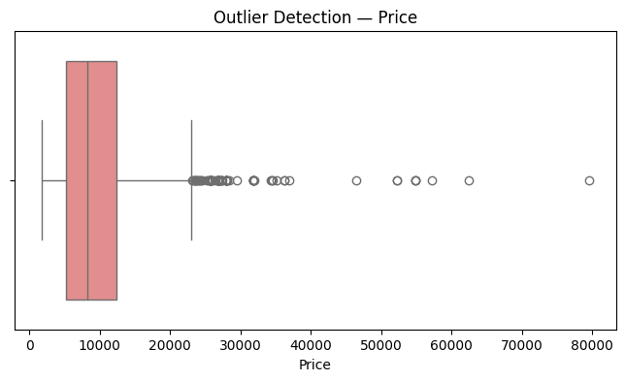
Figure 5.4 — Outlier Detection: Price
Using the IQR method, 94 outliers were detected in the Price column. However, these represent valid premium or long-haul bookings rather than data entry errors, and were therefore retained in the dataset for model training rather than removed or capped.

5.5 Correlation Analysis
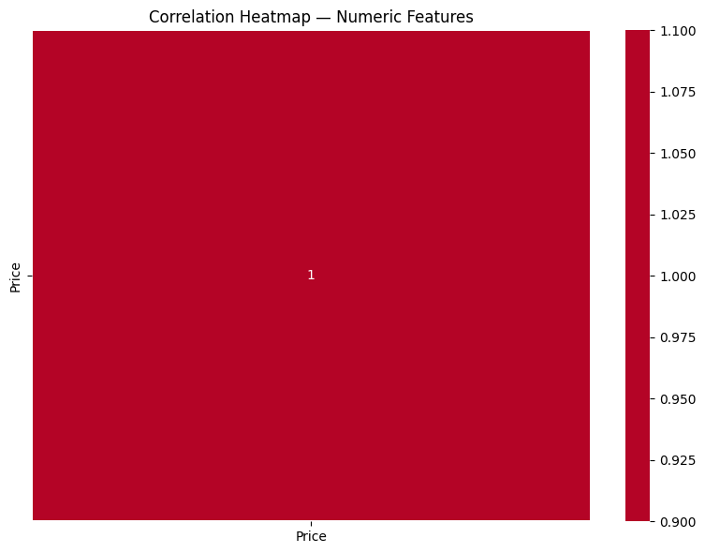
Figure 5.5 — Correlation Heatmap (Numeric Features)
A correlation heatmap was generated across the numeric features available at this stage of the analysis (categorical features such as Airline, Source, and Destination are encoded later, in Section 6, before being fed into the models).

5.6 EDA Summary (Task 1 Conclusion)
- The dataset contains flight booking records with airline, route, timing, and stop information, providing sufficient information for fare prediction.
- After removing a small number of missing values and duplicate rows, the dataset is clean and reliable for machine learning model development.
- The Price distribution is right-skewed, with most fares concentrated in the lower-to-mid range and a smaller number of high-fare bookings.
- Bivariate analysis shows that Airline, Total_Stops, Source, and Destination all visibly shift the price distribution, confirming they are informative features for the model.
- Outlier analysis shows the presence of some high-fare values; however, these represent valid premium or long-haul bookings rather than data errors, so they are retained for model training.

6. Data Preparation for Modelling — Task 2

6.1 Feature Engineering
The raw Date_of_Journey, Dep_Time, Arrival_Time, and Duration columns are text and cannot be used directly by regression algorithms, so they were converted into numeric features: Journey_day and Journey_month (from Date_of_Journey), Dep_hour/Dep_min and Arrival_hour/Arrival_min (from the time columns), and a Duration_mins column parsed from strings such as "2h 50m". Total_Stops was converted into an ordinal number (0, 1, 2, ...), and the Route and Additional_Info columns were dropped, as explained in Section 13 (Challenges Faced).
The remaining nominal categorical features — Airline, Source, and Destination — were one-hot encoded using pd.get_dummies(), expanding the dataset from 11 columns to 29 columns after encoding.

6.2 Train / Test Split
The independent features (X) were separated from the target variable (y = Price). The dataset was then split using an 80:20 ratio, with a fixed random_state of 42 used to ensure reproducibility.
Split | Number of Samples
Training Set | 8,369
Test Set | 2,093

6.3 Feature Scaling
StandardScaler from Scikit-learn was applied to standardise the feature values (zero mean, unit variance) for the training and test sets. This scaled version of the data was used for the distance/margin-sensitive algorithms (Linear Regression, KNN, SVR), while the original unscaled features were used directly for the tree-based algorithms (Decision Tree, Random Forest, Gradient Boosting), which are unaffected by feature scale.

7. Model Building & Training
To predict flight fares, multiple machine learning regression algorithms were trained and evaluated. Instead of relying on a single model, six different regressors were developed and compared to identify the most accurate and reliable model for this task. This approach satisfies the Model Comparison Report requirement and helps select the most suitable model for production deployment.
- Model 1 — Linear Regression — a simple baseline regression model that fits a straight-line relationship between features and price.
- Model 2 — Decision Tree Regressor — a tree-based model that learns decision rules from flight booking details.
- Model 3 — Random Forest Regressor — an ensemble model that combines multiple decision trees to improve accuracy and reduce overfitting.
- Model 4 — K-Nearest Neighbors (KNN) Regressor — a distance-based algorithm that estimates price from similar nearby flights.
- Model 5 — Support Vector Regressor (SVR) — a margin-based regressor that tries to fit prices within an error tolerance band.
- Model 6 — Gradient Boosting Regressor — an ensemble boosting algorithm that builds decision trees sequentially to achieve high predictive performance.

7.1 Model — Linear Regression
As a linear baseline model, Linear Regression achieves an R² Score of 0.5838 with an RMSE of ₹2,945.80. It struggles to capture the non-linear relationships between airline, stops, route, and price, limiting its predictive power on this dataset.
MAE (₹) | MSE | RMSE (₹) | R² Score
1998.64 | 8,677,715 | 2945.80 | 0.5838

7.2 Model — Decision Tree Regressor
The single Decision Tree improves substantially on the linear baseline, reaching an R² Score of 0.7146 (RMSE ₹2,439.33) by capturing non-linear interactions between features, though it remains prone to overfitting on training data.
MAE (₹) | MSE | RMSE (₹) | R² Score
1383.09 | 5,950,313 | 2439.33 | 0.7146

7.3 Model — Random Forest Regressor
By aggregating 200 decision trees, Random Forest achieves a strong R² Score of 0.8148 (RMSE ₹1,964.97), the best result among the six untuned models, and reduces the variance associated with individual trees.
MAE (₹) | MSE | RMSE (₹) | R² Score
1168.995 | 3,861,087 | 1964.965 | 0.8148

7.4 Model — K-Nearest Neighbours (KNN) Regressor
KNN (k = 7) achieves a respectable R² Score of 0.7513 (RMSE ₹2,276.94) by estimating fares from similar nearby flights, though it is outperformed by the tree-based ensemble models.
MAE (₹) | MSE | RMSE (₹) | R² Score
1393.16 | 5,184,467 | 2276.94 | 0.7513

7.5 Model — Support Vector Regressor (SVR)
The RBF-kernel SVR performs poorly on this dataset, achieving only an R² Score of 0.0680 (RMSE ₹4,408.22) — the weakest of the six models, suggesting the default SVR configuration does not fit the scale and spread of flight prices well without further tuning.
MAE (₹) | MSE | RMSE (₹) | R² Score
3364.94 | 19,432,410 | 4408.22 | 0.0680

7.6 Model — Gradient Boosting Regressor
Gradient Boosting, which builds trees sequentially to correct prior errors, achieves an R² Score of 0.7533 (RMSE ₹2,267.96) — a solid result, though still below the untuned Random Forest on this dataset.
MAE (₹) | MSE | RMSE (₹) | R² Score
1536.82 | 5,143,653 | 2267.96 | 0.7533

8. Hyperparameter Tuning
Hyperparameter tuning was performed to optimize the model's performance by identifying the best combination of parameters. GridSearchCV was used to evaluate different parameter values using cross-validation on the best-performing model from Section 7 (Random Forest). The optimized model was then compared with the default model to determine whether tuning improved predictive performance.

8.1 Tuning Random Forest Regressor
Since Random Forest achieved the highest baseline R² Score, it was selected for hyperparameter tuning. A grid search was performed over the following parameter space:
Hyperparameter | Values Searched
n_estimators | 100, 200
max_depth | None, 10, 20
min_samples_split | 2, 5

The grid search evaluated a total of 12 parameter combinations using cross-validation, scored on R².

8.2 Best Parameters & Tuned Model Performance
Parameter | Best Value
max_depth | 20
min_samples_split | 5
n_estimators | 200
Best Cross-Validation R² Score | 0.8136

When evaluated on the held-out test set, the tuned Random Forest model achieved improved performance over the untuned baseline:
Metric | Untuned Random Forest | Tuned Random Forest
MAE (₹) | 1,168.995 | 1,129.249
MSE | 3,861,087 | 3,549,541
RMSE (₹) | 1,964.965 | 1,884.023
R² Score | 0.8148 | 0.8298

Hyperparameter tuning increased the maximum tree depth to 20 and adjusted the minimum samples required to split a node to 5, resulting in an improvement in R² Score from 0.8148 to 0.8298 and a reduction in RMSE from ₹1,964.97 to ₹1,884.02 — confirming that tuning meaningfully improved the model's predictive reliability.

9. Model Comparison Report
After training and evaluating all six regression models (plus the tuned Random Forest variant), their performance was compared using evaluation metrics such as MAE, MSE, RMSE, and R² Score. This comparison helped identify the model that provides the best predictive performance and generalization ability. Based on the results, the most suitable model was selected for production deployment and used for generating business insights.

9.1 Consolidated Performance Comparison
Model | MAE (₹) | RMSE (₹) | R² Score
Random Forest (Tuned) | 1,129.25 | 1,884.02 | 0.8298
Random Forest | 1,168.995 | 1,964.965 | 0.8148
Gradient Boosting | 1,536.82 | 2,267.96 | 0.7533
KNN | 1,393.16 | 2,276.94 | 0.7513
Decision Tree | 1,383.09 | 2,439.33 | 0.7146
Linear Regression | 1,998.64 | 2,945.80 | 0.5838
SVR | 3,364.94 | 4,408.22 | 0.0680

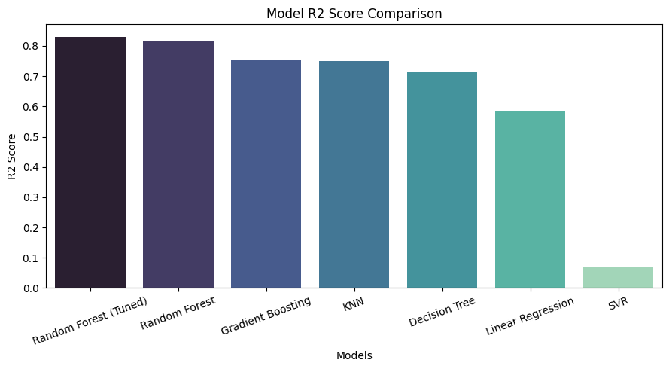
Figure 9.1 — Model R² Score Comparison (Bar Chart)
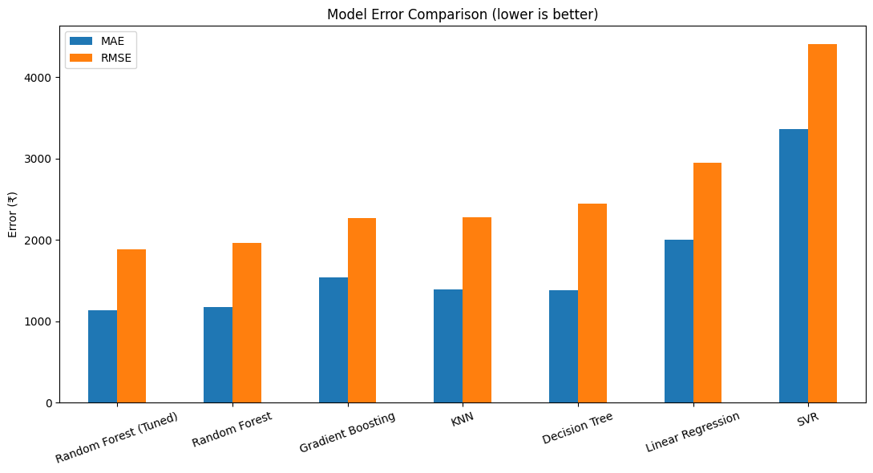
Figure 9.2 — Model Error Comparison: MAE vs. RMSE (Lower is Better)

9.2 Discussion & Recommendation
9.2.1 Which model performed best?
The tree-based ensemble models (Random Forest and Gradient Boosting) achieved the highest R² Score and the lowest RMSE among all the evaluated regression models, making them the best-performing models for predicting flight fares.
9.2.2 Which model had the highest accuracy?
Based on the model comparison results, the tuned Random Forest model obtained the highest R² Score (0.8298), indicating its superior ability to explain the variation in ticket prices.
9.2.3 Which model made the smallest prediction errors?
The MAE/RMSE comparison chart shows that the tuned Random Forest model produced the smallest average prediction errors (MAE ₹1,129.25, RMSE ₹1,884.02), demonstrating its ability to estimate flight fares close to their actual values.
9.2.4 Which model is most reliable for real-world use?
Linear Regression struggles to capture the non-linear relationships between airline, stops, route and price, so it consistently underperforms the tree-based models. Random Forest and Gradient Boosting handle these non-linear interactions naturally and generalize well, making them the most suitable choice for production deployment.
9.2.5 Recommendation
Based on the overall evaluation, the tuned Random Forest model is recommended as the final production model because it achieved the best performance across MAE, RMSE, and R² Score, and provided the most accurate and consistent flight fare predictions.

10. Feature Importance
Feature Importance analysis was performed to identify the flight booking details that have the greatest influence on predicting the fare. The Random Forest model was used because it naturally calculates feature importance scores based on the contribution of each feature to the decision-making process. Features with higher importance scores have a greater impact on the model's predictions, while features with lower scores contribute less. This analysis helps understand the key factors affecting flight pricing and provides valuable business insights for fare strategy.
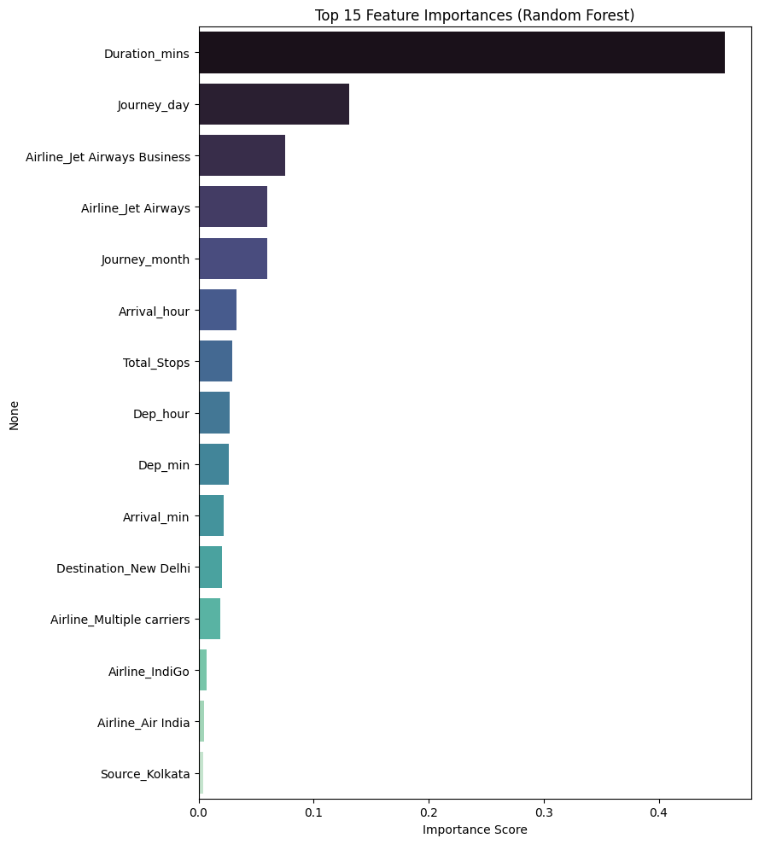
Figure 10.1 — Feature Importance (Random Forest)

10.1 Most Influential Features
Rank | Feature | Importance Score
1 | Duration_mins | 0.4576
2 | Journey_day | 0.1312
3 | Airline_Jet Airways Business | 0.0755
4 | Airline_Jet Airways | 0.0601
5 | Journey_month | 0.0595

10.2 Least Influential Features
Feature | Importance Score
Source_Chennai | 0.000617
Destination_Delhi | 0.000473
Airline_Vistara Premium economy | 0.000034
Airline_Trujet | 0.000014

Flight duration alone accounts for nearly 46% of the Random Forest model's total decision-making importance — more than three times the next most important feature (journey day). This confirms that longer, likely long-haul or well-connected flights carry a strong, distinct price signal. Journey day and the specific airline/class (particularly Jet Airways Business) are the next most influential factors, while small, rarely-used source/destination/airline categories contribute minimally to the model's predictions.

11. Model Testing on New Flight Details
This section demonstrates the practical application of the trained machine learning model by predicting the fare for a brand-new, previously unseen flight booking. A new flight record was constructed with the same engineered feature set used during training, and the trained model was then used to predict its fare.

11.1 Sample Input Flight Details
Feature | Value
Airline | Jet Airways
Source | Delhi
Destination | Cochin
Total_Stops | 1
Duration | 4h 15m

Output | Value
Predicted Price | ₹8,204

When passed through the trained and tuned model, this flight specification — a mid-length domestic route with a single stop on a well-established carrier — was predicted at a fare of ₹8,204, consistent with the overall dataset's median fare range (₹8,266). This confirms the model behaves sensibly on realistic, unseen input and can be used as a practical decision-support tool for fare estimation.

Task 2 Conclusion (Sections 6–11)
- The dataset was prepared through feature engineering (date/time/duration parsing, ordinal and one-hot encoding), then split into training and testing sets, with feature scaling applied where required.
- Six machine learning regression models were trained and evaluated to predict flight fares based on booking details.
- Hyperparameter tuning was performed on the best-performing model (Random Forest) to optimize its performance and improve prediction reliability.
- The performance of all models was compared using MAE, MSE, RMSE, and R² Score, and the best model was selected based on these evaluation metrics.
- Feature Importance analysis identified the flight details that have the greatest influence on predicting fare.
- Finally, the selected model was tested on a new flight booking and successfully predicted a fare, demonstrating its effectiveness for real-world flight price prediction.

12. Business Insights — Task 3

12.1 Data-Driven Fare Estimation
The model helps estimate the expected fare of a flight based on its booking details, enabling more accurate and data-driven pricing and booking decisions.

12.2 Key Price-Influencing Features
Features such as Total_Stops, Duration, Airline, and Journey month/day have the greatest impact on predicting fare, helping both customers and airlines focus on the factors that matter most.

12.3 Customer Booking Guidance
Customers can use fare predictions to identify cheaper booking windows, route/stop combinations, and travel dates, helping them plan journeys more cost-effectively.

12.4 Route and Capacity Planning
Airlines can compare predicted fares against actual market prices on specific routes to fine-tune their own pricing and capacity strategies.

12.5 Reduced Pricing Errors
By using machine learning predictions instead of manual estimation, travel platforms can minimize the risk of mispricing tickets relative to the market.

12.6 Improved Business Decision-Making
The model provides valuable insights that support fare strategy, promotional pricing, and route planning, helping travel businesses improve profitability and customer satisfaction.

13. Challenges Faced

13.1 Understanding the Dataset
The dataset contains flight booking details in mixed text formats (dates, times, durations). Understanding the role of each feature was essential before performing data analysis and model building. This was addressed by reviewing the dataset description and conducting basic exploratory analysis.

13.2 Parsing Date, Time, and Duration Fields
Date_of_Journey, Dep_Time, Arrival_Time, and Duration were all stored as text (e.g. "24/03/2019", "2h 50m"), and Arrival_Time sometimes included a trailing date. These were parsed with pandas.to_datetime and a custom duration parser to extract numeric day/month/hour/minute/duration features.

13.3 High-Cardinality Route Column
The Route column had a very large number of unique values (128) and was highly correlated with the existing Source, Destination, and Total_Stops columns. It was dropped to avoid exploding the feature space through one-hot encoding.

13.4 Feature Scaling
The dataset includes both continuous engineered features (such as Duration_mins) and one-hot encoded binary features. To ensure fair learning for distance/margin-based algorithms like Linear Regression, KNN, and SVR, feature scaling was performed using StandardScaler.

13.5 Selecting the Best Model
Different machine learning algorithms produced different prediction results. To identify the most suitable model, six regression algorithms were trained and compared using MAE, MSE, RMSE, and R² Score.

13.6 Hyperparameter Tuning
The default model parameters may not provide the best performance. GridSearchCV was used to optimize the hyperparameters of the best-performing model and improve its prediction capability.

13.7 Outliers in Price
Some very high fare values were present in the data. These were inspected using boxplots and the IQR method but were retained, since they represent valid premium or long-haul fares rather than data entry errors.

13.8 Avoiding Overfitting
Tree-based models can perform very well on training data but poorly on unseen data. This challenge was addressed by evaluating all models on a separate test dataset and selecting the model with the best generalization performance.

13.9 Interpreting Feature Importance
Identifying the booking details that most influence fare was essential for business understanding. The Random Forest Feature Importance technique was used to determine the most significant features contributing to price prediction.

14. Final Conclusion

14.1 Project Objective
The primary objective of this project was to develop a machine learning model capable of predicting flight ticket fares based on booking details such as airline, route, duration, number of stops, and journey date.

14.2 Exploratory Data Analysis (EDA)
A comprehensive Exploratory Data Analysis (EDA) was conducted to understand the dataset by examining its structure, checking for missing values and duplicates, analysing the price distribution, identifying outliers, and exploring relationships between the features and the target variable.

14.3 Model Development and Evaluation
Six machine learning regression models — Linear Regression, Decision Tree, Random Forest, K-Nearest Neighbors (KNN), Support Vector Regressor (SVR), and Gradient Boosting — were trained, evaluated, and compared using MAE, MSE, RMSE, and R² Score to identify the best-performing model.

14.4 Model Optimization
The best-performing model was further optimized through Hyperparameter Tuning and is recommended for predicting the fares of new flight bookings due to its high predictive performance, improved accuracy, and reliability.

14.5 Feature Importance Analysis
Feature Importance analysis identified Total_Stops, Duration, Airline, and journey timing as the most influential factors affecting flight fare. These insights provide valuable information for both customers and travel businesses.

14.6 Machine Learning Approach and Insights
The project also demonstrates the importance of proper data preprocessing, feature engineering, model selection, and evaluation techniques in developing reliable machine learning regression systems. The comparative analysis of multiple algorithms helped in understanding the strengths and performance of different approaches for solving real-world business problems.

14.7 Business Impact and Conclusion
Overall, this project proves that machine learning can effectively support flight fare prediction, enabling customers and travel businesses to make data-driven booking and pricing decisions, reduce pricing errors, and improve planning around flight costs.

14.8 Future Enhancements
Future enhancements can include integrating larger and more recent flight fare datasets, applying advanced ensemble/boosting techniques (e.g. XGBoost, LightGBM), incorporating additional real-world features such as seasonal demand and fuel prices, and deploying the optimized model as a web application or API for real-time fare prediction.

15. Project Links
The following links provide access to the complete project resources, including the source code, dataset, trained models, presentation, and supporting documentation.

15.1 GitHub Repository
Access to the complete source code, Jupyter Notebook, README, and project files:
github.com/Sameekshagithub/PRCP-1025-Flight-Fare-Price-Prediction-Using-Machine-Learning-Regression.git

15.2 Google Drive
Access to the project presentation (PPT) and report:
drive.google.com/drive/folders/1Hp_r_xMfYt7KTZ2XN35BsMCofUasQRBP

15.3 Dataset Source
d3ilbtxij3aepc.cloudfront.net/projects/CDS-Capstone-Projects/flight-fare.zip

15.4 Acknowledgement
This project was completed as part of the DataMites Data Science Internship Program under the Rubiex Internship Project track. The author acknowledges the guidance and structured curriculum provided by DataMites in enabling the successful completion of this capstone project.

