Great question—this is exactly what separates an average Medium post from a high-performing, professional article.
Here’s a battle-tested structure you can follow, along with where to place diagrams and code for maximum clarity and engagement 👇

✍️ Medium Article Framework (For Technical Use Case + Code)
1. 🚀 Title (Hook-Based)
Make it outcome-driven, not generic.
Examples:
- “How I Built an AI-Powered Backend in Python (Beginner-Friendly Guide)”
- “From Zero to AI Backend: A Practical Python Implementation”
👉 Tip: Focus on what the reader gains, not what you did.

2. 🎯 Subtitle (Optional but Powerful)
Add context + audience clarity.
Example:
A step-by-step guide to building a real-world AI system using Python, LLMs, and local storage.

3. 🧠 Introduction (Problem + Promise)
Structure:
- Problem statement
- Why it matters
- What reader will learn
Template:
Modern applications are increasingly powered by AI, but many developers struggle to understand how to integrate AI into real systems.
In this article, we’ll walk through a practical use case where we build a simple AI-powered backend using Python. By the end, you’ll understand how to structure, validate, process, and store data in an AI-driven application.

4. 📌 Use Case Explanation (Very Important)
Explain the real-world scenario before code.
Example:
- “We are building an AI assistant for SRE teams to analyze incidents.”
👉 Keep it simple:
- Who is the user?
- What problem are they solving?
- What does success look like?

5. 🏗️ High-Level Architecture (📍 INSERT DIAGRAM HERE)
This is where your diagram should go.
What to include in diagram:
- User → Backend → AI → Database → Response
👉 Place it right after explaining the use case
Why?
- Gives readers a mental model before code
- Reduces confusion later

6. ⚙️ Tech Stack & Components
List tools with purpose (not just names):
Component | Purpose
Python | Core language
Pydantic | Input validation
SQLite | Data storage
LLM | AI processing

7. 🔄 System Flow (Optional Mini Diagram)
📍 You can insert a simple flow diagram here
Example flow:
- User sends request
- Validate input
- Process with AI
- Store result
- Return response

8. 🧩 Implementation (Core Section)
Break into small digestible sections

8.1 Project Setup
📍 Insert code block
import os
from pathlib import Path
👉 Keep explanation short:
- What it does
- Why it matters

8.2 Configuration Management
📍 Code block
class Settings(BaseSettings):
openai_api_key: str
👉 Explain:
- Why .env is used
- Security benefits

8.3 Data Models
📍 Code block
class ChatRequest(BaseModel):
message: str
👉 Add:
- Real example input JSON

8.4 AI Integration
📍 Code block
llm = ChatOpenAI(...)
👉 Explain:
- What is LLM
- What “temperature” means (simple terms)

8.5 Storage Layer
Split into 2 parts:
🔹 Cache (Redis Simulation)
📍 Code block
🔹 Database (SQLite)
📍 Code block

9. 🔍 End-to-End Example (📍 VERY IMPORTANT)
This is where most articles win or lose readers.
Structure:
Input:
{
"message": "Why is API slow?"
}
Flow explanation (bullet points)
Output:
{
"answer": "Possible reasons include..."
}
👉 This makes your article practical, not theoretical

10. 📊 Deep Dive / Insights (Optional but High Value)
Add:
- Design decisions
- Trade-offs
Example:
- Why SQLite instead of PostgreSQL?
- Why simulate Redis?

11. 🚀 Improvements / Future Work
Show how to scale:
- Replace SQLite → PostgreSQL
- Add FastAPI
- Add UI
- Add RAG
👉 This shows engineering thinking

12. 🏁 Conclusion
Structure:
- Recap what was built
- Reinforce learning
- Encourage next steps

13. 📢 Call to Action (Optional)
- “Follow for more”
- “Try extending this project”

📍 Where to Place Diagrams (Summary)
Section | Diagram Type | Purpose
After Use Case | Architecture Diagram | Big picture
Before Implementation | Flow Diagram | Step-by-step logic
Storage Section | Component Diagram | Redis + DB clarity

📍 Where to Place Code
Section | Code Type
Setup | Imports
Config | Settings class
Validation | Pydantic model
AI | LLM setup
Storage | DB + Cache
Example | Input/Output JSON

💡 Pro Tips for Medium Success
✅ Keep paragraphs short (2–4 lines)
✅ Use headings every 2–3 sections
✅ Add emojis (but don’t overdo it)
✅ Use real-world examples
✅ Avoid long code dumps → break into chunks

🧠 Golden Rule
👉 Explain like you're teaching a junior developer
Not:
“We initialize a configuration object…”
But:
“We create a settings class to store things like API keys safely.”

If you want next, I can:
- Turn your article into a top 1% Medium post (viral style)
- Add SEO tags + keywords
- Or create multiple diagrams (flow + architecture + sequence) tailored to your code 👍

  - Introduction & Use Case Explanation
Structure:
- Problem statement
- Why it matters
- What reader will learn

Modern applications are increasingly powered by AI. In this article, we’ll walk you through an Agentic RAG (Retrieval-Augmented Generation) platform that combines LLM-powered AI agents with an internal knowledge base (runbooks, FAQs, policies, technical docs) to provide context-grounded answers for operational and engineering questions. In many organizations, mention which area in the org, we observe that:
- On-call SREs waste precious minutes during incidents searching through runbooks, past incidents, and service graphs to diagnose root causes and find remediation steps.
- Engineers lack a single place to query internal architecture docs, service dependencies, and best practices when making design or debugging decisions.
- Institutional knowledge is siloed in markdown files, wikis, and databases with no unified, conversational interface to query it.

< ADD THE GRAPHICAL REPRESENTATION HERE>
Now, if we implement an Agentic RAG platform then we can streamline the existing process where instead of a human manually orchestrating searches across runbooks, incident databases, dependency graphs, and code execution during high-pressure situations, the agent does all of that in a single chat turn — collapsing a multi-tool, multi-minute workflow into a few seconds. The summary of the upgrade in approach is as follows:

Existing Process | Agentic RAG platform
SRE gets paged → manually searches Confluence/wiki for the right runbook → scans through pages → cross-references past incidents in a separate dashboard | Ask one question ("5xx on payment-service, what do I check?") and get the relevant runbook steps + matching past incidents + remediation in seconds
Engineer needs to understand a service's dependencies → queries multiple internal tools, reads scattered ADRs/RFCs | Ask "what are order-service's dependencies?" and get the full dependency graph + relevant architecture docs in one response
Debugging requires running diagnostic calculations (pool utilization, error rates) → open a separate terminal/notebook | Paste a code block directly in the chat — the sandbox executes it and the agent interprets the results inline
Context-switching between 4-5 tools (monitoring, wiki, incident tracker, dependency map, terminal) during a live incident | Single conversational interface that aggregates all sources automatically, reducing MTTR
New team members lack tribal knowledge about past incidents and service behavior | The knowledge base persists institutional knowledge; any team member gets the same quality of answer regardless of tenure

Through the chat interface, User can input their query into a chat input. The user can upload upload .md/.txt files as part of the reference documents. The agents remember their prior messages in the session without re-explaining the context.
There will be a series of article regarding the solution to this use case right from its development in your local system to productionizing it using Microsoft Azure. In this article, we will discuss on how to implement the solution locally. In the next couple of articles, we will work towards how to productionize the solution.

This hands-on exercise walks you through building an AI-powered internal knowledge assistant from scratch — one that doesn't just generate answers from a generic LLM, but grounds every response in your organization's own documentation, incident history, and service architecture.
By the end, you'll understand how to:
Connect an LLM to private knowledge — ingest internal runbooks and docs into a vector store so the AI can search and cite them instead of hallucinating
Build specialized AI agents — create purpose-built agents (one for operations/SRE, one for engineering) that automatically pull context from the right sources before answering
Give agents real tools — let the AI query an incident database, look up service dependencies, and even execute diagnostic code in a sandbox, all within a single conversation
Maintain conversational memory — keep multi-turn chat history so users can drill deeper without repeating themselves
Ship it with a UI — wrap everything in a chat interface that any team member can use, no API knowledge required
The key takeaway: we’ll see how RAG (Retrieval-Augmented Generation) and agentic tool use turn a general-purpose LLM into a domain-specific copilot that reduces incident response time and eliminates the need to manually search across scattered wikis, dashboards, and runbooks during high-pressure situations.

2. High Level Architecture Diagram

<Insert the high level architecture diagram from deployment_Guide.md>

<Insert the high-level diagram to be implemented at a local level from architecture_local.md>

The Agentic RAG platform runs entirely on a single machine with no cloud dependencies — only an OpenAI API key is required. A user interacts through a Streamlit chat UI served at localhost:8501, where they select either the SRE Agent (for incident triage, root cause analysis, and runbook lookup) or the Engineering Agent (for architecture questions, code review, and dependency exploration).
When a message is sent, the selected agent orchestrates a 7-step pipeline: it loads conversation history from an in-memory dictionary, retrieves relevant document chunks from a ChromaDB vector store using semantic search, queries a SQLite database for incident records or service dependencies, optionally executes embedded Python code in a restricted sandbox, assembles all gathered context into a prompt, calls the OpenAI LLM via LangChain, and finally persists the interaction for audit and future conversation continuity.
The knowledge base is powered by ChromaDB, which stores document chunks as 384-dimensional vectors using the all-MiniLM-L6-v2 embedding model — running locally with no API cost. Documents are ingested from the raw-docs directory by splitting them into overlapping chunks (800 characters, 120 overlap) and upserting them into a persistent collection. The relational layer uses SQLite with three tables mirroring the production PostgreSQL schema, pre-seeded with sample incidents and a microservice dependency graph so the agents have structured data to query from the start.

Component | Technology | Role | Storage/Location
LLM | LangChain ChatOpenAI (OpenAI API) | Generates grounded answers from assembled context | Remote API call (api.openai.com)
Vector Store | ChromaDB PersistentClient + all-MiniLM-L6-v2 | Semantic search over ingested documents (384-d embeddings) | chroma_rag
Database | SQLite | Stores incidents, service dependencies, and audit logs | demo_local.db
Session Store | LocalRedis (Python dict) | Maintains per-session conversation history (last 20 turns) | In-memory (lost on restart)
Document Store | Local filesystem | Source directory for .md / .txt  runbooks and docs | raw-docs
Sandbox | Restricted exec() with 18 allowlisted builtins | Safe execution of diagnostic Python snippets | In-process
UI | Streamlit (3 tabs: Chat, Ingest, Health) | Browser-based chat interface with agent selection | localhost:8501
Configuration | Pydantic BaseSettings + .env file | Loads OPENAI_API_KEY, model name, RAG tuning params | Project root .env

3. Code Implementation

3.1 Project Setup
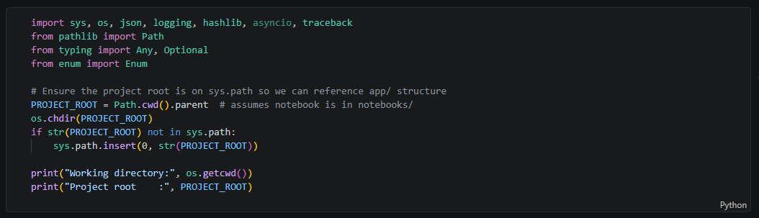
In this section, as shown in the cell above, it loads all standard Python libraries needed throughout the notebook — json for serialization, hashlib for generating unique chunk IDs during ingestion, logging for agent diagnostics, traceback for sandbox error reporting, and Path for cross-platform file handling. Crucially, it also computes PROJECT_ROOT by going one directory up from notebooks and adds it to sys.path, which allows all subsequent cells to reference data directories (raw-docs, chroma_rag) and the .env config file using paths relative to the project root rather than the notebook's location. Without this path setup, ChromaDB storage, SQLite database creation, document ingestion, and environment variable loading would all resolve to the wrong directory.

3.2 Configuration Management
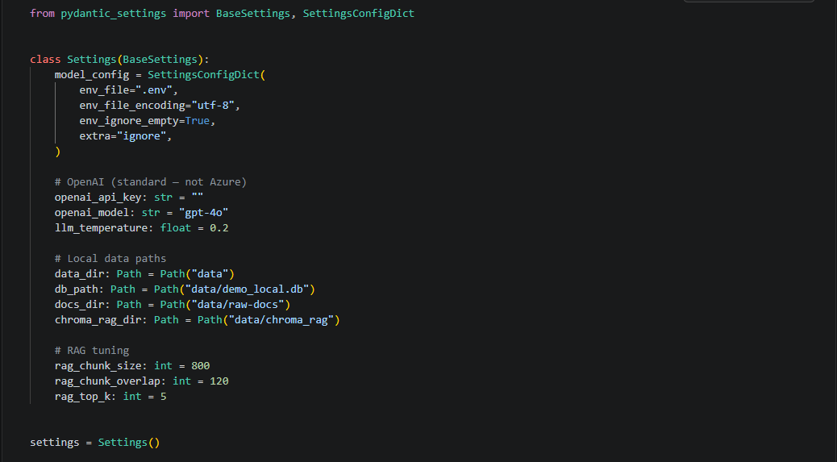
The Settings class uses pydantic-settings (BaseSettings) to centralise every configurable value the notebook needs into a single, validated object. It automatically loads environment variables from the project-root .env file — the only secret required is OPENAI_API_KEY, alongside optional overrides for the model name (gpt-4o) and temperature (0.2). Beyond the LLM credentials, it declares local data paths (data, demo_local.db, raw-docs, chroma_rag) so every downstream component — SQLite, ChromaDB, document ingestion — references the same locations. It also exposes three RAG-tuning knobs (rag_chunk_size=800, rag_chunk_overlap=120, rag_top_k=5) that control how documents are chunked and how many results the vector search returns. After instantiation, the cell creates any missing directories and prints a quick sanity check of the active configuration, ensuring the environment is ready before any client or agent code runs.

3.4 Local Service Clients
In production the app uses Azure Managed Identity to initialize Key Vault, Blob Storage, AI Search, OpenAI, PostgreSQL, and Redis clients.
For this **local demo** we create:
- A **LangChain ChatOpenAI** LLM client using a standard OpenAI API key (following `demo1.ipynb` pattern)
- A **local in-memory Redis substitute** (dict-based)
- A **local SQLite substitute** for PostgreSQL
- A **local file-based ingestion** substitute for Blob Storage

3.4.1. LangChain ChatOpenAI LLM
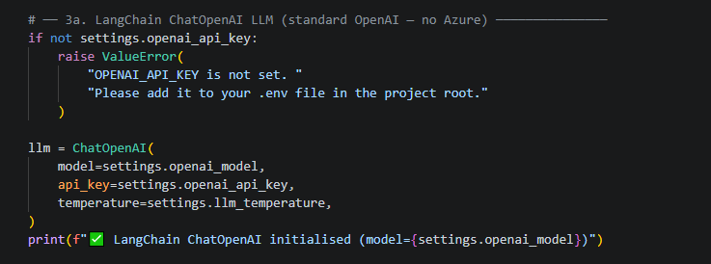

We will use the Langchain ChatOpenAI LLM for our analysis. We fetch all the credentials from the .env file using settings object.

3.4.2. Local Redis Substitute (in-memory dict)
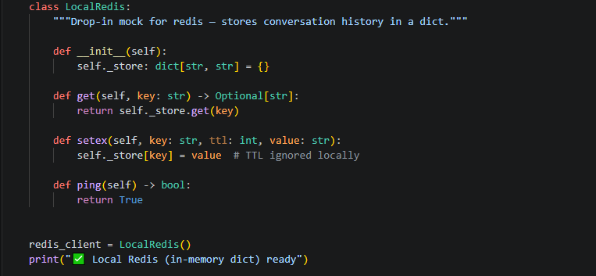
As we are implementing the project locally, we need to store the conversation history in a dictionary. For that, we have created a `LocalRedis` class which will mimic the Redis functionalities in the production environment.

3.4.3 Local SQLite substitute database
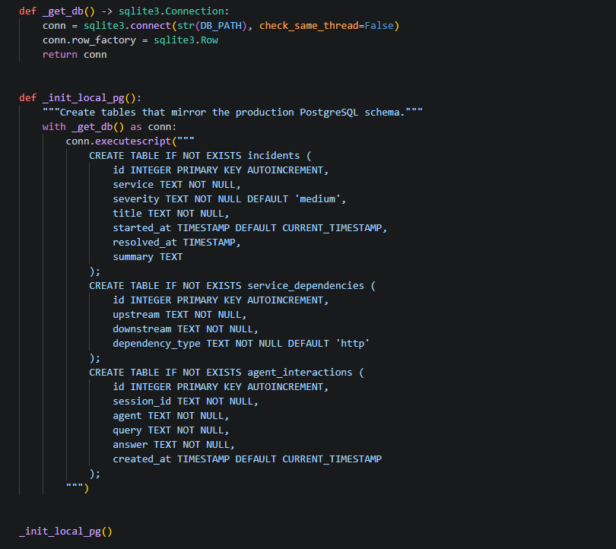

We will use SQLite database for our local implementation. We have created three tables - `incidents`, `service_dependencies`, `agent_interactions` for storing the information related to any incidents being logged by the end users, information related to the dependencies between services and interaction information between the SRE and Engineering agents.
For the purpose of our project, we are adding a few sample examples in our `incidents` and `service_dependencies` DB tables.

3.4.4. Local Document Folder
We have also created a `raw_docs` folder where we have uploaded 4 .md files which we would require for our RAG implementation.

3.5 Agent tools
In this section, we will discuss about the tool modules that the agents can invoke given the different scenarios.
Tool | Local Clients | Purpose
Search Tool | ChromaDB | Ingests documents, generates embeddings, and performs vector similarity search so agents can retrieve relevant knowledge base chunks
Postgres Tool | SQLite | Stores and queries structured operational data — incident history, service dependency graph, and agent audit logs
Redis Tool | Local Redis | Maintains per-session conversation history and provides general-purpose key-value caching
Sandbox Tool | Restricted exec() | Executes user-supplied Python code safely so agents can run inline diagnostics

3.5.1 Search Tool
As part of the search tool, we have created the `KnowledgeBaseService` class which is the central component that powers the platform's knowledge retrieval. It wraps a **ChromaDB PersistentClient** and uses the built-in `DefaultEmbeddingFunction` (all-MiniLM-L6-v2, 384-dimensional vectors) to embed and index documents — no external API key is needed for embeddings. On initialization it creates or connects to a collection called `rag_knowledge_base` and sets up a `RecursiveCharacterTextSplitter` configured with the Settings-driven chunk size (800) and overlap (120). Its `ingest_directory()` method reads all `.md` and `.txt` files from a given folder, splits them into chunks, generates SHA-1–based deduplication IDs, and upserts them into ChromaDB with source metadata. Its `search()` method takes a natural-language query, automatically embeds it, and returns the top-k nearest chunks along with their source file name and distance score. Downstream, the RAG service's `retrieve_context()` function calls `kb.search()` to fetch relevant chunks, concatenates them into a context string (capped at 6 000 characters), and injects that context into the system message before every LLM call — this is how both the SRE and Engineering agents ground their answers in the organization’s actual runbooks and documentation.
3.5.2. Postgres Tool
The Postgres tool is a local SQLite stand-in for the production PostgreSQL database, providing three helper functions that give agents access to structured operational data. When a user asks about a specific service, the agent pipeline scans the message for service names and automatically calls query_incident_history() (SRE agent) or query_service_dependencies() (Engineering agent) to fetch relevant records. The returned rows are formatted as bullet-point context and injected into the LLM's system message alongside RAG results, allowing the model to ground its answer in real incident data and dependency graphs. After every agent response, log_agent_interaction() writes the full Q&A pair to the agent_interactions table, creating an audit trail that can be reviewed later in the notebook.
Function | Purpose | How It Works
query_incident_history | Retrieves recent incidents (severity, title, timestamps, summary) for a given service, ordered by most recent first | Agent scans the user message for words > 4 chars; first match against the service column triggers the query
query_service_dependencies | Returns all upstream and downstream connections for a service, along with the connection type (http, grpc, async/sqs) | Same word-scan logic; first match against upstream or downstream columns triggers the query
log_agent_interaction | Persists every agent Q&A exchange with a timestamp for auditing and debugging | Called automatically at the end of every agent run, after the LLM response is generated

3.5.3 Reddis Tool
The Redis tool provides multi-turn conversation memory and general-purpose caching for both agents, backed locally by the LocalRedis in-memory dictionary define. It exposes four functions: get_conversation_history() retrieves the full message list for a given session by reading a JSON string keyed as session:{id}:history, while append_to_history() adds a new user or assistant message and trims the list to the most recent 20 turns before writing it back — this keeps the LLM context window manageable without losing important conversational continuity. Two additional helpers, cache_set() and cache_get(), offer a simple key-value cache that agents or other components can use for arbitrary data. A HISTORY_TTL of 3 600 seconds (one hour) is declared and passed through for API parity with the production Redis client, but is silently ignored locally since the in-memory dictionary has no expiration mechanism. During each agent run, the history functions are called twice — once at the start to load prior turns into the LangChain message array, and once at the end to persist the latest Q&A pair — giving the agents awareness of what the user asked previously in the same session.

3.5.4 Sandbox Tool
The Sandbox Tool provides a restricted Python execution environment through a single function, execute_code(), which compiles and runs untrusted code snippets submitted by users or generated during agent interactions. It enforces a strict allowlist of just 18 safe builtins — such as print, len, range, sum, list, dict, and basic type constructors — while blocking all imports, file I/O, network access, and dangerous operations like eval or exec from within the sandbox. A custom _capture_print function intercepts print() calls so output is collected into a list and returned as a string rather than written to stdout. The function returns a dict with a "status" field ("ok" or "error") and the captured "output", plus a "locals" snapshot of any variables created during execution.
The sandbox is required because both the SRE and Engineering agents accept free-form user messages that may contain embedded Python code blocks (delimited by ```python ... ```). When a code block is detected, the agent extracts it and delegates execution to execute_code() so the LLM can incorporate the computation results — such as utilisation percentages or diagnostic calculations — into its response. Without the sandbox, running arbitrary user-supplied code would pose severe security risks including arbitrary file access, data exfiltration, or system compromise. The restricted-builtins approach ensures agents can offer interactive diagnostic capabilities while keeping the execution surface minimal and safe.

3.6 RAG Service – Ingestion & Retrieval
Both the agents call `retrieve_context` and inject the returned context string as a `SystemMessage` so the LLM can ground it’s answer in the retrieved documents.
Function | Purpose
retrieve_context | Searches ChromaDB for relevant document chunks and assembles a context string for the LLM
Ingest_local_docs | Ingests .md and .txt files from a local directory into ChromaDB

3.7 Agent
The platform defines two specialized agents — **SRE Agent** and **Engineering Agent** — that share an identical 7-step execution pipeline but differ in their domain focus and which database tool they invoke. When a user sends a message, both agents follow the same flow:
  - load conversation history from Redis to maintain multi-turn context.
  - retrieve relevant document chunks from ChromaDB via `retrieve_context()` to ground the answer in internal knowledge.
  - query the database for domain-specific structured data (incidents for SRE, service dependencies for Engineering)
  - detect and execute any embedded Python code blocks through the sandbox for interactive diagnostics
  - assemble all gathered context into a LangChain message array — starting with a system prompt that defines the agent's persona, followed by RAG context, database results, sandbox output, prior conversation turns, and the current user message
  - invoke the LLM via `llm.invoke(messages)` to generate a grounded response
  - persist the exchange to Redis (conversation history) and SQLite (audit log) before returning the answer, sources, and tool call metadata.

Aspect | SRE Agent | Engineering Agent
Domain focus | Incident triage, RCA, runbook lookup, postmortem drafting, SLO/SLI questions | Architecture, code review, service integration patterns, debugging, best practices
System prompt persona | Expert Site Reliability Engineer | Expert Software Engineer
Database tool used | query_incident_history— retrieves past incidents by service name from the incidents table | query_service_dependencies — retrieves upstream/downstream links from the service_dependencies table
Service name detection | Scans user message for words > 4 chars (excluding stop words), queries SQLite for matching incidents | Same word-scanning logic, but queries SQLite for matching service dependency rows
Sandbox tool | Extracts ```python ``` code blocks and runs them via execute_code() | Same — extracts and executes embedded Python code blocks
RAG tool | Calls retrieve_context() → searches ChromaDB | Same — identical RAG retrieval call
Redis tool | Reads/writes history keyed as sre:{session_id} | Reads/writes history keyed as eng:{session_id}
Audit logging | Writes to agent_interactions table with agent="sre" | Writes to agent_interactions table with agent="engineering"
LLM invocation | llm.invoke(messages) via LangChain ChatOpenAI | Same LLM client and parameters
Return value | {"answer", "sources", "tool_calls"} | Same structure

3.8 Service Check
The check_health() function verifies connectivity to all four backend services the platform depends on. It pings the local Redis substitute (in-memory dict), executes a SELECT 1 against SQLite (standing in for PostgreSQL), sends a lightweight "ping" message to the LLM via llm.invoke() to confirm the OpenAI API key and model are functional, and reads the chunk count from the ChromaDB knowledge base. Each service is tested inside a try/except block — on success it records an "ok" status with a descriptive note (e.g., the model name or chunk count), and on failure it captures the exception and downgrades the overall status from "ok" to "degraded". The function returns a dict with a top-level status field and a services sub-dict, which maps directly to the HealthResponse Pydantic model defined in the Schemas section. In the Streamlit UI this same logic powers the "Health" tab, giving operators a single-glance dashboard of platform readiness.

4. Streamlit Chat UI Interface Workflow
For local implementation, we are using Streamlit app. The notebook provides the code to create a `streamlit_app.py` file which can be used by the users. To run the streamlit app, open the terminal and execute : `streamlit run streamlit_app_noAzure.py`

4.1. Worked Out Examples

