Data Analytics Face ID Dataset
In this dataset we check why the result is not clear what is the problem occurs. So in this first of all we highlighted what is our dependent or independent variables.
Variables:
- user_id,
- result,
- visual_authenticity_result,
- image_integrity_result,
- face_detection_result,
- image_quality_result,
- created_at,
- supported_document_result,
- conclusive_document_quality_result,
- colour_picture_result,
- data_validation_result,
- data_consistency_result,
- data_comparison_result,
- attempt_id,
- police_record_result,
- compromised_document_result,
- properties,
- sub_result,
- gender,
- nationality,
- document_type,
- issuing_country,
- date_of_expiry
According to above variables we need to decide what is variable is really creates result consider.
Dependent Variable:
- result
Independent Variables:
- Gender
- Nationality
- police_record_result

Result columns:
In result column we have 2 different values
- Clear
- Consider
According to above we analyze every single independent variable according to above values

Gender Columns:
In Gender column we have 2 different values
- Male
- Female
Male:
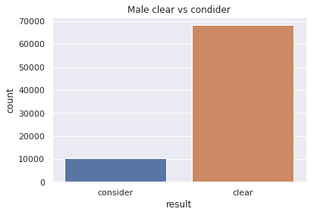
According to above figure we analyze that Male consider values is approximately 10,000 and Male Clear value is approximately 69,000
Female:
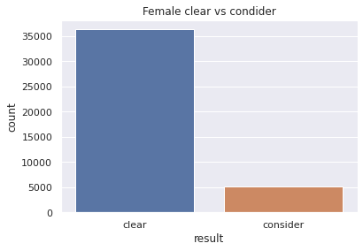
According to above figure we analyze that Female consider values is approximately 5,000 and Female Clear value is approximately 37,000
Nationality Columns:
In Nationality column we have 200+ different countries, But according to visualize perspective I select top 10 countries according to maximum number of consider and clear values.
Clear result countries:
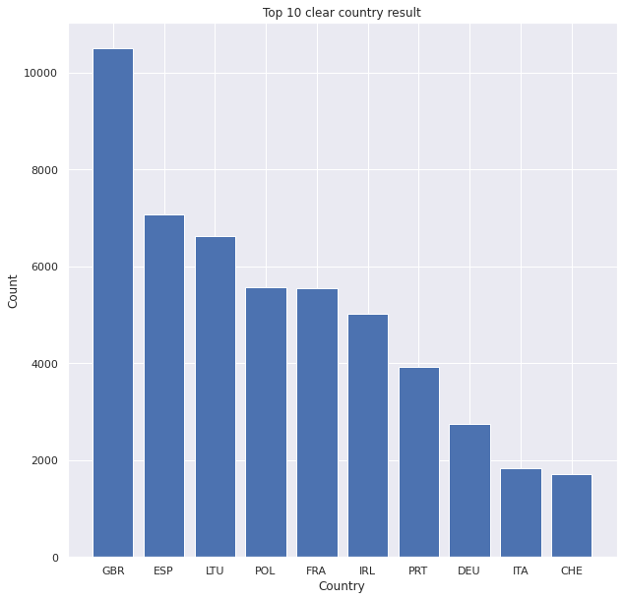

According to above figure we analyze that country wise clear values are as follows
- GBR approximately 11,000
- ESP approximately 7,000
- LTU approximately 6,500
- POL approximately 5,800
- FRA approximately 5,800
- IRL approximately 5,000
- PRT approximately 4,000
- DEU approximately 2,500
- ITA approximately 1,900
- CHE approximately 1,800
Consider result countries:
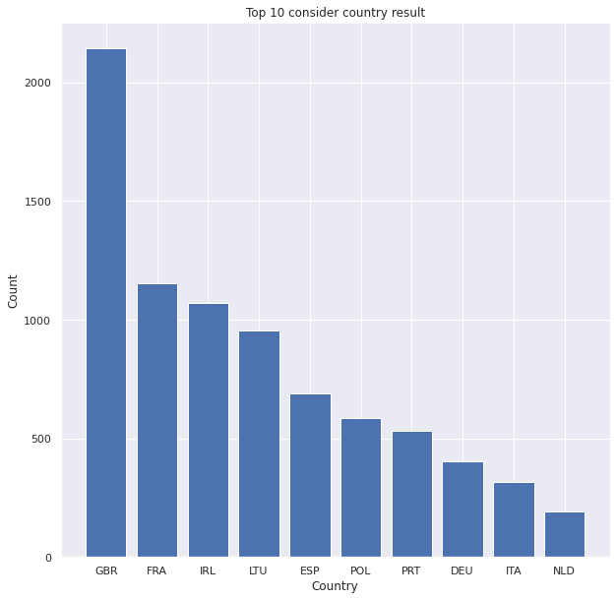
According to above figure we analyze that country wise consider values are as follows
- GBR approximately 2,500
- FRA approximately 1,200
- IRL approximately 1,100
- LTU approximately 950
- ESP approximately 700
- POL approximately 600
- PRT approximately 550
- DEU approximately 400
- ITA approximately 350
- NLD approximately 200
Police Columns:
In Police column we have 2 different values
- Clear
- Consider
Police Clear Result:
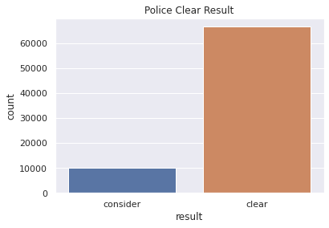
According to above figure we analyze that Police consider values is approximately 10,000 and Police Clear value is approximately 67,000
Police Consider Result:
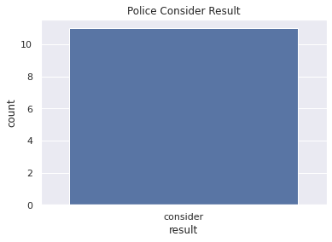
According to above figure we analyze that Police consider values is approximately 9 and Police Clear value is approximately 0
Conclusion:
According to above insights we analyze that 2 variable values is create a consider values is high if it’s reduce the results is better enough
- Male Consider is approximately 10,000
- Police Clear result is approximately 10,000
Both are approximately same that’s why we consider both values.

