A
Project Report
On
“FIND MY PG: An Android Paying-Guest Discovery Application using Kotlin, Jetpack Compose and PHP/MySQL”
Submitted in partial fulfilment of the
Requirements for the award of the degree
IN
MASTER OF COMPUTER APPLICATIONS
Submitted By
SAMEER KHAN (25MC201A64)
Under the guidance of
A. MAHESH
[INSERT GUIDE DESIGNATION]
DEPARTMENT OF INFORMATION TECHNOLOGY
ANURAG UNIVERSITY
(Approved by AICTE and NBA Accredited)
Venkatapur (V), Ghatkesar (M), Medchal District,
Hyderabad, Telangana, 500088
(2025 – 2027)

ANURAG UNIVERSITY
(Approved by AICTE and NBA Accredited)
Venkatapur (V), Ghatkesar (M), Medchal District,
Hyderabad, Telangana, 500088
DEPARTMENT OF INFORMATION TECHNOLOGY
CERTIFICATE
This is to certify that the project report entitled “FIND MY PG: An Android Paying-Guest Discovery Application using Kotlin, Jetpack Compose and PHP/MySQL” is a bonafide work done and submitted by SAMEER KHAN (25MC201A64) in partial fulfilment of the requirements for the award of the degree of MASTER OF COMPUTER APPLICATIONS from Anurag University during the academic year 2026–2027. The bonafide work has not been submitted elsewhere for the award of any other degree.
Internal Guide  A. MAHESH  [INSERT GUIDE DESIGNATION] | Head of the Department  Dr. Niteesha Sharma  Assistant Professor
ACKNOWLEDGEMENT
I would like to express my profound sense of gratitude to all who have helped me in completing this project. I would like to express my deep-felt gratitude and sincere thanks to my guide, A. MAHESH, [INSERT GUIDE DESIGNATION], Department of Information Technology, Anurag University, for the skilful guidance, timely suggestions, and continuous encouragement throughout the completion of this project.
A special acknowledgement is extended to Dr. Niteesha Sharma, Head of the Department (IT), for her valuable support, and to Mr. G. Sekhar Reddy, Program Coordinator (MCA), for his guidance, which significantly contributed to the successful completion of this project.
I would like to express my sincere thanks to Dr. K. Sudheer Reddy, Dean of Academics and Planning, Anurag University, whose motivation in the field of software development has helped me overcome all hardships during my studies and the successful completion of the project.
I extend my sincere appreciation to Dr. V. Vijaya Kumar, Dean, School of Engineering, for his encouragement and consistent support during this endeavour.
Finally, I would like to express my heartfelt thanks to my parents, who were very supportive both financially and mentally and for their encouragement to achieve my set goals.
SAMEER KHAN (25MC201A64)
DECLARATION
This is to certify that the project titled “FIND MY PG: An Android Paying-Guest Discovery Application using Kotlin, Jetpack Compose and PHP/MySQL” is a bona fide work done by me in fulfilment of the requirements for the award of the degree MASTER OF COMPUTER APPLICATIONS and submitted to Anurag University, Hyderabad. I also declare that this project is a result of my own effort and has not been copied or imitated from any source. Citations from any websites and references are duly mentioned in the bibliography. This work has not been submitted earlier at any other university for the award of any degree.
SAMEER KHAN (25MC201A64)
ABSTRACT
Students and young professionals who move to a new city usually look for Paying Guest (PG) accommodation through brokers, notice boards and messaging groups. The information is scattered, vacancies are not reliable, the exact location is rarely shown on a map, and enquiries are made through calls that are not recorded. Mobile application development, on the other hand, has matured around Kotlin, Jetpack Compose and simple web back ends, which makes it practical for a single developer to build a complete client–server system.
This report presents FIND MY PG, an Android application with a PHP and MySQL back end, developed as a self-initiated project for the MCA programme. The system has two roles. PG owners register, publish listings with a photograph uploaded from the phone and a location taken from the device GPS or set by moving a pin on an OpenStreetMap map, mark each PG as Occupied or Available, and reply to enquiries. Tenants search the available PGs by area, maximum monthly rent and amenities, view the details and the map of a PG, and send enquiries to the owner. A PG that is marked occupied is hidden from tenants until the owner makes it available again. The Android client is written in Kotlin with Jetpack Compose and Material 3, uses Retrofit, OkHttp and Moshi to call the REST API, Coil to show images, the Fused Location Provider for GPS and Leaflet in a WebView for the map. The server consists of eleven PHP endpoints using PDO prepared statements and a MySQL database with three tables: users, pg_listings and enquiries. When the server cannot be reached, the application continues to work with a local JSON store on the phone.
The final project contains 20 Kotlin source files with 4,578 non-blank lines, 12 PHP files with 600 non-blank lines and a database script of 74 lines. The report documents the requirements, the architecture, the data flow, use case, entity–relationship, class and sequence diagrams, the implementation of every development phase, the functional test cases and the limitations found in the code, such as the missing token authentication and the lack of synchronisation of offline data. Screenshots, measurements and the recorded results of the tests are marked as items to be filled in.
TABLE OF CONTENTS
Acknowledgement ii
Declaration iii
Abstract iv
List of Figures vii
List of Tables viii
List of Abbreviations ix
1. INTRODUCTION 1
1.1 Overview of the Domain 1
1.2 Background and Problem Statement 1
1.3 Project Details 1
1.4 Scope 3
1.5 System Requirements 3
1.5.1 Software Requirements 3
1.5.2 Hardware Requirements 4
1.6 System Analysis 4
1.6.1 Functional Requirements 4
1.6.2 Non-Functional Requirements 5
1.6.3 Feasibility Analysis 6
2. LITERATURE SURVEY AND PROJECT OBJECTIVE 7
2.1 Objective of the Literature Survey 7
2.2 Survey of Related Work and Technologies 7
2.3 Existing System 8
2.4 Limitations of Existing System 8
2.5 Proposed System 9
2.6 Advantages 9
2.7 Research Gaps 9
2.8 Project Objectives 9
2.9 Project Justification 10
3. METHODOLOGY 11
3.1 Introduction 11
3.2 Development Methodology 11
3.3 System Architecture 11
3.4 Application Flow 12
3.5 Screen Navigation 13
3.6 Data Flow Diagram 14
3.7 Use Case Diagram 15
3.8 Data Design 15
3.8.1 REST API Design 15
3.8.2 Database Design and Entity–Relationship View 16
3.9 Class Diagram 18
3.10 Sequence Diagram 18
3.11 User Interface Design Principles 19
4. IMPLEMENTATION 20
4.1 Introduction 20
4.2 Phase-wise Implementation 20
4.2.1 Phase 1: Requirement Analysis and Environment Setup 20
4.2.2 Phase 2: Database and API Design 20
4.2.3 Phase 3: Back-end Development 20
4.2.4 Phase 4: Android App Development 20
4.2.5 Phase 5: Integration and Advanced Features 21
4.2.6 Phase 6: Testing and Documentation 21
4.3 Project Structure 21
4.4 Key Implementation Details 22
4.5 Results: Screens of the Final Application 24
4.5.1 Authentication 24
4.5.2 Tenant: Search and Filters 25
4.5.3 Tenant: PG Detail and Map 25
4.5.4 Tenant: Sending Enquiries and Reading Replies 26
4.5.5 Owner: Listings and Occupancy 26
4.5.6 Owner: Posting a PG, Enquiries and Settings 27
4.6 Challenges and Limitations 28
5. RESULTS AND ANALYSIS 30
5.1 Introduction 30
5.2 Components Delivered 30
5.3 Distribution of the Code in the Final Application 30
5.4 Achievement of the Objectives 31
5.5 Measurements Not Yet Recorded 31
5.6 Discussion 32
6. TESTING 33
6.1 Testing Strategy 33
6.2 Test Cases 33
6.3 Test Summary 34
7. CONCLUSION 36
7.1 Conclusion 36
7.2 Future Scope 36
REFERENCES 37
LIST OF FIGURES
1 System architecture of FIND MY PG 12
2 Flowchart of the application 13
3 Screen navigation map 14
4 Data flow diagram of FIND MY PG 14
5 Use case diagram of FIND MY PG 15
6 Entity–relationship diagram of the FIND MY PG database 17
7 Class diagram of the main classes 18
8 Sequence diagram for searching PGs and sending an enquiry 19
9 Login and registration screens 25
10 Tenant search screen with filters and results 25
11 PG detail dialog with map 26
12 Enquiry dialog, confirmation and My Enquiries screen 26
13 Owner portal: My Listings and occupancy 27
14 Post New PG form 27
15 Owner Inquiries tab 28
16 Settings dialog 28
17 Kotlin source lines in each package of the final application 31
LIST OF TABLES
1 Project Details 2
2 Development Phases of the Project 2
3 Technology Stack 4
4 Functional Requirements 5
5 Non-Functional Requirements 5
6 Summary of the Literature and Technology Survey 7
7 Features Added in Each Development Phase 11
8 REST Endpoints of the Back End 16
9 Database Tables 16
10 Packages of the Final Android Application 21
11 Components of the Delivered System 30
12 Achievement of the Project Objectives 31
13 Measurements To Be Recorded 31
14 Functional Test Cases and Results 33
LIST OF ABBREVIATIONS
S. No. | Full Form | Abbreviation
1 | Application Programming Interface | API
2 | Representational State Transfer | REST
3 | JavaScript Object Notation | JSON
4 | Software Development Kit | SDK
5 | Integrated Development Environment | IDE
6 | User Interface | UI
7 | User Experience | UX
8 | Structured Query Language | SQL
9 | PHP Data Objects | PDO
10 | Paying Guest | PG
11 | Global Positioning System | GPS
12 | Cross-Origin Resource Sharing | CORS
13 | Multipurpose Internet Mail Extensions | MIME
14 | OpenStreetMap | OSM
15 | Data Flow Diagram | DFD
16 | Entity–Relationship | ER
17 | Hypertext Transfer Protocol | HTTP
18 | Uniform Resource Locator | URL
19 | Android Package Kit | APK
20 | Kotlin Symbol Processing | KSP

1. INTRODUCTION

1.1 Overview of the Domain
Finding a place to stay is one of the first problems faced by students and young professionals who move to a new city for study or work. In India a large part of this demand is met by Paying Guest (PG) accommodation: a room, or a bed in a shared room, rented by the month, usually with meals, Wi-Fi, laundry and other facilities included. PG owners range from individual house owners to small businesses that run several buildings, and the listings change constantly as rooms fill up and become vacant.
Mobile applications are the natural medium for this domain, because the person searching is almost always on the move and uses a phone. Android, developed by Google, runs on a very large share of the world’s smartphones. Modern Android development is built around the Kotlin programming language [2], the Jetpack libraries and the Jetpack Compose toolkit for building user interfaces declaratively [1], with Android Studio as the official development environment [19]. A mobile client is normally connected to a server through a REST API [15], and the server stores the shared data, such as users, listings and messages, in a relational database.
A PG discovery application therefore combines many of the skills that a developer must practise: user accounts with different roles, lists loaded from a server, search and filtering, images, maps and device location, enquiry messages between two parties, and a server with a database. For this reason it is a suitable project for learning the complete life cycle of a client–server mobile application.

1.2 Background and Problem Statement
A person who looks for a PG usually depends on brokers, notice boards, social-media groups or word of mouth. Several practical difficulties follow from this. First, the information is scattered and often out of date: a room that was advertised last week may already be taken, and there is no reliable way to know whether a PG still has a vacancy before travelling to see it. Second, the exact location is rarely shown on a map, so the tenant cannot judge the distance to a college or office. Third, the tenant cannot filter by monthly rent or by the facilities that matter to them, such as Wi-Fi, air conditioning, food or laundry. Fourth, communication with the owner takes place through phone calls and messages that are not recorded anywhere. Finally, owners have no simple tool to publish a listing with photographs and to mark it as full when no room is left.
Problem statement: To design and develop FIND MY PG, an Android application with a PHP and MySQL back end, in which PG owners can publish listings with photographs and a map location, mark a PG as occupied or vacant and answer enquiries, and in which tenants can search and filter the available PGs, view them on a map and send enquiries to the owner, while the application remains usable even when the server cannot be reached.

1.3 Project Details
FIND MY PG is a self-initiated project. It was not carried out at an internship company or on the instructions of an outside organisation; the problem was chosen, analysed, designed and implemented by the student as part of the MCA programme. The details of the project are summarised in Table 1.
Table 1: Project Details
Item | Details
Project title | FIND MY PG: An Android Paying-Guest Discovery Application using Kotlin, Jetpack Compose and PHP/MySQL
Developer | SAMEER KHAN
Roll number | 25MC201A64
Programme | Master of Computer Applications (MCA), Department of Information Technology, Anurag University, Hyderabad
Internal guide | A. MAHESH, [INSERT GUIDE DESIGNATION]
Type of project | Self-initiated (independent) project
Project period | [INSERT START DATE] to [INSERT END DATE]
Platforms | Android client (Kotlin, Jetpack Compose); web server with PHP 8 and MySQL
Source code | [INSERT GITHUB REPOSITORY LINK]

The work was organised in six development phases, listed in Table 2. The phases describe the order in which the parts of the system were studied and built; they are not tied to a fixed number of days.
Table 2: Development Phases of the Project
Phase | Title | Main Activities
1 | Requirement Analysis and Environment Setup | Studying the PG search problem, identifying the two user roles, choosing the technology stack, installing Android Studio, the Android SDK, XAMPP (Apache, MySQL, PHP) and Git
2 | Database and API Design | Designing the three database tables, the REST endpoints and the common JSON response format
3 | Back-end Development | Writing the PHP endpoints with PDO prepared statements, password hashing, input validation and image upload
4 | Android App Development | Material 3 theme, login and registration screen, tenant and owner screens, ViewModels and state handling
5 | Integration and Advanced Features | Retrofit and Moshi integration, repository with offline fallback, session and Base URL settings, multipart image upload, GPS location and the Leaflet map
6 | Testing and Documentation | Manual functional testing, unit tests, back-end guide and this report

1.4 Scope
The scope of this project covers the design and implementation of a complete two-role system. The Android application provides: registration and login as a Tenant or as a PG Owner; for tenants, a search screen with a text search on area, name or city, a maximum-rent slider, amenity filters and a switch to hide occupied PGs, a PG detail view with photograph, description, amenities, house rules and an interactive map, a dialog to send an enquiry to the owner, and a screen that lists the tenant’s enquiries and the owner’s replies; for owners, a dashboard of their own listings with a one-tap switch between Available and Occupied, a form to publish a new PG with a photograph uploaded from the phone, the device’s GPS position and a map on which the pin can be moved, and a screen that lists incoming enquiries and lets the owner reply. A settings dialog allows the user to change the back-end Base URL, to switch the active role and to log out.
The back end consists of a MySQL database with three tables and eleven PHP REST endpoints. When the server is not reachable, the application continues to work with a local store on the phone.
The project is a learning and demonstration system. It does not include online payment or rent collection, room booking, in-app chat, ratings and reviews, push notifications, an administrator module for approving listings, or token-based authentication of API requests; these are listed as future work in Chapter 7.

1.5 System Requirements
The following requirements are needed for the development and use of the application. The technology stack is summarised in Table 3.

1.5.1 Software Requirements
- Programming language: Kotlin 2.2.10 for the Android application; PHP 8.x for the server.
- UI toolkit: Jetpack Compose with the Compose BOM 2024.09.00 and Material 3 components, with Material Icons Extended.
- Networking: Retrofit 2.12.0 with the Moshi converter, Moshi 1.15.2 (with KSP code generation) for JSON, OkHttp 4.10.0 and its logging interceptor; Coil 2.7.0 for loading images.
- Location and map: Google Play services Location 21.3.0 (Fused Location Provider) and the Android Geocoder; Leaflet 1.9.4 with OpenStreetMap tiles inside a WebView.
- Local storage: Android SharedPreferences, holding JSON written with Moshi, for the session and the offline data store.
- Server and database: PHP 8 with PDO, MySQL (InnoDB, utf8mb4) and the Apache web server from XAMPP, or the PHP built-in web server.
- Build system and IDE: Gradle with the Android Gradle Plugin 9.1.1, a version catalog (libs.versions.toml) and the KSP plugin, developed in Android Studio version [INSERT ANDROID STUDIO VERSION].
- Version control: Git and GitHub.
- Target platform: Android; minimum SDK 24 (Android 7.0), compile and target SDK 36.

1.5.2 Hardware Requirements
- Development computer: Windows, macOS or Linux able to run Android Studio and XAMPP; processor, RAM and operating system of the computer used: [INSERT PROCESSOR / RAM / OPERATING SYSTEM].
- Test device: An Android phone or emulator running Android 7.0 or higher; device or emulator used: [INSERT DEVICE OR EMULATOR MODEL]. A real device is needed to test the GPS location and the photograph picker properly.
- Network: The phone and the server must be reachable from each other, for example the emulator address 10.0.2.2 for the host computer, or the local network address of the computer for a real phone.
- Storage: A few hundred megabytes of free space on the development computer for the SDK, Gradle caches, XAMPP and the project.
Table 3: Technology Stack
Component | Technology | Purpose
Language | Kotlin 2.2.10, PHP 8 | Application logic and UI code; server endpoints
UI | Jetpack Compose, Material 3 | Declarative screens, theme, tabs and bottom navigation
Networking | Retrofit 2.12.0, OkHttp 4.10.0 | Calling the PHP REST API, timeouts, request logging
JSON | Moshi 1.15.2 | Converting JSON to Kotlin data classes
Image Loading | Coil 2.7.0 | Loading PG photographs from their URLs
Location | Play services Location, Geocoder | Current GPS position and reverse geocoding to an address
Map | Leaflet 1.9.4, OpenStreetMap | Interactive map and draggable pin in a WebView
Local store | SharedPreferences + Moshi | Session and offline copy of users, listings and enquiries
Server | PHP 8, PDO, Apache / built-in server | REST endpoints returning JSON
Database | MySQL (InnoDB) | Users, PG listings and enquiries
Build | Gradle, AGP 9.1.1, KSP | Building the app and generating Moshi adapters
Version Control | Git, GitHub | Source control

1.6 System Analysis

1.6.1 Functional Requirements
The functional requirements describe what the system must do and are listed in Table 4.
Table 4: Functional Requirements
ID | Requirement
FR1 | A new user can register with full name, email, phone number and password, choosing the role Tenant or PG Owner.
FR2 | A registered user can log in and log out; the session is remembered when the app is closed and opened again.
FR3 | A tenant can search PGs by text (area, PG name or city), by maximum monthly rent and by required amenities.
FR4 | By default only vacant PGs are shown to tenants; the tenant can switch on the display of occupied PGs.
FR5 | A tenant can open a PG to read its description, amenities, house rules, owner details and location on a map.
FR6 | A tenant can send an enquiry message to the owner of a vacant PG.
FR7 | A tenant can see all of their enquiries together with the owner’s replies and the enquiry status.
FR8 | An owner can publish a new PG with title, description, address, monthly rent, amenities, house rules and a photograph.
FR9 | An owner can set the PG location by using the current GPS position or by moving a pin on a map.
FR10 | An owner can see all of their own listings and mark each one as Occupied or Available; an occupied PG is hidden from tenants.
FR11 | An owner can see the enquiries received for their PGs and reply to each of them.
FR12 | The user can change the back-end Base URL in the settings dialog without rebuilding the application.
FR13 | If the server cannot be reached, registration, login, search, posting, enquiries, replies and occupancy changes continue to work with a local store.
FR14 | The user can switch the active role between Tenant and Owner from the settings dialog.

1.6.2 Non-Functional Requirements
The quality attributes expected from the system are listed in Table 5.
Table 5: Non-Functional Requirements
Attribute | Requirement
Usability | Clean Material 3 interface with a top bar, role badge, tabs for the owner and a bottom navigation bar for the tenant; clear empty-state and error messages.
Performance | Network calls run in coroutines so that the interface stays responsive; connection, read and write time-outs of 15, 20 and 30 seconds are set in the HTTP client.
Reliability | Every repository call falls back to the local store when the server cannot be reached, so that the application does not stop working.
Security | Passwords are hashed with bcrypt on the server; all SQL uses PDO prepared statements; owner-only actions check the owner identity on the server. The limitations of this design are described in Section 4.6.
Maintainability | Code is separated into packages for screens, components, dialogs, theme, ViewModels, models, network, repository, local data and utilities; the server has one file per endpoint.
Portability | The Android application runs on Android 7.0 (API 24) and above; the server runs on any host with PHP 8 and MySQL.

1.6.3 Feasibility Analysis
Technical feasibility. Kotlin, Jetpack Compose, Retrofit, PHP and MySQL are mature and well documented, and the whole system can be developed and tested with Android Studio and XAMPP on an ordinary computer and an emulator or phone.
Economic feasibility. Android Studio, the Jetpack libraries, Leaflet, OpenStreetMap, PHP, MySQL and XAMPP are free of charge, so the project had no software cost.
Operational feasibility. The interface follows common mobile patterns (cards, search field, filter chips, tabs, bottom navigation), so tenants and owners need no training.
Schedule feasibility. The work was divided into six phases, from analysis to documentation, and each phase produced a part of the system that could be tested before the next one was started.

2. LITERATURE SURVEY AND PROJECT OBJECTIVE

2.1 Objective of the Literature Survey
A literature survey is an essential preliminary stage of any technical project. It reviews prior work on the same or related problems so that existing approaches, their strengths and their limitations are understood before a new system is developed. Because FIND MY PG is an application-development project and not a research experiment, the survey concentrates on the official platform documentation, the standard libraries and the established software-engineering and usability literature that guided the design and implementation. No research results are quoted as the findings of this project.

2.2 Survey of Related Work and Technologies
Table 6 summarises the main sources that were studied and how each one was used in the project.
Table 6: Summary of the Literature and Technology Survey
Ref. | Source | Focus | Use in Project
[1] | Android Developers: Jetpack Compose | Declarative UI toolkit for Android | All screens and components
[2] | Kotlin Documentation | Kotlin language, coroutines | Application code, asynchronous calls
[3] | Material Design 3 | Design guidelines and components | Colours, cards, chips, tabs, navigation bar
[4] | Retrofit (Square) | Type-safe HTTP client | Calling the PHP REST API
[5] | Moshi (Square) | JSON library for Kotlin | Converting JSON to data classes and back
[6] | OkHttp (Square) | HTTP client, interceptors | Time-outs and request logging
[7] | Coil | Image loading for Compose | PG photographs
[8] | Google: Fused Location Provider | Device location API | Current GPS position of the owner
[9] | Leaflet | JavaScript map library | Interactive map and draggable pin
[10] | OpenStreetMap | Open map data and tiles | Map background
[11] | PHP Manual: PDO | Database access layer | Prepared statements in every endpoint
[12] | PHP Manual: password_hash | Password hashing | Storing and verifying passwords
[13] | MySQL Reference Manual | Relational database | Schema, keys and indexes
[14] | Android Guide to App Architecture | Layers, state and data flow | ViewModel and repository structure
[15] | Fielding, REST dissertation | Architectural style of web APIs | Design of the endpoints
[16] | Sommerville, Software Engineering | Requirements, design, testing | Report structure, diagrams, test cases
[17] | Nielsen, Usability Engineering | Usability principles | Interface and error-message design

The Android documentation describes Jetpack Compose as a modern toolkit in which the interface is a function of the application state [1]. The official architecture guidance recommends separating the interface from the data layer and keeping screen state in ViewModels that outlive the composable functions [14]. These ideas are visible in the package structure of the application (Chapter 4): the screens only display a state object and send events to a ViewModel, and the ViewModel asks a single repository for data. Retrofit, Moshi and OkHttp are the libraries that the platform documentation and common practice use for network access and JSON [4, 5, 6].
On the server side, PDO with prepared statements is the recommended way of talking to MySQL from PHP because it separates the SQL text from the values supplied by the user [11], and password_hash with bcrypt is the recommended way of storing passwords [12]. The REST style, in which each URL represents an operation on a resource and results are returned as JSON, was introduced by Fielding [15]. For the map, Leaflet and OpenStreetMap provide a free alternative to commercial map services that does not need an API key [9, 10]. On the design side, the Material 3 guidelines provide the colour, shape and navigation patterns [3], and Nielsen’s usability principles, such as visibility of system status and help in recovering from errors, motivated the empty-state messages and the offline fallback [17]. The general software-engineering process, with requirement analysis, design and testing, follows standard textbook practice [16].

2.3 Existing System
At present a person who wants a PG usually relies on local brokers, notice boards near colleges, social-media and messaging groups, or general property websites. These sources can contain many listings, but they are not designed around the PG business: listings are often not removed when the rooms are full, the location is a text address without a map pin, filters for rent and facilities are missing or limited, and every enquiry has to be made through a phone call. Brokers may also charge a fee for introducing a PG.

2.4 Limitations of Existing System
- Information about vacancy is not reliable; full PGs remain visible and waste the time of tenants and owners.
- The exact location is not shown on a map, so the distance to a college or workplace cannot be judged.
- Searching by monthly rent and by amenities such as Wi-Fi, AC, food and laundry is limited or missing.
- Enquiries and replies are scattered over phone calls and chat messages and are not kept in one place.
- Owners have no simple tool to publish a listing with a photograph, to mark it occupied, and to manage the enquiries.
- Applications depend on a permanent internet connection and show nothing when the server is down.

2.5 Proposed System
The proposed system, FIND MY PG, is a lightweight Android application with a PHP and MySQL back end. A user registers as a Tenant or as a PG Owner. Owners publish PGs with a photograph, a rent, amenities, rules and a location that is taken from the phone’s GPS or set by moving a pin on an OpenStreetMap map. Listings are published immediately. Owners mark a PG as Occupied when it is full, and it is then hidden from tenants until it is marked Available again. Tenants search by area, rent and amenities, open a PG to see its details and map, and send an enquiry to the owner; the owner answers from the Inquiries tab and the reply appears in the tenant’s My Enquiries screen. All calls go through one repository that uses the server first and, if the server cannot be reached, a local JSON store on the phone, so the application remains usable offline.

2.6 Advantages
- Only vacant PGs are shown by default, which removes the problem of outdated listings.
- Search by area text, maximum rent and required amenities, with the number of matching results shown on the filter button.
- Exact map location, with a draggable pin for owners and a one-tap link to open the place in Google Maps.
- A recorded enquiry and reply channel between tenant and owner.
- Photographs are uploaded from the phone through a multipart upload and stored on the server.
- Offline fallback: the application keeps working when the server is stopped or the Base URL is wrong.
- Built entirely with free tools and libraries and without a paid map key; easy to build and extend.

2.7 Research Gaps
The survey shows that excellent documentation exists for each individual technology (Compose, Retrofit, Moshi, PHP with PDO, MySQL, Leaflet), but a beginner has to combine them into one coherent client–server application without a worked example that includes two user roles, a REST back end, image upload, GPS and map handling and an offline fallback in a small code base. This project fills that gap as a documented example of a complete system with an Android client of about four and a half thousand lines and a server of about six hundred lines.

2.8 Project Objectives
The primary objective of this project is to develop a complete and easy-to-use PG discovery and management system. The specific objectives are:
- To analyse the PG search problem, to identify the two user roles and to set up the Android and PHP/MySQL development environment (Phase 1).
- To design a relational schema and a REST API with a uniform JSON response format (Phase 2).
- To implement the PHP endpoints for registration, login, posting a PG, listing own PGs, toggling occupancy, searching PGs, sending and answering enquiries and uploading images (Phase 3).
- To design and implement a consistent Material 3 interface with separate experiences for tenants and owners (Phase 4).
- To integrate the REST API with Retrofit and Moshi, and to add multipart image upload, GPS location, an interactive map and an offline fallback (Phase 5).
- To test the application, to write the back-end guide and to document the project (Phase 6).

2.9 Project Justification
A PG search application is a realistic and widely understood problem, so it allows the full set of mobile and web development skills to be practised in one project: interface design, networking, database design, server programming, device sensors, maps, local storage and testing. Because the application uses free and open tools, it can be built and extended by any student on an ordinary computer, and the same design can be extended into a production service by adding the security and administration features listed in Chapter 7.

3. METHODOLOGY

3.1 Introduction
This chapter explains how FIND MY PG was planned and designed. The design is presented with the architecture diagram, the application flow, the screen navigation map, the data flow diagram, the use case diagram, the REST API and database design with the entity–relationship diagram, the class diagram and a sequence diagram. The project does not use machine learning or a training dataset, so no data pre-processing or model-evaluation steps are involved.

3.2 Development Methodology
The project followed an iterative, module-by-module approach. For each module the cycle was the same: define the requirement, design the database fields or the screen, implement the PHP endpoint, implement the Retrofit call, the repository function, the ViewModel state and the Compose screen, test the feature on the emulator or phone, and correct defects before the next module was started. Because the server and the client are separate programs, each endpoint could be tested on its own in a browser or with an HTTP client before the Android screen that uses it was written. Table 7 shows the features added in each phase.
Table 7: Features Added in Each Development Phase
Phase | Part of the System | Features Added
1 | Analysis and set-up | Requirements, roles, technology choice, project skeleton that builds and runs on the emulator
2 | Design | Schema with users, pg_listings and enquiries; endpoint list; JSON envelope with status, message and data
3 | PHP back end | register, login, post_pg, my_pgs, toggle_occupancy, enquiries, reply_enquiry, search_pg, send_enquiry, my_enquiries and upload_image
4 | Android UI | Theme and colours, login and registration, tenant search and detail screens, owner tabs, enquiry dialogs, top bar with role badge
5 | Integration | Retrofit client, repository with offline fallback, session store, editable Base URL, multipart image upload, GPS location, Leaflet map
6 | Quality | Test cases, unit tests, README files, project report

3.3 System Architecture
The system is organised in layers, shown in Figure 1. The presentation layer contains the Jetpack Compose screens, the map component and the settings dialog. The application logic layer holds the three ViewModels (authentication, tenant and owner), the repository and the session manager. The data and service layer contains the Retrofit client, the local data store, the image-upload helper and the location helper. Behind the Retrofit client is the PHP REST API, which reads and writes the MySQL database. This separation follows the layered structure recommended in the Android architecture guidance [14].
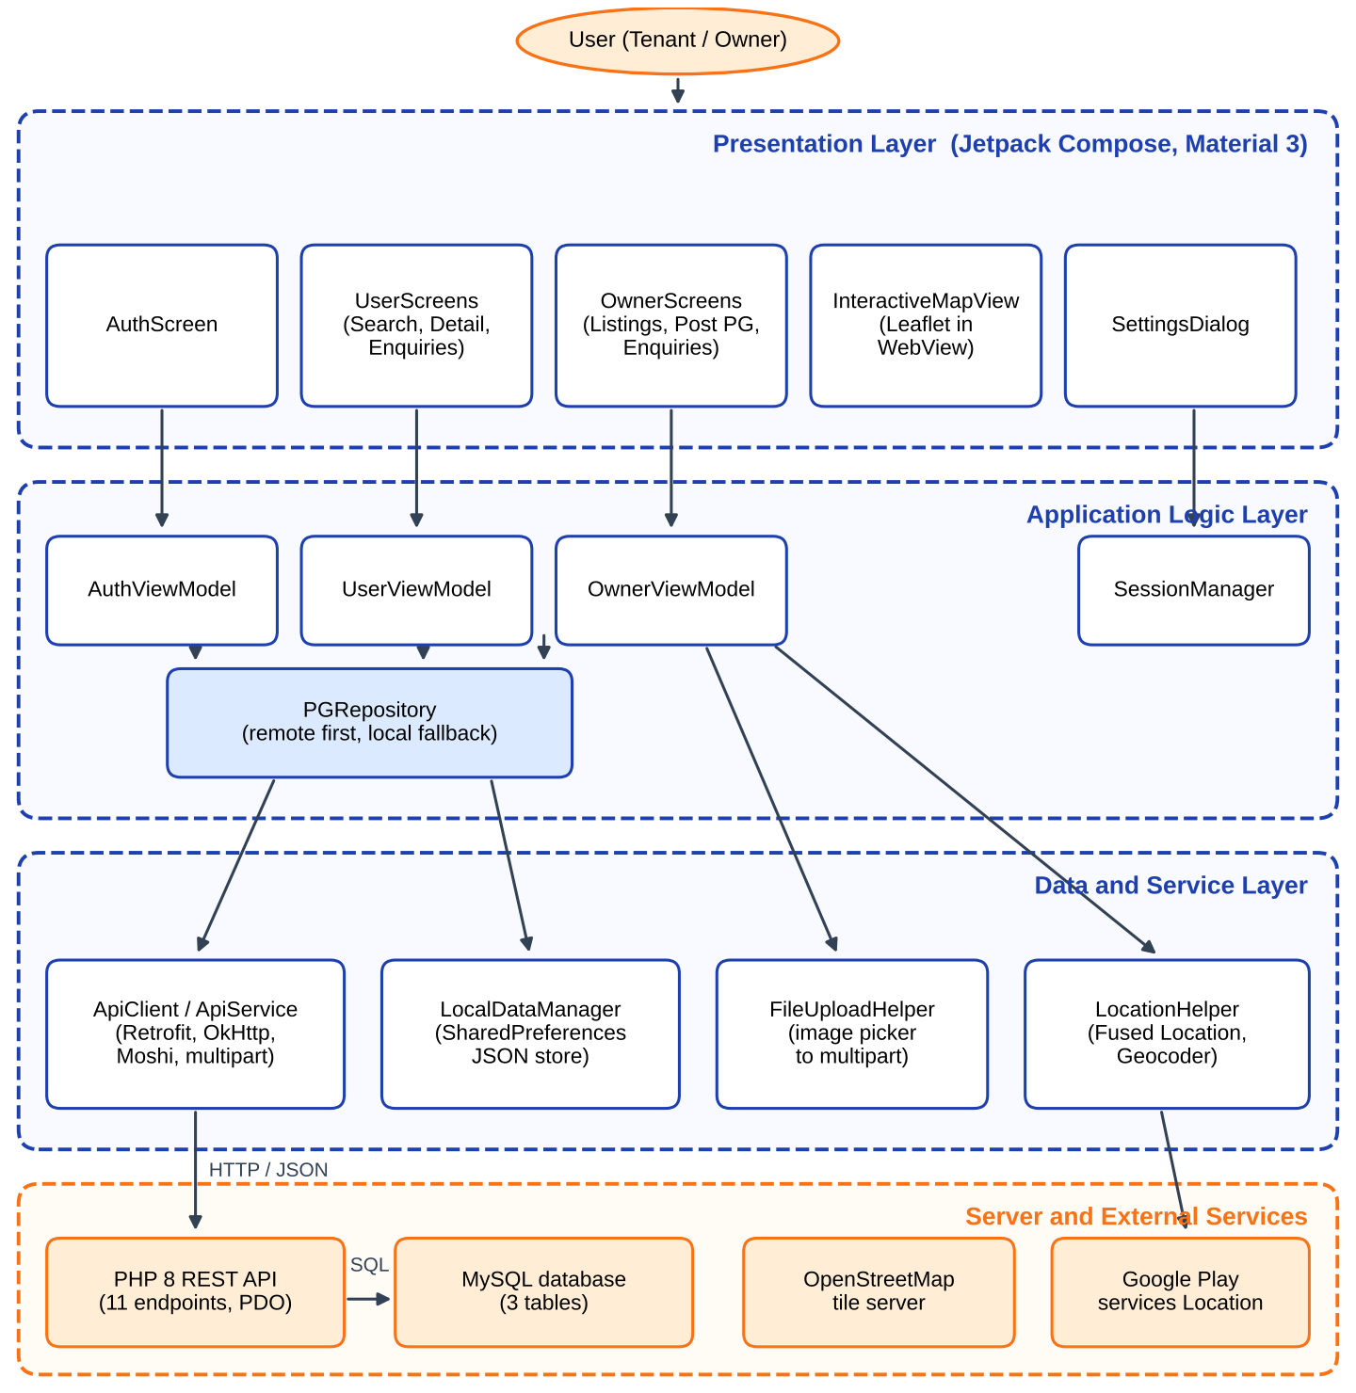
Figure 1: System architecture of FIND MY PG
As Figure 1 shows, the user only interacts with the Compose screens. Each screen observes the state of its ViewModel. The ViewModels never talk to the network directly; they call the single repository, which first tries the REST API and, when the call fails, answers from the local store. Photographs travel as multipart requests to the same API, and the GPS position comes from the Google Play services location client. The map tiles are loaded from OpenStreetMap by the WebView that hosts Leaflet.

3.4 Application Flow
The overall behaviour of the application from launch to use is described by the flowchart in Figure 2. When the application starts, the saved session and the saved Base URL are loaded. A user who is not logged in sees the login and registration screen; the credentials are sent to the PHP API and, if the server cannot be reached, are checked against the local store. After login the application routes the user by role: owners to the Owner Portal with three tabs and tenants to the Tenant Discovery screens with a bottom navigation bar.
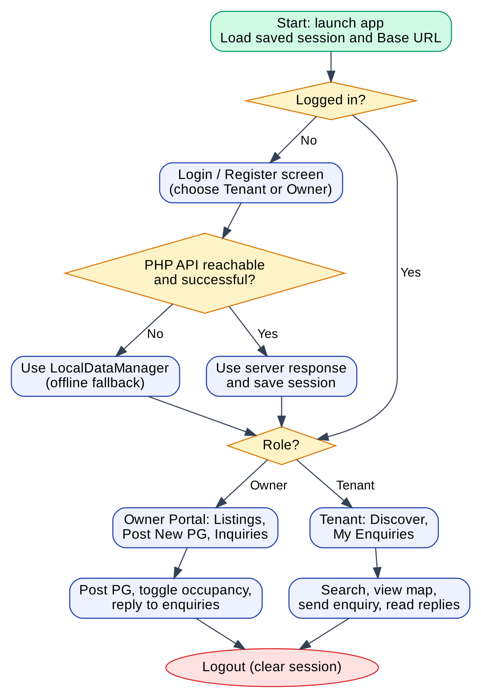
Figure 2: Flowchart of the application

3.5 Screen Navigation
Navigation inside the application is simple. After authentication, the tenant reaches two main destinations, Discover and My Enquiries, from a bottom navigation bar; tapping a PG card opens a detail dialog, and the Enquire button opens a dialog to type the message. The owner works in one screen with three tabs: My Listings, Post New PG and Inquiries. The settings dialog can be opened from the top bar in both roles. Figure 3 shows the navigation map.
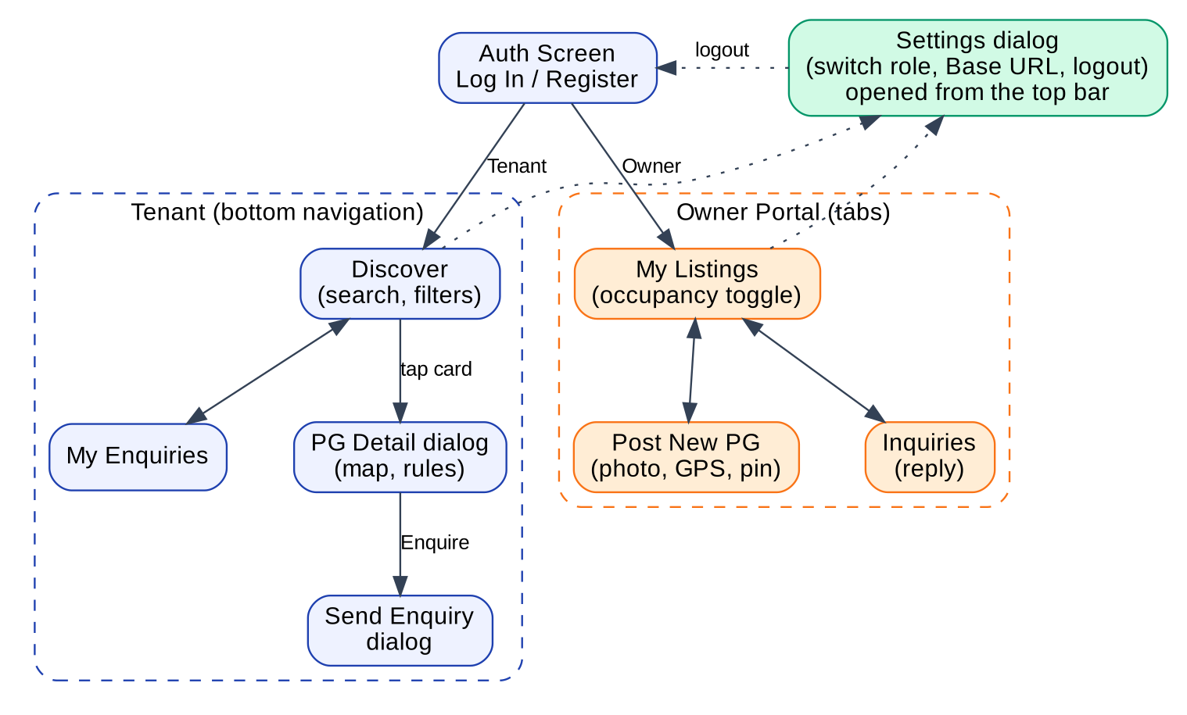
Figure 3: Screen navigation map

3.6 Data Flow Diagram
Figure 4 shows the data flow of the system. Credentials go to the authentication process, which reads and writes the users data store. Search text, rent limit and amenity choices go to the search process, which reads the approved listings; tenants receive the matching PGs. Owners send PG details to the listing process, which inserts or updates the listings, and photographs go to the upload process, which returns an image URL that is stored with the listing. Enquiries and replies pass through the enquiry process, which reads and writes the enquiries data store. The dashed lines show the local store that is used for the session and as the fallback when the server cannot be reached.
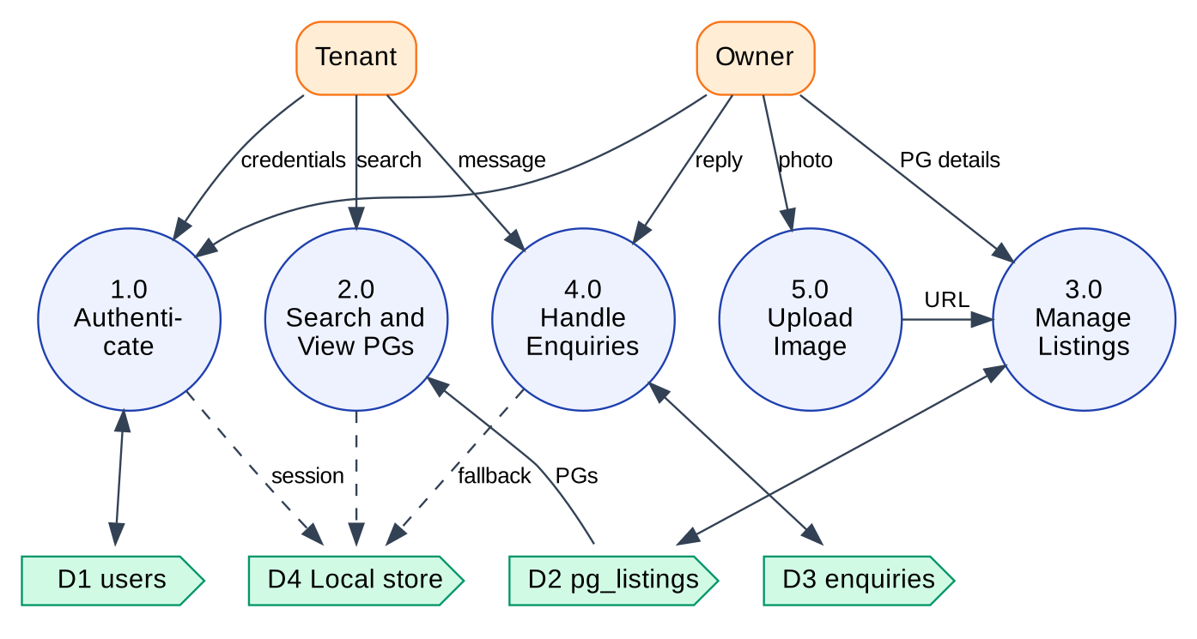
Figure 4: Data flow diagram of FIND MY PG

3.7 Use Case Diagram
The use case diagram in Figure 5 lists what the two actors can do. Both Tenant and Owner can register, log in and out, and change the Base URL or switch role. The tenant can search PGs, view their details, show or hide occupied PGs, send an enquiry and view the owner’s replies. The owner can post a PG with a photograph and a location, view their own listings, mark a PG occupied or vacant, view the tenants’ enquiries and reply to them.
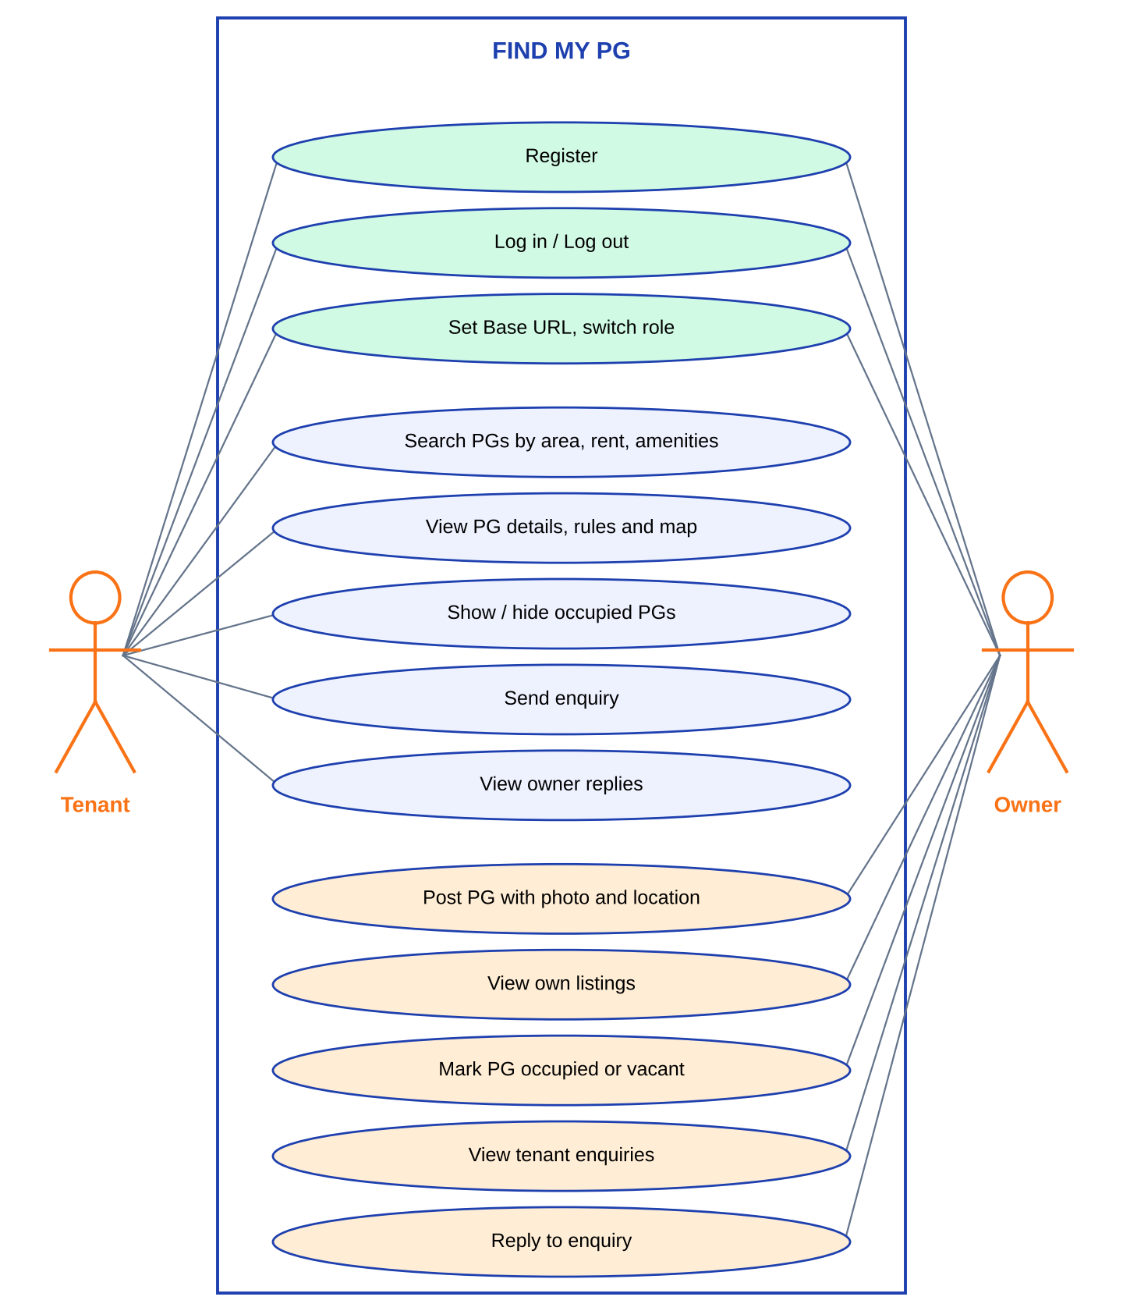
Figure 5: Use case diagram of FIND MY PG

3.8 Data Design

3.8.1 REST API Design
All endpoints are PHP files under backend/api/ and return the same JSON envelope with three fields: status (true or false), message (text for the user) and data (the result or null). Requests with a body use JSON; the image upload uses multipart form data. Table 8 lists the eleven endpoints.
Table 8: REST Endpoints of the Back End
No. | Endpoint | Method | Purpose
1 | auth/register.php | POST | Validates the fields, rejects a duplicate email, stores the bcrypt hash and returns the user with a token
2 | auth/login.php | POST | Verifies the password with password_verify and returns the user profile
3 | upload/upload_image.php | POST | Accepts a JPEG, PNG or WebP image up to 10 MB, checks its real MIME type and returns its URL
4 | owner/post_pg.php | POST | Creates a listing after checking that the user is an owner; status is set to approved
5 | owner/my_pgs.php | GET | Returns all listings of one owner
6 | owner/toggle_occupancy.php | POST | Sets is_occupied to 0 or 1 after checking that the PG belongs to the owner
7 | owner/enquiries.php | GET | Returns the enquiries received by one owner, with tenant details
8 | owner/reply_enquiry.php | POST | Stores the owner’s reply and sets the status to replied
9 | user/search_pg.php | GET | Searches approved listings by location text, rent range and amenities; occupied PGs are excluded unless requested
10 | user/send_enquiry.php | POST | Creates an enquiry for a PG; the owner is found from the listing
11 | user/my_enquiries.php | GET | Returns the enquiries of one tenant with the owner’s reply and contact details

3.8.2 Database Design and Entity–Relationship View
The MySQL database pg_locator has three InnoDB tables in utf8mb4, shown in Figure 6 and described in Table 9. The users table holds both roles, distinguished by the role column. A user with role owner owns many PG listings, and every listing can receive many enquiries. An enquiry stores the tenant (user_id), the owner (owner_id) and the listing (pg_id), so that both sides can read it with one simple query. All foreign keys use ON DELETE CASCADE, and indexes exist on the email, role, status, rent, occupancy and coordinates.
Table 9: Database Tables
Table | Main Columns | Constraints and Notes
users | id, full_name, email, phone, password_hash, role, created_at | email is UNIQUE; role is ENUM(owner, user); passwords are stored as bcrypt hashes
pg_listings | id, owner_id, title, description, address, latitude, longitude, monthly_rent, amenities, rules, image_url, is_occupied, status, created_at | owner_id references users; amenities holds a JSON array as text; is_occupied is 0 (vacant) or 1 (full); status is ENUM(approved, rejected), default approved
enquiries | id, pg_id, user_id, owner_id, message, status, owner_reply, created_at, updated_at | three foreign keys with ON DELETE CASCADE; status is ENUM(pending, replied, closed)

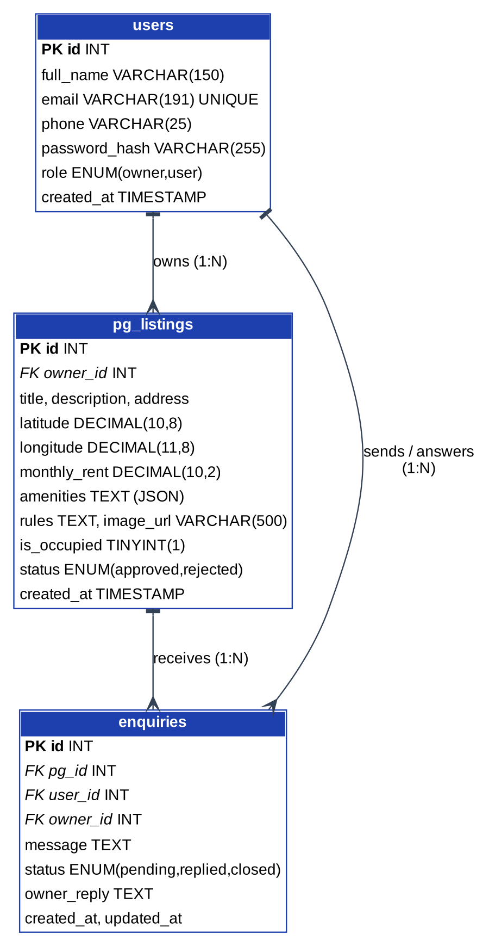
Figure 6: Entity–relationship diagram of the FIND MY PG database
The Android application mirrors these entities in three Kotlin data classes (User, PGListing and Enquiry). The local store keeps the same three lists as JSON text in SharedPreferences, together with a separate preferences file for the passwords of locally registered accounts.

3.9 Class Diagram
The main classes and interfaces of the application are shown in Figure 7. ApiService is the Retrofit interface with one function per endpoint, and ApiClient creates it for the current Base URL. PGRepository is the only class that uses both ApiService and LocalDataManager. AuthViewModel, UserViewModel and OwnerViewModel expose an immutable UI state as a Kotlin StateFlow and call the repository from coroutines. SessionManager stores the logged-in user and the Base URL.
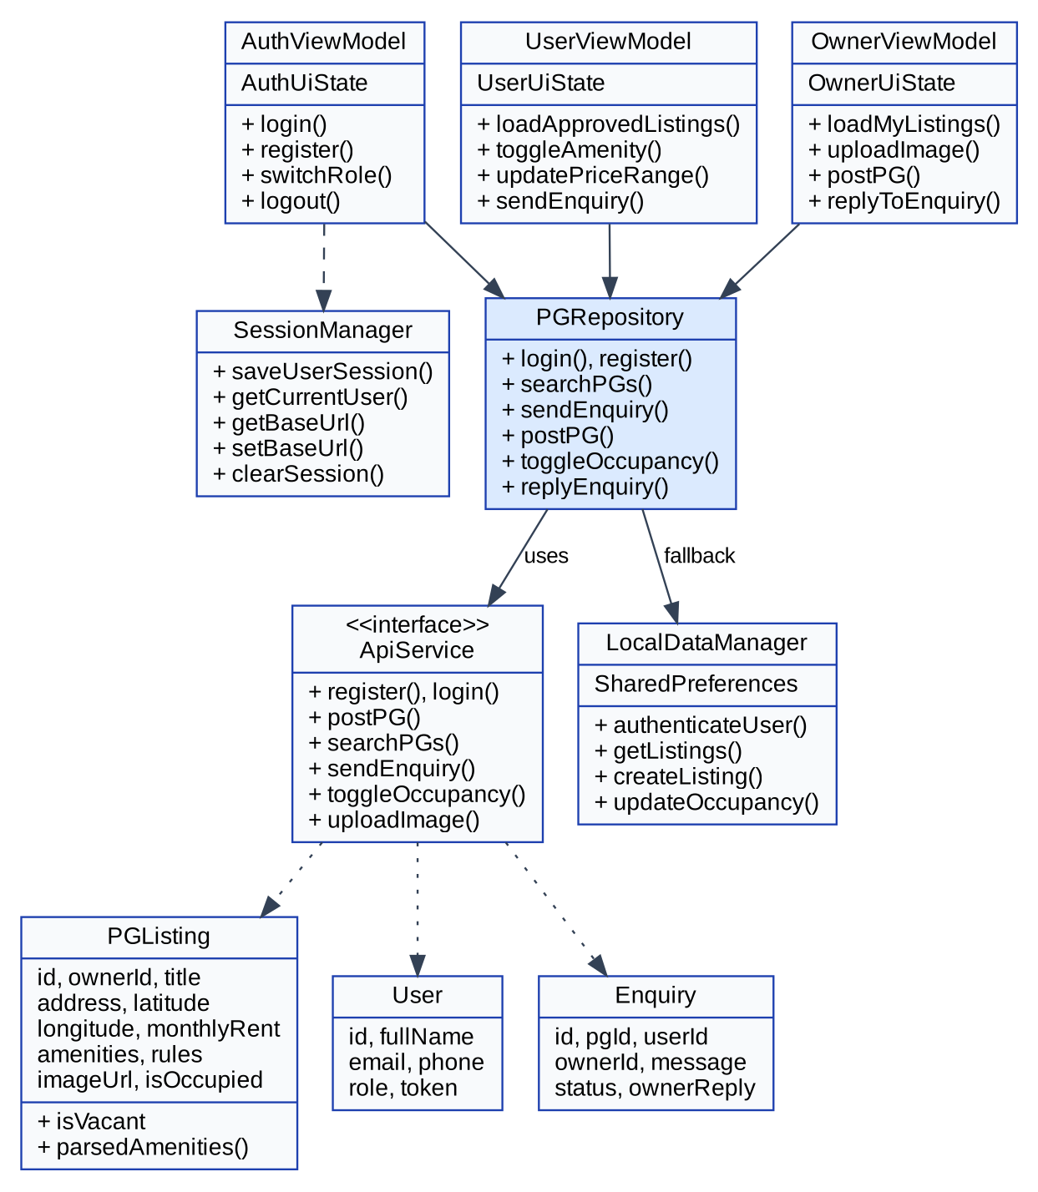
Figure 7: Class diagram of the main classes

3.10 Sequence Diagram
Figure 8 shows the sequence of messages when a tenant searches for a PG and then sends an enquiry. The screen passes the search text and filters to the ViewModel, which calls the repository. The repository requests user/search_pg.php; the PHP script runs a prepared SELECT on MySQL and returns JSON. If the request fails, the repository answers from the local store. Later, when the tenant sends an enquiry, the repository posts it to user/send_enquiry.php, which inserts a row with status pending, and the ViewModel shows the “Enquiry Sent!” dialog.
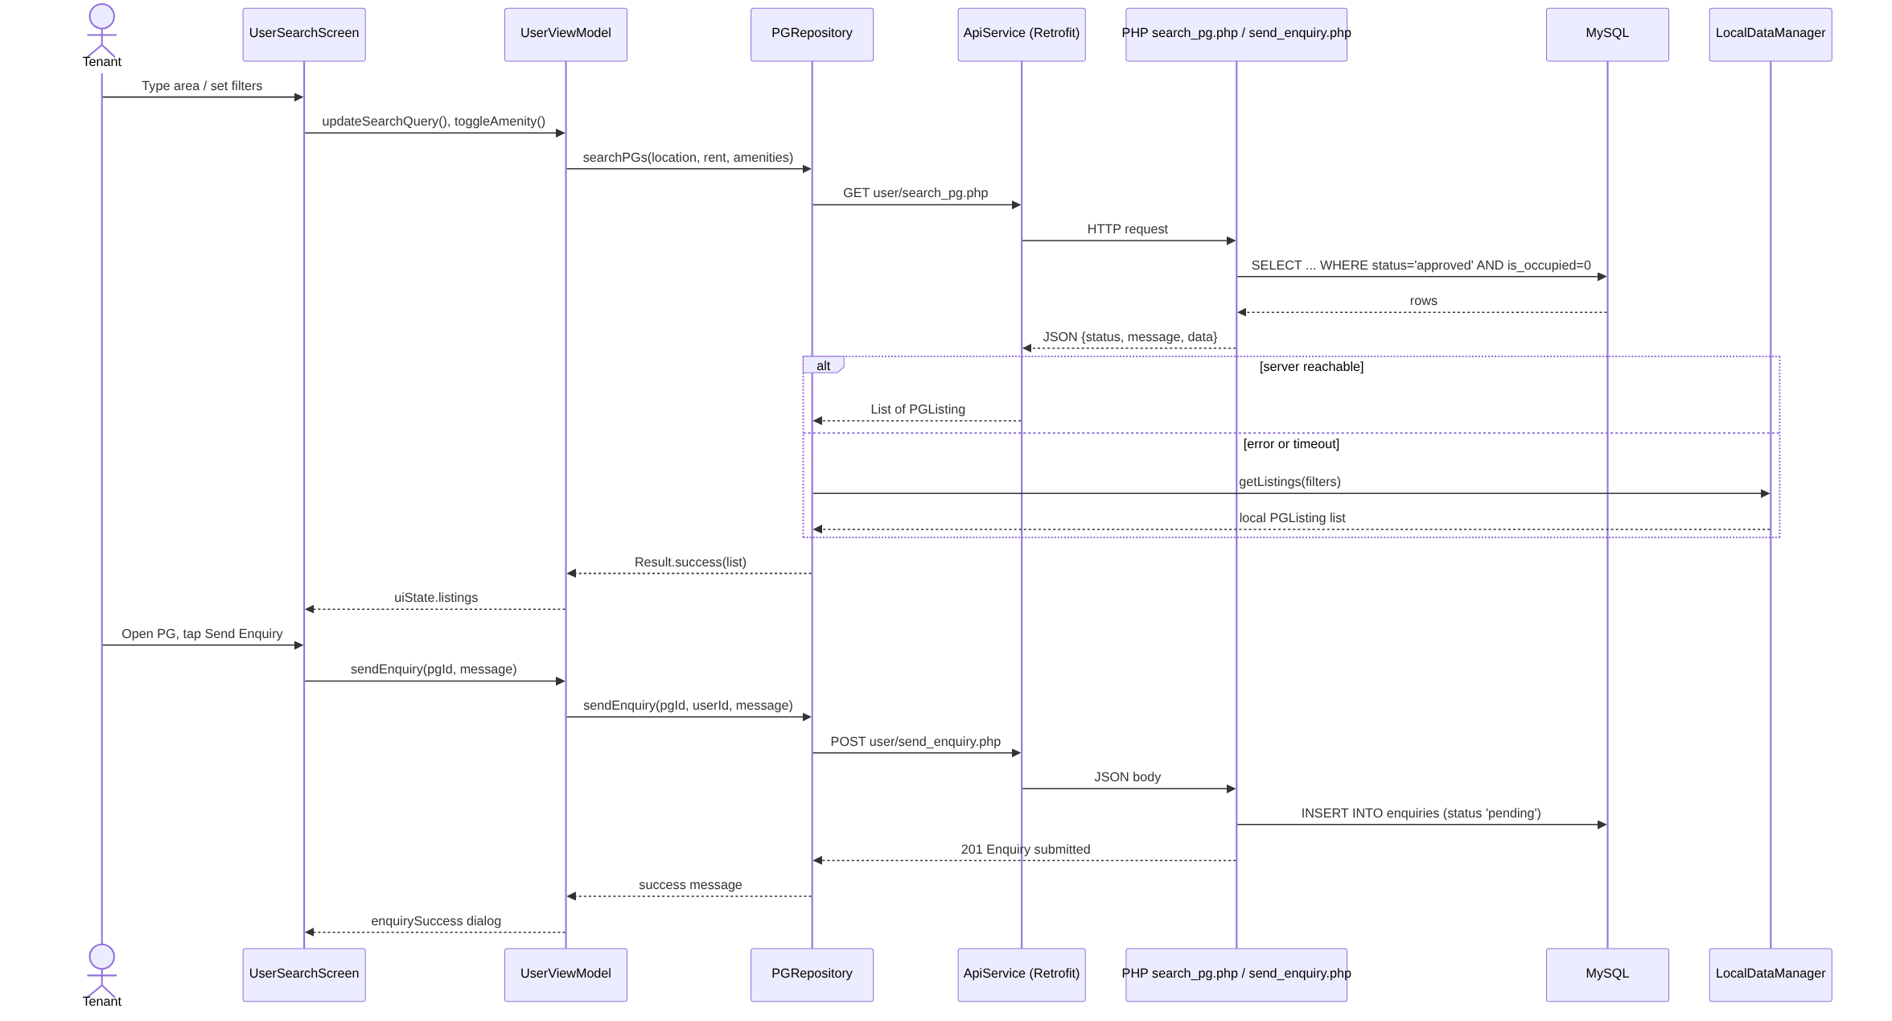
Figure 8: Sequence diagram for searching PGs and sending an enquiry

3.11 User Interface Design Principles
The interface uses Material 3 components [3] with a blue primary colour (#1E40AF) for the top bar and buttons and an orange accent (#F97316) for the owner badge. Status colours are used consistently: green for available or approved, amber for pending and red for occupied or rejected. PGs are displayed as rounded cards with a large photograph, the monthly rent and a row of amenity chips; the top bar shows the application logo, the name of the portal (Owner Portal or Tenant Discovery) and a role badge. The owner’s three tabs and the tenant’s bottom navigation bar keep the main destinations always reachable. Status is always visible to the user: a progress indicator appears while data load, empty lists show a message that explains what to do next, and a PG that is occupied is clearly marked and its enquiry button is disabled. These choices follow the usability principles of visibility of system status and error recovery [17].

4. IMPLEMENTATION

4.1 Introduction
This chapter describes how the design of Chapter 3 was turned into a working system. The Android application is written entirely in Kotlin with Jetpack Compose [1, 2], and the server in PHP 8 with PDO [11]. The implementation is described phase by phase, then the final project structure and key code excerpts are presented, and finally the screens of the running application are shown. The source code is available in the GitHub repository [INSERT GITHUB REPOSITORY LINK].

4.2 Phase-wise Implementation

4.2.1 Phase 1: Requirement Analysis and Environment Setup
The first phase fixed what the system must do. The two roles, Tenant and PG Owner, were identified and the functional requirements of Table 4 were written down. The technology stack was chosen, and the development environment was prepared: Android Studio, the Android SDK and the emulator, the Gradle build with a version catalog (gradle/libs.versions.toml), the KSP plugin for Moshi code generation, XAMPP with Apache, MySQL and PHP for the server, and Git.

4.2.2 Phase 2: Database and API Design
The second phase produced the schema in backend/schema.sql with the tables users, pg_listings and enquiries, their keys and indexes, and a small set of sample data: one owner, one tenant, three PG listings in Bengaluru, Hyderabad and New Delhi, and two enquiries. The REST endpoints of Table 8 and the JSON envelope {status, message, data} were fixed at this stage, so that the Android data classes could be written to match.

4.2.3 Phase 3: Back-end Development
In the third phase the eleven PHP endpoints were written. A shared file, config/db.php, creates one PDO connection with exceptions enabled and native prepared statements, sends the CORS headers, and provides two helper functions: sendResponse() for the uniform JSON reply and getJsonPayload() for reading the request body. Registration validates the fields, checks the email format and the minimum password length of six characters, rejects a duplicate email with HTTP status 409 and stores a bcrypt hash. Login verifies the password with password_verify. The search endpoint builds its SQL from the filters that were supplied and always binds the values as parameters. The image endpoint checks the size and the real MIME type of the file with finfo, and stores it under a random name.

4.2.4 Phase 4: Android App Development
The fourth phase created the Android interface. The theme (Color.kt, Theme.kt, Type.kt) defines the brand colours and status colours. MainActivity builds the session manager, the repository and the three ViewModels, and hosts a Scaffold with the top bar, the role badge, the settings button and, for tenants, the bottom navigation bar. AuthScreen provides login and registration with a role choice. UserScreens.kt contains the search screen with filters, the PG card, the PG detail dialog, the enquiry dialog and the My Enquiries screen. OwnerScreens.kt contains the three tabs: My Listings, Post New PG and Inquiries. Each screen reads the state of its ViewModel and sends user actions back as function calls.

4.2.5 Phase 5: Integration and Advanced Features
The fifth phase connected the client to the server and added the advanced features. ApiService declares the endpoints for Retrofit and ApiClient builds the client with Moshi, with time-outs and request logging, for the Base URL that is stored by SessionManager. PGRepository calls the server first and falls back to LocalDataManager on failure. FileUploadHelper copies the photograph chosen by the owner to a temporary file and posts it as multipart form data. LocationHelper obtains the current position from the Fused Location Provider with fall-backs and converts it to an address with the Geocoder. InteractiveMapView hosts a Leaflet map in a WebView and reports pin movements back to Compose through a JavaScript interface.

4.2.6 Phase 6: Testing and Documentation
In the last phase the features were tested manually on the emulator and the phone, the unit tests for the amenity parsing in PGLocatorUnitTest were written, the back-end guide (backend/README.md) was written with the set-up steps for XAMPP and for the PHP built-in server, and this report was prepared. The testing is described in Chapter 6. The status of publication on the Google Play Store is: [INSERT PLAY STORE LINK OR STATUS].

4.3 Project Structure
The Android project is organised into packages according to responsibility, as shown in Table 10. The line counts were obtained by counting the non-blank lines of the Kotlin files in each package of the final project. The server has twelve PHP files with 600 non-blank lines, of which eleven are endpoints and one is the shared db.php, and the schema file has 74 non-blank lines.
Table 10: Packages of the Final Android Application
Package | Contents | Lines
(root) | MainActivity: Scaffold, top bar with role badge, bottom navigation, role routing, settings dialog host | 210
ui.screens | AuthScreen, UserScreens (search, card, detail, enquiry dialog, My Enquiries), OwnerScreens (listings, post form, inquiries) | 2203
ui.components | InteractiveMapView: Leaflet map in a WebView with a JavaScript bridge | 322
ui.dialogs | SettingsDialog: role switch, Base URL field, logout | 125
ui.theme | Colour definitions, Material 3 theme, typography | 121
viewmodel | AuthViewModel, UserViewModel, OwnerViewModel with their UI state classes | 480
data.model | User, PGListing, Enquiry, ApiResponse and the request classes | 135
data.network | ApiClient (Retrofit, OkHttp, Moshi) and ApiService | 87
data.repository | PGRepository: server first, local fallback | 220
data.local | LocalDataManager: JSON store in SharedPreferences with seed data | 421
util | SessionManager, FileUploadHelper, LocationHelper | 254
 | Total (20 files) | 4578

4.4 Key Implementation Details
1. Application start-up and role routing. MainActivity creates SessionManager, PGRepository and the three ViewModels, and sets the Compose content. The function PGLocatorApp reads the authentication state. If the user is not logged in it shows AuthScreen; otherwise it shows OwnerHomeScreen when the role is owner, and the tenant screens selected by the bottom navigation bar when the role is user. Tapping My Enquiries also reloads the enquiries from the repository.
2. Calling the API with Retrofit. Every endpoint is declared in the ApiService interface as a suspend function, and Retrofit creates the implementation, with Moshi converting the JSON reply. The search function, for example, passes the optional filters as query parameters:
@GET("user/search_pg.php")
suspend fun searchPGs(
@Query("location") location: String? = null,
@Query("min_price") minPrice: Double? = null,
@Query("max_price") maxPrice: Double? = null,
@Query("amenities") amenities: String? = null,
@Query("include_occupied") includeOccupied: Boolean? = null
): ApiResponse<List<PGListing>>

ApiClient builds the Retrofit instance with a default Base URL of http://10.0.2.2/pg_locator/api/ (the address of the host computer as seen from the Android emulator), with connection, read and write time-outs of 15, 20 and 30 seconds, and with an OkHttp logging interceptor. When the user edits the Base URL in the settings dialog, SessionManager.setBaseUrl() stores it and ApiClient.updateBaseUrl() discards the cached service so that the next call uses the new address.
3. Repository with offline fallback. PGRepository is the only class that decides between the server and the local store. Every function follows the same pattern: try the server; if the call succeeds, return its data; if it throws an exception, because the server is off or unreachable, answer from LocalDataManager:
suspend fun searchPGs(
location: String?, minPrice: Double?, maxPrice: Double?,
amenities: String?, includeOccupied: Boolean = false
): Result<List<PGListing>> = withContext(Dispatchers.IO) {
try {
val res = apiService.searchPGs(location, minPrice, maxPrice,
amenities, if (includeOccupied) true else null)
if (res.status && res.data != null)
return@withContext Result.success(res.data)
} catch (_: Exception) { }
Result.success(localDataManager.getListings(location, minPrice,
maxPrice, amenities, includeOccupied))
}

4. Search on the server. search_pg.php starts from the approved listings, joins the owner’s name, phone and email, and appends one condition for each filter that was supplied. Occupied PGs are removed unless include_occupied is set. All user values are bound as named parameters:
$sql = 'SELECT p.id, p.owner_id, p.title, ... , u.full_name AS owner_name
FROM pg_listings p JOIN users u ON p.owner_id = u.id
WHERE p.status = "approved"';
if (!$includeOccupied) { $sql .= ' AND p.is_occupied = 0'; }
if (!empty($location)) {
$sql .= ' AND (p.title LIKE :loc_title OR p.address LIKE :loc_address
OR p.description LIKE :loc_desc)';
$params[':loc_title'] = '%' . $location . '%'; ...
}
if ($minPrice !== null && $minPrice >= 0) {
$sql .= ' AND p.monthly_rent >= :min_price'; ...
}
foreach ($amenityList as $idx => $amenity) {
$sql .= " AND p.amenities LIKE :amenity_$idx"; ...
}

5. Occupancy toggle. When the owner taps Hide (Mark Occupied) or Mark Empty (Show), the app posts the PG id, the owner id and the new value. The server first checks that the PG exists and belongs to that owner and only then updates it, so that an owner cannot change somebody else’s listing:
if ((int)$listing['owner_id'] !== $ownerId) {
sendResponse(false, 'Unauthorized. You can only modify
your own PG listings.', null, 403);
}
$stmt = $pdo->prepare('UPDATE pg_listings SET is_occupied = :is_occupied
WHERE id = :pg_id AND owner_id = :owner_id');

6. Amenities as JSON text. The amenities of a PG are stored as a JSON array in one TEXT column. The server adds a normalised amenities_list to every result, and the Kotlin class PGListing has a function parsedAmenities() that uses this list or, if it is missing, parses either a JSON-like array or a comma-separated string. This function is covered by the unit tests.
7. Image upload. The owner picks a photograph with the system photo picker. FileUploadHelper copies it to a temporary file in the cache directory, builds a MultipartBody.Part named image and posts it. The server accepts only JPEG, PNG and WebP, up to 10 MB, determines the real type of the file with finfo_file instead of trusting the file name, saves it as pg_<time>_<random>.<ext> and returns its public URL, which is then stored with the listing.
8. GPS location and map pin. LocationHelper requests the current position with high accuracy from the Fused Location Provider, falls back to the last known position and then to the Android LocationManager, and converts the coordinates to a readable address with the Geocoder. If no position can be obtained, a default position in Bengaluru is used. InteractiveMapView loads a small HTML page with Leaflet and OpenStreetMap tiles into a WebView. In interactive mode the marker is draggable and a JavaScript interface calls back into Kotlin with the new latitude and longitude:
class MapLocationBridge(
private val onLocationChanged: ((Double, Double) -> Unit)?
) {
private val mainHandler = Handler(Looper.getMainLooper())
@JavascriptInterface
fun onPinMoved(lat: Double, lng: Double) {
mainHandler.post { onLocationChanged?.invoke(lat, lng) }
}
}

9. Session and local store. SessionManager stores the logged-in user and the Base URL in SharedPreferences. LocalDataManager seeds the local store with the same sample users, PGs and enquiries as the SQL file and then keeps users, listings and enquiries as JSON lists written with Moshi. When the user logs in successfully on the server, the account is also copied into the local store so that it can be used offline.
10. ViewModel state. Each ViewModel keeps a data class with the complete screen state (for example UserUiState with the listings, filters and messages) in a MutableStateFlow and exposes it read-only. When a filter changes, the ViewModel updates the state and calls the repository again, so the result list and the count on the button are always consistent with the filters.

4.5 Results: Screens of the Final Application
This section presents the screens of FIND MY PG. The screenshots are to be captured from the running application and inserted in the marked places; the text under each heading describes what the screen shows in the final version of the code.

4.5.1 Authentication
Figure 9 shows the login and registration screen. It has the application logo and the title FIND MY PG with the tagline Paying Guest Discovery & Management, a switch between Log In and Register, fields for email and password, and, in registration mode, fields for full name and phone number and the choice I want to register as: Tenant / User or PG Owner.
[INSERT SCREENSHOT]  (a) Log In | [INSERT SCREENSHOT]  (b) Register (role choice)
Figure 9: Login and registration screens

4.5.2 Tenant: Search and Filters
Figure 10 shows the tenant’s Discover screen. The search field accepts an area, a PG name or a city. A filter panel provides a slider for the maximum monthly rent, chips for the amenities (WiFi, AC, Food, Gym, Laundry, Security, Power Backup) and a switch to hide occupied accommodations, which is on by default; the Apply Filters button shows the number of results. Each result is a card with the photograph, title, address, rent per month and amenity chips. When nothing matches, the message No PG listings found is shown.
[INSERT SCREENSHOT]  (a) Search results | [INSERT SCREENSHOT]  (b) Filter panel | [INSERT SCREENSHOT]  (c) No results
Figure 10: Tenant search screen with filters and results

4.5.3 Tenant: PG Detail and Map
Figure 11 shows the detail dialog of a PG with the sections About this Accommodation, Amenities, House Rules and Location & Map, the interactive map with the View on Map button that opens Google Maps, and the owner’s contact details. For a PG that is occupied, a notice explains that the owner will make it available once rooms get empty, and the button reads Currently Occupied (Inquiries Paused).
[INSERT SCREENSHOT]  (a) Details and amenities | [INSERT SCREENSHOT]  (b) Location and map | [INSERT SCREENSHOT]  (c) Occupied PG
Figure 11: PG detail dialog with map

4.5.4 Tenant: Sending Enquiries and Reading Replies
Figure 12 shows the Send Enquiry to Owner dialog, which offers quick questions and a text field for the message, the Enquiry Sent! confirmation and the My Enquiries screen. Each enquiry is shown with the PG, the owner, the message, its status and, when the owner has answered, the Owner’s Response.
[INSERT SCREENSHOT]  (a) Send enquiry | [INSERT SCREENSHOT]  (b) Enquiry sent | [INSERT SCREENSHOT]  (c) My Enquiries
Figure 12: Enquiry dialog, confirmation and My Enquiries screen

4.5.5 Owner: Listings and Occupancy
Figure 13 shows the Owner Portal. The tab My Listings shows a summary such as 2 Available (Visible) and 1 Occupied (Hidden), and a card for each PG with its id, rent and a status line, Available / Vacant with Visible to other users, or Occupied / Full with Removed from other users until empty, and a button to switch between Hide (Mark Occupied) and Mark Empty (Show). If the owner has no PG, the message No PG listings posted yet with the button Post Your First PG is shown.
[INSERT SCREENSHOT]  (a) My Listings | [INSERT SCREENSHOT]  (b) Empty state
Figure 13: Owner portal: My Listings and occupancy

4.5.6 Owner: Posting a PG, Enquiries and Settings
Figure 14 shows the Post New PG tab with fields for PG title, street and city, monthly rent, description and house rules, the amenity chips, the photograph upload with the Uploading Image (Multipart) progress message, and the location section with the Use My Current Location button, the map with a draggable pin and the Selected Coordinates. The button Publish PG Accommodation publishes the listing immediately. Figure 15 shows the Inquiries tab, in which the owner reads each tenant’s question and types a reply, and Figure 16 shows the settings dialog with the account card, the Tenant and Owner role chips, the PHP Backend Base URL field and the Log Out button.
[INSERT SCREENSHOT]  (a) Details and amenities | [INSERT SCREENSHOT]  (b) Photo and GPS location | [INSERT SCREENSHOT]  (c) Map pin
Figure 14: Post New PG form
[INSERT SCREENSHOT]  (a) Incoming enquiries | [INSERT SCREENSHOT]  (b) Reply
Figure 15: Owner Inquiries tab
[INSERT SCREENSHOT]  (a) Settings and role switch | [INSERT SCREENSHOT]  (b) Base URL
Figure 16: Settings dialog

4.6 Challenges and Limitations
The main limitations of the implementation, found while reading the final code, are the following. They are stated openly because they mark the work that is needed before the system could be used by real customers.
- No request authentication. The login endpoint returns a random token, but the server neither stores nor checks it. Endpoints trust the owner_id or user_id sent by the client, so a client that changes the id could read another user’s enquiries. Owner actions that change data (posting, occupancy, replying) do verify ownership on the server, but this is not a substitute for token-based authentication.
- Sample password hash. The bcrypt hash used for the two sample users in schema.sql does not verify against the documented password Password@123 when tested with PHP’s password_verify. Sample accounts created from the SQL file therefore cannot log in on the server; a new hash has to be generated, or the accounts have to be created through the registration endpoint. The local store of the app does contain working sample accounts with this password.
- Local and server data can differ. The repository falls back to the local store whenever the server call fails. A listing, an enquiry or a reply created while the server is unreachable exists only on that phone and is not synchronised to the server later. A call that the server rejects with status false, for example a 403 for a user who is not an owner, is also saved locally and reported to the user as a success.
- Passwords in the local store. To allow offline login, passwords of locally registered accounts are kept in plain text in a private SharedPreferences file, and the manifest allows cleartext HTTP traffic while the HTTP client logs complete request and response bodies. This is acceptable for a development set-up on an emulator but must be replaced by HTTPS, hashed storage and reduced logging for a real release.
- Role switching. The settings dialog lets any logged-in user switch between the Tenant and Owner views. The switch changes only the interface; the server still refuses to publish a listing for an account whose stored role is not owner.
- Moderation was removed. Listings are published immediately with status approved. The value rejected exists in the schema, and a request class for status updates is still present in the code, but there is no administrator module.
- Enquiry rules. The server does not stop a tenant from sending several identical enquiries or enquiring about an occupied PG; the interface blocks the second case, but the endpoint does not.
- Search is simple. Location search is a text match on title, address and description; the coordinates are not yet used to sort by distance. There is no paging, so all matching listings are returned at once.
- Unused parts. The build file lists libraries that the code does not use (Room, Firebase AI, App Check), the manifest contains a placeholder map key that is not needed because the map uses OpenStreetMap, and three XML layout files remain from an earlier design and are not referenced by any screen.
- Tests. Only three project-specific unit tests exist, for the amenity parsing; the other test files are the examples generated by Android Studio. The testing is otherwise manual (Chapter 6).

5. RESULTS AND ANALYSIS

5.1 Introduction
FIND MY PG is an application and not a prediction model, so its results are the working features, the code produced and the evidence of correct behaviour. The screens of the application are presented in Chapter 4 and the functional tests in Chapter 6. This chapter summarises what was delivered, analyses the structure of the code base using the real project data, and states which measurements have not yet been recorded.

5.2 Components Delivered
Table 11 lists the components of the delivered system. The sizes were counted from the final project; only non-blank lines are counted, and the test files and resource files are not included.
Table 11: Components of the Delivered System
Component | Language | Files | Non-blank Lines
Android application (app/src/main/java) | Kotlin | 20 | 4578
REST API and database access (backend/api, backend/config) | PHP | 12 | 600
Database schema and sample data (backend/schema.sql) | SQL | 1 | 74
Test sources (app/src/test, app/src/androidTest) | Kotlin | 4 | 3 project-specific unit tests
Documentation | Markdown | 2 | Project README and back-end guide

The repository of the project is [INSERT GITHUB REPOSITORY LINK]. Together, the application and the server contain 32 source files and about 5,200 lines of code, which a single developer could write, test and document without any paid tool.

5.3 Distribution of the Code in the Final Application
Figure 17 shows how the 4,578 lines of Kotlin are distributed among the packages. The screens package is by far the largest, with 2,203 lines, because every screen contains its own layout, dialogs and state handling. It is followed by the local data manager (421 lines), which holds the seed data and the offline logic, the ViewModels (480 lines) and the map component (322 lines).
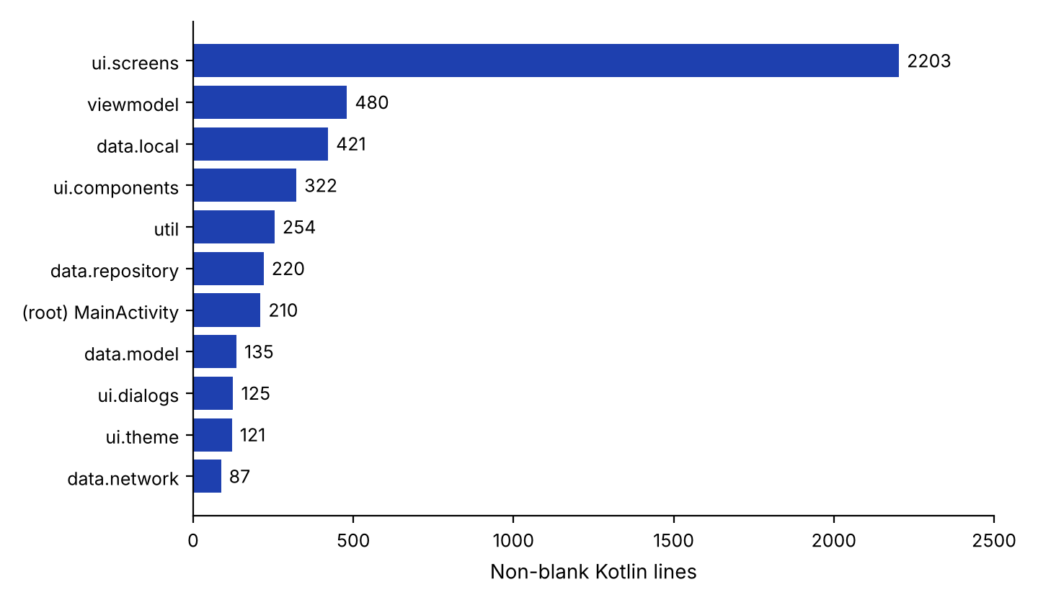
Figure 17: Kotlin source lines in each package of the final application

5.4 Achievement of the Objectives
Table 12 compares the project objectives of Section 2.8 with what was achieved.
Table 12: Achievement of the Project Objectives
Phase | Objective | Outcome and Evidence
1 | Analyse the problem and set up the environment | Achieved; requirements in Section 1.6, two roles identified
2 | Design the schema and the REST API | Achieved; three tables (Figure 6) and eleven endpoints (Table 8)
3 | Implement the PHP endpoints | Achieved; 12 PHP files, 600 lines; sample hash defect noted in Section 4.6
4 | Design and implement the Material 3 interface for both roles | Achieved; 20 Kotlin files, screens in Section 4.5
5 | Integrate the API and add upload, GPS, map and offline fallback | Achieved in the code; synchronisation of offline data to the server is not implemented
6 | Test and document | Manual test cases defined (Chapter 6) and three unit tests written; results to be recorded; report completed

5.5 Measurements Not Yet Recorded
No performance measurement is part of the delivered material. To avoid presenting estimated numbers, the values below are left to be filled in from the running application.
Table 13: Measurements To Be Recorded
Measurement | Value
Size of the release APK | [INSERT ACTUAL VALUE]
Time from launch to the Discover screen | [INSERT ACTUAL VALUE]
Response time of search_pg.php on the local server | [INSERT ACTUAL VALUE]
Number of PG listings in the database during the tests | [INSERT ACTUAL VALUE]
Android version and device used for the screenshots | [INSERT ACTUAL VALUE]

5.6 Discussion
The results show that a complete client–server application with two user roles can be built by one developer with free tools. The application delivers the features that were missing in the existing way of searching for a PG: vacancy is visible and controlled by the owner, the location is shown on a map, search can be narrowed by rent and amenities, enquiries and replies are recorded, and the application keeps working when the server is not available. The analysis also shows what remains: requests must be authenticated with tokens, the offline data must be synchronised with the server, a few server rules should be made stricter, and automated tests and measurements must be added before the system can be released with confidence.

6. TESTING

6.1 Testing Strategy
The system is tested at three levels. First, the PHP endpoints are tested one by one with a browser or an HTTP client, by sending valid and invalid requests and checking the JSON reply and the database rows. Second, the Android application is tested manually by running it and using each feature as a user would, in the order of the screens, once with the server running and once with the server stopped to check the offline fallback. Third, the pure Kotlin logic is covered by unit tests: the class PGLocatorUnitTest contains three tests, for parsing the amenities from a JSON-like text, from a comma-separated text, and for the default values of a listing.
The results of the test cases in Table 14 are to be recorded when they are executed; a case whose result has not yet been recorded is marked with a red placeholder. The device or emulator used for the tests is [INSERT DEVICE OR EMULATOR MODEL]. Apart from the three unit tests, the test files in the project are the example files that Android Studio generates for a new project [18], so no further automated test results are reported.

6.2 Test Cases
Table 14: Functional Test Cases and Results
ID | Test | Expected Behaviour | Status
TC1 | Launch the app for the first time | Login screen with the title FIND MY PG and the Log In / Register switch is shown | [INSERT RESULT]
TC2 | Register as a Tenant with valid data | Account is created and the Tenant Discovery screen opens | [INSERT RESULT]
TC3 | Register as a PG Owner with valid data | Account is created and the Owner Portal opens | [INSERT RESULT]
TC4 | Register with an empty name, an email without @, or a short password | A validation message is shown and no account is created | [INSERT RESULT]
TC5 | Register with an email that already exists | A message says that an account with this email already exists | [INSERT RESULT]
TC6 | Log in with a correct email and password | The portal of the account’s role opens and the session is kept after the app is restarted | [INSERT RESULT]
TC7 | Log in with a wrong password | An error message is shown and the user stays on the login screen | [INSERT RESULT]
TC8 | Open Discover as a tenant | Only vacant PGs are listed as cards with photograph, rent and amenities | [INSERT RESULT]
TC9 | Search for an area or city name | Only PGs matching the text are listed | [INSERT RESULT]
TC10 | Move the maximum-rent slider | PGs above the chosen rent disappear and the result count changes | [INSERT RESULT]
TC11 | Select one or more amenity chips | Only PGs that have all selected amenities are listed | [INSERT RESULT]
TC12 | Switch off Hide Occupied Accommodations | Occupied PGs appear and are marked Occupied | [INSERT RESULT]
TC13 | Open a PG | Description, amenities, house rules, owner details and the map are shown | [INSERT RESULT]
TC14 | Send an enquiry for a vacant PG | The Enquiry Sent! dialog appears and the enquiry is listed in My Enquiries with status pending | [INSERT RESULT]
TC15 | Open an occupied PG | A notice is shown and the enquiry button is disabled | [INSERT RESULT]
TC16 | Owner publishes a PG with a photograph | The image is uploaded, the listing is published and appears in My Listings | [INSERT RESULT]
TC17 | Owner taps Use My Current Location | The latitude, longitude and address are filled in from the GPS | [INSERT RESULT]
TC18 | Owner drags the pin on the map | The Selected Coordinates change to the new position | [INSERT RESULT]
TC19 | Owner taps Hide (Mark Occupied) | The PG is marked Occupied and no longer appears in the tenant’s default search | [INSERT RESULT]
TC20 | Owner taps Mark Empty (Show) | The PG is marked Available and appears again for tenants | [INSERT RESULT]
TC21 | Owner opens Inquiries and sends a reply | The enquiry status changes to replied | [INSERT RESULT]
TC22 | Tenant opens My Enquiries after the reply | The owner’s response is shown under the enquiry | [INSERT RESULT]
TC23 | Change the Base URL in the settings dialog | The following requests are sent to the new address | [INSERT RESULT]
TC24 | Stop the server and use the app | Search, enquiry, posting and login continue to work with the local data | [INSERT RESULT]
TC25 | Switch the role from Tenant to Owner and back | The portal changes without logging out | [INSERT RESULT]
TC26 | Log out from the settings dialog | The login screen is shown again | [INSERT RESULT]
TC27 | Run the unit tests in PGLocatorUnitTest | All three tests pass | [INSERT RESULT]

6.3 Test Summary
Twenty-seven test cases are defined, covering authentication, tenant search and enquiries, owner listing management, location and map, settings, the offline fallback and the unit tests. Their results must be executed and recorded before the testing can be regarded as complete. One defect is already known from the code review and from a direct check with PHP: the password hash of the sample users in schema.sql does not match the documented sample password, so TC6 must be run with an account created through the registration screen when the sample SQL data are used (Section 4.6). The tests do not include automated UI tests, load tests, security tests or usability testing with real users, which are left for future work.

7. CONCLUSION

7.1 Conclusion
This project has developed FIND MY PG, a Paying Guest discovery and management system consisting of an Android application and a PHP/MySQL back end. The Android application is written in Kotlin with Jetpack Compose and Material 3 and has 20 source files with 4,578 lines; the server has 12 PHP files with 600 lines and a three-table MySQL database. Owners can publish PGs with a photograph and a map location, mark them occupied or available, and answer enquiries; tenants can search by area, rent and amenities, view PGs on a map and send enquiries. The application loads data with Retrofit and Moshi, shows photographs with Coil, uses the device GPS and an OpenStreetMap map, and falls back to a local store when the server is not reachable.
The work gave practical experience of the complete life cycle of a client–server mobile system: analysing a real problem, designing a schema and a REST API, writing a PHP server, building a Compose interface, integrating the two, adding device features, testing and documenting. The analysis in Chapter 5 and the limitations in Section 4.6 also show the present limits of the system: requests are not authenticated with tokens, offline data are not synchronised, the sample password hash has to be corrected, and automated tests, measurements and a store release are still to be completed. The project therefore delivers a working and well-structured learning system and a clear list of the next improvements.

7.2 Future Scope
Several directions can improve the system. The first is security: token-based authentication (for example JSON Web Tokens) checked on every endpoint, HTTPS instead of cleartext HTTP, hashed storage of any locally kept credentials, rate limiting and stricter server-side rules for enquiries. The second is data consistency: a synchronisation queue that sends the changes made offline to the server when the connection returns, and a Room database in place of JSON in SharedPreferences.
The search and discovery features can be extended by sorting PGs by distance from the user with the stored coordinates, searching on a map area, paging the results and saving favourite PGs. Communication can be improved with push notifications through Firebase Cloud Messaging when an enquiry or a reply arrives, and with in-app chat. Business features can follow: room booking and online rent payment, ratings and reviews, verification of owners and an administrator module for approving or rejecting listings, which the schema already prepares with the status column. Finally, the quality of the application can be raised by writing unit tests for the ViewModels and the repository, instrumented UI tests for the main screens and API tests for the PHP endpoints, by measuring start-up time and memory use, by adding a continuous integration pipeline, and by preparing the application for the Google Play Store.

REFERENCES
[1] Android Developers, “Jetpack Compose,” Google. [Online]. Available: https://developer.android.com/jetpack/compose
[2] JetBrains, “Kotlin Documentation.” [Online]. Available: https://kotlinlang.org/docs/home.html
[3] Google, “Material Design 3.” [Online]. Available: https://m3.material.io
[4] Square, Inc., “Retrofit: A type-safe HTTP client for Android and Java.” [Online]. Available: https://square.github.io/retrofit/
[5] Square, Inc., “Moshi: A modern JSON library for Kotlin and Java.” [Online]. Available: https://github.com/square/moshi
[6] Square, Inc., “OkHttp.” [Online]. Available: https://square.github.io/okhttp/
[7] Coil Contributors, “Coil: Image loading for Android and Compose Multiplatform.” [Online]. Available: https://coil-kt.github.io/coil/
[8] Google, “Fused Location Provider API,” Google Developers. [Online]. Available: https://developers.google.com/location-context/fused-location-provider
[9] V. Agafonkin, “Leaflet: an open-source JavaScript library for mobile-friendly interactive maps.” [Online]. Available: https://leafletjs.com
[10] OpenStreetMap Contributors, “OpenStreetMap.” [Online]. Available: https://www.openstreetmap.org
[11] The PHP Group, “PHP Manual: PHP Data Objects (PDO).” [Online]. Available: https://www.php.net/manual/en/book.pdo.php
[12] The PHP Group, “PHP Manual: password_hash.” [Online]. Available: https://www.php.net/manual/en/function.password-hash.php
[13] Oracle Corporation, “MySQL Reference Manual.” [Online]. Available: https://dev.mysql.com/doc/
[14] Android Developers, “Guide to app architecture,” Google. [Online]. Available: https://developer.android.com/topic/architecture
[15] R. T. Fielding, “Architectural Styles and the Design of Network-based Software Architectures,” Ph.D. dissertation, Dept. of Information and Computer Science, University of California, Irvine, CA, USA, 2000.
[16] I. Sommerville, Software Engineering, 10th ed. Harlow, U.K.: Pearson, 2016.
[17] J. Nielsen, Usability Engineering. San Diego, CA, USA: Academic Press, 1993.
[18] Android Developers, “Test apps on Android,” Google. [Online]. Available: https://developer.android.com/training/testing
[19] Android Developers, “Meet Android Studio,” Google. [Online]. Available: https://developer.android.com/studio/intro

