SUPERMARKET SALES & BUSINESS INTELLIGENCE
AICTE | IBM SkillsBuild Internship Capstone Project

Author: Md Sameer Khan | Email: kmdsameer993@gmail.com
Institution: Maharaja Agrasen Institute of Technology (MAIT) | Repository: github.com/Sameer-khan-27/IBM-SkillsBuild-Sales-Analytics
1. Executive Summary
This analytical report presents an operational and exploratory evaluation of 1,000 retail transaction records originating from three supermarket branches (Naypyitaw, Yangon, and Mandalay). Developed as an end-to-end internship capstone project, the analysis examines product category sales distributions, customer segment purchasing power, checkout payment preferences, and branch contribution levels to produce strategic business intelligence.
TOTAL REVENUE  $322,966.75  1,000 Transactions | AVG ORDER VALUE  $322.97  +9.59% Member Lift | TOP CATEGORY  Food & Beverage  $56,144.84 Gross | SATISFACTION  6.97 / 10.0  Stable CSAT Index
2. Key Strategic Insights
• Geographical Revenue Parity: Store revenues remain balanced across cities. Naypyitaw leads with $110,568.71 (34.2%), while Yangon ($106,200.37) and Mandalay ($106,197.67) record nearly identical top-line results (~32.9% each).
• Product Line Performance: Food and Beverages ($56,144.84) and Sports and Travel ($55,122.83) generate the highest sales volume. Even the lowest contributor (Health & Beauty at $49,193.74) captures 15.2% of total turnover, indicating a resilient, diversified product catalog.
• High Digital Payment Penetration: Cashless payment methods account for 65.6% of customer checkouts (E-wallets at 34.5% and Credit Cards at 31.1%), outperforming traditional cash settlement (34.4%).
• Loyalty Member Uplift: Registered Loyalty Members generate an average basket size of $335.74 per order compared to $306.37 for Regular walk-in customers, delivering a statistically verified 9.59% revenue increase per transaction.

3. Visual Exploratory Analysis
A. Product Category Revenue Distribution
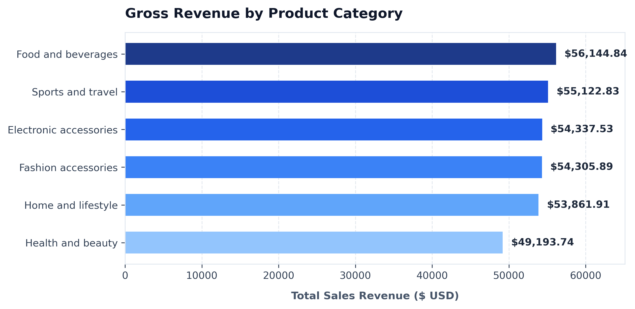
Figure 1: Ranked gross sales revenue across the six core product divisions.
B. Geographical Sales & Payment Channel Breakdown
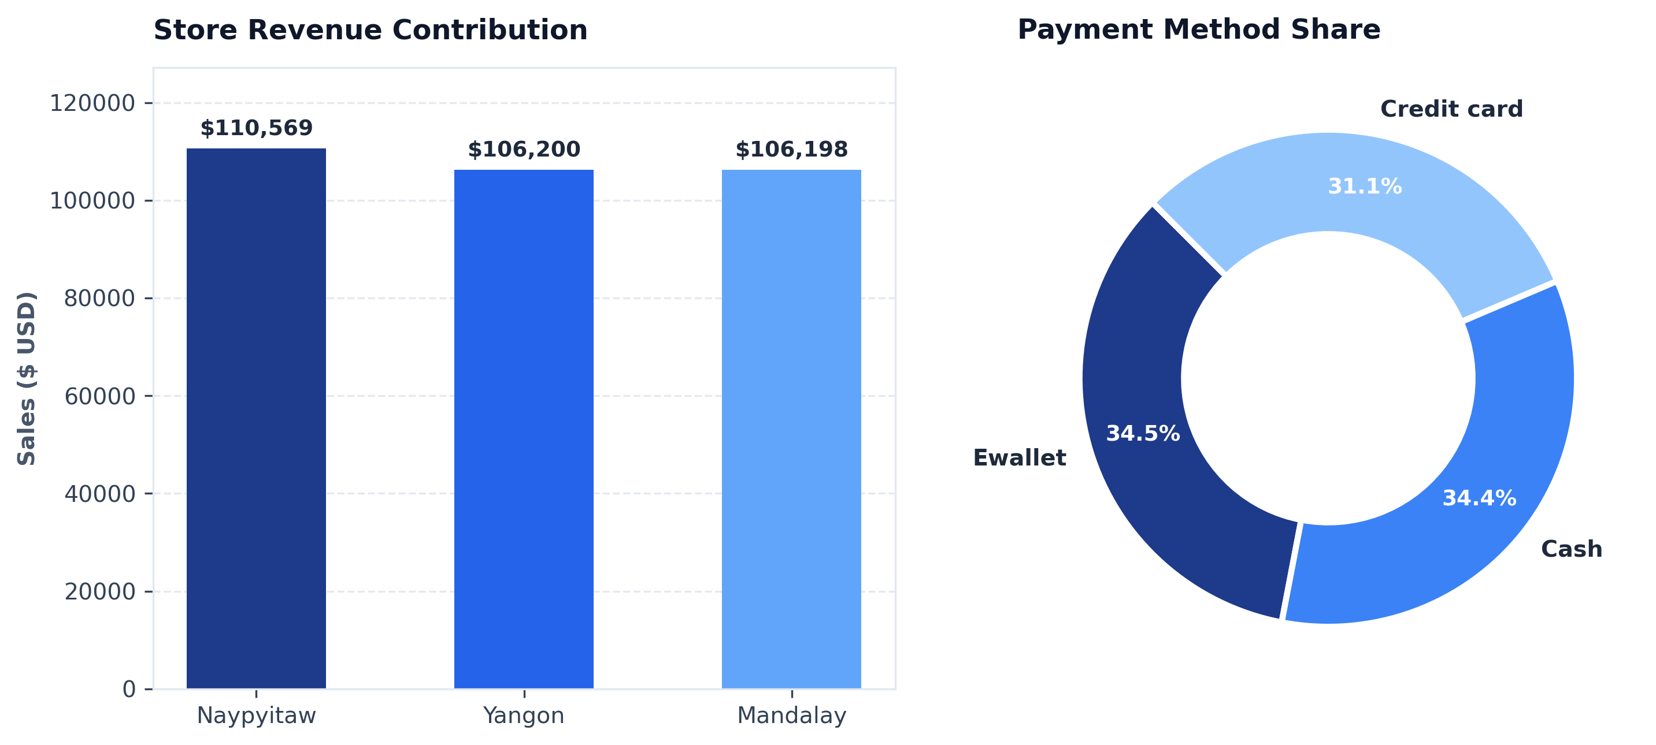
Figure 2: Store branch gross sales (left) and transaction settlement mode percentages (right).
C. Customer Segment Spending Behavior
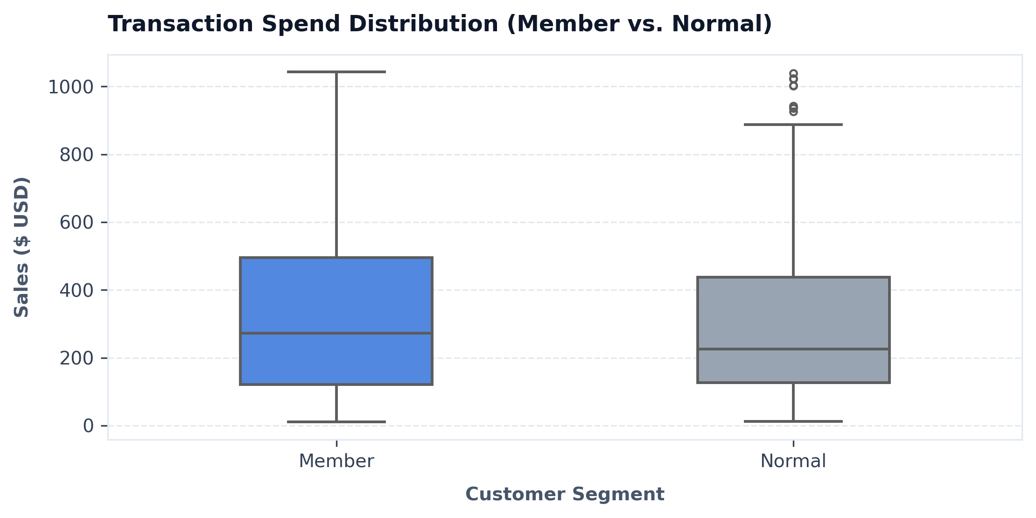
Figure 3: Interquartile ranges and median transaction expenditures for Members vs. Normal shoppers.
4. Strategic Business Recommendations
1. Membership Conversion Strategy: Because loyalty members spend ~$29.37 more per visit, store personnel should be incentivized with enrollment targets, offering an immediate 5% first-purchase coupon on sign-up.
2. Express Digital Checkout Kiosks: With 65.6% of checkouts conducted via E-wallet or Credit Card, setting up dedicated digital self-checkout lanes will shorten wait times and reduce cashier overhead during peak hours.
3. Cross-Merchandise Bundling: To boost the lowest-performing category (Health & Beauty at $49,194), create co-promotional discount bundles with top-performing Food & Beverage staples.
5. Analytical Stack & Repository Deliverables
• Python Analytical Stack: Pandas (data cleaning, aggregations), NumPy (statistical indexing), Matplotlib & Seaborn (visualizations).
• Project Deliverables: Jupyter Notebook (Md_Sameer_Khan_Sales_Analytics.ipynb), Requirements (requirements.txt), Markdown Briefing (README.md).
• Version Control: Git workflow tracked and publicly accessible at https://github.com/Sameer-khan-27/IBM-SkillsBuild-Sales-Analytics.

