Innovative Full Stack Web Developer known for productivity and efficiency in task completion. Possess deep knowledge in JavaScript, React, and Node.js, ensuring robust web application development. Excel at problem-solving, teamwork, and adaptability, skills that enhance project outcomes and foster collaborative work environments.

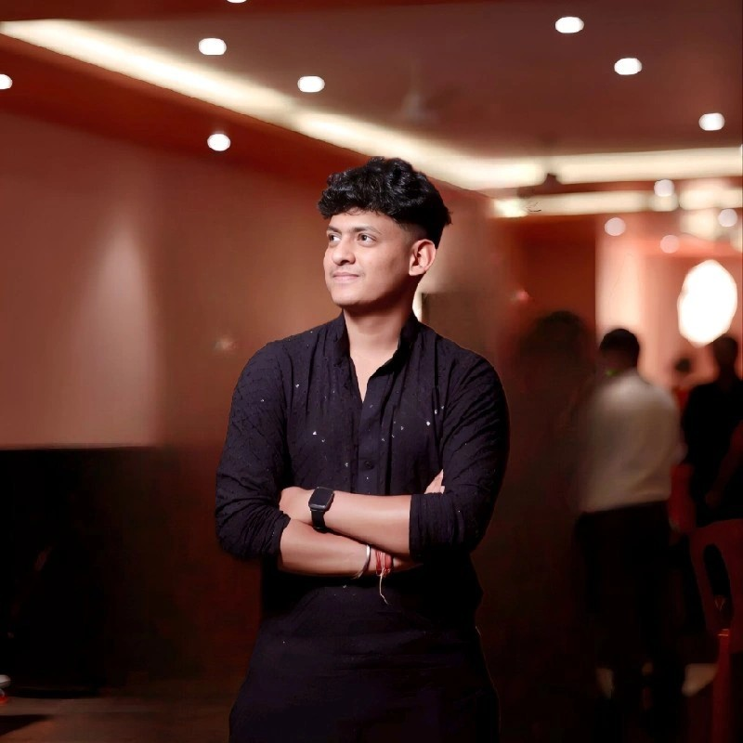

**SAMEER NEGI**

■

Dehradun, India 248001

■

+91 9058420228

✉■

negisameer72@gmail.com

■

https://negisameer.live

**SUMMARY**

# SKILLS

|  |  |
| --- | --- |
| - Full-stack web developer | - Backend frameworks |
| - Front-end frameworks | - UI and UX design principles |
| - Git version control | - Interactive 3D development |
| - React.js proficiency | - Next.js proficiency |

# EDUCATION AND TRAINING

**Foundation Computer Institute, Premnagar Dehradun - 08/2023**

DCA: Diploma in Computer Applications (DCA)

**DD College, Dehradun - 08/2025**

Bachelor of Science: Chemistry, Botany, Zoology

**Shree Guru Ram Rai Public School, Srinagar Uttarakhand - 08/2022** High School Diploma

# CERTIFICATIONS

- Diploma in Computer Applications

# LANGUAGES

Hindi: First Language

English: Intermediate (B1)

# Socials

LinkedIn - <https://www.linkedin.com/in/sameer-negi-52a85b336/>

Github - <https://github.com/Sameer1311>

Leetcode - <https://leetcode.com/u/Codesameer>