Table of Contents | Page No.
Monitoring Python jobs from SupervisorD. | Page1
Scheduling/analysing a Python script. | Page1-7
Create a Virtual Environment. | Page2-5
Error handling and logging in Python. | Page7-10
Schedule a Python script in the Cron daemon. | Page10-15
Python job scheduling use cases. | Page13
Python script automation with Windows Task Scheduler. | Page15-17
Identifying Common Errors in Pipeline Code. | Page17-19
Python Code Profiling & Optimization. | Page19-27
- Monitoring Python jobs from SupervisorD
This is usually located on client VDI.
You can also use the below tools.
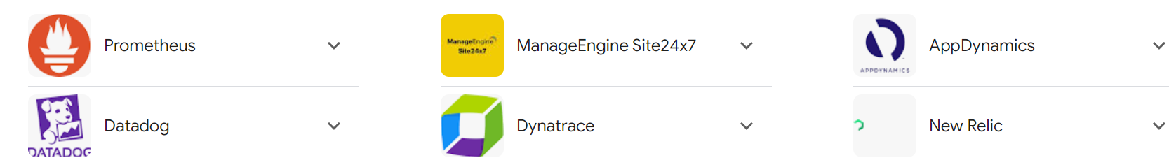
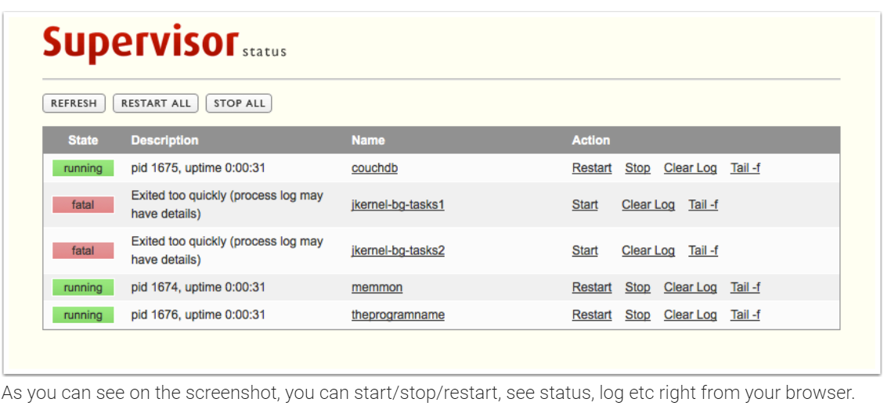
- Scheduling and Analysing a Python Script
Download Python from CompanyPortal.
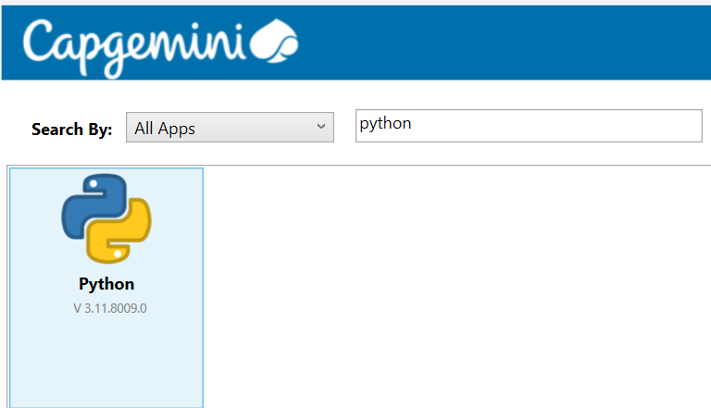
Download PyCharm from: https://www.jetbrains.com/pycharm/download/
Or any IDE of your choice. You can also download from CompanyPortal.
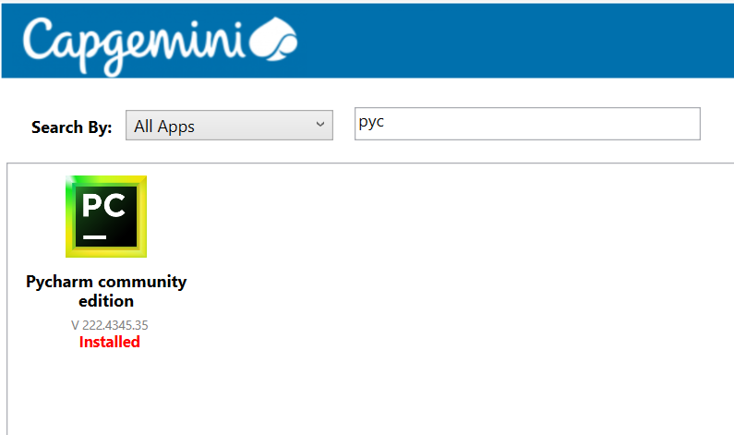
Python virtual environments allow developers to control software dependencies in Python code. They're useful ways of ensuring that the correct package/library versions are consistently used every time the software runs. Virtual environments also help ensure that the results from running code are reproducible.
- Create a Virtual Environment:(optional but advisable)
- Go to View | Tool Windows | Terminal or press AltF12.
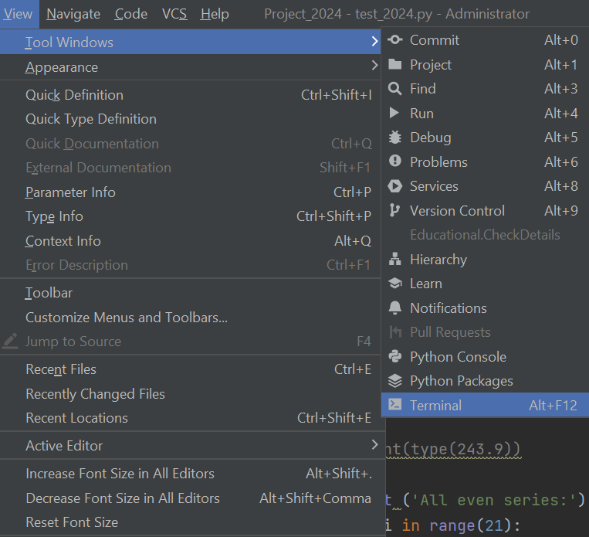

- Navigate to the project path (if existing)
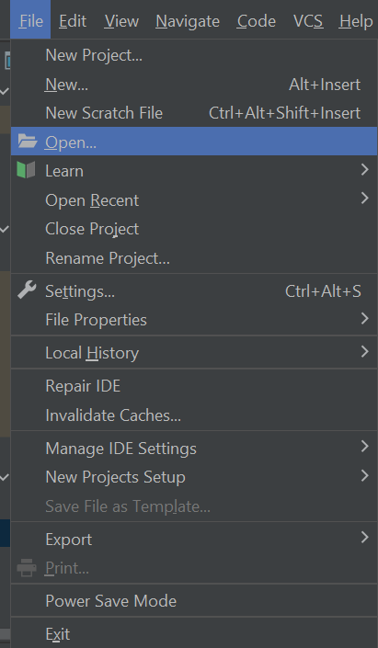
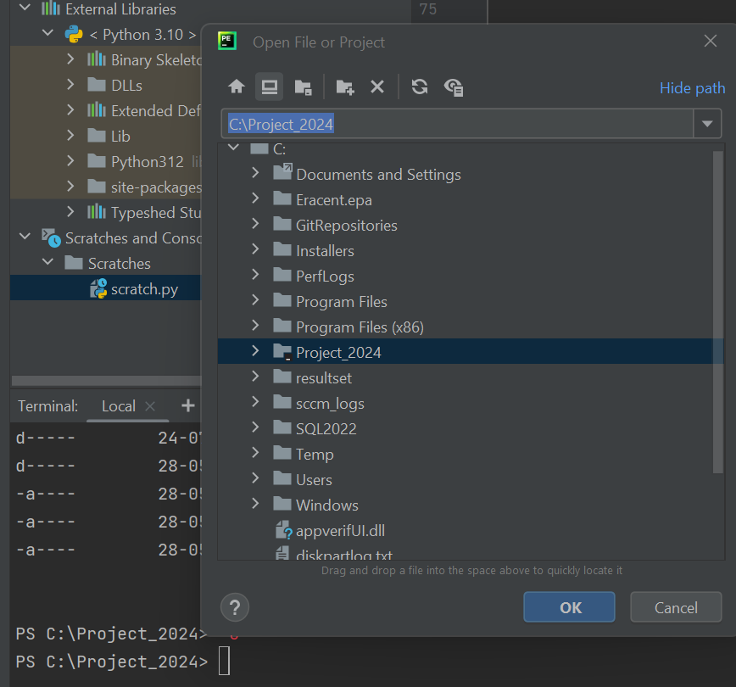
- How to activate existing Virtual Environment?
Navigate cd C:\Project_2024\env\Scripts
Execute -> ./Activate.ps1
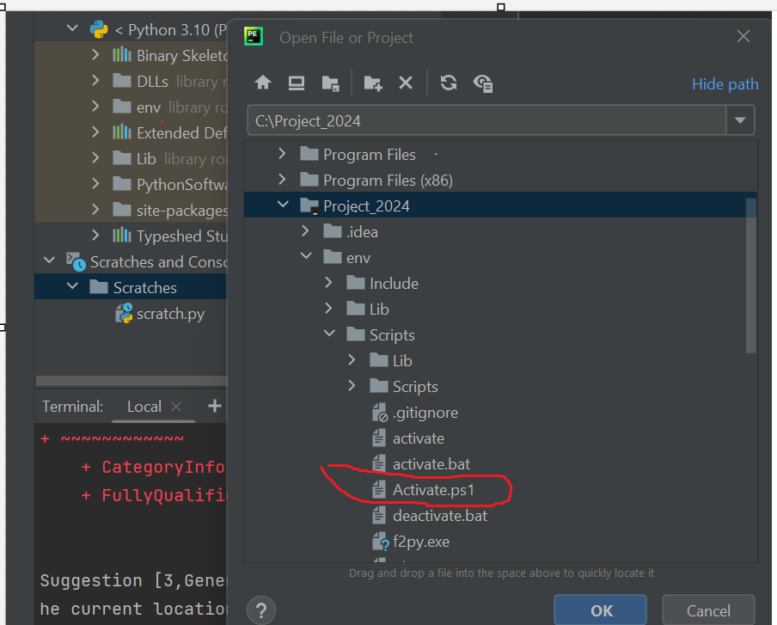

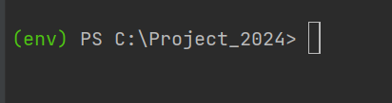

Virtual Environment activated!!

- Check for dependencies (installed Python libraries)
From the terminal window | pip list |
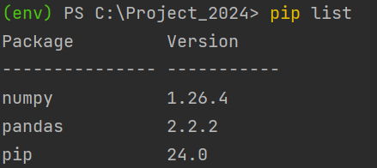

- From the terminal install additional libraries (if required). Example:
From the terminal window | pip install matplotlib |
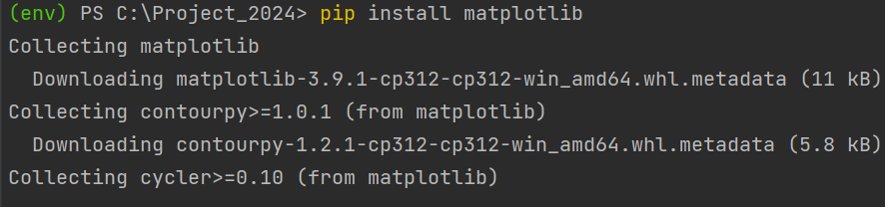

- Now execute to test whether script running or not.
- First create a script. A new Python file <filename> .py. Example test1.py.
- Go to File | New | Python File
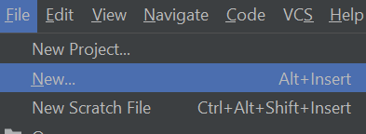
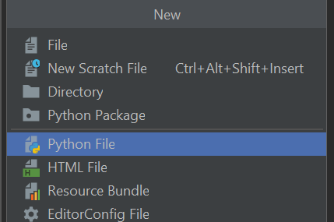

- A new empty Python file gets created.
- Create the script and save (ctrl + s)
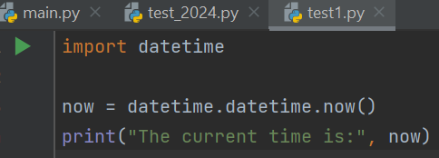

- From the terminal window | python test1.py |
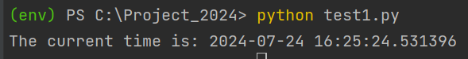
- Error handling and logging in Python.
In Python logs can store information, like which user or IP address accessed the application. If an error occurs, then logs may provide more insights than a stack trace by telling you the state of the program before the error and the line of code where it occurred.
Python provides a logging system as part of its standard library. You can add logging to your application with just a few lines of code.
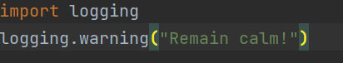
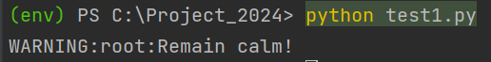
The output shows the severity level before each message along with root, which is the name the logging module gives to its default logger. This output shows the default format that can be configured to include things like a timestamp or other details.
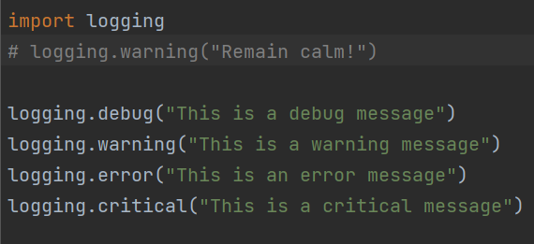
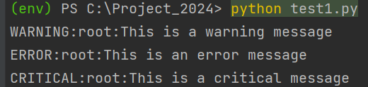
Notice that the debug() and info() messages didn’t get logged. This is because, by default, the logging module logs the messages with a severity level of WARNING or above. You can change that by configuring the logging module to log events of all levels.
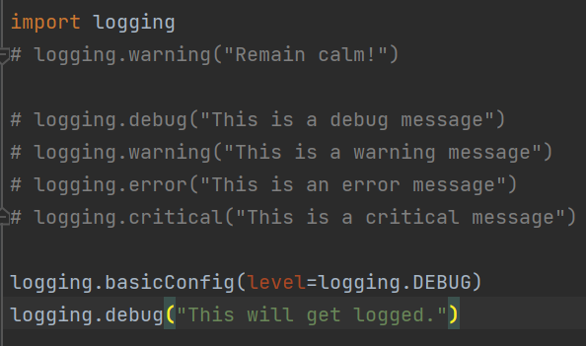
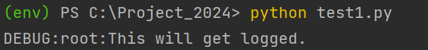
Logging levels:
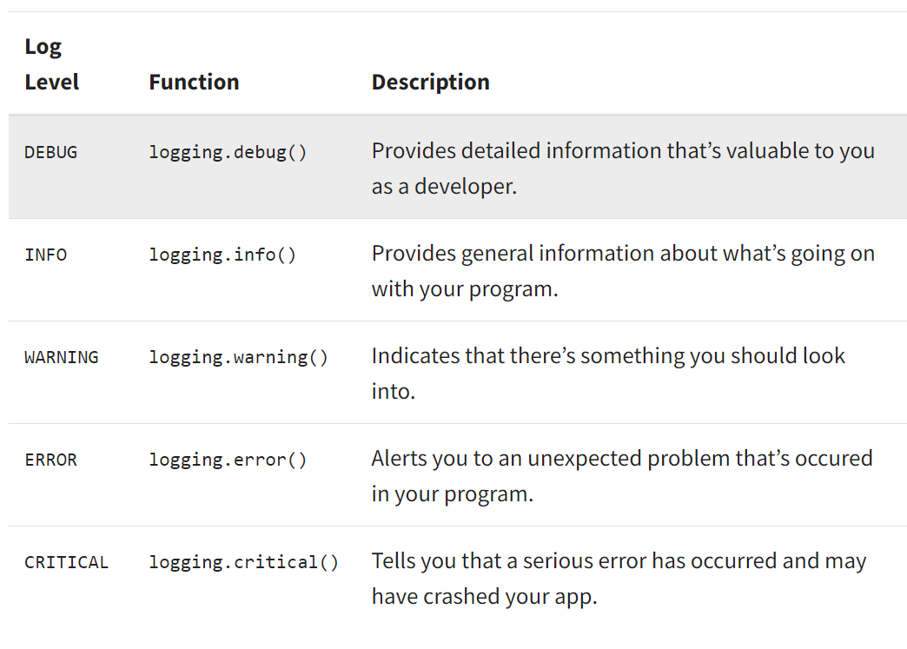

- Logging errors to a file
So far, you’ve logged the messages into your console. But if you want to archive your logs, then it’s a good idea to save log messages in a file that grows over time.
To save your logs in a file, you can set up your logger’s baseConfig() with the filename argument.
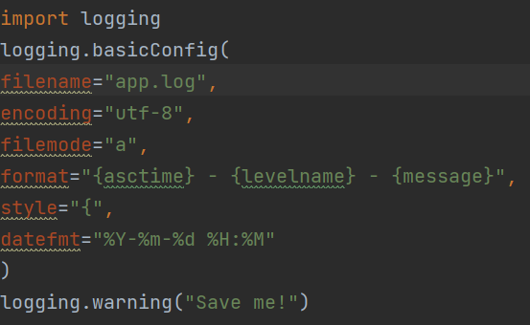
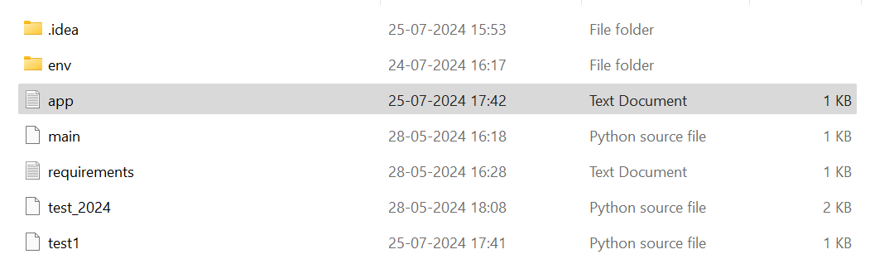
The log file gets created in the project folder.
Log file contents.
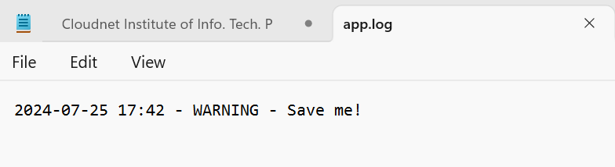
Error messages get logged sequentially along with timestamp after each run of the script.
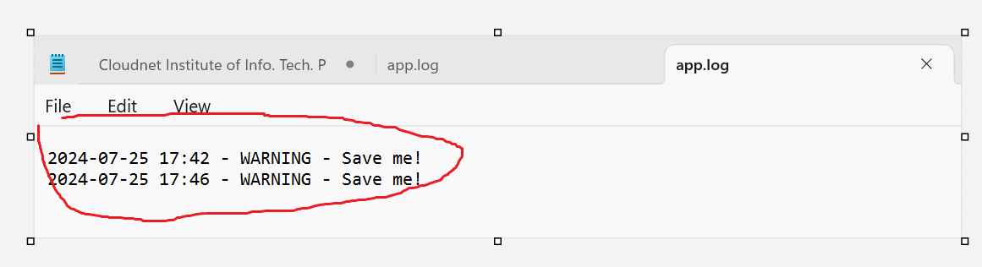
- Logging errors to a file in Try – Except block.
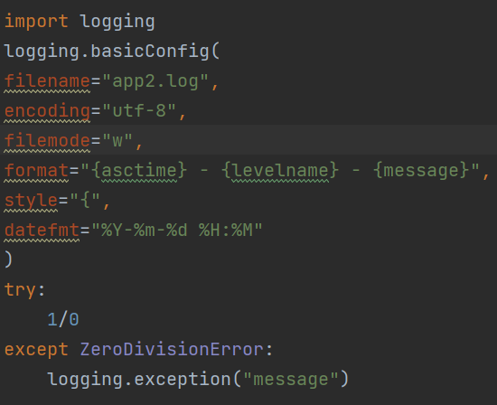
The log file gets created in the project folder.
Log file contents. (Error trace stack messages do not get appended to the file but overwritten)
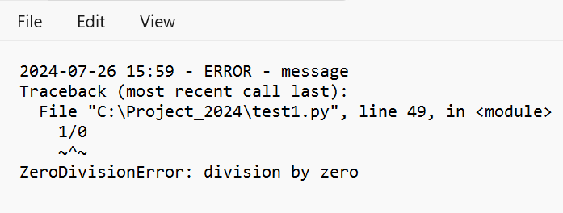

- Schedule a Python script in the Cron daemon (using any variety of LINUX flavors or UNIX). Check for error logs in LINUX.
- Download Putty from CompanyPortal.(required for login to LINUX server)
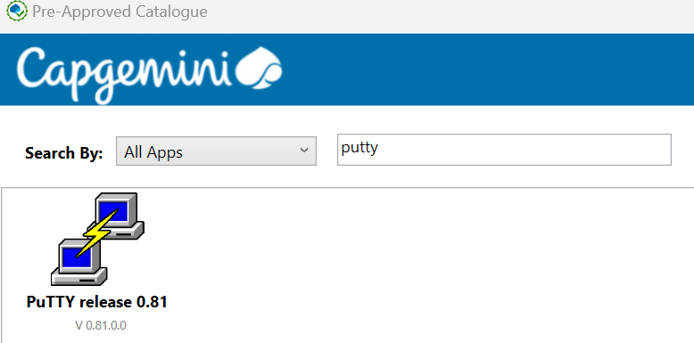

- Login to Putty with the required credentials. (Host name / IP address, Port no.)
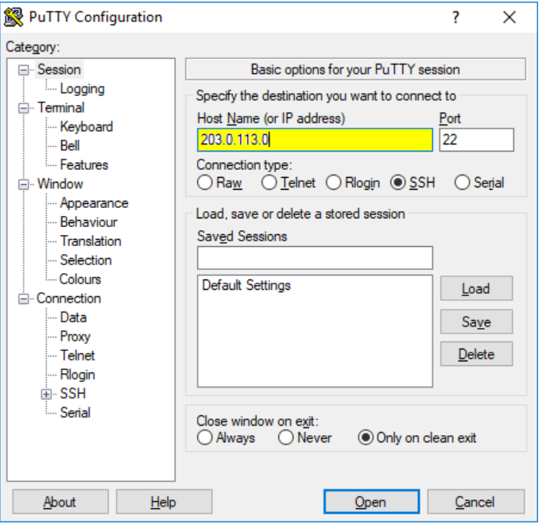

- If you are connected to the system console you will see a screen similar to the following:
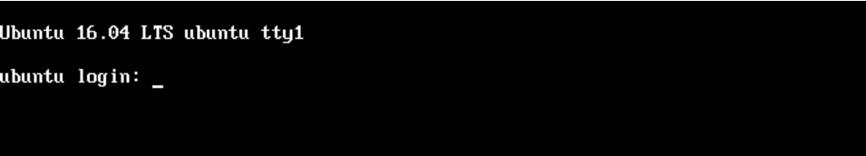
At the login prompt, enter your username and press the Enter key when complete.
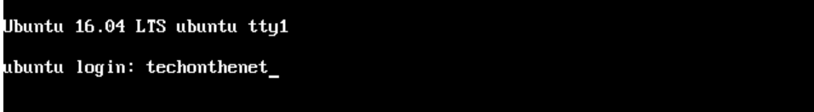
Next the system will display the prompt Password: to indicate that you should enter your password. Type in your password and press the Enter key to continue.
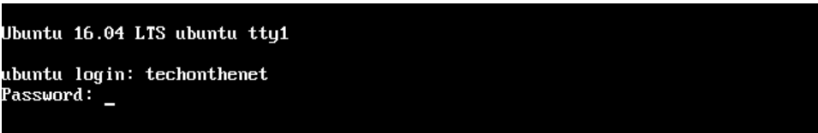
Please note that no characters will show as you type your password. This is normal and is important to preserve the security of your password.
If all goes well you will now be logged in to your Ubuntu Linux Server 16.04 LTS system and you will see a screen similar to the following:
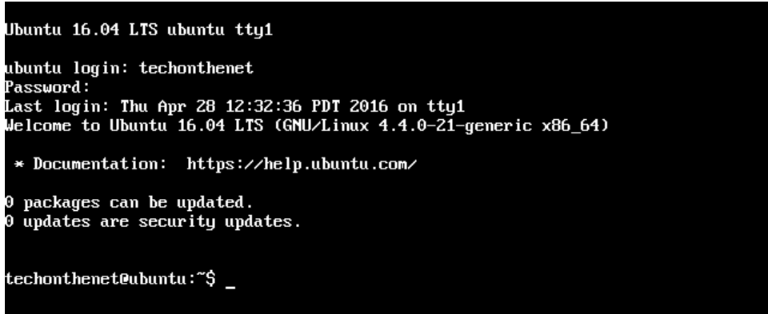
Cron a time-based scheduler is one of the easiest ways to schedule tasks in LINUX. It allows users to schedule tasks or jobs to run automatically or at specified intervals or at specified times.
The tasks can be simple commands or complex scripts and the scheduler can be configured to run them at specific times or with specific frequency, such as daily, weekly or monthly.
System administrators and programmers use Cron to automate repetitive tasks, such as backups, log rotation, database maintenance, and more.
A Cron tab is a configuration file containing a list of commands that the Cron daemon should execute at specified times. The syntax of the Crontab file (either asterisk, values and ranges) is composed of six fields that specify the schedule of each command: minute, hour, day of the month, month, day of the week and the command to be executed.
The Crontab is what actually allows users to schedule repetitive tasks such as backups or system maintenance to be run automatically at specific intervals.
Python job scheduling use cases.
Python job scheduling has a wide range of use cases across various industries. One common use case is automating data processing tasks in data science and machine learning applications. For example, scheduling jobs to run Python scripts that retrieve data from APIs or databases, preprocess the data, and apply machine learning algorithms to generate insights.
Also, developers can schedule jobs to run scripts that build, test, and deploy the code on a periodic basis.
Python job scheduling can also schedule periodic backups of critical data, automate report generation, and monitor system health.
How to schedule a Cron job.
Step 1: Write Your Python Script
The first step is to write the Python script that you want to schedule. For example, let’s say you want to run a script called my_script.py that prints the current time every hour. Here’s what the script might look like:
import datetime
now = datetime.datetime.now()
print("The current time is:", now)
Save this script to a file in your preferred(project) directory.
Step2:
Once you have your Python script, you need to create a Cron job to schedule it. Here’s how to do it:
Open the crontab file by running the command crontab -e in your terminal.
If this is the first time, you’re creating a Cron job, you might be prompted to choose an editor. Choose your preferred editor or leave the default.
Add a new line to the crontab file with the following format:
* * * * * /usr/bin/python /path/to/my_script.py
This line tells cron to run the Python interpreter at every minute of every hour of every day of every month of every year (* * * * *). The second part of the line (/usr/bin/python) specifies the path to the Python interpreter. The third part (/path/to/my_script.py) specifies the path to your Python script.
How to find the Python interpreter path?
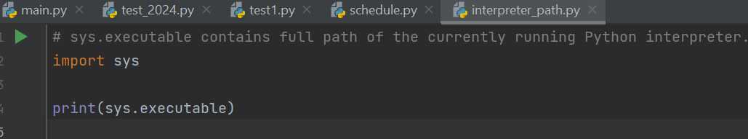
Save and exit the crontab file.
Step3: Test your Cron job.
To test your cron job, wait for the next minute to arrive (or change the cron job to run every minute by changing the first asterisk to a specific number, such as 5 * * * * for every 5th minute of every hour). When the minute changes, your Python script should run and print the current time to the terminal.
If your script doesn’t run, there may be an error in the crontab file or the Python script. Check the log file at default path /var/log/syslog for error messages.
You can filter the Cron logs in the system log by using the grep command.
cat /var/log/syslog | grep cron
Step4: Customize your Cron job.
You can customize your cron job to run at different intervals by changing the * * * * * part of the crontab line. Here are some examples:
Run every hour: 0 * * * *
Run every day at midnight: 0 0 * * *
Run every Monday at 8:30am: 30 8 * * 1
You can also specify ranges of values or use commas to separate multiple values. For example:
Run every weekday at 5pm: 0 17 * * 1-5
Run every hour on the half-hour: 30 * * * *
- Python script automation with Windows Task Scheduler.
Step1: Prepare the Python script.
For example, the goal is to display the current date and timestamp each day at 11:00 am.
The Python script to be used for our example.
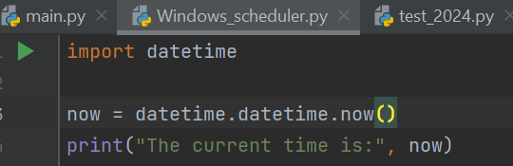
Step2: Save the Python script.
Once you have done writing the script save it as Python file (extension .py)
For example, let’s save the file as Windows_scheduler.py
C:\Project_2024\ Windows_scheduler.py
Step3: Create a Batch file to run the Python script.
To start, open Notepad, and then use the following template:
@echo off
"Path where your Python exe is stored\python.exe" "Path where your Python script is stored\script_name.py"
Pause

Example:
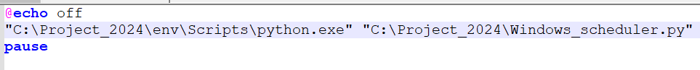

Finally save the notepad with your filename and “.bat” file extension. For our Example – test_prog.bat
Step4: Schedule the Python Script using the Windows Scheduler.
In order to schedule the Python script using the Windows Scheduler:
- Type Task Scheduler in the Windows search bar and then open the app.
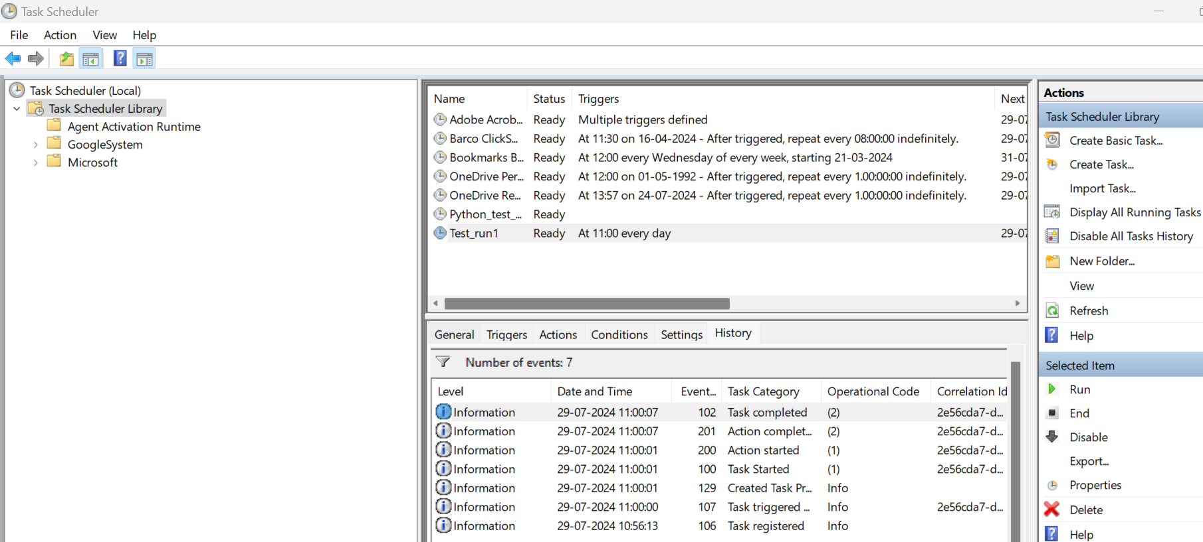

- In the Task Scheduler, select the option to ‘Create Basic Task…’ on the right-side.
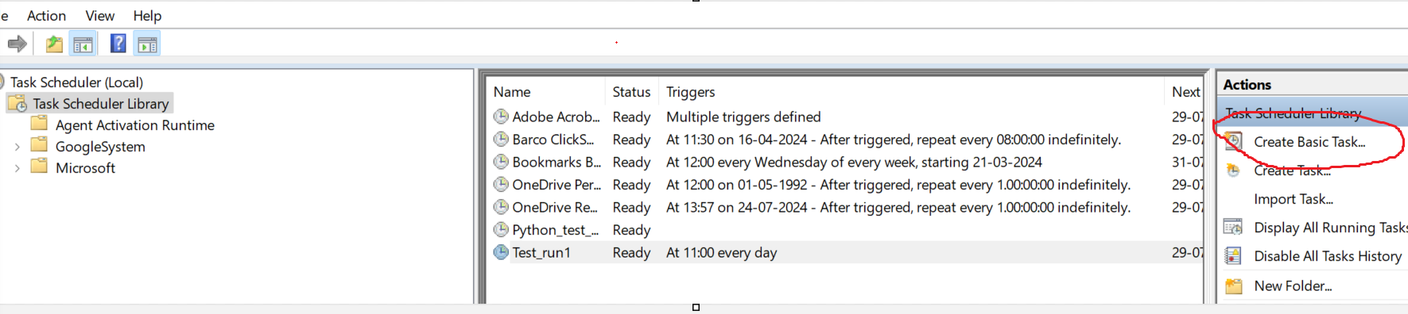
- Type a name for your task (you can also type a description if needed), and then press Next. For instance, let’s name the task as: Test_run1
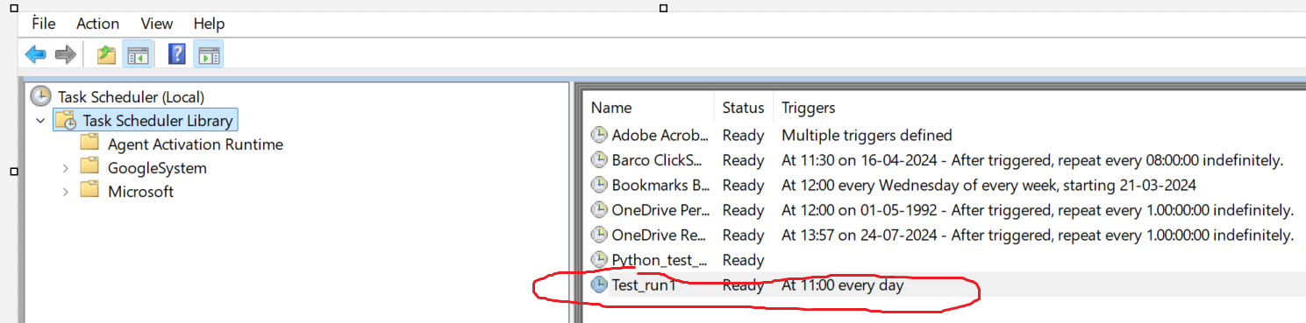
- Choose to start the task ‘Daily’ since we wish to run the Python script daily at 11am. Also specify the start date and time (11am for our example)
- Select, Start a program, and then press Next.
- Use the Browse button to find the batch file (Test_run1.bat) that runs the Python script. In our case: C:\Project_2024\test_prog.bat
- Finally, click on Finish, and you should be good to go. From this point onward, current date and timestamp will be shown every day at 11:00am.

- Identifying Common Errors in Pipeline Code
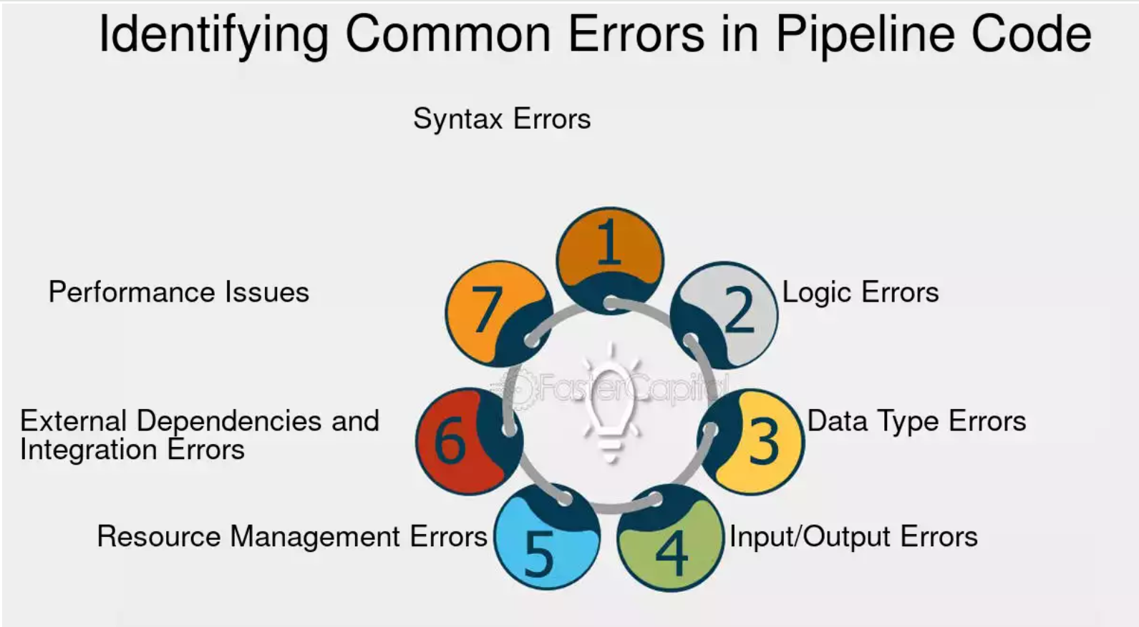
- Syntax Errors: One of the most basic types of errors encountered in pipeline code is syntax errors. These errors occur when the code violates the rules of the programming language being used. They can range from missing or misplaced brackets, semicolons, or quotation marks to incorrect variable names function calls, or indentation. Syntax errors are usually identified by the compiler or interpreter and result in a failed compilation or execution of the code. For example:
```python
If x = 5: # SyntaxError: invalid syntax
Print("x is equal to 5")
- Logic Errors: Logic errors are more complex to identify as they do not cause the code to fail directly but lead to unexpected or incorrect results. These errors occur when there is a flaw in the algorithm or logic implemented within the pipeline code. Debugging logic errors often requires careful examination of the code's flow and understanding the expected behaviour. For example:
```python
Def calculate_average(numbers):
Total = sum(numbers)
Average = total / len(numbers)
Return average
Numbers = [1, 2, 3, 4, 5]
Average = calculate_average(numbers)
Print(average) # Incorrect output: 2.0 instead of 3.0
- Data Type Error: Another common error in pipeline code arises from mismatched or incompatible data types. These errors occur when operations are performed on variables or data structures that do not support the specific operation. For example, attempting to concatenate a string with an integer or performing arithmetic operations on non-numeric values can lead to data type errors. Consider the following code snippet: ```python
X = "Hello"
Y = 5
Result = x + y # TypeError: can only concatenate str (not "int") to str
- Input/Output Errors: Input/output errors occur when there are issues with reading or writing data during pipeline execution. These errors can be caused by incorrect file paths, permissions, or even missing files. It is essential to ensure that the input data is in the expected format and that the output is generated correctly. Here's an example:
```python
With open("data.txt", "r") as file:
Data = file.read()
Print(data) # FileNotFoundError: [Errno 2] No such file or directory: 'data.txt'
- Resource Management Errors:
Pipeline development often involves managing resources such as memory, network connections, or external services. Errors related to resource management can occur when resources are not properly allocated, released, or handled. For instance, failing to close a database connection after use can lead to resource leaks and potential performance issues.
- External Dependencies and Integration Errors: Pipelines often rely on external libraries, APIs, or services for various functionalities. Errors can arise due to version mismatches, incorrect configurations, or issues with the external dependencies themselves. Properly managing and troubleshooting these dependencies is crucial for maintaining the integrity of the pipeline code.
- Performance Issues: While not necessarily errors, performance issues can significantly impact the efficiency and speed of your pipeline. Identifying bottlenecks, optimizing code, and utilizing appropriate algorithms and data structures can help address these issues. Profiling tools and techniques can aid in identifying performance bottlenecks and areas for improvement.

- Python Code Profiling & Optimization
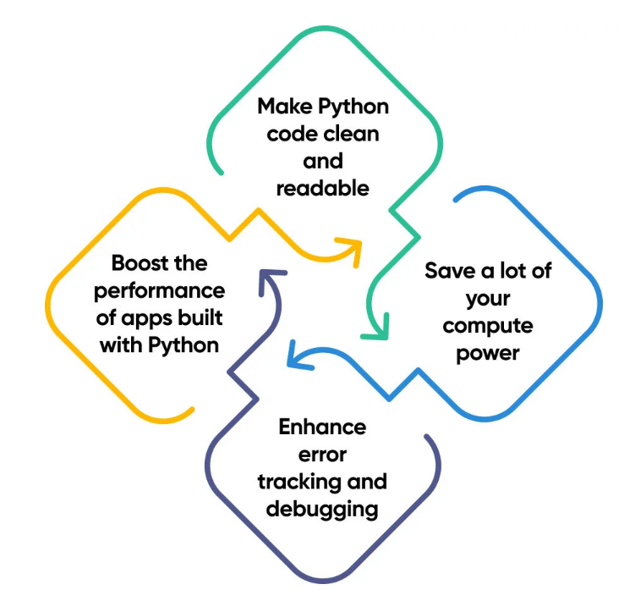

- 1)Embrace Django - There’s no better Python framework than Django. It is fast, efficient, popular, and rich with Python development tools.

2)Use PyPy Instead of CPython- PyPy is an implementation of Python that uses just-in-time compilation instead ahead-of-time compilation, peculiar to this language. Sometimes, code execution with PyPy can be seven times faster than with CPython.

3)Use NumPy Arrays Instead of Lists-The NumPy library has a great implementation in scientific computing. When dealing with substantial data and mathematical operations, NumPy arrays can significantly outpace common Python lists.

NumPy arrays are tailored for numerical tasks, enhancing efficiency with sizable datasets and consuming less memory than lists. This, in turn, means improved performance.
- 4) Use the Built-in “timeit” Module- The “timeit” module is a special feature that allows you to control Python, improve performance, and track its efficiency much better. It allows the developer to measure how long it takes to execute a piece of code. Use stop-watch profiling with this module. <timeit> records the time needed for task execution by a certain code segment and measures the time elapsed in milliseconds.
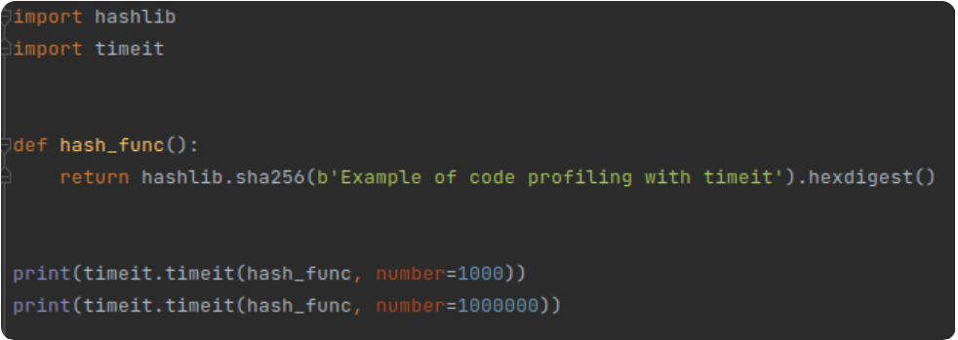
Here’s how it’s calculated:
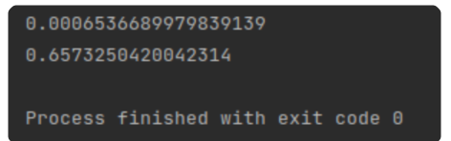
- 5)Use <cProfile> -This is advanced profiling, which is part of the Python package since Python 2.5. There are several ways to connect it to the Python code:
- Wrap a function inside its run method and thus measure the performance;
Run the whole script from the command line while activating cProfile as an argument, using Python’s “-m” option.
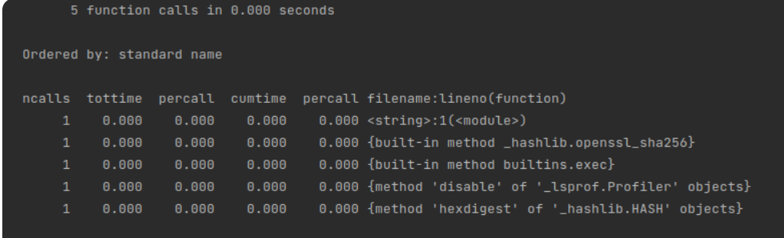

Here are the elements to consider:

<ncalls> — the number of calls made;

<tottime> — the aggregate time spent in the given function and which has the greatest value;

<percall> — the quotient of <tottime> divided by <ncalls>;

<cumtime> — another parameter of high importance for all the projects that represents cumulative time in executing functions, its subfunctions;

<percall> — the quotient of <cumtime> divided by primitive calls;

<filename_lineno(function)> — a point of action in a program.

6)Use Generators and Keys For Sorting-This is a way to optimize memory by using such a great tool as generators. Their peculiarity is that they don’t return all items (iterators) at once, but can return only one at a time. It’s better to use keys and the default <sort()> method while sorting items in a list. Thus, for instance, you can sort the list and strings according to the index selected as part of the key argument.
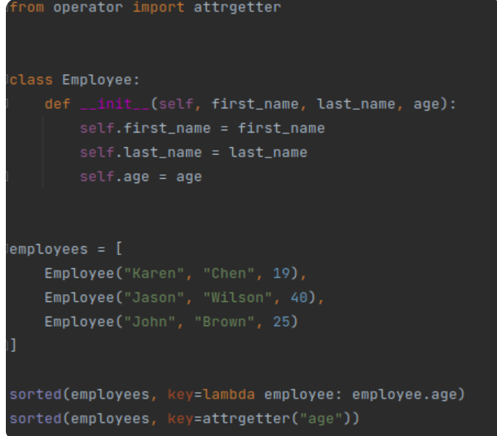

7) Limiting Method Lookup-To optimize method lookup in Python, you can store a reference to a method or function in a local variable rather than repeatedly accessing it through attribute lookup. This can be particularly useful in loops or frequently called functions. Let’s explore this with an example:
# Non-optimized code
for item in my_list:
result = some_object.some_method(item)

# Optimized code
some_method = some_object.some_method # Store a reference
for item in my_list:
result = some_method(item) # Use the local reference
By doing this, you reduce the overhead of attribute lookup on each iteration, potentially improving performance.
- 8) Using the Peephole Optimization Technique-To better understand the Peephole optimization technique, let’s start with how the Python code is executed. Initially the code is written to a standard file, then you can run the command “python -m compileall <filename>”and get the same file in *.pyc format which is the result of the optimization.
<Peephole> is a code optimization technique in Python that is done at compile time to improve your code performance. With the Peephole optimization technique, code is optimized behind the scenes and is done either by pre-calculating constant expressions or by using membership tests. For example, you can write something like the number of seconds in a day as a = 60*60*24 to make the code more readable, but the language interpreter will immediately perform the calculation and use it instead of repeating the above statement over and over again and thereby reducing the software performance.
The result of the Peephole optimization technique is that Python pre-calculates constant expressions 60*60*24, replacing them with 86400. So even if you write 60*60*24 all the time, it won’t decrease performance.
This transformation can only be performed by Python for literals. Thus, the optimization will not happen if any of the sets or lists used are not literals.

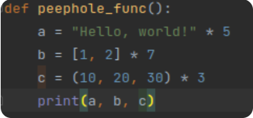
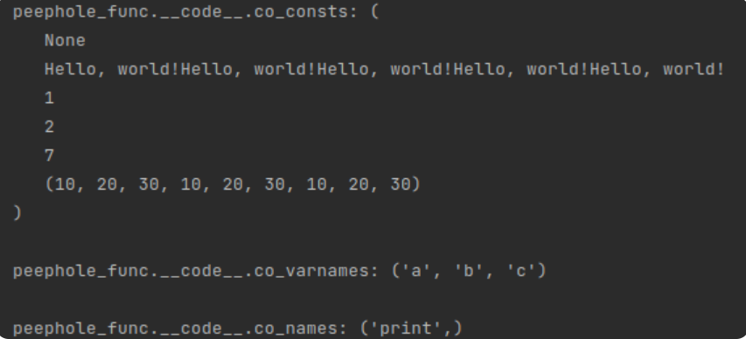
- “Hello, world!” * 5 is a constant expression less than 4096 long. So it gets evaluated by the compiler as “Hello, world!” 5 consecutive times
- [1, 2] * 7 is a list (mutable object) so it’s not evaluated.
- (10, 20, 30) * 3 is a sequence of length 9 which is less than 256 (for tuples), so it’s stored as (10, 20, 30, 10, 20, 30, 10, 20, 30).

9)Optimizing with String Operations- String concatenation can be slow, especially when performed in a loop. In such cases, using a list to accumulate parts of the string and then joining them at the end can be much more efficient. Here’s an example:
# Non-optimized code
result = ""
for item in my_list:
result += str(item)

# Optimized code
result_parts = []
for item in my_list:
result_parts.append(str(item))
result = "".join(result_parts)
The optimized code avoids creating unnecessary intermediate string objects during concatenation.


10)Optimizing with if Statements- Minimizing the number of if statements or optimizing their structure can also improve code performance. Use early returns when possible to avoid unnecessary condition checking.
# Non-optimized code
def process_data(data):
if data:
# Perform some operation
else:
# Handle the empty data case

# Optimized code
def process_data(data):
if not data:
# Handle the empty data case
return

# Perform some operation
In the optimized code, the function avoids the need to check the data condition twice and simplifies the code flow.
- 11)Apply Multiple Assignments-This approach optimizes and speeds up the code execution. Instead of this

Use this


12)Use List Comprehension- Take a look at an example. What you see is a code to list all the numbers between 1 and 1000 that is the multiplier of 3:
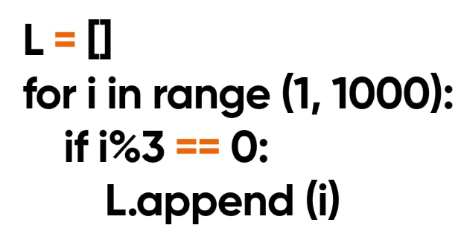
With list comprehension the code will look like this.
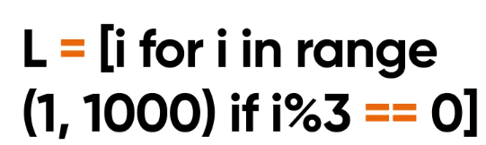

- 13) Do not use the .dot Operation- Instead of this
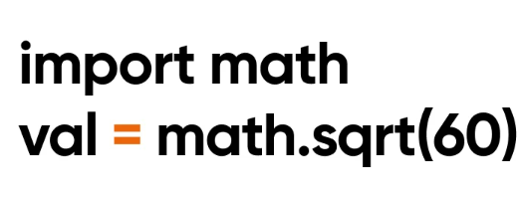
Use this
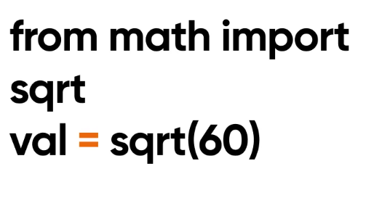
- 14)Use 1 for Infinity Loops - Instead of using the “while True” construct in your code, rely on the “while 1” construct. Unless quite simple, this modification can reduce your code’s runtime. The point is that “while 1” offers a more straightforward depiction of an infinite loop condition. This can enhance performance compared to “while True” construct, which is slightly more abstract.

15)Use Special Libraries to Process Large Datasets- Notably, Numpy, Scipy, and Pandas are three prominent examples, known for their effectiveness in handling large datasets.

**********************************************************************************

