**Amigo**

**(An initiative that helps to protect vulnerable populations from COVID-19)**

**#flattenthecurve Hackathon**

Team Name: **Technocrats**

**Github Link:** <https://github.com/Sameer2307/flattenthecurve>

Team Members:

1.Avinash Rao (MS Data Science, Student at University of Melbourne)

2.Amar Babuta (MS Data Science, Student at University of Melbourne)

3.Sameer Saxena (MS Computer Science, Student at University of Melbourne)

4.Samir Patel (MS Computer Science, Student at University of Melbourne)

Date- 11/04/2020

**Abstract:**

WHO has declared coronavirus (covid-19) as a pandemic. We can only win through this pandemic by coming together. The biggest problem currently faced by us is how to spread awareness about this, what all should we do to make a better tomorrow? Our aim was to protect the vulnerable population from this pandemic which we have achieved through various ways: providing videos and knowledge about the pandemic, what all can we do to prevent this from spreading, safety measures that can be taken by us. Not only this we also provide a live test that takes the information from the user and recognizes whether the person is suffering from low/moderate/high risk of carrying the coronavirus. We lastly provide all the emergency contact details and the official reports and cases that are present in Australia and state wise tally making our project one-stop location for fighting against the coronavirus and stopping this spread.

**Introduction**

On 31 December 2019, the World Health Organization (WHO) was informed of a cluster of cases of pneumonia of unknown cause detected in Wuhan, Hubei Province, China. A novel coronavirus (SARS coronavirus-2 (SARS-CoV-2)) was subsequently identified from patient samples.

To date, the virus impact on Australian Business has been profound particularly in industries reliant on China for supply of goods and for China’s demand for resources/services.

While all sectors have and will be impacted by Covid-19, the key sectors currently most impacted by the virus include:

1. Retail Sector – many clothing retailers have felt the impact of a lost summer due to the bushfires reducing turnover during the key turnover month of January 2020. This may lead to stock being retained and sold through the year (potentially at discount to recover costs) particularly if supply of future stock is delayed or not possible. Supply of Winter Stock may either not be completed or unable to be shipped on time or at all. From conversations with industry contacts, revenue reduction of over 30% from FY19 could occur, subject to the relevant supply position and success (or lack thereof) in the winter season.
2. Tourism & Education Sectors – Both Sectors have been hit hard by the travel bans on China and now other countries in the world given Chinese students and travelers are a large component of each industry. Travelers are generally starting to defer non-essential travel to avoid potential exposure to the virus on airplanes and Cruise ships.
3. Mining – The shutdown of the Chinese economy for close to four weeks has resulted in reduced demand for our commodities and a fall in commodity prices excluding gold that is reaching 7-year highs as a protective investment. Demand may recover with the oversupply being absorbed once supply arrangements are implemented; however, there will be a working capital issue to be managed as a minimum.

Given this sector has been the driving force behind economic growth in the Australian economy for a long period of time, should this crisis be drawn out, the impact of a contraction in the sector on other parts of the economy should not be discounted.

**Background Problem**

After WHO recognized the need to address the coronavirus the biosecurity officials at airports in Australia started screening passengers arriving from Wuhan. On 25th Jan the first ever patient of covid-19 arrived in Australia from China. Since then the number has increased to 6238 as of 11th March 2020 0600am. Coronavirus can spread through human interaction and hence the biggest problem was stopping the spread. The current problem that is faced by the population is that no one knows who might be carrying the coronavirus as there may not be any symptoms seen in the patient for the initial 14 days. Only solution was to stop human interaction by limiting the public gathering.

We are currently unable to recognize whether we are at low/moderate/high risk of carrying coronavirus. What all should be done by us at humans on our level to stop the spread of this deadly virus. We are also unable to recognize who all might be affected and why there is a need for the test.

**Description of our Idea**

Our idea was to create a “One Stop Location” for all the users through which a user can find all the necessary information regarding coronavirus, current scenario of coronavirus in Australia, Advice and Spreading Awareness regarding the coronavirus, how can we help frontline soldiers like doctors and nurses and having a self-assessment test which helps us in recognizing the immediate risk category that we face during this pandemic. This idea was mainly for creating a one stop location unlike the current solution that provides multiple websites, links, and mobile application. We provide many more features which can help people to make themselves safe during this pandemic.

**Advantages of our Ideas**

The current solution provided by the Australian government is the mobile application called coronavirus and the information is updated on health.gov.au. The current mobile application is not a one-stop location for all the services that should be provided. The application provides us with the symptom checker, Advice regarding the coronavirus, Register yourself for the isolation ward, news, and current status of the covid-19 in Australia

1. Identifying who/when/why the test should be taken: The biggest advantage that our one-stop location website Amigo provides is the self-assessment test. The test can be taken on the website and it checks for various scenarios and various diseases that you have a history of and recognize whether you are at low/moderate/high risk of carrying coronavirus. This test also helps us in advising the further steps that we as humans should take in order to be safe.

We have also made the self-assessment available through the Google Assistant so that the test can be taken from anywhere (Not able to launch as google takes time to launch the bot. Video of the working of chatbot in google assistant added.)

1. Creating Awareness among people: The website also provides us with Do’s and Don'ts, safety measures that can be taken by us as an individual in order to stop the spread.  It also specifies the reason why social distancing is necessary during this pandemic. It provides images and videos to describe the necessity to fight this virus. The website also provides with the various data that have been posted on the government website with all the different articles and current news with the current status of coronavirus cases that are present in the country.
2. Finding possible local-area infections. Lastly our aim was to find the possibility of local-area infections. This could have been done especially in areas where the coronavirus is rising at high peaks and in public transport where there is a need to maintain the social distance during this pandemic. This could have been done by accessing the user’s location tracking.
3. Donation: We as humans can help government by donating little amounts to provide enough funds for the government to buy medical equipment’s and safety gear for all the doctors and nurses that are frontline soldiers during this pandemic.

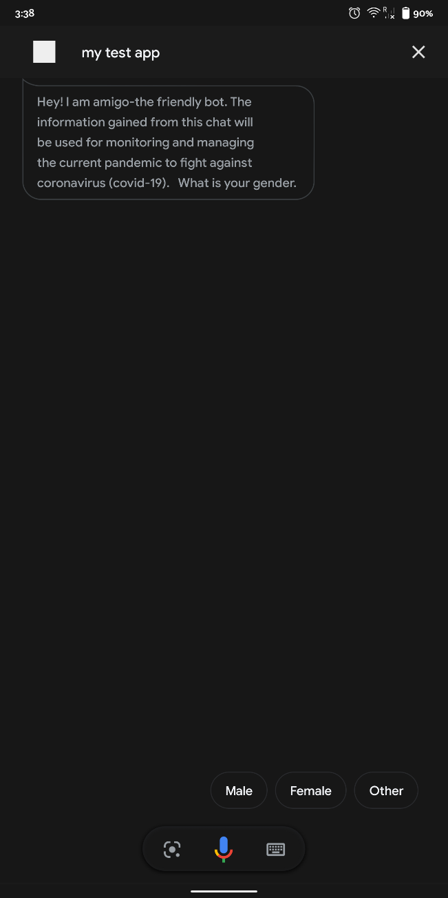 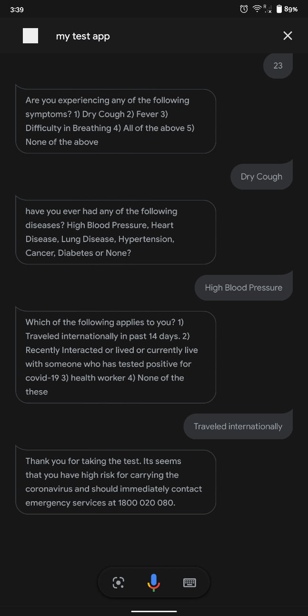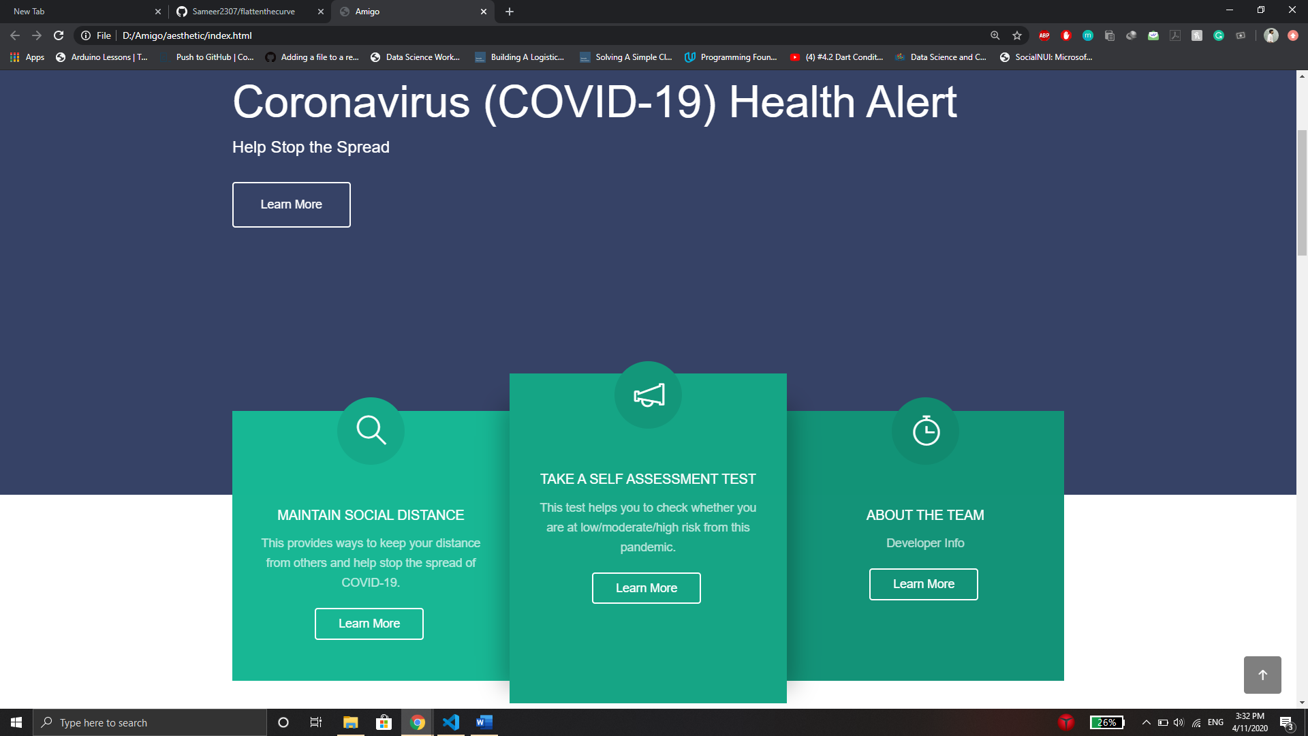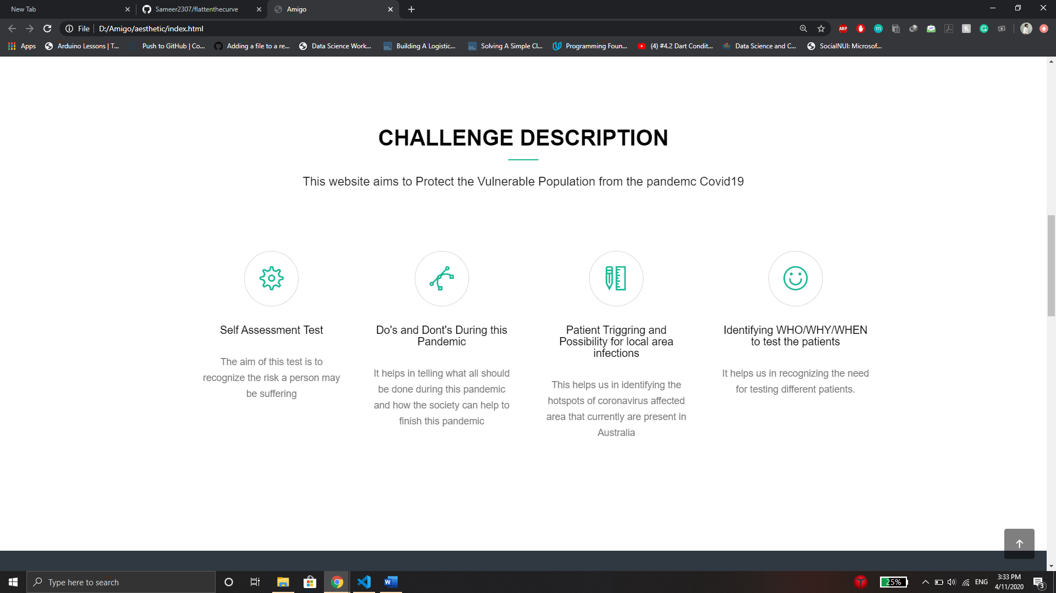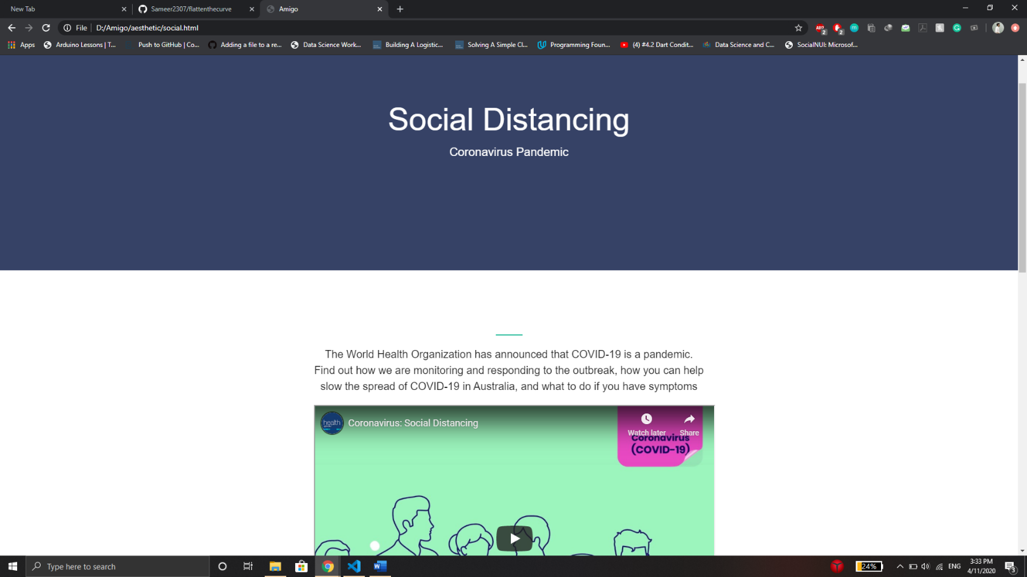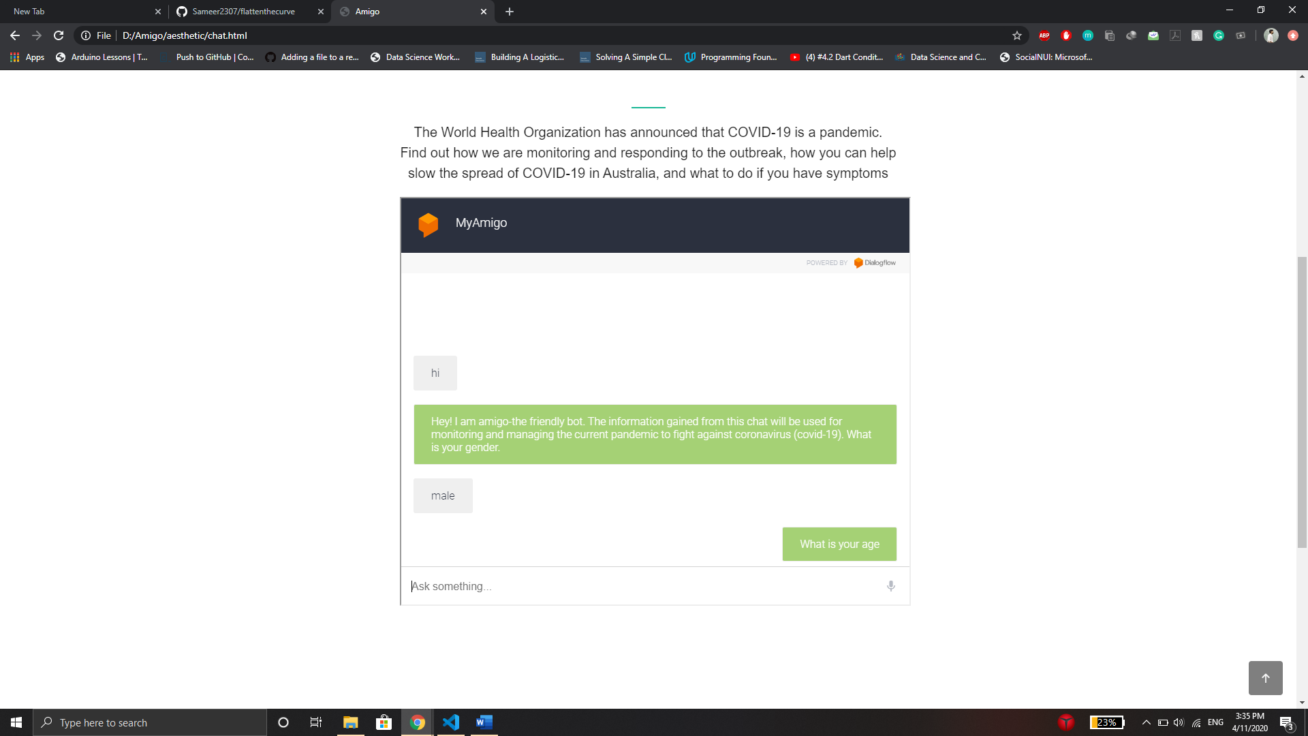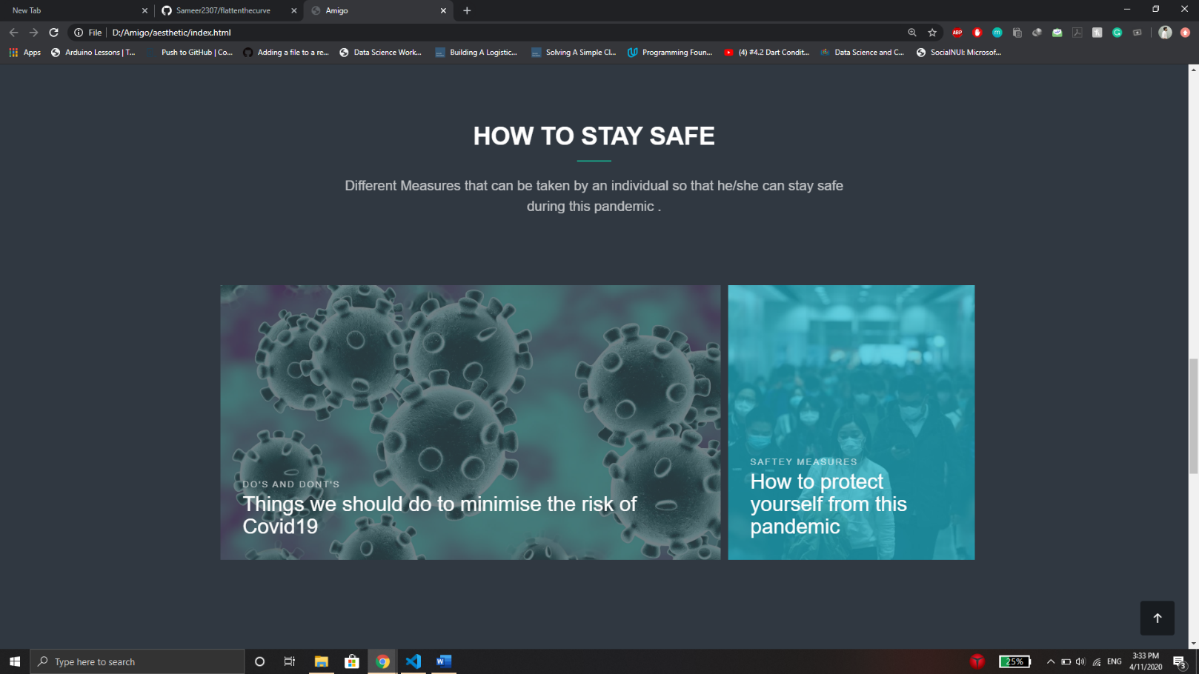

**Working of Our Self- Assessment Test or Chatbot**

**Future Scope**

1. Coronavirus exigency:

With the rise in coronavirus cases daily taking immediate steps are necessary to stop the spread of coronavirus. And for that the government should navigate the streets and the coronavirus cases reported in every street and if there are more than 10 cases reported in a single street it should be declared as coronavirus exigency spot and the street must be lockdown completely for at least 2-3 days and sanitized along with door-to-door screening for symptoms to avoid the spread of coronavirus with only essential services available to the lockdown streets via an emergency number provided by the Australian government.

1. Integrating this website into an app: The mobility and efficiency could have increased if we would have been able to provide a mobile application and hence making it the complete one stop location for every need.
2. Making this chatbot available through a bigger platform like google assistant: We have also made it available as Google Assistant Chatbot which we were not able to get it approved by google due to the lack of time.
3. Patient Triggering and Possibility for local area infections:

We wanted to do live geolocation tracking of the user and send the information to our website for analyzing, visualization and public use. Public transmit users can then reach our website to see live data for where they should go to the least crowded public transport to maintain social distancing. We wanted to figure out if there is a possibility of a local area infection in a street but due to time constraint and resources, we could not build on that.

1. Small Interesting Quizzes can be placed after each video and images so that we can make it more interesting. After each video and images that are provided in the website for creating awareness among the people regarding the coronavirus we could have provided small games and quizzes that check the learning outcomes and help us involve different aged group people in our application.
2. The assessment data can be monitored for identifying coronavirus cases spike. The self-assessment test or the chatbot could have been made better by saving the user’s information and through accessing the location of people suffering from high risk of having coronavirus. This will help us in finding more cases immediately and multiple actions could be done in various scenarios and finding the possible cases.

**Difficulties**