Project

Audio Forensics to match the suspect voice from the received sample file from the suspect/victim device.

Digital Forensics(Audio)

CDAC, Noida
CYBERGYAN VIRTUAL INTERNSHIP PROGRAM

Submitted By :

Sameer Singh

Project trainee, (Nov-Dec)2024

Bonafide Certificate

This is to certify that this project report titled “Audio Forensics - Matching Suspect Voice from
Evidence” submitted to CDAC Noida, is a genuine record of work completed by Sameer Singh under my supervision from 11,November 2024 to 22,December 2024.

Supervisor’s Name:
Mr. Varun Mishra

Date:
21,December 2024

Table of Contents

1. Introduction
2. Problem Statement
3. Learning Objectives
4. Approach
5. Implementation
6. Results & Discussion
7. Conclusion & Recommendations
8. References

Declaration by Author(s)

This is to declare that this report has been written by me/us. No part of the report is plagiarized from other sources. All information included from other sources have been duly acknowledged. I/We aver that if any part of the report is found to be plagiarized, I/we are shall take full responsibility for it.

Name of Author(S): Sameer Singh

Acknowledgment

I extend my sincere gratitude to Mr. Varun Mishra, whose expertise and guidance have been invaluable throughout this project. My appreciation also goes to CDAC Noida for providing the tools and environment required to complete this work. Lastly, I thank my peers and family for their constant support.

- Introduction

Audio forensics is an emerging field in digital forensics, critical for analyzing audio evidence in criminal investigations. This project focuses on matching a suspect’s voice to recordings provided as evidence to establish connections and motives behind the alleged crime.

The project employs advanced forensic tools like Audacity and Goldwave to extract and compare voice patterns, ensuring accuracy and reliability in findings.

2. Problem Statement

The challenge is to determine if the voice sample recorded in the lab matches the voice in three provided call recordings.

Details:

• The suspect’s voice was recorded in a controlled environment.

• The recordings allegedly involve conversations between the suspect and their mother regarding a crime’s motive.

• The aim is to verify if the voices belong to the same individual.

- Learning Objectives

• Understand the principles and practices of audio forensics.

• Develop skills in using forensic tools for voice analysis.

• Learn to interpret spectrograms and frequency patterns for forensic purposes.

4. Approach

Tools Used:
• Audacity: For initial audio cleaning, noise reduction, and voice segmentation.
• Goldwave: For feature extraction, detailed analysis, and pattern matching.

Infrastructure Setup:
• A secure digital forensic lab with dedicated systems for analysis.
• Ensured data integrity through secure file handling protocols.

Process Overview:
• Preprocessing of audio samples.
• Feature extraction and comparison.
• Verification through advanced tools.

Screenshots:

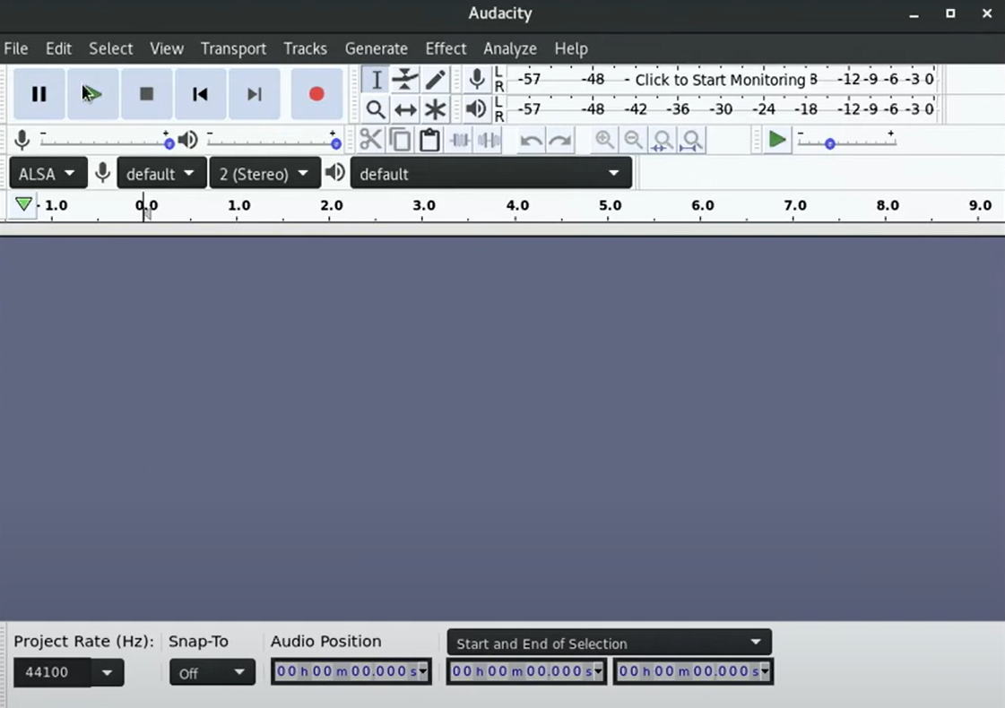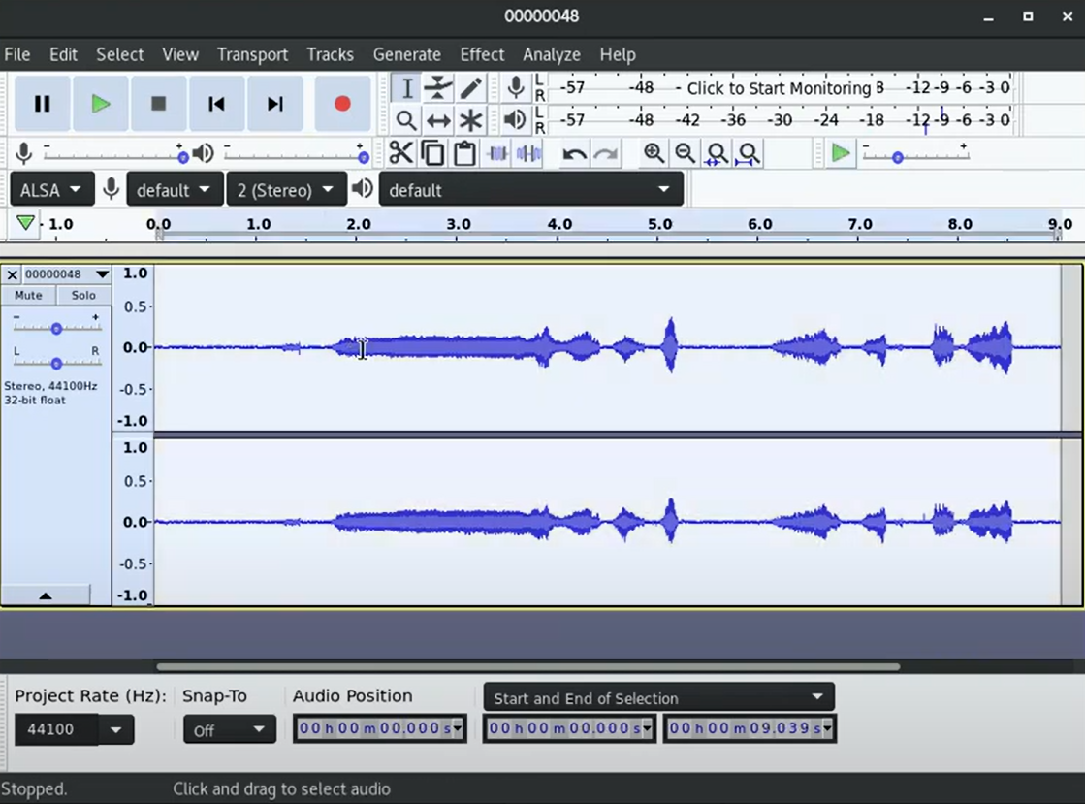

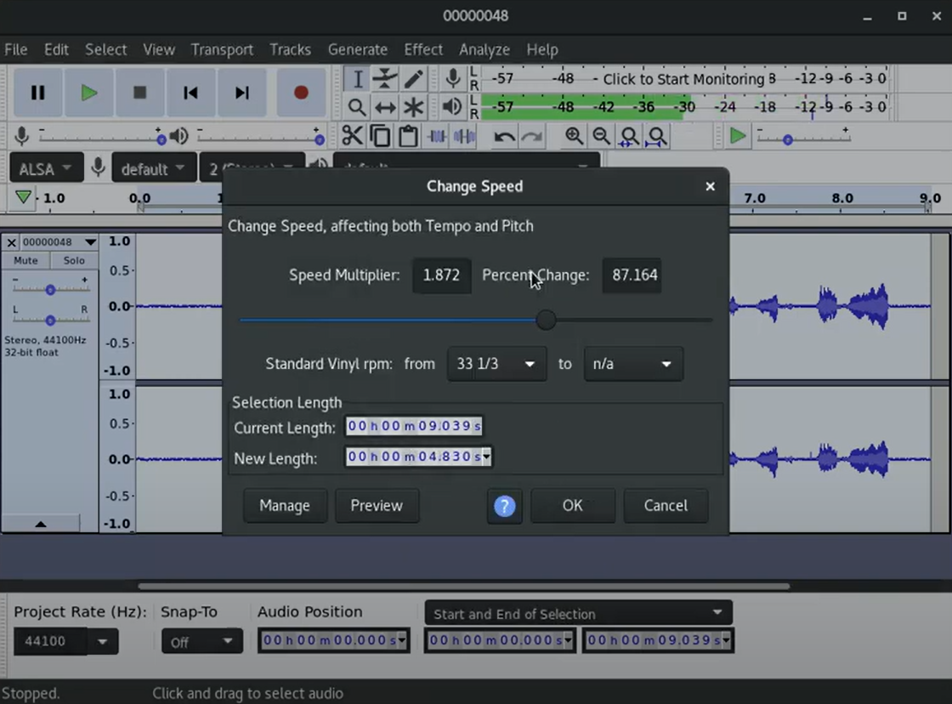
5. Implementation

Step 1: Data Collection
• Collected a voice sample of the accused in a controlled lab environment.

• Obtained three call recordings suspected to involve the accused.

Step 2: Preprocessing
• Used Audacity to clean and enhance audio clarity by removing background noise.

• Segmented recordings into meaningful chunks for analysis.

Step 3: Analysis
• Extracted voice features such as pitch, tone, and frequency using Goldwave.

• Generated spectrograms for both the suspect’s sample and the call recordings.

• Performed a detailed comparison of audio markers.

Step 4: Validation

• Rechecked findings using cross-validation techniques with secondary tools.

6. Results & Discussion

The analysis confirmed that the spectrogram patterns of the suspect’s voice matched the voice in the provided call recordings.

Discussion:

- The evidence strongly indicates that the suspect was part of the recorded conversations.

- The process ensured data reliability through multiple validation checks.

7. Conclusion & Recommendations

Conclusion:

The project demonstrates the effectiveness of audio forensics in solving criminal cases. The matching process revealed a clear correlation between the suspect’s lab-recorded voice and the voices in the call recordings.

Recommendations:

• Incorporate AI-based voice analysis tools for future forensic projects.

• Maintain strict protocols for handling audio evidence to prevent tampering.

• Train investigators in advanced forensic techniques for accurate results.

8. References:

- Audacity Official Website

2. Goldwave Forensic Tools

