**THE CODAY**

Ground Rules

Let’s gear up for CODAY, following are the ground rules.

**Coding Language**

**JAVA**

**Environment Setup**

**1.** Create a root folder with **<TeamName> eg. MyTeam**

**2.** Unzip the project file in this folder

It should look like the following:

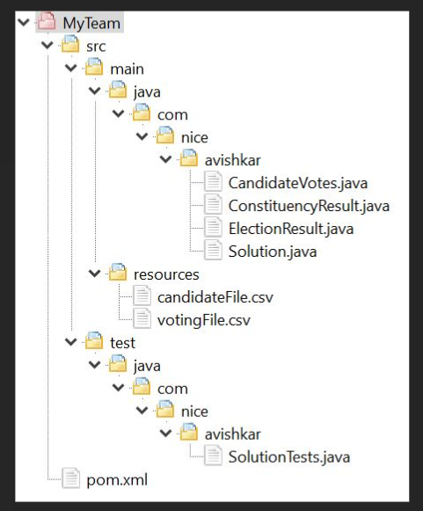

**Image1**

**3.** The basic folder structure will be provided, it will contain

- Main program

- Unit test cases

**4.** Use Java 8 for development

**Development Process**

1. Update the code, compile and provide a solution

- Consider all test cases

- Validate test input and output

- All the test cases should pass

- Compile using **mvn clean install** command

2. You can use CODAY [**Support Helpline**](https://join.slack.com/t/nicecodayevent/shared_invite/zt-1hg2p0n68-yEcWCNi81~EsLU5ARtlfRg)Slack Channel for any queries you may have.

**Submission**

**1.** Create a ZIP of root folder and keep the zip file name as **(refer below Image2 for the structure of the zip)**

**<TeamName>.zip** e.g. **MyTeam.zip**

**2. Make sure that the .class files and jars are not bundled as part of zip in the submission**

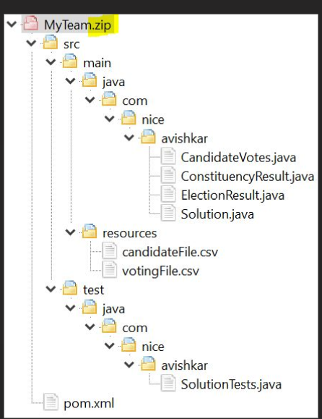

**Image2**

**2.** Send your solution to **Innovation.GTC@nice.com** by reply to the content email (don’t change the subject)

**Evaluation Criteria (Combination of all)**

* Some of the Various criteria considered under the execution of your solution
  + Space Complexity
  + Time Complexity
  + Scalability
  + Cyclometric Complexity
  + Correctness of the result
* All test cases must be passed
* Other edge scenarios are also considered
* Fastest submission
* Final review of top 5 submissions by Architects
* Code should be as per industry standards.

Happy Coding!