1. First take a backup of your assignments & projects. This is required because due to

incorrect GIT operation you may lose your files.

1. Create an empty directory ‘Assignments’ & cd to ‘Assignments’.
2. Create a file README.txt inside ‘Assignments’ & write few lines about the contents of

‘Assignments’ folder.

1. Commit README.txt file.
2. Now create a new branch ‘html-assignments’.
3. Switch to ‘html-assignments’ branch.
4. Copy all HTML assignments inside ‘Assignments’ folder.
5. Commit HTML assignments into ‘html-assignments’ branch.

29. Make minor changes into few files belonging to ‘html-assignments’ branch.

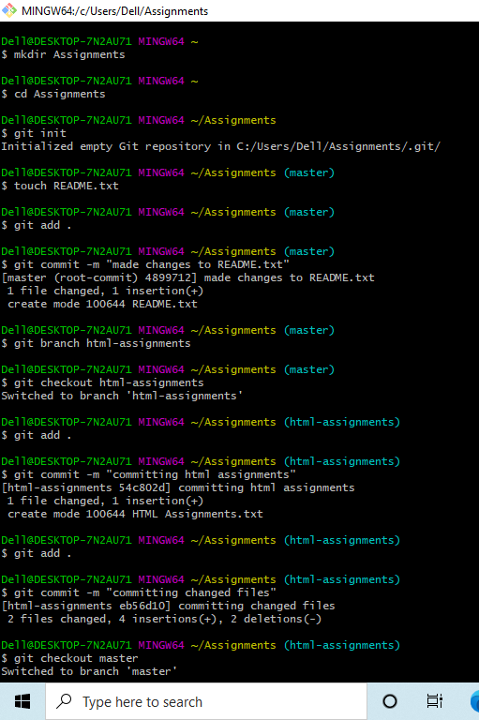

30. Commit those changed files.

31. Switch to master branch.

32. Make minor changes into README.txt file & commit those changes into master.

33. Again switch to ‘html-assignments’ branch.

34. Make minor changes into few files belonging to ‘html-assignments’ branch.

35. Commit those changes.

36. Switch to master.

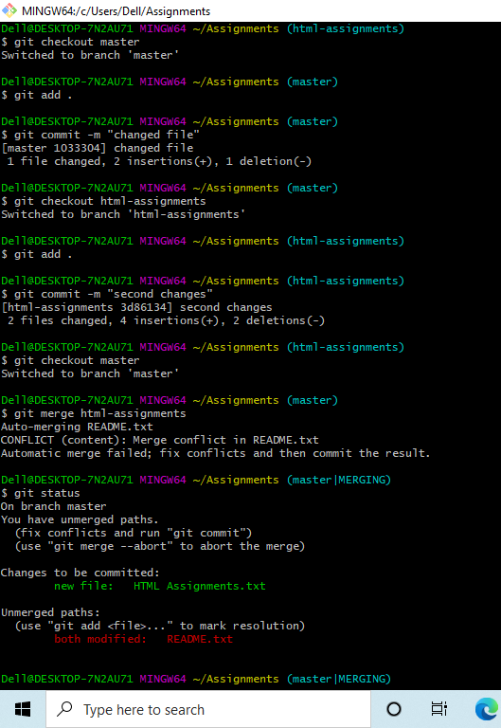

37. Merge ‘html-assignments’ branch into master. Confirm all html assignments are shown

in master.

1. Finally delete the ‘html-assignments’ branch.

