1. Create a new branch ‘css-assignments’.
2. Switch to ‘css-assignments’ branch.
3. Copy all CSS assignments inside ‘Assignments’ folder.
4. Commit CSS assignments into ‘css-assignments’ branch.
5. Make minor changes into README.txt file on line 1 belonging to ‘css-assignments’

branch.

1. Commit those changed files.
2. Switch to master branch.

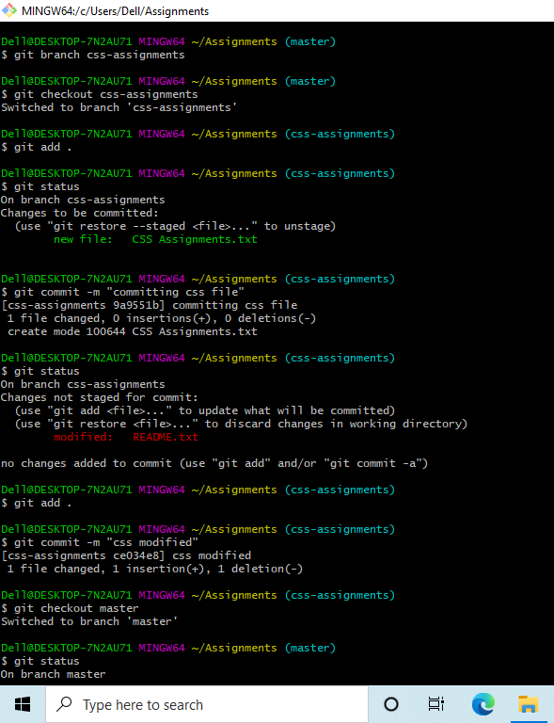

1. Make minor changes into README.txt file on line 3 & commit those changes into

master.

1. Again switch to ‘css-assignments’ branch.
2. Make minor changes into few files belonging to ‘css-assignments’ branch.
3. Commit those changes.
4. Switch to master.

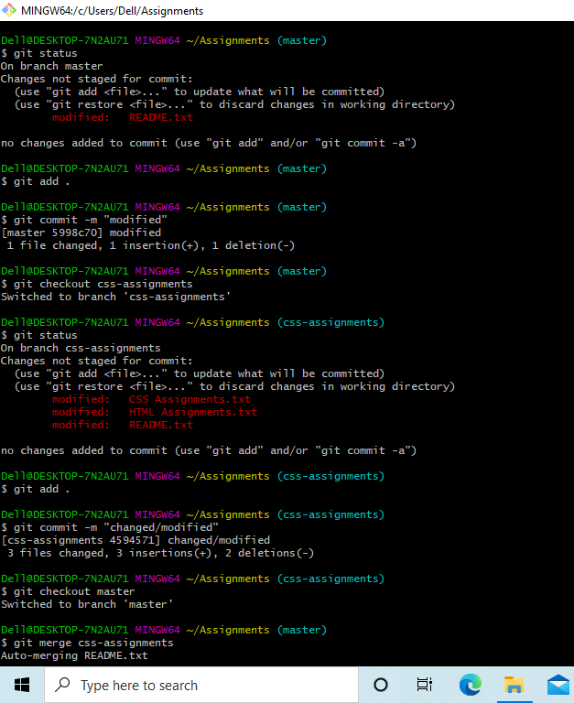

1. Merge ‘css-assignments’ branch into master. Confirm all css assignments are shown in

master.

1. Finally delete the ‘css-assignments’ branch.

