1. Create a new branch ‘js-assignments’.

2. Switch to ‘js-assignments’ branch.

3. Copy all JavaScript assignments inside ‘Assignments’ folder.

4. Commit JavaScript assignments into ‘js-assignments’ branch.

5. Make minor changes into README.txt file on line 1 belonging to ‘js-assignments’ branch.

6. Commit those changed files.

7. Switch to master branch

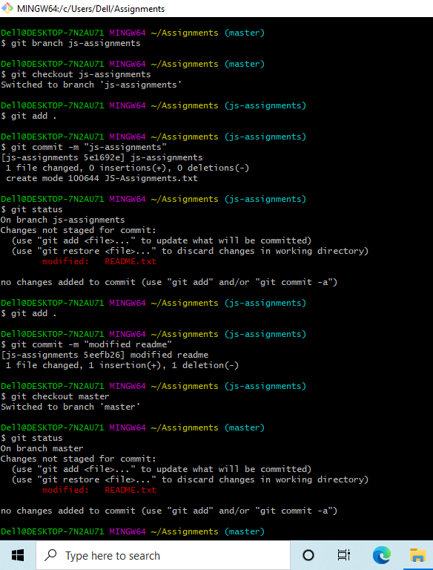

1. Make minor changes into README.txt file on line 1 & commit those changes into

master.

1. Again switch to ‘js-assignments’ branch.
2. Make minor changes into few files belonging to ‘js-assignments’ branch.
3. Commit those changes.

12. Switch to master.

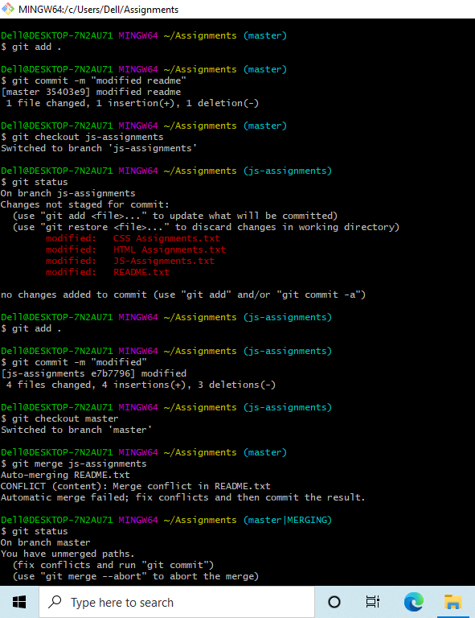

13. Merge ‘js-assignments’ branch into master. Confirm all JavaScript assignments are

shown in master.

1. Finally delete the ‘js-assignments’ branch.

