**Documentation**

Brief report summarizing your findings:

1. **Objective** : Analyze the dataset to calculate financial metrics for each account, rank them, and provide a top 20 list.
2. **Data Cleaning**: Handled missing data and parsed Trade_History.

* Droped missing values as it is creating inconsistancing
* Parse the JSON-like Trade_History Column. The Trade_History column contains JSON-like objects. Converted these into a structured format for further analysis. After that extracted the trade details (e.g., symbol, price, quantity, etc.) from Trade_History for each Port_ID.

1. **Metrics**: metric calculated

* ROI (Return on Investment)
* PnL (Profit and Loss)
* Sharpe Ratio
* MDD (Maximum Drawdown)
* Win Rate
* Win Positions
* Total Positions

1. **Ranking Algorithm**: Mention how you weighted the metrics and ranked the accounts.

* Ranking Accounts - Combine all the metrics into one DataFrame and rank the accounts:

# Merge all metrics into one DataFrame

metrics_df = roi_df.merge(pnl_df, on='Port_ID') \

                   .merge(win_rate_df, on='Port_ID') \

                   .merge(win_positions_df, on='Port_ID') \

                   .merge(total_positions_df, on='Port_ID') \

                   .merge(sharpe_df, on='Port_ID') \

                   .merge(mdd_df, on='Port_ID')

# Rank based on custom weighting (you can adjust weights)

metrics_df['Score'] = (metrics_df['ROI'] * 0.2 +

                       metrics_df['PnL'] * 0.2 +

                       metrics_df['Win_Rate'] * 0.2 +

                       metrics_df['Sharpe_Ratio'] * 0.2 +

                       (1 - metrics_df['MDD']) * 0.2)

# Rank the accounts

metrics_df['Rank'] = metrics_df['Score'].rank(ascending=False)

# Sort by rank and select top 20

top_20_accounts = metrics_df.sort_values('Rank').head(20)

# Preview top 20 accounts

top_20_accounts[['Port_ID', 'Score', 'Rank']]

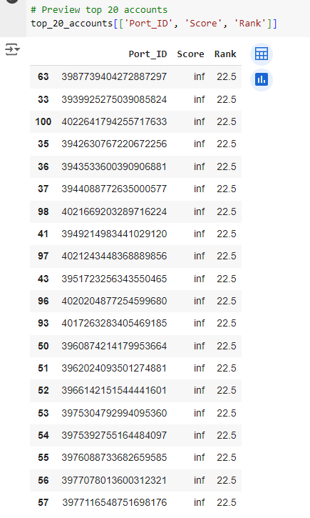

Drive link : https://drive.google.com/drive/folders/14n4BclgqmZzrmvIyURqjTiWGu2CZy0Hl

Github link : https://github.com/SameerHussain128/Internshala_DataScience_Python_Internship