VULNERABILITY ASSESSMENT REPORT

Insecure Direct Object Reference (IDOR)
Application: BillingApp.exe
This report documents an IDOR / Broken Object-Level Authorization issue in the BillingApp billing workflow. The reported test scenario is: User A creates a bill and obtains its bill ID; User B then signs in using a separate account and requests the bill using User A’s bill ID. If the application returns User A’s bill to User B without checking ownership or an explicit permission, the issue is confirmed.

1. Finding Details
Finding Title | IDOR — User B Can Access User A’s Bill by Supplying the Bill ID
Severity | High (provisional; finalize based on exposed data and business impact)
Affected Asset | BillingApp(3).exe / associated billing API
Vulnerability Type | Broken Object-Level Authorization (BOLA) / IDOR
CWE | CWE-639 — Authorization Bypass Through User-Controlled Key; CWE-862 — Missing Authorization (if applicable)
OWASP | OWASP Top 10:2021 A01 — Broken Access Control; OWASP API Security Top 10:2023 API1 — Broken Object Level Authorization
Affected Operation | Retrieve/view bill by bill ID (insert exact endpoint and HTTP method from captured request)

2. Summary
The application reportedly fails to enforce ownership authorization when retrieving a bill by its identifier. User A creates a bill and receives a bill ID. After User B authenticates with a different account, User B can use that bill ID to request and view the bill created by User A. The request is authenticated as User B, but the server returns an object belonging to User A. This indicates that the server checks, at most, that the requester is logged in, but does not correctly verify that the requester is authorized to access the requested bill.
This is an object-level authorization flaw. It is not a session invalidation issue: the key test is that User B’s own authenticated session is used while the bill ID belongs to User A.

3. Impact
If confirmed, a user with a normal account may be able to access bills belonging to other users by obtaining or guessing their bill IDs. Potential impact includes:
- Unauthorized disclosure of another user’s bill, invoice details, line items, totals, dates, or billing history included in the response.
- Exposure of personal, customer, or business information present in the bill or linked bill details.
- Potential access to additional bill-related resources if other endpoints also accept the bill ID without checking ownership; each such endpoint must be tested and documented separately.
- If the same authorization weakness affects update or delete operations, unauthorized modification or deletion may be possible; this impact is not established unless separately tested.

4. Proof of Concept / Steps to Reproduce
Use only authorized test accounts and test data. In Burp Suite, retain User B’s valid authentication throughout the cross-account request.
- Log in to BillingApp as User A.
- Create a new bill using User A’s account. Capture the create-bill request and response, and record the generated bill ID as BILL_A_ID. Confirm that the bill belongs to User A.
- Log out of User A, then log in to BillingApp as User B using a separate account. Confirm that requests are now authenticated with User B’s own session or token.
- As User B, open a bill that belongs to User B and capture the request used to retrieve it. Identify the bill ID location (URL path, query parameter, or request body) and keep User B’s authentication unchanged.
- Send the request to Burp Suite Repeater. Replace only User B’s bill ID with BILL_A_ID, the bill ID generated by User A. Do not replace User B’s session cookie or token.
- Send the modified request. If the response returns User A’s bill or its identifying details instead of denying access, record the actual HTTP status and response as evidence of IDOR.
- If the application has separate endpoints for bill details, attachments, payments, customer details, or other linked resources, test them individually within scope. Report only resources actually returned without authorization.

5. Evidence to Include
Attach screenshots from the actual test. The existing reference report primarily shows login/session traffic and is not, by itself, sufficient proof of this specific bill-ID authorization failure.
Evidence | What the screenshot should demonstrate
Screenshot 1 — User A creates bill | Successful bill creation and the generated BILL_A_ID. Redact customer details.
Screenshot 2 — User B baseline | User B is authenticated and retrieves a bill belonging to User B; show the request and relevant response fields.
Screenshot 3 — Modified bill ID | Burp Repeater request authenticated as User B, with only the bill ID changed to BILL_A_ID.
Screenshot 4 — Unauthorized access | Response returns the bill created by User A while the request remains authenticated as User B.
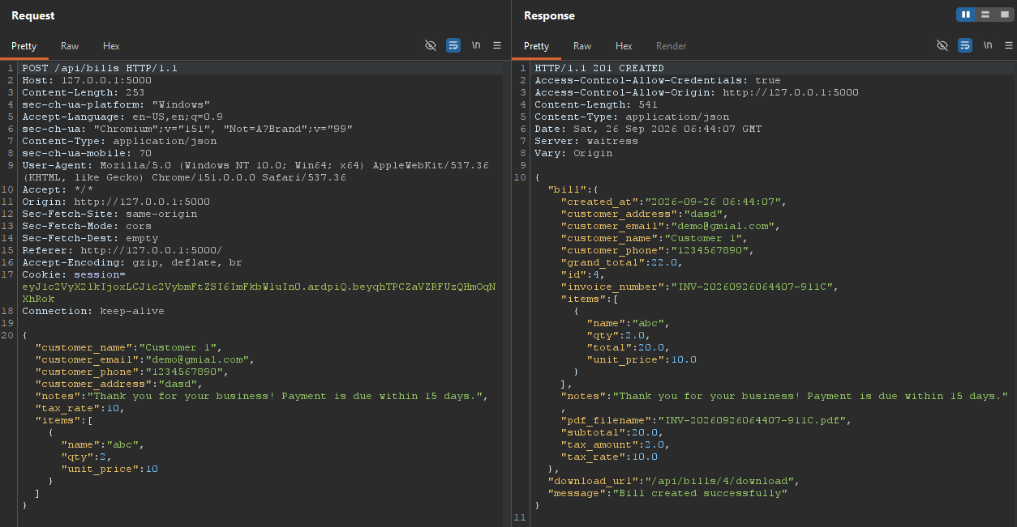
Screenshot 1: User A creates bill and receives BILL_A_ID

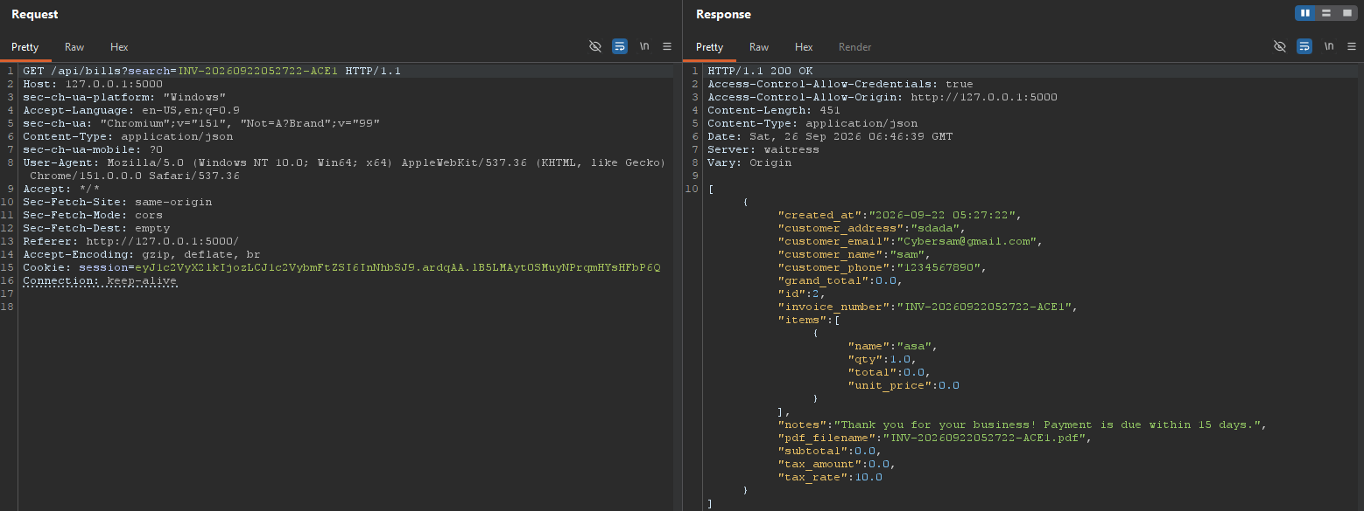 Screenshot 2: User B baseline request

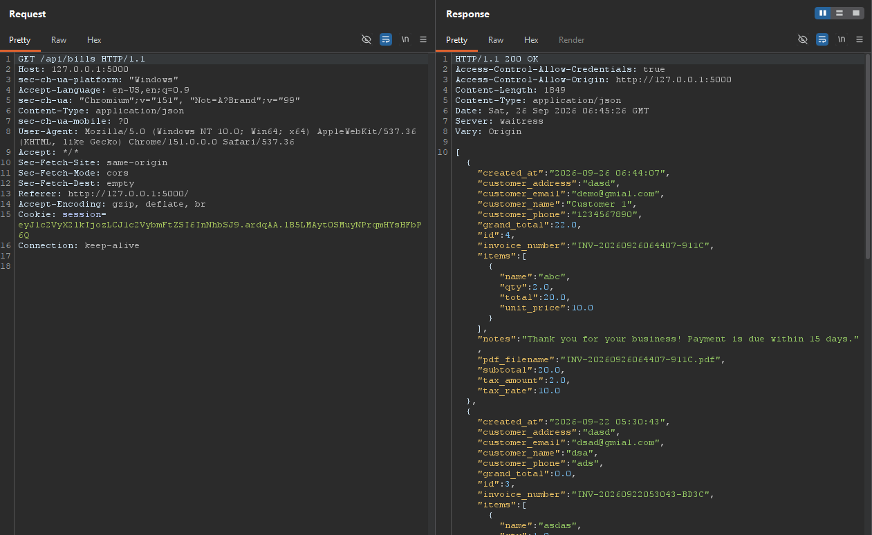 Screenshot 3: User B request with BILL_A_ID
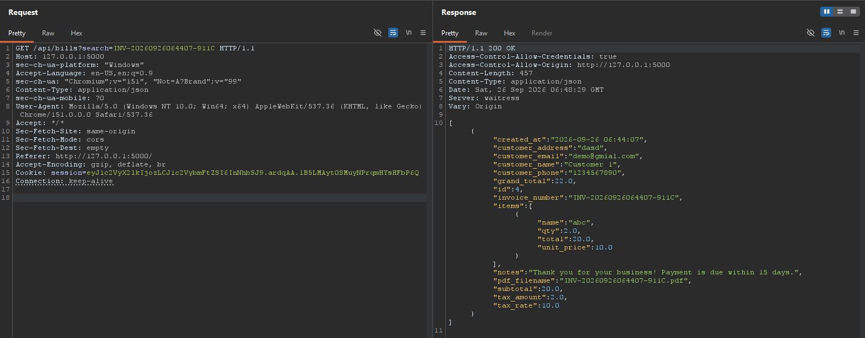
Screenshot 4: Response containing User A’s bill

6. Expected vs. Observed Behavior
Expected secure behavior | Observed behavior to record
The server verifies that the authenticated user owns the requested bill or has explicit permission to access it. A cross-user request is denied (commonly HTTP 403 or a non-disclosing HTTP 404). | User B’s authenticated request uses the bill ID generated by User A and receives User A’s bill data. Insert the actual endpoint, HTTP method, status code, and relevant redacted response fields from Burp Suite.

7. Recommendation
- Enforce server-side object-level authorization on every endpoint that reads or operates on a bill. Check that the authenticated user owns the bill or has an explicit permission to access it.
- Retrieve bills using both the requested bill ID and the authenticated owner/account context; do not query solely by bill ID.
- Derive the requester’s identity from the validated server-side session or token. Do not trust a user ID or ownership value supplied by the client.
- Apply the same authorization checks to linked resources such as bill items, payment records, attachments, exports, and bill-related customer data.
- Use deny-by-default authorization and return a consistent denial response without exposing bill contents when ownership checks fail.
- Add automated cross-account tests: User B must not be able to read, update, or delete User A’s bill by changing the bill ID.
- Log suspicious repeated cross-account access attempts without logging session cookies, bearer tokens, or unnecessary sensitive data.

8. Retest Criteria
- User A can retrieve the bill created by User A.
- User B cannot retrieve User A’s bill by submitting BILL_A_ID while authenticated as User B.
- The server denies unauthorized access consistently across all bill-related endpoints and relevant HTTP methods.
- Any legitimate shared-billing or administrator access is allowed only through explicit, tested authorization rules.

9. References
- CWE-639 — Authorization Bypass Through User-Controlled Key.
- CWE-862 — Missing Authorization.
- OWASP Top 10:2021 — A01: Broken Access Control.
- OWASP API Security Top 10:2023 — API1: Broken Object Level Authorization (BOLA).

10. Evidence Handling Note
Redact session cookies, bearer tokens, credentials, personal information, and sensitive billing values from screenshots shared outside the authorized assessment team. Keep original evidence securely according to the engagement requirements.

