**Hadoop Installation Steps**

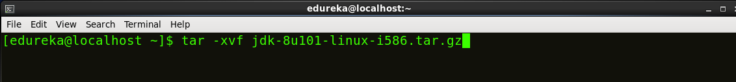

Fig: Hadoop Installation – Extracting Java Files

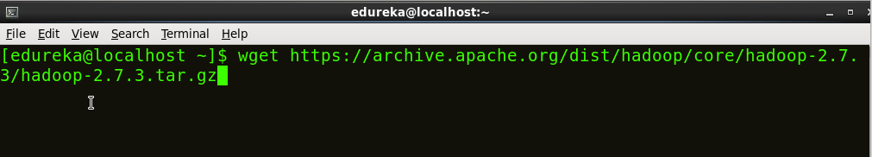

Fig: Hadoop Installation – Downloading Hadoop

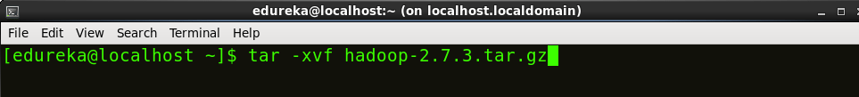

Fig: Hadoop Installation – Extracting Hadoop Files

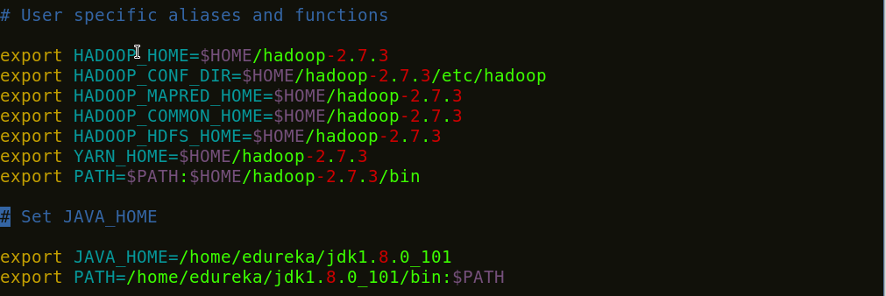

Fig: Hadoop Installation – Setting Environment Variable

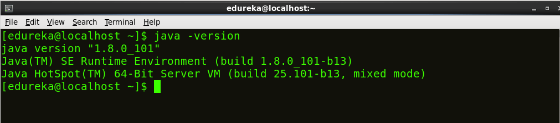

Fig: Hadoop Installation – Checking Java Version

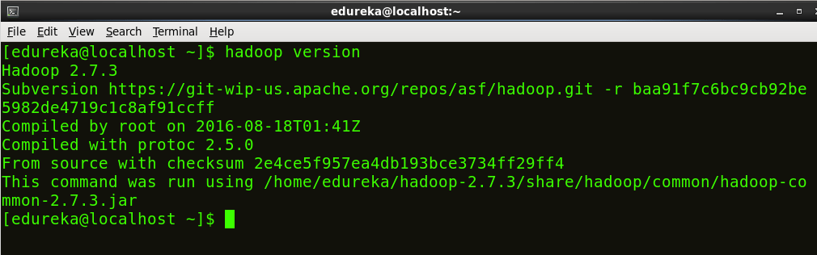

Fig: Hadoop Installation – Checking Hadoop Version

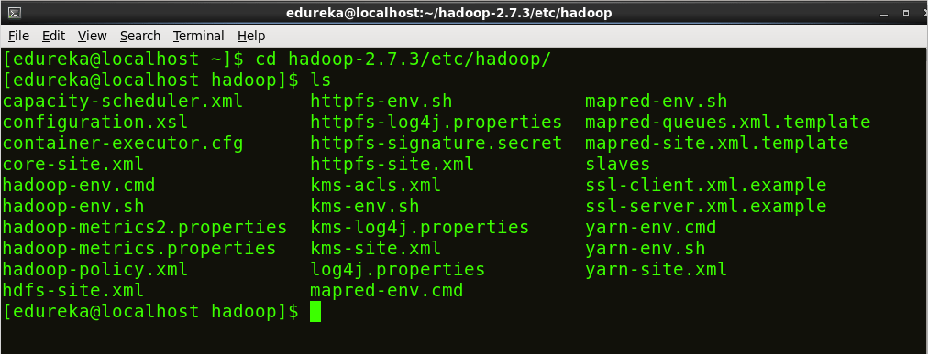

Fig: Hadoop Installation – Hadoop Configuration Files

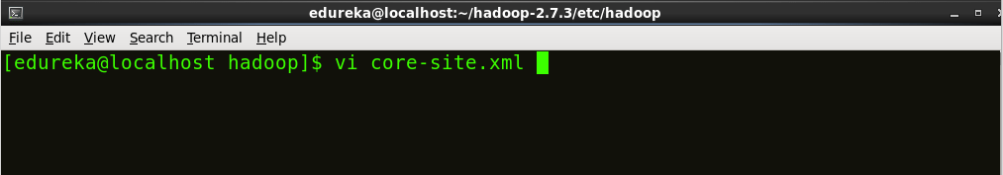

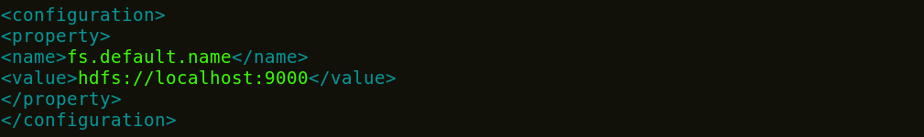

Fig: Hadoop Installation – Configuring core-site.xml

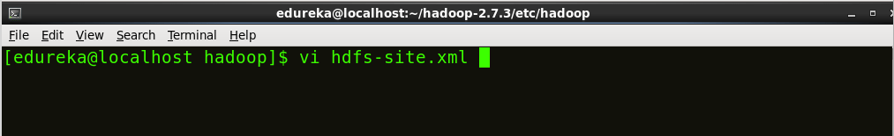

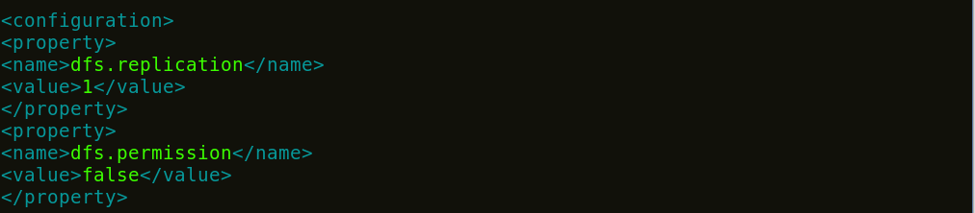

Fig: Hadoop Installation – Configuring hdfs-site.xml

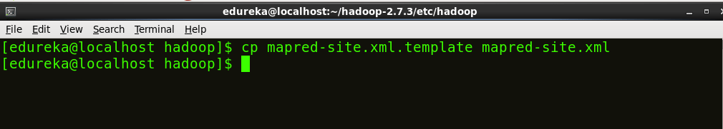

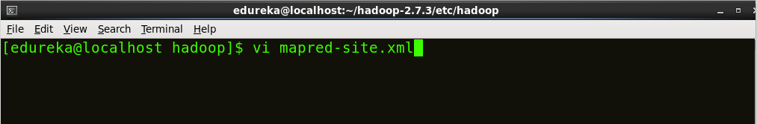



Fig: Hadoop Installation – Configuring mapred-site.xml

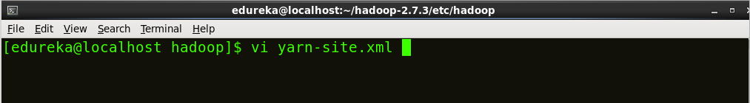

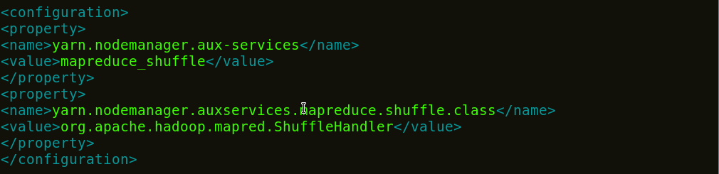

Fig: Hadoop Installation – Configuring yarn-site.xml

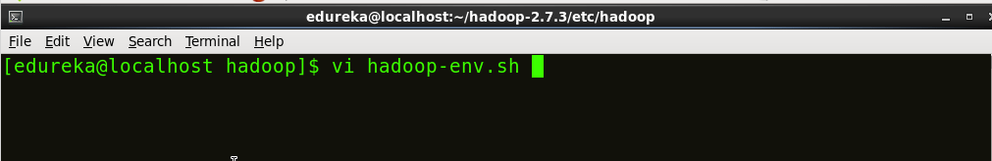



Fig: Hadoop Installation – Configuring hadoop-env.sh

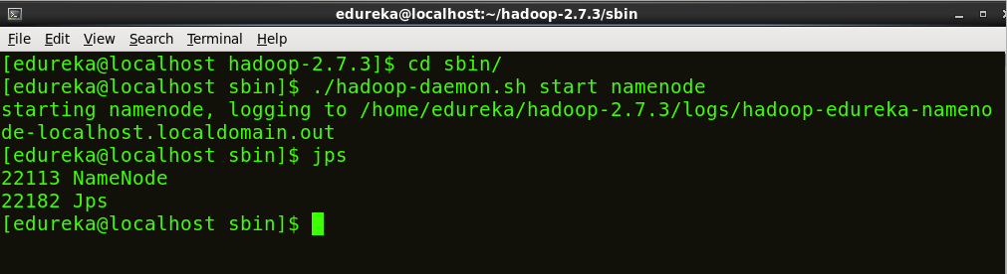

*Fig: Hadoop Installation – Starting NameNode*

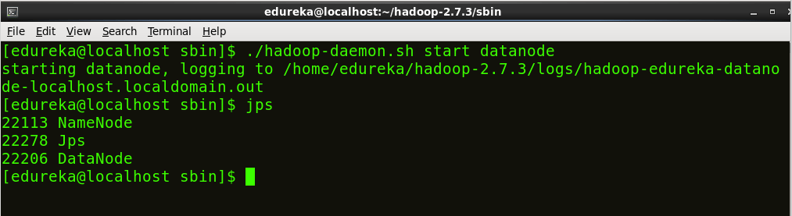

Fig: Hadoop Installation – Starting DataNode

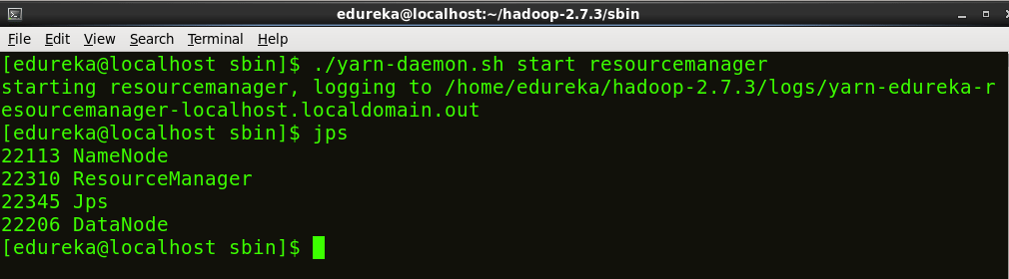

Fig: Hadoop Installation – Starting ResourceManager

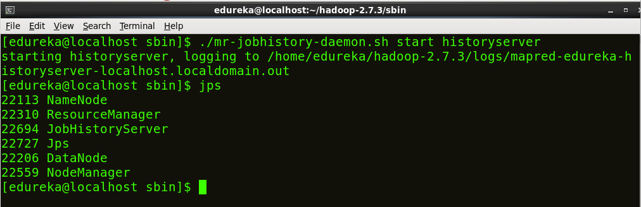

Fig: Hadoop Installation – Checking Daemons

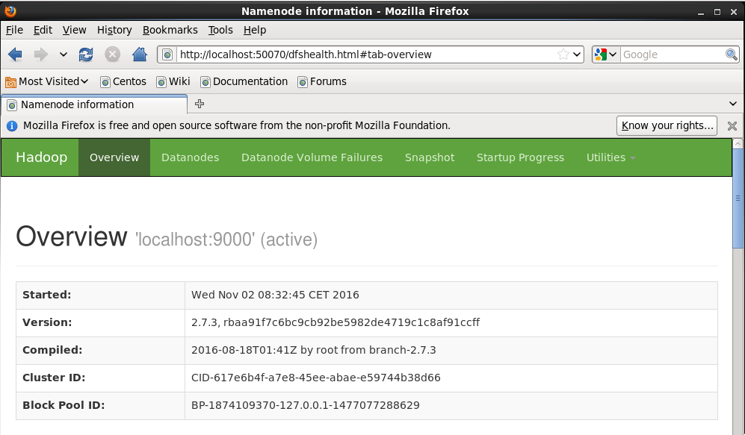

Fig: Hadoop Installation – Starting WebUI