# Git Repository Creation Process

This document explains the step-by-step process to create a GitHub repository, organize folders for assignments, upload files, and share the repository link.

**Step 1: Create a Repository**

1. **Log in to GitHub**: Go to [GitHub](https://github.com) and log in to your account.
2. **Create a New Repository**:
   * Click the **“+”** icon in the top-right corner and select **“New repository”**.
   * Enter your **enrollment number** as the repository name (e.g., 12345678).
   * Add an optional description (e.g., "Repository for Assignments").
   * Choose **Public** or **Private** as per your preference.
   * Leave the other options unchecked.
   * Click **Create repository**.
   * 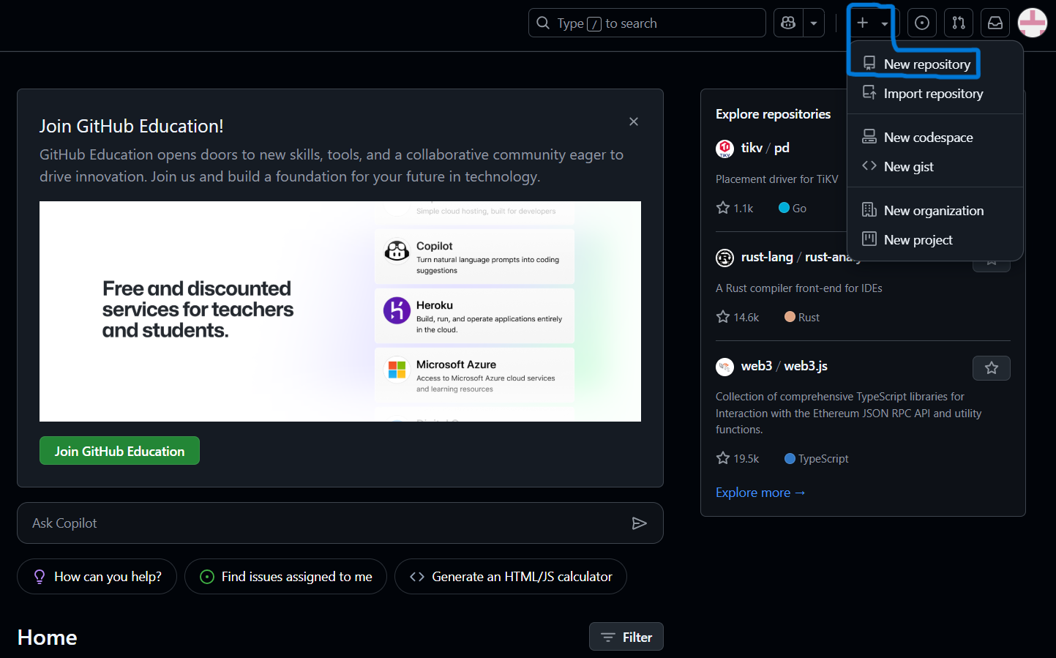

**Step 2: Create Folders**

1. Open your newly created repository.
2. **Create the Assignment_1 folder**:
   * Click **“Add file”** > **“Create new file”**.
   * In the **file name field**, type Assignment_1/placeholder.txt (the / creates the folder).
   * Add some text like This is a placeholder file. (GitHub does not allow empty folders).
   * Scroll down and click **Commit new file**.
3. **Create the Assignment_2 folder**:
   * Repeat the above steps, but name the folder Assignment_2/placeholder.txt.

Now your repository contains two folders: Assignment_1 and Assignment_2.

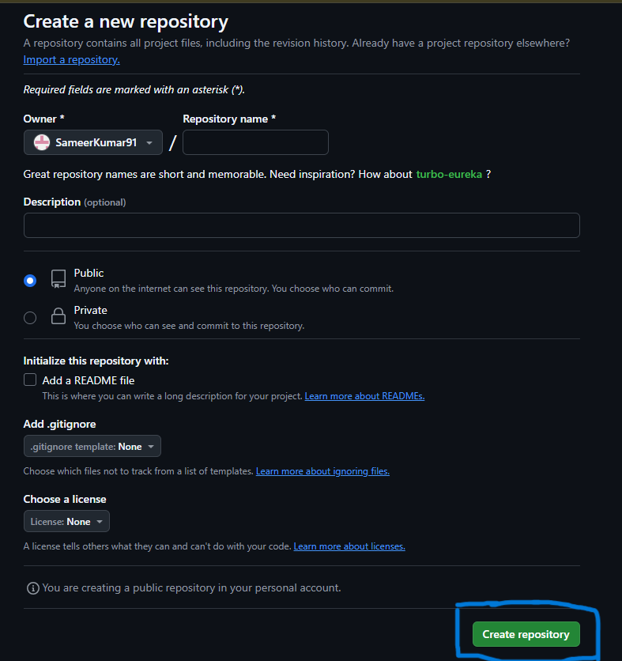

**Step 3: Upload Assignments**

1. Open the **Assignment_1** folder.
2. Click **“Add file” > “Upload files”**.
3. Drag and drop or select your Assignment 1 files from your computer.
4. Add a commit message like **“Added Assignment 1 files”**.
5. Click **Commit changes**.
6. Repeat the same steps for the **Assignment_2** folder to upload your Assignment 2 files.

