**Programming Assignment - Game Playing Algorithms**

**EVALUATION FUNCTION:**

The implementation of the evaluation function analyses both the completed and the possible connect 4’s on the Game Board. It analyses the possible connect 4’s in the all the possible directions (horizontal vertical and diagonal).The scores assigned are:

* Completed Connect 4 's:
* If all the slots are filled :100
* Possible Connect 4 's:
* If 3 are continuous and 1 is empty:30
* If 2 are continuous and 2 are empty:10
* If 1 are continuous and 3 are empty:5

The scores are used for both min and max player.

The utility value used is:

**(100*max_4 + 30* max_3 + 10* max_2 + 5* max_1) - (100*min_4 + 20*min_3 + 10*min_2 + 5*min_1)**

**Depth limit vs CPU Runtime:**

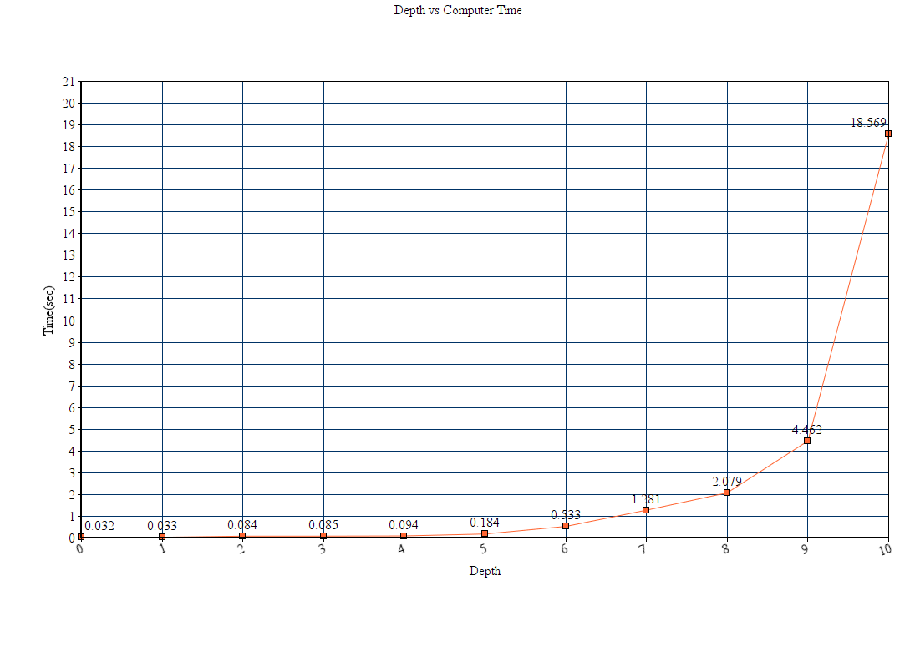

|  |  |
| --- | --- |
| **Depth** | **CPU Time(sec)** |
| 0 | **0.032** |
| **1** | **0.033** |
| 2 | **0.084** |
| **3** | **0.085** |
| **4** | **0.094** |
| **5** | **0.184** |
| **6** | **0.533** |
| **7** | **1.281** |
| **8** | **2.079** |
| **9** | **4.462** |
| **10** | **18.569** |

The code implemented does not go beyond depth level 10.If it goes beyond depth level 10 it gives an error of java.lang.OutOfMemoryError: Java heap space error.

Another class Node.java has been implemented to generate the successors and store their column value.