#### ****Experiment Title: Detecting Faces****

Principal Investigator: Dr. Elizabeth Chua

Brooklyn College - Psychology Department

#### Additional Information

Purpose of the Research Study: The research is being conducted to test the efficacy of a visual masking procedure. You will view faces that are presented briefly on the computer and asked to say if the face pictured “disgust” or was “neutral.”

Risks/Discomforts: There are no risks for participating in this study beyond those associated with normal computer use.

Benefits: Although it will not directly benefit you, this study will provide a foundation for a future study with the goal of advancing basic science on the cognitive processes involved in memory.

Voluntary participation and right to withdraw: Participation in this study is voluntary, and you can stop at any time without penalty. To stop, click on the “Return HIT” button, or close your browser window.

Confidentiality: The only identifying information kept based on your participation in this study will be your Amazon Mechanical Turk WorkerID serial number.

Compensation: If you satisfactorily complete the study, you will receive $4 to compensate you for your participation. $1.50 of this amount is a bonus for completing the entire HIT. Payments are made via Amazon’s payment system.

Questions or Concerns: You can ask questions about this research study now or any time during the study by emailing chua.lab@brooklyn.cuny.edu. If you have any questions about your rights as a research participant or if you would like to talk to someone other than the researchers, you can contact CUNY Research Compliance Administrator at 646-664-8918 or HRPP@cuny.edu.

By clicking ACCEPT, you have indicated that you agree to participate in the study and that you understand the information in this consent form. You agree that you are between 18 and 65 years old, and that you have not waived any legal rights you otherwise would have as a participant in a research study. The purpose of the informed consent is to provide participants with the general nature of their task and describe any risks or benefits of their participation.

Cognition is in Beta. Please, help us by providing feedback.

#### Instructions [On New Screen]

*Below for Directions – Associative Memory Task*

**Directions**

This task consists of two phases: a five-minute memorization phase and a ten-minute recall phase.

During the memorization phase, you will be presented with a person’s face and name. For each face-name pair, you will respond whether or not you feel as though the name “fits” the face. There will be a total of 128 face-name pairs, do your best to memorize the face-name pairs as you go along. Each face will be presented for no more than 5 seconds.

During the recall phase, some of the face-name pairs will have been rearranged, and your job is to answer whether or not the pair has been rearranged or is the same as before?

**Directions**

For each trial, you will be shown 3 images in rapid succession. The first is a scrambled picture. The second or middle image is either a “neutral face” or a “disgust face.” This may be presented so quickly that you may not see it. The final image will always be a neutral face.

At the end of the trial you will be asked the following question,

*Did you see a disgust face?*

Press **1** for *yes*

Press **2** for *no*

There will be a total of 150 trials. You will have one hour to complete the task.

**Directions**

In the previous task, you likely noticed some briefly presented faces in greyscale. In this task, you will *only* see these greyscale faces, and you be asked whether or not you detected a face with an expression of “disgust.”

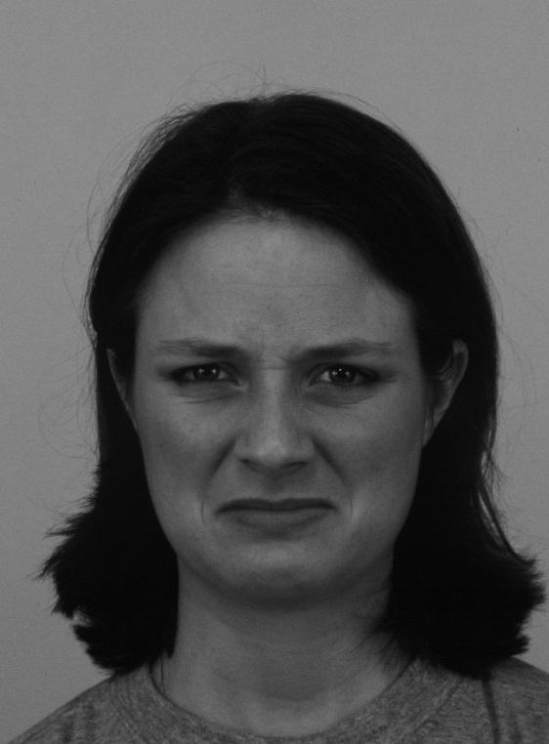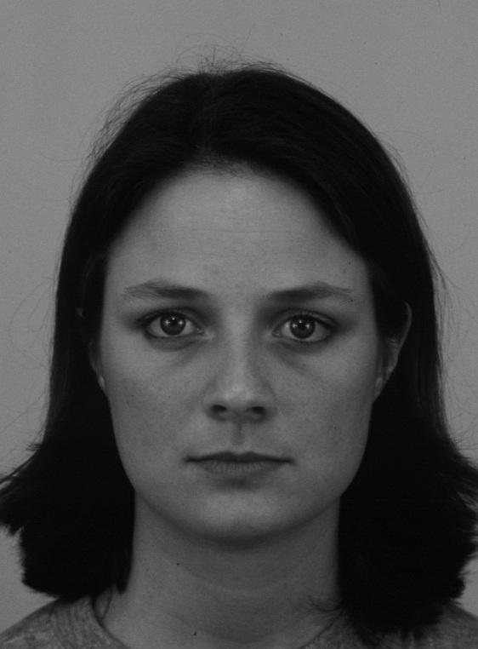

Neutral Face Example

Disgust Face Example