**Detection of Fake and Clone accounts in Twitter using Classification and Distance Measure Algorithms**

**ABSTRACT:**

Online Social Network (OSN) is a network hub where people with similar interests or real world relationships interact. As the popularity of OSN is increasing, the security and privacy issues related to it are also rising. Fake and Clone profiles are creating dangerous security problems to social network users. Cloning of user profiles is one serious threat, where already existing user’s details are stolen to create duplicate profiles and then it is misused for damaging the identity of original profile owner. They can even launch threats like phishing, stalking, spamming etc. Fake profile is the creation of profile in the name of a person or a company which does not really exist in social media, to carry out malicious activities. In this paper, a detection method has been proposed which can detect Fake and Clone profiles in Twitter. Fake profiles are detected based on set of rules that can effectively classify fake and genuine profiles. For Profile Cloning detection two methods are used. One using Similarity Measures and the other using C4.5 decision tree algorithm. In Similarity Measures, two types of similarities are considered – Similarity of Attributes and Similarity of Network relationships. C4.5 detects clones by building decision tree by taking information gain into consideration. A comparison is made to check how well these two methods help in detecting clone profiles.

**EXISTING SYSTEM:**

* Brodka, Mateusz Sobas and Henric Johnson in their paper have proposed two novel methods for detecting cloned profiles. The first method is based on the similarity of attribute values from original and cloned profiles and the second method is based on the network relationships. A person who doubts that his profile has been cloned will be chosen as a victim. Then treating name as primary key, a search is made for profiles with the same name as that of victim, using query search. Potential clone (Pc) and the Victim profile (Pv) are compared and similarity S is calculated. If S(Pc, Pv) > Threshold, then profile is suspected to be a clone. In the verification step, the user does it manually as he knows which is his original profile and which one is a duplicate.
* Cresci S, Di Pietro R, Petrocchi M, Spognardi A, Tesconi M, in their paper have reviewed some of the most relevant existing features and rules (proposed by Academia and Media) for fake Twitter accounts detection. They have used these rules and features to train a set of machine learning classifiers. Then they have come up with Class A classifier which can effectively classify original and fake accounts.

**DISADVANTAGES OF EXISTING SYSTEM:**

* Fake and clone profiles have become a very serious social threat. As information like phone number, email id, school or college name, company name, location etc are readily exposed in social networks, hackers can easily hack this information to create fake or clone profiles. They then try to cause various attacks like phishing, spamming, cyberbullying etc. They even try to defame the legitimate owner or the organisation.

**PROPOSED SYSTEM:**

* In the proposed system we used to detect fake Twitter profiles. Here fake profiles are detected based on rules that effectively distinguish fake profiles from genuine ones. Some of the rules that are used to detect fake profiles are - usually fake profiles do not have profile name or image. They do not include any description about the account. The geo-enabled field will be false as they do not want to expose their location in tweets. They usually make large number of tweets or sometimes the profiles would not have made any tweets etc. The rules are applied on the profile, for each matching rule, a counter is incremented, if the counter value is greater than pre-defined threshold, then the profile is termed as fake.

**ADVANTAGES OF PROPOSED SYSTEM:**

* The modules worked fine and was able to detect clones with good accuracy.
* Good Results

**SYSTEM ARCHITECTURE:**

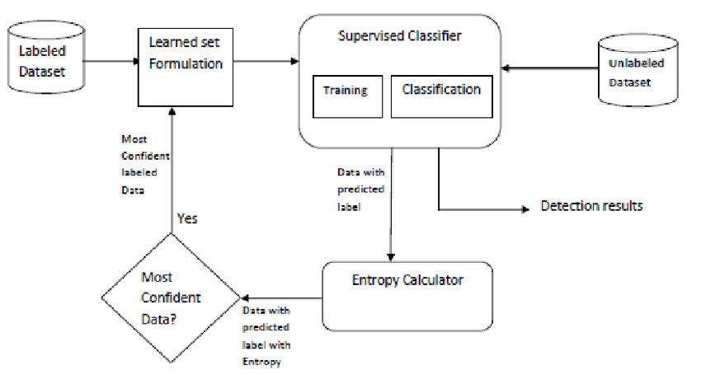

**SYSTEM REQUIREMENTS:**

**HARDWARE REQUIREMENTS:**

* System : Pentium i3 Processor.
* Hard Disk : 500 GB.
* Monitor : 15’’ LED
* Input Devices : Keyboard, Mouse
* Ram : 2 GB

**SOFTWARE REQUIREMENTS:**

* Operating system : Windows 10.
* Coding Language : Python

**REFERENCE:**

Sowmya P and Madhumita Chatterjee, “Detection of Fake and Clone accounts in Twitter using Classification and Distance Measure Algorithms”, IEEE CONFERENCE, 2020.