Business name: SR Woodcraft and Designs
Logo: 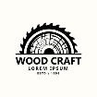
Slogan: Saw it. Designed it. Nailed it.

Dev stack: HTML, CSS, javascript
Hosting: netlify
CMS: cloudinary

Pages:
- Home

- About
- Contact
- Footer

